E-Commerce Data Warehouse & ETL Pipeline
Entry Level Data Engineering Project

- Source Data Understanding
Q1) Inspect all 5 CSV files and understand the purpose of each dataset
Ans) The 5 csv files of E-Commerce Data Warehouse and ETL Pipelines are of
Customers.csv,order_items.csv,orders.csv,payments.csv and products.csv.Customers.csv is a dimension table and has the descriptive information or attributes of customers ie id,name,city,email.It basically has the descriptive information of details of customers.order_items.csv is a fact table and mainly has all numerical values ie order_id,product_id,quantity,unit_price and discount.Orders.csv is also a dimension table which has columns of order_id,customer_id,order_date,order_status and shipping city.It is basically a dimension table which has information related to order_status of specific customer on a given order_date with order_number.Payments.csv is also a dimension table which is small in size and has descriptive information of payment_id with the different types of payment_methods of various payment_status of Paid and Failed.Payments.csv file basically contains Paid and Failed information as Payment_Status of different payment_ids of various types of Payment_method of Wallet,Credit Card,Net Banking and Debit Cards.
Products.csv is also a dimension table which has descriptive information of various categories of product_names of different product_ids of different suppliers ie Supplier_A,Supplier_B,Supplier_C,Supplier_D of different unit_price of various unit_cost.
File Names | Purpose
- Customers.csv | Descriptive information of customer details ie name,city,email,state and sign_up_date
- Order_items.csv | Fact_table stating information related to quantity,unit_price and discount of order_item_id,order_id and product_id
- Orders.csv | Dimension table giving information of order_status of different customer_ids for various order_numbers
- Payments.csv | Information of Payment status of various Payment methods ie Wallet,Credit and Debit cards of various payment_ids of different order ids
- Products.csv | Dimension table giving information related to various product categories ie Electronics,Home and Fashion of various product names of different types of suppliers with different product ids

Q2) Identify the primary keys and foreign-key relationships between the datasets
Ans) Primary key->is an unique identifier,which uniquely identifies each row in the table.It consist of unique and not null values.It specifically identifies the column in a table
Foreign key-> is also a constraint and it basically specify the unique column names of different table.For example->customer_id is the primary key of customers table ie of customers.csv.order_item_id is the primary key of order_items.Here order_id and product_id are the foreign keys as these colum_ids are also present in orders and in products table
Customers.csv->customer_id is the primary key of customers table
Order_items.csv->order_item_id is the primary key.Here order_id and product_id are the foreign keys of orders and products table
Orders.csv->order_id is the primary key.Here customer_id is the foreign key of customers table
Payments.csv->Here payment_id is the primary key and order_id is the foreign key of orders and order_items table
Products.csv->In this dataset,product_id is the primary key

Q3) Determine the grain of each dataset: customers, products, orders, order_items, and payments.
Ans) Grain of dataset means lod ie level of detail or detailed information of a row of a table.Example of Grain of customers,products,orders,order_items and payments are mentioned below
Grain of customers.csv means detailed information of customer.For example:Arjun Sharma of Kolkata in WestBengal State has customer_id of 1
And email of arjun.sharma1@example.com on 08-10-2024 signup_date.
Grain of order_items.csv means detailed information of order_item details.For example:product_id 1053 has 4 quantity and order_id , order_item_id of 1with 15 discountpercentage of unit_price 2880
Grain of orders.csv is a detailed information of orders table.For example->On 10-01-2025 15:20:00 order_date,customer_id 98 of Gurgaon shipping city has returned the order_id 1
Grain of payments.csv is a detailed information of row of payment table.For example->Wallet method of payment_method has payment_id and order_id of 1 each of Paid payment_status with 27916.8 payment_amount.
Grain of products.csv is a detailed information of row of the product table.For example->Electronics category of Laptop1 of Supplier_A has Laptop1 of Product_name with 1001 product_id of 19118 unit_price and 12018.41 unit_cost

Q4) Identify at least 5 data-quality issues present in the source datasets
Ans) The data quality issue in the datasets are mentioned below
- The datatype of customer_id of customers.csv is object.It should be of int data type because values are numerical
- There are some blank values of in email column of customers.csv dataset ie N/A Values
- City column of customers.csv dataset also has blanks which are null or N/A values
- In products.csv dataset,there are missing or blank values in unit_price column
- In payments.csv dataset,there are blank values in payment_status column
- The source datasets of Ecommerce ETL has null values,duplicates and incorrect datatypes of some of the columns

Section D: Data Warehouse Modeling

Q18) Design a star schema for the E-Commerce Data Warehouse.
Ans) The star schema for the E-Commerce Data Warehouse is mentioned below:
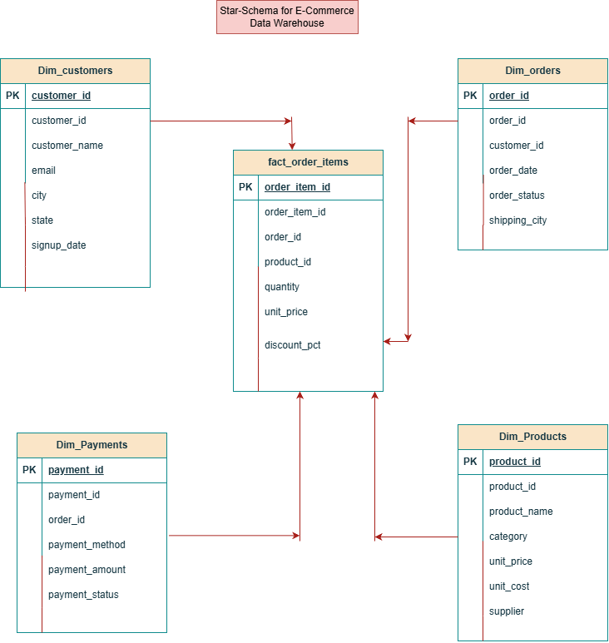

Q19) Clearly define the grain of the main fact table.
Ans) Fact_table exists in datawarehouse.This table is large in size and has mainly all the numerical columns in it.Grain of the main fact table is the lod ie level of detail or detailed information of the row of the table.Here,the fact table is order_items ie fact_order_items.In this table the grain is There are 4 quantities of product_id 1053 with order_id of 1 and order_item_id of 1with 15 discount_pct of 2880 unit_price.This is the grain of first_row of fact_order_items.

Q20) Choose appropriate business keys and surrogate keys for the dimension tables.
Ans) The business keys are primary and foreign keys,while surrogate keys are artificially unique identifier that uniquely identifies the each record in the table
The business keys and surrogate keys of dimension tables are mentioned below:
- Dim_customer-> is a dimension table.In this table customer_id is the primary key.It can also be count as business key and can be abbreviated as 101,102,103.Surrogate keys are helpful in datawarehouse of dimension table and that can be stated as CK101,CK102,CK103.
- Dim_order->is also a dimension table.In this table,order_id is the primary key and it can also be serve as business key and can be abbreviated as 1,2,3.The surrogate key of order_ids can be stated as OK1,OK2,OK3
- Dim_payments->is also a dimension table.Here,primary key is the payment_id and it can also be stated as business key.Examples of payment_id are 1,2,3,4,5.The surrogate keys of payment_id are Pa1,
Pa2,Pa3
- Dim_product->is also a dimension table.The primary key of products is product_id.Examples of product_id are 1001,1002,1003.The surrogate key of dim_product are Pr1001,pr1002,Pr1003

Q21) Create the following warehouse tables:
- Dim_customer
- Dim_product
- Dim_date
- Fact_order/fact_sales
Ans) The dim_customer table is mentioned below
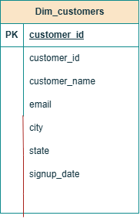

Dim_customers is a dimension table.Here,customer_id is the primary key and is also the column.The columns of dim_customers table are customer_id,customer_name,email,city,state and signup_date.

Dim_product is also a dimension table.In this dimension table product_id is the primary key product_id,product_name,category,unit_price,unit_cost and supplier.The dimension table of dim_product is mentioned below

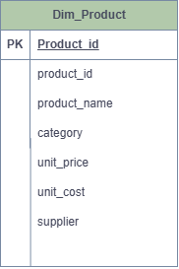

Dim_date is a dimension table.The Dim_date dimension table is mentioned below
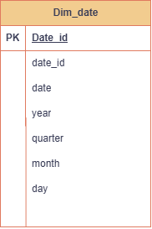

Here,date_id is the primary key with columns date,year,quarter,month and day.
Fact_order is a fact table which is larger in size and has all the numerical columns.The fact_order table is mentioned below

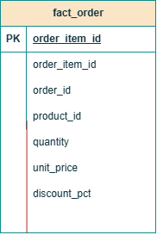
In fact_order fact table,order_item_id is the primary key.The columns of the fact table are order_item_id,order_id,product_id,quantity,unit_price and discount_pct

Section E-> MySQL Warehouse Loading
Q24) Compare source and target record counts and create an ETL audit table containing:

* pipeline_run_id
* run_start_time
* run_end_time
* source_row_count
* target_row_count
* pipeline_status

Ans) The source records are customers.csv,orders.csv,order_items.csv,payments.csv and products.csv. These are the raw source files
The source count of these files are as follows:
- There are 501 rows and 6 columns in customers dataframe
- There are 3819 rows and 6 columns of order_items_dataframe
- There are 1500 rows and 5 columns of orders dataframe
- There are 1500 rows and 5 columns of payments dataframe
- There are 120 rows and 6 columns of products dataframe
The target record count are of the target datawarehouse and the tables mentioned are listed below:
- There are total 500 rows and 6 columns in dim_customers
- There are 1000 rows and 6 columns in dim_order_items
- There are 1000 rows and 5 columns in dim_orders
- There are 1000 rows and 5 columns in dim_payments
- There are 119 rows and 6 columns in dim_products

The ETL Audit table is mentioned below:
Below mentioned is the table creation of EL Audit
create table etlaudit(pipeline_run_id bigint,run_start_time time,
run_end_time time,source_row_count bigint,target_row_count bigint,
pipeline_status varchar(150));
desc etlaudit;

Field | Type | Null | Key | Default | Extra
pipeline_run_id | bigint | YES |  | NULL
run_start_time | time | YES |  | NULL
run_end_time | time | YES |  | NULL
source_row_count | bigint | YES |  | NULL
target_row_count | bigint | YES |  | NULL
pipeline_status | varchar(150) | YES |  | NULL

