**Canteen Ordering System for Unilever**

Q1)-Identifying stakeholders – Create a list of stakeholders (as taught in Business Analysis Planning and Monitoring Knowledge Area)

Ans 1) The list of the stakeholders are:

1. Unilever Employees: They are the users who will order the food from the automated online canteen ordering system
2. Menu Manager: is responsible for creation and updation of menu
3. Canteen Manager: must be able to request the delivery to employee workstation
4. Meal Delivery Boy: is responsible for delivering the lunch to the employee’s workstation and also the closing of the online order

Q2) Identify the problem statement in this system

Ans 2) The Problem statement is: Poor, monotonous and low quality manual canteen ordering system of Unilever

Q3) Identify the Objectives of new Canteen Ordering System

Ans 3) The Objectives of new Canteen Ordering System are:

1. The automated Canteen Ordering System must reduce the cost
2. The new canteen system must reduce the food wastage by minimum of 30% within 6 months of first release
3. The automated Canteen system should also reduce the operating costs by 15% within 12 months of its implementation
4. The new canteen system must be able to operate with less workforce.
5. It should also increase the average effective work time by 30 minutes per employee per day within 3 months

Q4) Create as-is and future process map (using flowcharts). You can use any of the popular tools in the market like Microsoft Visio, Lucid Chart, Creately, Pidoco, or Balsamiq

Ans4) Existing Process Map of Unilever: The below mentioned diagram is the process Map of Unilever. It contains the Manual Canteen Ordering System of Unilever

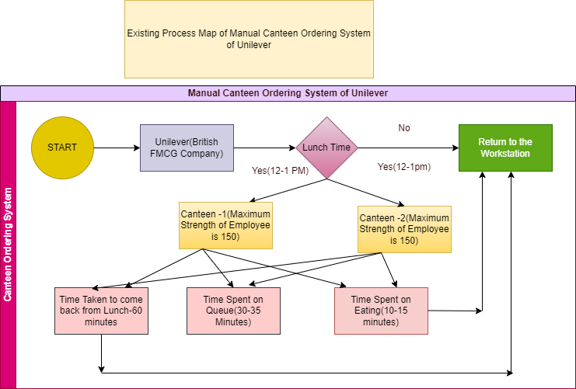

Future Process Map of Unilever: The below mentioned diagram is the Future process Map of Unilever. It contains the Automated Canteen Ordering System of Unilever

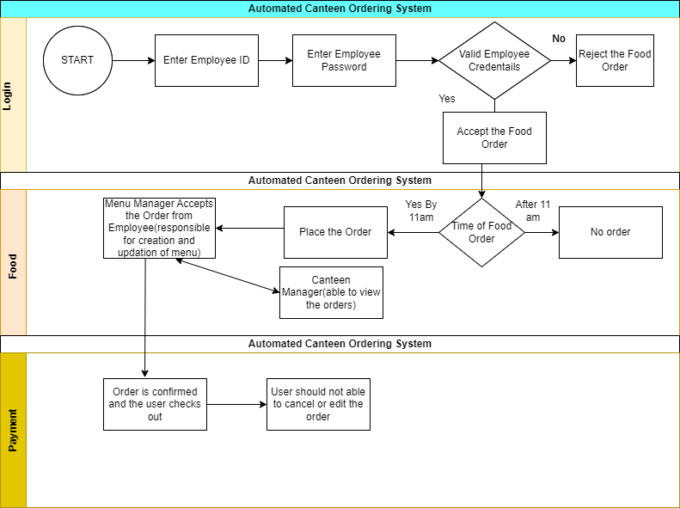

Q5) As a Business Analyst working on this project, find out the scope of the Canteen Ordering System. To find the scope you can use the case diagram (UML) or context diagram for the same.

Ans) Scope of the Canteen Ordering System

Scope Modelling is one of the Acceptance Criteria of Business Analysis. Scope Modelling is of two types one is In-Scope and the next one is Out-scope. Example of In-Scope in Unilever Canteen Ordering are:

1. 1500 employees of the Unilever
2. Two canteens to cater 1500 employees
3. Maximum employee capacity per canteen is 150

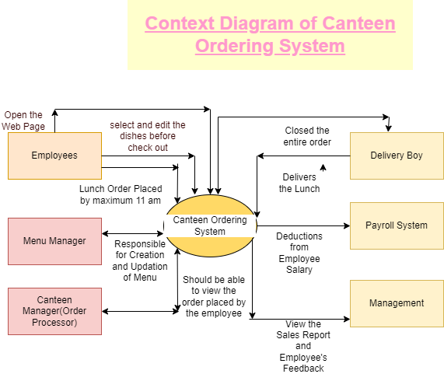

Q6) Write down the main features that need to be developed

Ans) The main features that need to be developed are:

1. In Automated Canteen Order System ,the canteen Manager should be able to request the delivery to employee’s Workstation
2. Automated Canteen Ordering System should automatically deduct the payment from the employee’s salary as there is no payment gateway for the system
3. Automated Canteen Ordering System must have the feature of employee’s feedback submission.
4. The payroll system shall calculate the total number of dishes ordered by each employee

Q7) Write the in-scope and out-of-scope items for this software.

Ans) In-Scope requirements are the requirements which lie inside the Boundary while Out-scope requirements are those which lie outside the Boundary

**List of In-Scope requirements**

1. Only 1500 employees located at UK may order food
2. The automated canteen system is accepting the lunch orders of employees by maximum 11am
3. The web page of automated canteen system contains the menu or dishes which are available in manual canteen system along with prices
4. Only one menu manager is required for creation and updation of menu
5. The employees of Unilever(users) can edit the dishes prior to checkout
6. Only one canteen manager can view the employees lunch orders

**List of Out-Scope Requirements**

1. Any employee outside Unilever UK is not allowed to ordered food
2. More than 1500 employees located at UK can’t order food
3. If the lunch order is placed at 11:05 am or after that then the automated canteen ordering system will not accept the order and throws a warning message of time-out
4. Any outsider or a random person is not allowed to access the automated canteen ordering system because the system will ask for Unilever employee’s credentials
5. More than one canteen manager who is viewing the employees lunch orders is an out-of scope requirements
6. If the employee is placing the order twice for lunch then it’s an out of scope requirement

Q8) Draw an activity diagram for the system

Ans) There are two activity diagrams one is of the manual canteen ordering system and the next one is of the automated canteen ordering system.

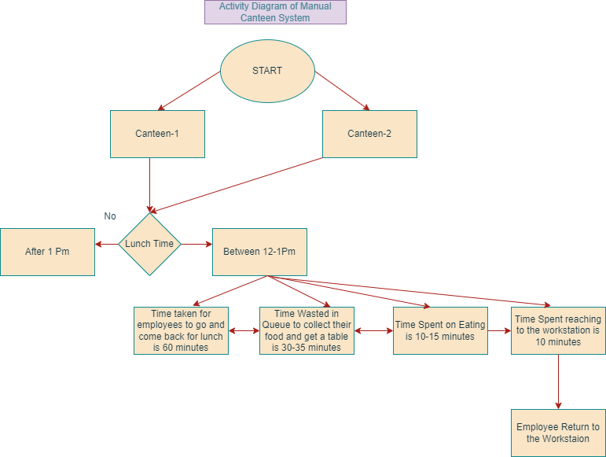

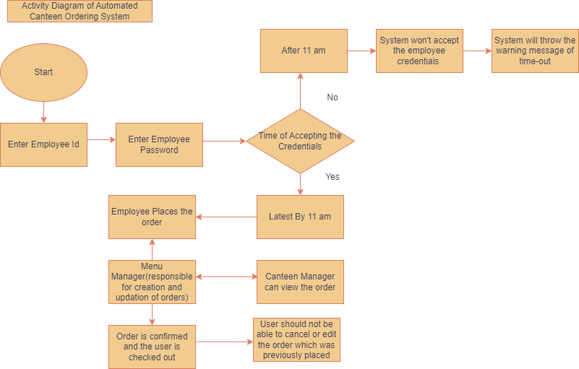

Q9) Draw an ER Diagram for the Same.

Ans) The ER Diagram of the Automated Canteen ordering System is mentioned below:

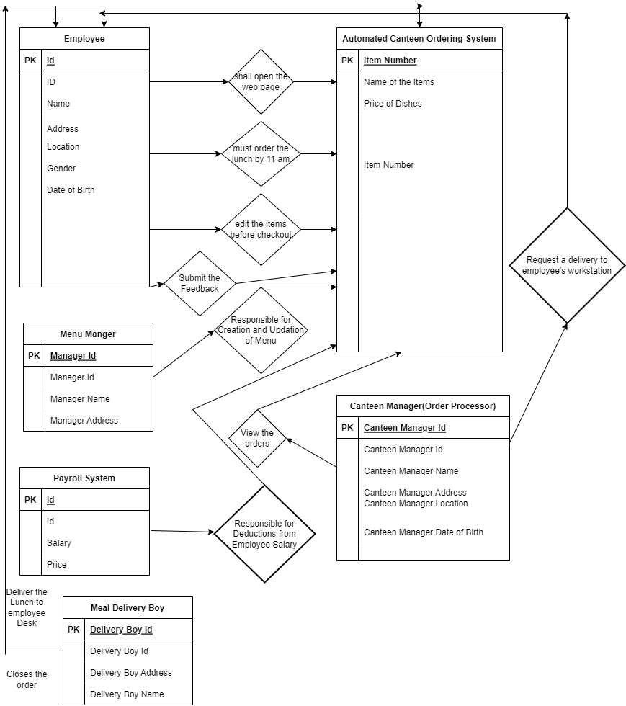

Q10) Write down the business requirements both functional and non-functional requirements

Ans) **Functional requirements**: are the requirements that must be present in the product. These are the functions that developer must enable to accomplish their task.

Some of the functional requirements of the Automated canteen ordering System are as follows:

1. Login Page must contains the username and password field as well as submit and Reset Button
2. Once, the user clicks on the submit button the detailed list of menu along with prices should be visible in front of user
3. There should be an edit button inside the web page which gives the facility to user/Unilever employees to edit the items before placing the order
4. There must be a button of place order(checked-out) which gives the facility of placing the order. Once the user clicked on checked-out button, they should not be able to cancel the order
5. Reset Button gives the facility of erasing the credentials from the username and password field and setting the cursor to the username tab
6. Once, the order is placed by the Unilever Employee, there must be an another page of delivery boy assignment, the canteen Manager should be able to assign the delivery boy
7. Inside the web-page there should be a button of the feedback submission, where employees of Unilever can submit their feedback
8. Payroll System- handles the payroll deductions and deducts the money from employee’s salary

**Non-Functional Requirements:** are the quality of the system. These are the Quality attributes. These are basically the support features

Some of the Non-Functional Requirements are:

1. Availability: The software is available for Unilever UK employees
2. Compatibility: The software must handle the maximum capacity of Unilever 1500 employees UK which are spread across 12 floors
3. Usability: The software is easy to use for Unilever Employees
4. Portability: These 1500 employees of Unilever UK can access the automated software on every desk
5. Security: The automated canteen ordering system can handle threats, viruses and malicious attacks
6. Compliance: Only 1500 Unilever UK employees can use the automated canteen ordering system. No outsider or employee of another organization can use the system because it will ask for the employees credentials
7. Localization: The UI(user-interface) of the software is designed in English Language and the price of items are mentioned in pounds
8. Extensibility: The software can incorporate the new features according to the Stakeholders requirements

Q11) Draw wireframes or mock screens for any two of the features namely Menu Creation and any other feature as deemed fit by the student. (Use the technique prototyping or wire framing that is taught in the Training). You can use any of the wireframing tools like Microsoft PowerPoint, Microsoft Word, Balsamiq, Sketch, Adobe XD, Adobe Illustrator, Figma, UXPin, InVision Studio, InVision Freehand, or Moqups.

Ans) Wireframe of Menu Creation of Unilever is as follows:

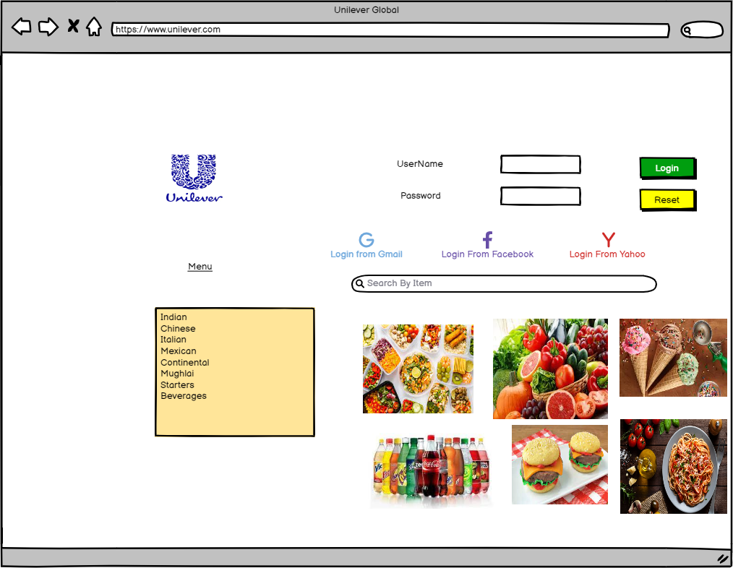

Wireframe of Order Details Unilever is as follows:

