Section C- Data Warehouse
11Ans) The Star-Schema of You-Tube Analytics of Data Warehouse is mentioned below:
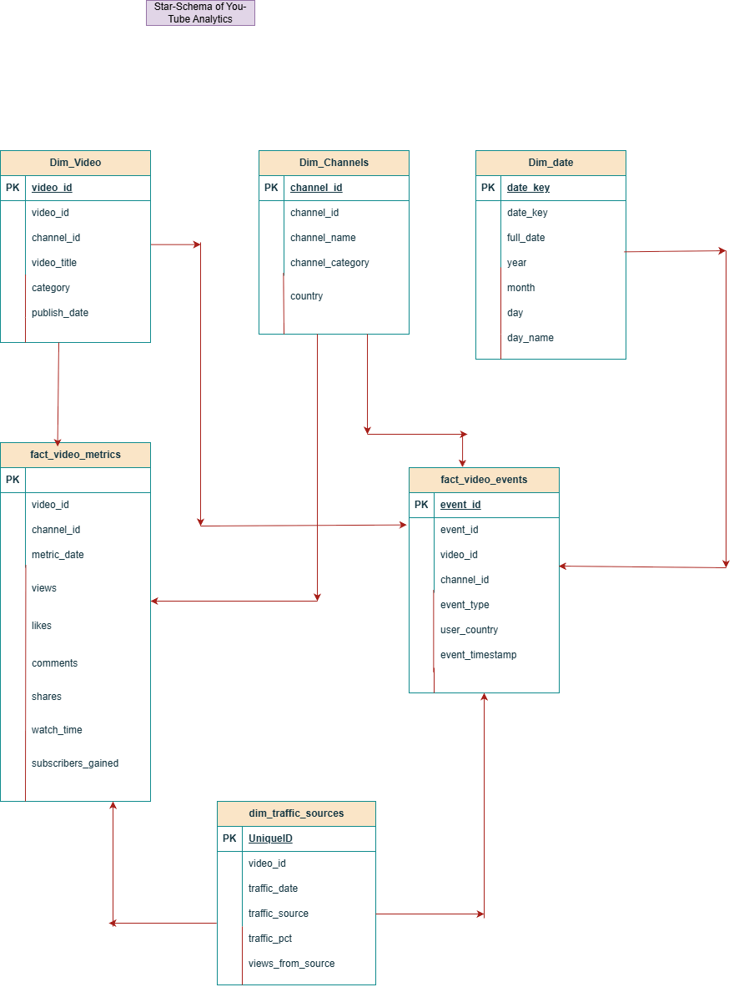
Primary keys are constraint,it is basically a unique identifier that identifies the record in the table.It doesn’t have null values and duplicates.Foreign keys are also the constraint,which is used to specify the relationship between tables.Primary key in one table can be a foreign key of another table,if that column is present in the another table.From the above mentioned star schema,there are 4 dimension tables and two fact tables.
The tables are:
Dim_Video->This is a dimension table.In this table video_id is the primary key and channel_id is the primary key.
Dim_Channels->is a dimension table.Here,channel_id is the primary key
Dim_date->This is also a dimension table,which is small in size and descriptive one,Here date_key is the primary key and full_date is the foreign key.
Dim_traffic_sources->This one is also a dimension table.In this table there is no primary key because all columns has duplicate values.Here,video_id is the foreign key
Fact_video_metrics->This one is fact table.In this table,there is no primary key and channel_id is the foreign key
Fact_video_events->This one is also fact_table.Here event_id is the primary key and video_id is the foreign key.
The measures of the star-schema are views,likes,comments,shares,watch_time and subscribers_gained of fact_video_metrics table.The measures are basically the attributes which has numerical values for aggregations
The dimensions of the star-schema are descriptive information of attributes of the columns.The dimension of star-schema are video_id,channel_id,video_title,category and publish date of dim_video.In the same way,the descriptive information of the columns are the dimensions of star-schema.
Grain of the fact_table is the lod ie level of detail or detailed information of the row of the table.Here,fact_video_metrics is the fact table.Here grain is on 12-09-2026,video_id 1001 of channel_id 101 has 158 likes,32 comments and 18 shares.The watch_time is 8900 minutes with 27 subscribers_gained.

