**NuOrder Selenium Coding Challenge**

* **Test Cases:**

According to the given application, I have put up some test cases in an excel sheet for the same. To view the test cases, click:

[Test Cases for Compare Numbers.xlsx](Test%20Cases%20for%20Compare%20Numbers.xlsx)

* **Executing Automated Tests:**

For the above mentioned test cases, I have come up with some Automated Tests using Eclipse Oxygen IDE, Java and TestNG for test results and analysis. In the NuOrder ‘Compare Number’ Application, I have created three Test Case Classes:

1. **CompareNumbersViaMethods.java** (Predefined values calling via method)
2. **CompareNumbersExcelSheet.java** (Pulls values dynamically from the excel sheet)
   1. **ExcelDataConfig.java**(Supporting file for CompareNumbersExcelSheet to count rows and get data)
3. **EmptyFieldErrorValidation.java** (Verify error messages when input fields are blank)
4. **NonNumberFieldErrorValidation.java** (Verify error messages when input fields are non-numeric)

To execute these test cases, for each class, Navigate to **‘Run’ > ‘Run As’ > ‘TestNG Test’**. After the execution of each test, to review the test result via TestNG in eclipse, navigate to: **‘NuOrder’ > ‘test-output’>‘Default Suite’ > ‘Default test.html’.**It displays the numberof passed and failed test cases along with Total Execution Time.

* **Issue found:**

The whole application seemed to work fine for all input values. The only issue I found in the application was that when a same numeric value is entered for all the three input fields (E.g.: 2), it displays the message: ‘2 is between 2 and 2’. According to me, it should display: ‘Number to compare cannot be the same as First number or Second Field’.

This issue can be noted in JIRA as:

**Project:** NuOrder Compare Numbers

**Issue Type:** Bug Sub-Task

**Summary:** Incorrect error message when ‘Number to Compare’ is same as First or Second Number

**Priority:** Medium

**Affecter Version:** Version Number

**Environment:** Chrome (Version 61.0.3163.100), Firefox (Version 56.0.1) and Edge (Version 40.15063.674.0) Browsers

**Description:**

When a numeric value entered for ‘Number to Compare’ is same as the First or the second number, it generates an incorrect error message.

Steps to recreate:

1. Navigate to ‘Localhost:3000’
2. Enter same values for all the input fields (E.g.: 2)
3. Click Compare
4. Review the Alert Message

**Expected Result:** ‘Number to Compare’ cannot have the same values as first or second number

**Actual Result:** 2 is between 2 and 2

Screenshot attached.

**Attachment:**

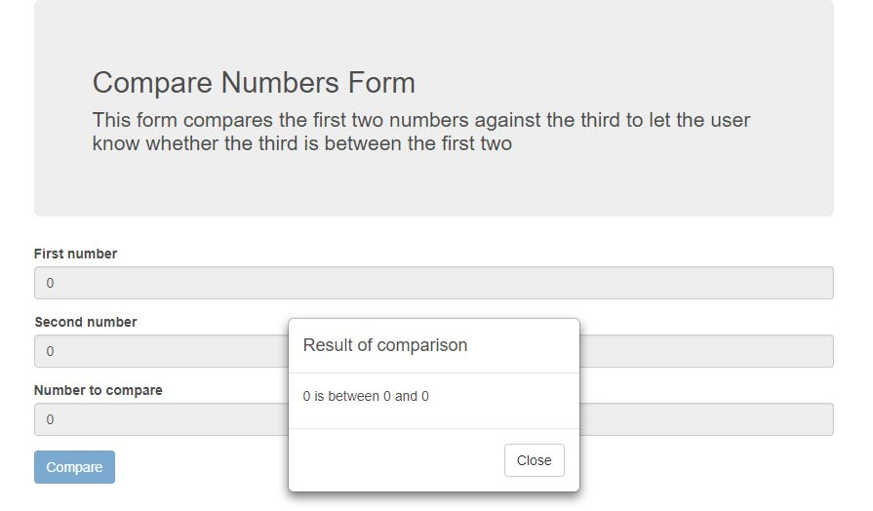

**Assignee:** Developer’s Name

**Reporter:** Shivani Sanghvi