Program:
//RSA
import java.io.DataInputStream;
import java.io.IOException;
import java.math.BigInteger;
import java.util.Random;
public class RSA{
private BigInteger p;
private BigInteger q;
private BigInteger N;
private BigInteger phi;
private BigInteger e;
private BigInteger d;
private int bitlength = 1024;
private Random r;
public RSA(){
r = new Random();
p = BigInteger.probablePrime(bitlength, r);
q = BigInteger.probablePrime(bitlength, r);
N = p.multiply(q);
phi = p.subtract(BigInteger.ONE).multiply(q.subtract(BigInteger.ONE));
e = BigInteger.probablePrime(bitlength / 2, r);
while (phi.gcd(e).compareTo(BigInteger.ONE) > 0 && e.compareTo(phi) < 0){ e.add(BigInteger.ONE); }
d = e.modInverse(phi);
}
public RSA(BigInteger e, BigInteger d, BigInteger N){
this.e = e;
this.d = d;
this.N = N;
}
@SuppressWarnings("deprecation")
public static void main(String[] args) throws IOException{
RSA rsa = new RSA();
DataInputStream in = new DataInputStream(System.in);
String teststring;
System.out.println("Enter the plain text:");
teststring = in.readLine();
System.out.println("String: " + teststring);
System.out.println("After Encryption: "+ bytesToString(teststring.getBytes()));
byte[] encrypted = rsa.encrypt(teststring.getBytes());
byte[] decrypted = rsa.decrypt(encrypted);
System.out.println("After Decryption: " + new String(decrypted));
}

private static String bytesToString(byte[] encrypted){
String test = "";
for (byte b : encrypted){ test += Byte.toString(b); }
return test;
}
public byte[] encrypt(byte[] message){ return (new BigInteger(message)).modPow(e, N).toByteArray(); }
public byte[] decrypt(byte[] message){ return (new BigInteger(message)).modPow(d, N).toByteArray(); }
}

Output:
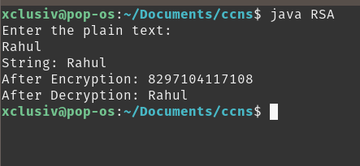

Conclusion:

Program
//MD5
import java.util.Scanner;
public class MD5{
private static final int INIT_A = 0x67452301;
private static final int INIT_B = (int) 0xEFCDAB89L;
private static final int INIT_C = (int) 0x98BADCFEL;
private static final int INIT_D = 0x10325476;
private static final int[] SHIFT_AMTS ={7, 12, 17, 22, 5, 9, 14, 20, 4,11, 16, 23, 6, 10, 15, 21};
private static final int[] TABLE_T = new int[64];
static{ for(int i =0; i <64; i++)
TABLE_T[i]=(int)(long)((1L <<32)*Math.abs(Math.sin(i +1)));}
public static byte[] computeMD5(byte[] message){
int messageLenBytes = message.length;
int numBlocks =((messageLenBytes +8)>>>6)+1;
int totalLen = numBlocks <<6;
byte[] paddingBytes =new byte[totalLen - messageLenBytes];
paddingBytes[0]=(byte) 0x80;
long messageLenBits =(long) messageLenBytes <<3;
for(int i =0; i <8; i++){
paddingBytes[paddingBytes.length-8+ i]=(byte) messageLenBits;
messageLenBits >>>=8; }
int a = INIT_A;
int b = INIT_B;
int c = INIT_C;
int d = INIT_D;
int[] buffer =new int[16];
for(int i =0; i < numBlocks; i++){
int index = i <<6;
for(int j =0; j <64; j++, index++)
buffer[j >>>2]=((int)((index < messageLenBytes)? message[index]: paddingBytes[index - messageLenBytes])<<24)|(buffer[j >>>2]>>>8);
int originalA = a;
int originalB = b;
int originalC = c;
int originalD = d;
for(int j =0; j <64; j++){
int div16 = j >>>4;
int f =0;
int bufferIndex = j;
switch(div16){
case 0:
f =(b & c)|(~b & d);
break;
case 1:
f =(b & d)|(c & ~d);
bufferIndex =(bufferIndex *5+1)& 0x0F;
break;
case 2:
f = b ^ c ^ d;
bufferIndex =(bufferIndex *3+5)& 0x0F;
break;
case 3:
f = c ^(b | ~d);
bufferIndex =(bufferIndex *7)& 0x0F;
break; }
int temp = b+Integer.rotateLeft(a + f + buffer[bufferIndex]+ TABLE_T[j],SHIFT_AMTS[(div16 <<2)|(j &3)]);
a = d;
d = c;
c = b;
b = temp; }
a += originalA;
b += originalB;
c += originalC;
d += originalD; }
byte[] md5 =new byte[16];
int count =0;
for(int i =0; i <4; i++){
int n =(i ==0)? a :((i ==1)? b :((i ==2)? c : d));
for(int j =0; j <4; j++){
md5[count++]=(byte) n;
n >>>=8; } }
return md5; }
public static String toHexString(byte[] b){
StringBuilder sb =new StringBuilder();
for(int i =0; i < b.length; i++){
sb.append(String.format("%02X", b[i]& 0xFF)); }
return sb.toString(); }
public static void main(String[] args){
Scanner sc = new Scanner(System.in);
System.out.println("Enter Your Message");
String n = sc.next();
String testStrings = n;
System.out.println(testStrings +"==>"+toHexString(computeMD5(testStrings.getBytes()))); } }
Output:
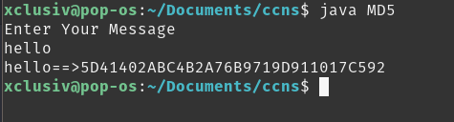

Conclusion:

Program:
import java.io.DataInputStream;
import java.io.IOException;
import java.math.BigInteger;
import java.util.Random;
public class DigitalSignature{
//RSA
private BigInteger p;
private BigInteger q;
private BigInteger N;
private BigInteger phi;
private BigInteger e;
private BigInteger d;
private int bitlength = 1024;
private Random r;
private static final int INIT_A = 0x67452301;
private static final int INIT_B = (int) 0xEFCDAB89L;
private static final int INIT_C = (int) 0x98BADCFEL;
private static final int INIT_D = 0x10325476;
private static final int[] SHIFT_AMTS ={7, 12, 17, 22, 5, 9, 14, 20, 4,11, 16, 23, 6, 10, 15, 21};
private static final int[] TABLE_T = new int[64];
static{
for(int i =0; i <64; i++)
TABLE_T[i]=(int)(long)((1L <<32)*Math.abs(Math.sin(i +1)));
}
public DigitalSignature(){
r = new Random();
p = BigInteger.probablePrime(bitlength, r);
q = BigInteger.probablePrime(bitlength, r);
N = p.multiply(q);
phi = p.subtract(BigInteger.ONE).multiply(q.subtract(BigInteger.ONE));
e = BigInteger.probablePrime(bitlength / 2, r);
while (phi.gcd(e).compareTo(BigInteger.ONE) > 0 && e.compareTo(phi) < 0){ e.add(BigInteger.ONE); }
d = e.modInverse(phi);
}
public DigitalSignature(BigInteger e, BigInteger d, BigInteger N){
this.e = e;
this.d = d;
this.N = N;
}
private static String bytesToString(byte[] encrypted){
String test = "";
for (byte b : encrypted){ test += Byte.toString(b); }
return test;
}
public byte[] encrypt(byte[] message){ return (new BigInteger(message)).modPow(e, N).toByteArray(); }
public byte[] decrypt(byte[] message){ return (new BigInteger(message)).modPow(d, N).toByteArray(); }
//MD5
public static byte[] computeMD5(byte[] message){
int messageLenBytes = message.length;
int numBlocks =((messageLenBytes +8)>>>6)+1;
int totalLen = numBlocks <<6;
byte[] paddingBytes =new byte[totalLen - messageLenBytes];
paddingBytes[0]=(byte) 0x80;
long messageLenBits =(long) messageLenBytes <<3;
for(int i =0; i <8; i++){
paddingBytes[paddingBytes.length-8+ i]=(byte) messageLenBits;
messageLenBits >>>=8;
}
int a = INIT_A;
int b = INIT_B;
int c = INIT_C;
int d = INIT_D;
int[] buffer =new int[16];
for(int i =0; i < numBlocks; i++){
int index = i <<6;
for(int j =0; j <64; j++, index++)
buffer[j >>>2]=((int)((index < messageLenBytes)? message[index]: paddingBytes[index - messageLenBytes])<<24)|(buffer[j >>>2]>>>8);
int originalA = a;
int originalB = b;
int originalC = c;
int originalD = d;
for(int j =0; j <64; j++){
int div16 = j >>>4;
int f =0;
int bufferIndex = j;
switch(div16){
case 0:
f =(b & c)|(~b & d);
break;
case 1:
f =(b & d)|(c & ~d);
bufferIndex =(bufferIndex *5+1)& 0x0F;
break;
case 2:
f = b ^ c ^ d;
bufferIndex =(bufferIndex *3+5)& 0x0F;
break;
case 3:
f = c ^(b | ~d);
bufferIndex =(bufferIndex *7)& 0x0F;
break;
}
int temp = b+Integer.rotateLeft(a + f + buffer[bufferIndex]+ TABLE_T[j],SHIFT_AMTS[(div16 <<2)|(j &3)]);
a = d;
d = c;
c = b;
b = temp;
}
a += originalA;
b += originalB;
c += originalC;
d += originalD;
}
byte[] md5 =new byte[16];
int count =0;
for(int i =0; i <4; i++){
int n =(i ==0)? a :((i ==1)? b :((i ==2)? c : d));
for(int j =0; j <4; j++){
md5[count++]=(byte) n;
n >>>=8;
}
}
return md5;
}
public static String toHexString(byte[] b){
StringBuilder sb =new StringBuilder();
for(int i =0; i < b.length; i++){
sb.append(String.format("%02X", b[i]& 0xFF));
}
return sb.toString();
}
public static void Sender(String teststring){
System.out.println("String: " + teststring);
String r = bytesToString(teststring.getBytes());
String hash = toHexString(computeMD5(r.getBytes()));
System.out.println("-----------Sender---------\nSignature sent is:"+hash+"\nData is:"+teststring);
Receiver(teststring, hash);
}
public static void Receiver(String teststring, String hash){
String r = bytesToString(teststring.getBytes());
String newHash = toHexString(computeMD5(r.getBytes()));
System.out.println("-----------Receiver---------\nSignature received is:"+hash+"\nSignature generated to verify is:"+newHash);
if(hash == newHash)
System.out.println("Data verified!");
else
System.out.println("Data issues");
}
@SuppressWarnings("deprecation")
public static void main(String[] args) throws IOException{
DigitalSignature rsa = new DigitalSignature();
DataInputStream in = new DataInputStream(System.in);
String teststring;
System.out.println("Signature-Based Detection using RSA and MD5");
System.out.println("Enter the plain text:");
teststring = in.readLine();
Sender(teststring);
}
}

Output:
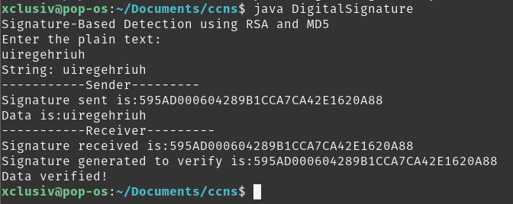

Conclusion:

Program:
import java.util.Scanner;
class CaesarC{
void Caesar(String message, int key){
String decryptedMessage = "";
char ch;
Scanner sc = new Scanner(System.in);
for(int i = 0; i < message.length(); ++i){
ch = message.charAt(i);
if(ch >= 'a' && ch <= 'z'){
ch = (char)(ch - key);
if(ch < 'a'){ ch = (char)(ch + 'z' - 'a' + 1); }
decryptedMessage += ch;
}
else if(ch >= 'A' && ch <= 'Z'){
ch = (char)(ch - key);
if(ch < 'A'){ ch = (char)(ch + 'Z' - 'A' + 1); }
decryptedMessage += ch;
}
else { decryptedMessage += ch; }
}
System.out.println("Decrypted Message (key = "+key+") = " + decryptedMessage);
}
}
class VigenereCipher{
public static String encrypt(String text, final String key){
String res = "";
text = text.toUpperCase();
for (int i = 0, j = 0; i < text.length(); i++){
char c = text.charAt(i);
if (c < 'A' || c > 'Z')
continue;
res += (char) ((c + key.charAt(j) - 2 * 'A') % 26 + 'A');
j = ++j % key.length();
}
return res;
}
public static String decrypt(String text, final String key){
String res = "";
text = text.toUpperCase();
for (int i = 0, j = 0; i < text.length(); i++){
char c = text.charAt(i);
if (c < 'A' || c > 'Z')
continue;
res += (char) ((c - key.charAt(j) + 26) % 26 + 'A');
j = ++j % key.length();
}
return res; } }
public class Cryptanalysis{
public static void main(String[] args){
//CAESARCIPHER
System.out.println("Enter your message");
Scanner sc = new Scanner(System.in);
String message = sc.next();
CaesarC c = new CaesarC();
VigenereCipher v = new VigenereCipher();
int keyi= 0;
System.out.println("-------Caesar Cipher--------");
for(keyi=0;keyi<26;keyi++)
c.Caesar(message,keyi);
//VIGENERECIPHER
System.out.println("-------Vigenere Cipher--------");
String key = "VIGENERECIPHER";
String encryptedMsg = v.encrypt(message, key);
System.out.println("String: " + message);
System.out.println("Decrypted message: " + v.decrypt(message, key));
//MULTIPLICATIVECIPHER
System.out.println("-------Multiplicative Cipher--------");
int shift,i,n;
String str;
String str1="",str2="";
str=message.toLowerCase();
n=str.length();
char ch1[]=str.toCharArray();
char ch3, ch4;
System.out.println("Enter the value by which each letter of the string is to be shifted");
shift=sc.nextInt();
System.out.println();
System.out.println("Decrypted text is");
for(i=0;i<n;i++){
if(Character.isLetter(ch1[i])){
ch3=(char)(((int)ch1[i]*shift-97)%26+97);
str1=str1+ch3;
}
else if(ch1[i]==' '){ str1=str1+ch1[i]; }
}
System.out.println(str1);
int q=0,flag=0;
for(i=0;i<26;i++){
if(((i*26)+1)%shift==0){
q=((i*26)+1)/shift;
break; } }
System.out.println(str2); } }

Output:
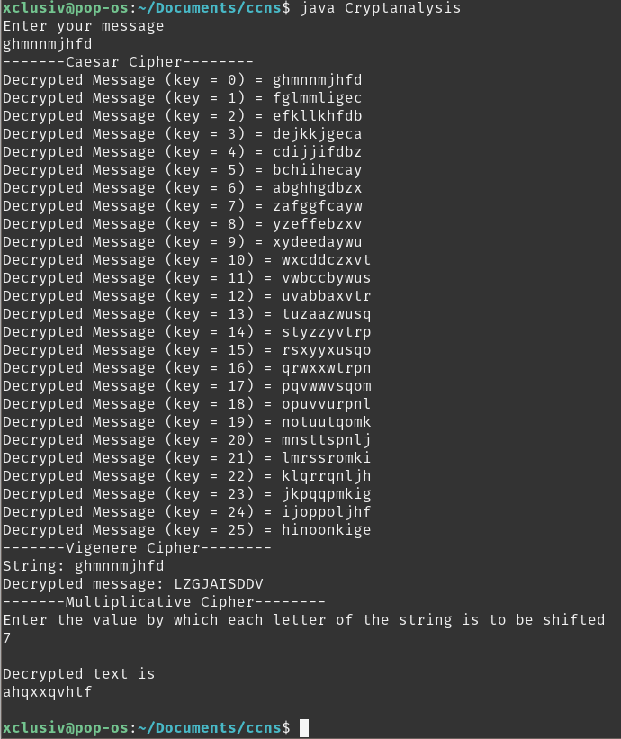

Conclusion:

