Annexure V
  - Cover Page for Academic Tasks
Course code MKTM503 | Course title Marketing Management I
Course instructor Dr.Arpit Tiwari | Academic task number 01
Academic task BrandSell Brand the Unbranded | Brand VYBE
Date of submission 15 October 2026 | Section Q1P2652
Student name : Shivani Sethi | Registration number : 12613604
Roll number : 50 | Student signature :

Evaluation Parameters
Criterion | Marks
Segmentation Targeting and Positioning | 15
Product Selection and Opportunity Justification | 10
Brand Identity Story and Physical Expression | 15
Digital Presence and Engagement | 10
Revenue Generated | 45
Financial Documentation | 5

Learning Outcomes
Applied segmentation and pricing to a real selling task. Developed customer outreach through WhatsApp and personal networks, maintained sales and expense records, and evaluated revenue and profit against the project target.

Declaration and Signature
Student declaration - I declare that this Assignment is my individual work. I have not copied it from any other student’s work or from any other source except where due acknowledgement is made explicitly in the text, nor has any part been written for me by any other person.
Signature __________________________ Date __________________________

Evaluator Comments
General observations | Suggestions for improvement | Best part of the assignment

Evaluator signature and date ______________________________
Marks obtained ____________________ Maximum marks 100


Lovely Professional University
Mittal School of Business
Phagwara Punjab

VYBE BrandSell Report
  - Brand the Unbranded
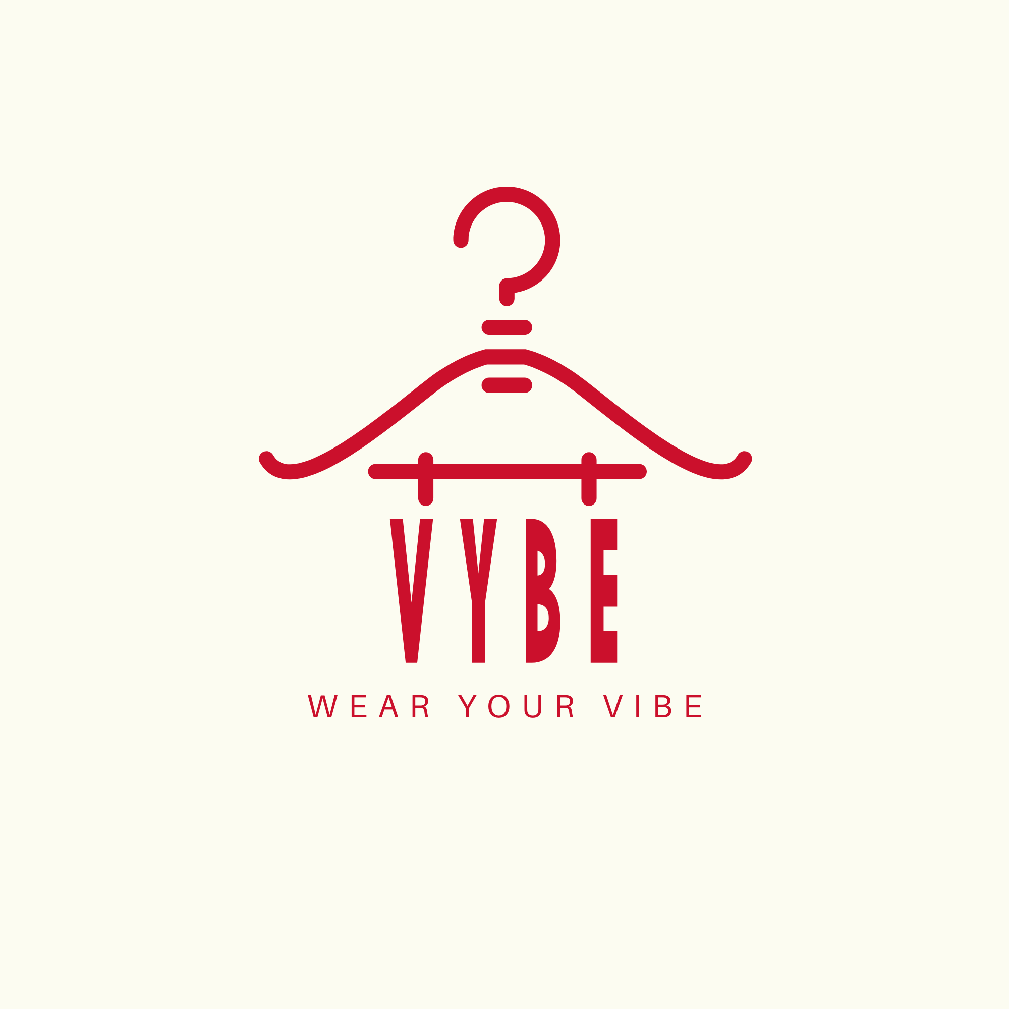
Wear Your Vibe
Plain and printed T-shirts
Course details | Project details
MKTM503 Marketing Management I | Academic task 1
Project period | Approximately 15 September to 15 October 2026
Revenue target | ₹5,000 per person and ₹20,000 for four members
Submitted to | Dr.Arpit Tiwari Section Q1P2652, Section Q1P2655
Submission date | 15 October 2026

Submitted By
No | Student name | Registration number | Roll number
1 | Shivani Sethi | 12613604 | RQ1P2652B50
2 | Praharsha Reddy | 12605370 | RQ1P2652A27
3 | Glimina C Morais | 12602119 | RQ1P2652A05
4 | Kunal  (Section Q1P2655) | 12604088 | RQ1P2660A22

Report Contents
Section | Page
Academic task form | 1
VYBE cover and team details | 2
Report contents and executive summary | 3
The product | 4
Segmentation Targeting and Positioning | 5
Sales mix and demand evidence | 6
Product selection and opportunity | 7
Competitor and substitute comparison | 8
Brand identity and physical expression | 9
Plain colour range | 10
Digital presence and engagement | 11
Customer outreach and sales promotion | 12
Revenue generated and financial workings | 13
Financial documentation and record checks | 14
Team learning and references | 15

Executive Summary
We started VYBE as a four-member venture for the BrandSell project in Marketing Management I. We sold plain and printed T-shirts and aimed to generate at least ₹20,000 in group revenue during approximately 15 September to 15 October 2026.
The final tracker records ₹36,850 in revenue from 104 T-shirts across 80 sales entries. Recorded expenses total ₹10,630, giving a reported net profit of ₹26,220 and a net margin of 71.15%. Revenue reached 184.25% of the group target. The reported totals retain the entries listed for date and payment-reference checks on page 14. [1, 2]
We promoted VYBE through WhatsApp, WhatsApp Status, classmates and personal contacts. Referrals and word of mouth supported outreach. We created an Instagram profile, with no posts, reels or stories published during the project. Channel-specific sales and engagement figures were not recorded in the tracker.

The Product
VYBE offered plain and printed T-shirts under the tagline Wear Your Vibe. Plain styles provided simple colour choices, while printed styles gave buyers graphic alternatives. Recorded selling prices ranged from ₹250 to ₹500 per T-shirt. [1, 2]
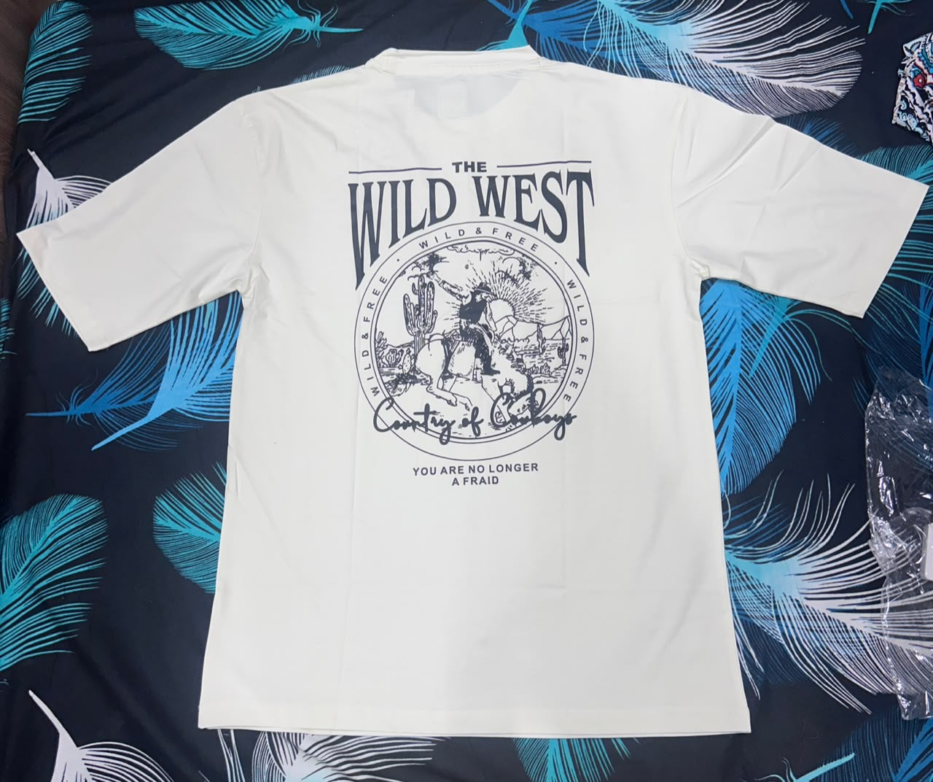  Wild West printed T-shirt | 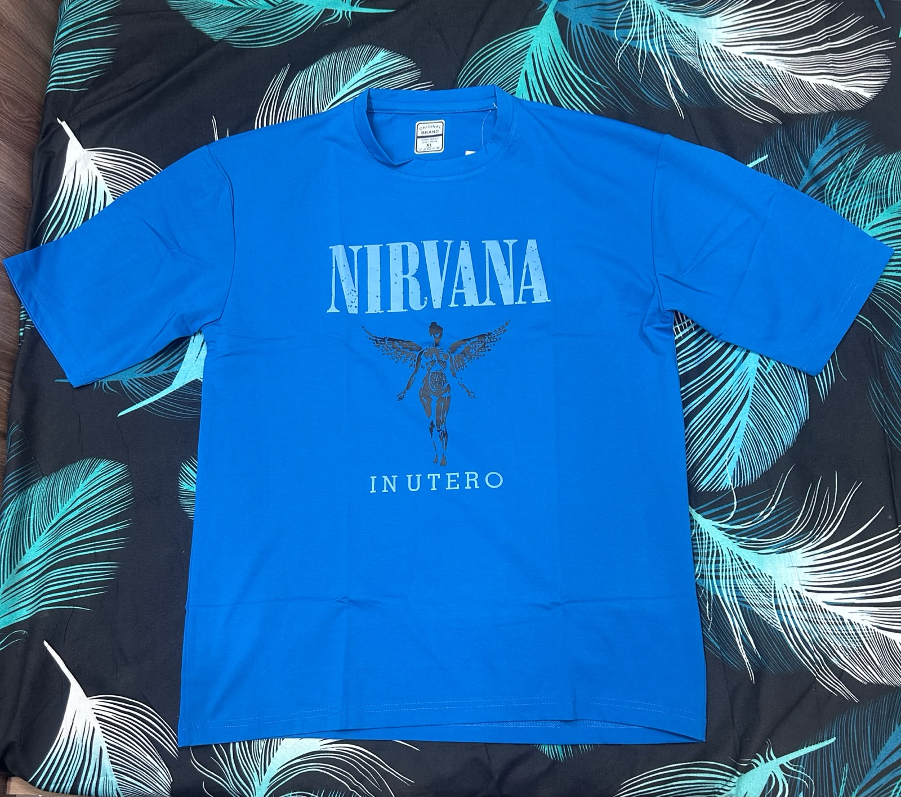  Nirvana printed T-shirt
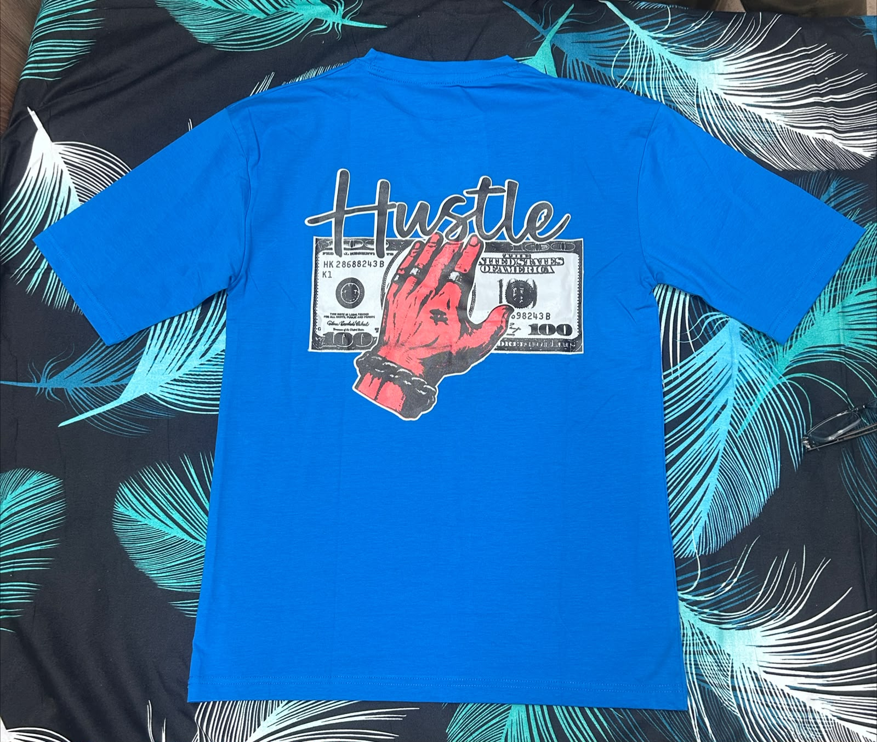  Hustle print in blue | 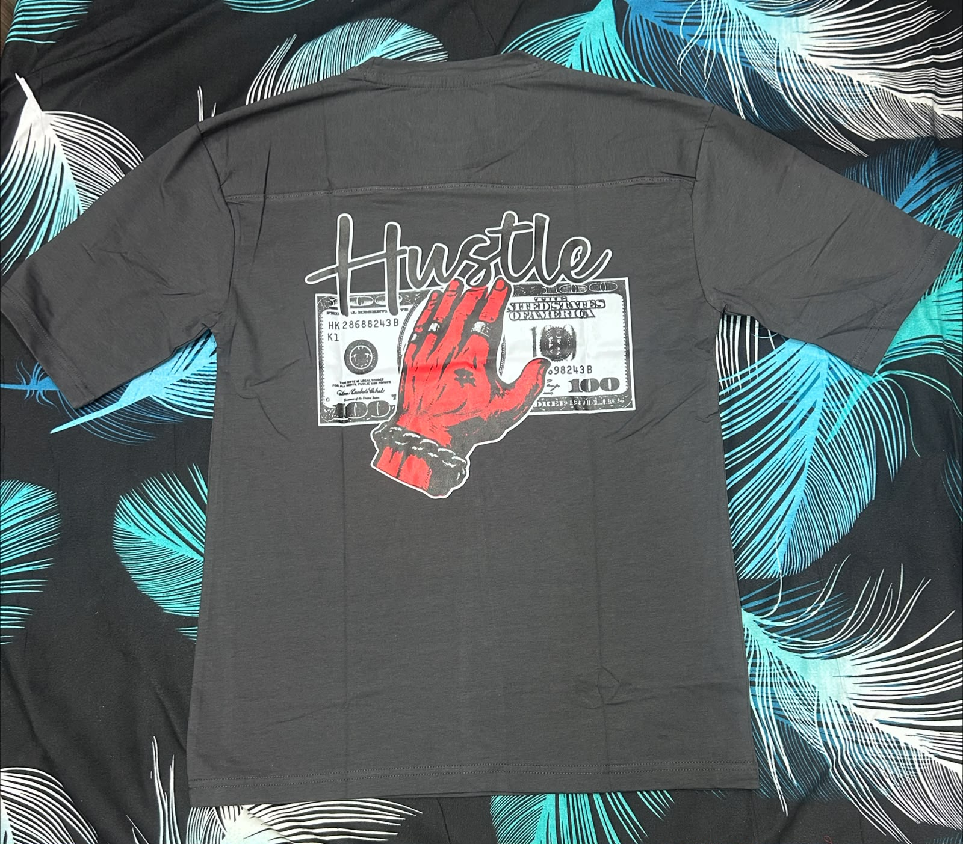  Hustle print in charcoal

Figure 1 Actual printed products from the VYBE range. Source: team photographs.
Range | Recorded price per T-shirt
Plain | ₹300 to ₹400
Printed | ₹250 to ₹500

The photographs illustrate product styles. Fabric specifications and a complete size or stock schedule were not recorded in the tracker, so the report makes no additional claims about those details.

Segmentation Targeting and Positioning
Our STP approach connects the T-shirt range with buyers seeking everyday clothing and personal style. The intended segment below describes the brand approach. The tracker does not contain a demographic survey of actual buyers.

Segmentation
The intended segment was LPU students and young adults who wear casual T-shirts. We considered differences in style preference and spending budgets. Some buyers may prefer a plain colour that works with different outfits, while others may choose a visible graphic design. Offering both types let us address these preferences within one range.

Targeting
We focused on buyers looking for everyday basics or graphic styles within the recorded ₹250 to ₹500 price band. Classmates and personal contacts gave the team an existing audience to approach. WhatsApp communication and Status updates supported promotion, while referrals and word of mouth helped us extend outreach beyond our immediate contacts.

Positioning Statement
For budget-conscious young adults, VYBE is a casual T-shirt brand that helps them express their style through plain and printed options at recorded prices of ₹250 to ₹500.

Customer Need
Plain styles address the need for versatile everyday clothing. Printed styles provide a way to show personal taste. The sales mix supports retaining both options: the tracker records purchases of each type, rather than demand for only one style. Customer ages, allowances and campus locations were not measured, so those characteristics are not presented as confirmed buyer findings. [1, 2]

Sales Mix and Demand Evidence
Paid sales entries provide the main demand evidence for VYBE. The tracker records 104 T-shirts across 80 entries. An entry may contain more than one unit, so the entry count should not be interpreted as a count of unique customers. [2]
Product type | Units sold | Share of units | Revenue
Plain | 39 | 37.5% | ₹12,650
Printed | 65 | 62.5% | ₹24,200
Recorded total | 104 | 100.0% | ₹36,850

Sales Mix Calculation
Printed share of units = 65 ÷ 104 × 100 = 62.5%.
Plain share of units = 39 ÷ 104 × 100 = 37.5%.
Printed T-shirts accounted for the larger share of recorded units. Plain T-shirts still contributed 39 units, which supports keeping a basic colour range alongside graphic styles. These figures describe purchases during this project and do not establish a wider market preference.

Order and Price Evidence
Recorded plain T-shirt prices were ₹300, ₹350 and ₹400. Printed T-shirt prices were ₹250, ₹350, ₹400 and ₹500. Four printed units were recorded at ₹250 each. Purchases across these price points show that orders occurred within the stated range, although they do not measure a maximum willingness to pay.
Some entries contained several T-shirts, including a ten-unit order worth ₹4,000. This is evidence of a larger order, rather than proof that a special discount or bundle campaign was offered. The tracker does not record a reason for each purchase.

Implication for the Range
The project results support maintaining both plain and printed options. A future order tracker could add product colour, size and marketing source to show which combinations sell best. This is a proposed improvement, separate from the activities completed during the project.

Product Selection and Opportunity

Product Introduction
We selected plain and printed T-shirts for VYBE. The range could be shown clearly through actual photographs and discussed with buyers through our existing contacts. The tracker records ₹5,040 for initial T-shirt stock and ₹3,200 for restocking, giving ₹8,240 in recorded stock expenditure. [2]

Demand Evidence
The strongest evidence is the recorded result of 104 T-shirts and ₹36,850 in revenue. Both product types generated sales. Revenue exceeded the ₹20,000 group target by ₹16,850. These are recorded tracker results, with the date and payment-reference checks retained on page 14.

Competitors and Substitutes
The presentation compares VYBE with two specific online alternatives: a Decathlon Domyos basic T-shirt and an H&M printed T-shirt. They provide reference points for a plain and a printed option. The comparison uses the listings retrieved for the presentation on 14 October 2026, rather than treating those prices as permanent. [1, 3, 4]

Reason to Choose VYBE
VYBE offered a choice between plain colours and graphic styles within one range. Buyers could enquire through WhatsApp or through the team’s personal network. The selected H&M printed listing was above VYBE’s recorded printed price band. The Decathlon basic was close to the lower end of VYBE’s plain range, so price alone cannot establish an advantage over every alternative.

Price Viability
Orders were recorded within the ₹250 to ₹500 band. Total recorded revenue exceeded recorded project expenses and produced a reported profit. The tracker does not allocate sourcing and transport costs to each style, so individual product margins cannot be calculated reliably. Product-level costing would improve future pricing decisions.

Competitor and Substitute Comparison
The following comparison uses the reference listings in the final presentation, retrieved on 14 October 2026. Product specifications and availability differ. The team did not physically test the comparator products. [1, 3, 4]
Option | Price per T-shirt | Material evidence | Availability
VYBE plain | ₹300 to ₹400 | Actual photographs available. Fabric specification not recorded. | Sales recorded during the project. Size and delivery details not recorded.
VYBE printed | ₹250 to ₹500 | Actual graphic styles photographed. Fabric specification not recorded. | Sales recorded during the project. Size and delivery details not recorded.
Decathlon Domyos Sportee grey | ₹299 | Listed as a cotton fitness T-shirt. Physical quality not tested. | Online listing. Size and local delivery availability vary.
H&M Regular Fit Printed Black Shush | ₹699 | Listed as lightweight cotton jersey. Physical quality not tested. | Online listing with an availability check.

Interpretation
VYBE’s recorded printed prices were lower than this selected H&M example. The ₹299 Decathlon reference shows that buyers can find a basic T-shirt at a similar or lower price. VYBE therefore needs to communicate style choice and an accessible enquiry process alongside price.
A specific listing is a benchmark, not a complete survey of a retailer or of the T-shirt market. The comparison does not establish equal fabric, durability or fit across products. The source URLs are listed in the references.

Brand Identity and Physical Expression
Figure 2 Original VYBE logo supplied by the team

Brand Name and Logo
VYBE uses the tagline Wear Your Vibe. The hanger icon links the identity to clothing, while the brand name and tagline connect the range with personal expression. We used one identity for both plain and printed T-shirts.
Brand colour | Hex code | Role in the identity
Red | CB102C | The main logo mark and lettering
Cream | FCFCF1 | The logo background

Brand Story
Four students started VYBE for BrandSell. We brought plain and printed T-shirts together under one brand, with everyday style and personal expression at its centre. The brand gave the range a name and a recognisable visual identity that we could use in customer communication.

Packaging and Labelling
The tracker records ₹500 for packing. Original stock photographs show clear protective packaging and supplier labels. Finished VYBE packaging was not documented, so supplier packaging is not presented as completed VYBE branding.

Sustainability
Fabric composition and packaging recyclability are unverified. Material or environmental claims would require supplier confirmation. The report does not describe the T-shirts or their packaging as certified sustainable.

Plain Colour Range
The actual product photographs below show examples of VYBE’s plain range. They illustrate colour choices and do not represent a complete size or remaining-stock list.
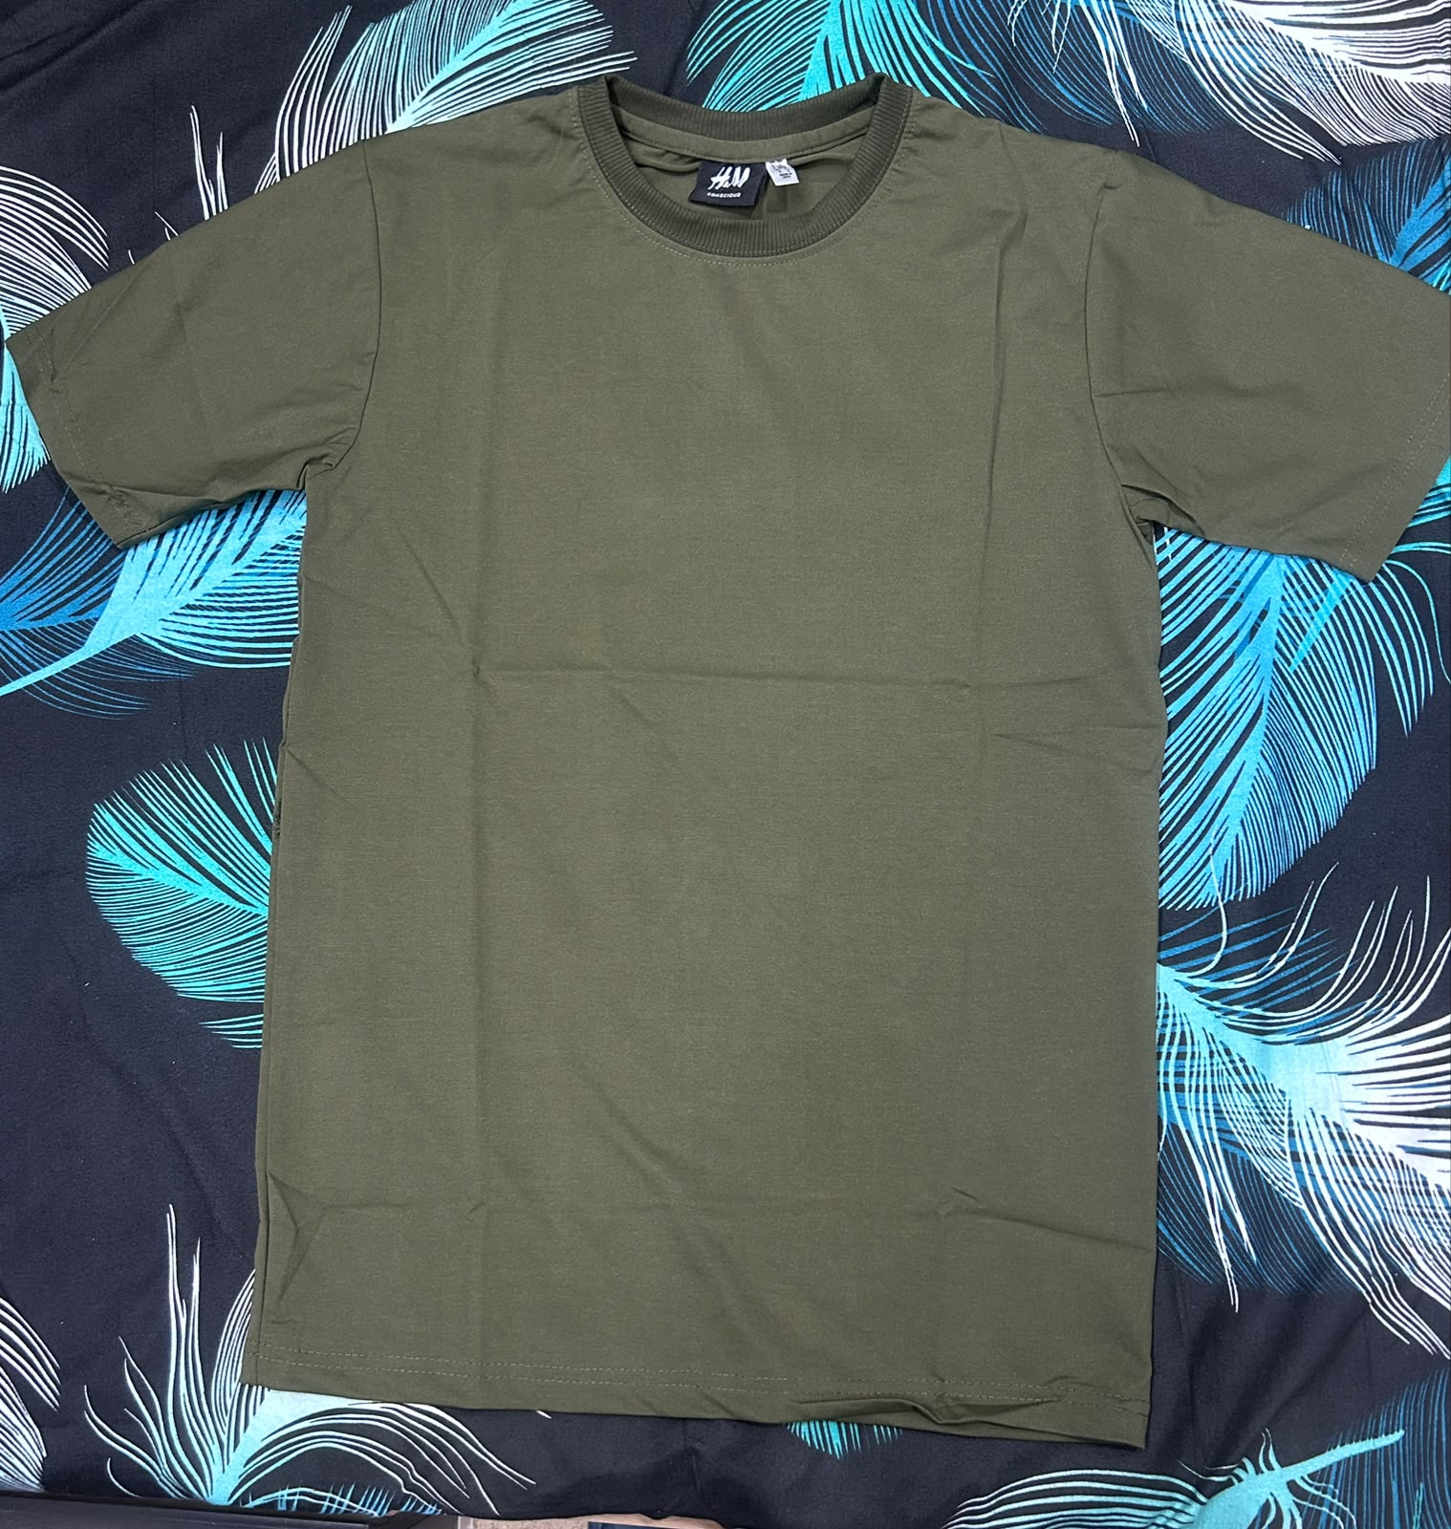  Olive green plain T-shirt | 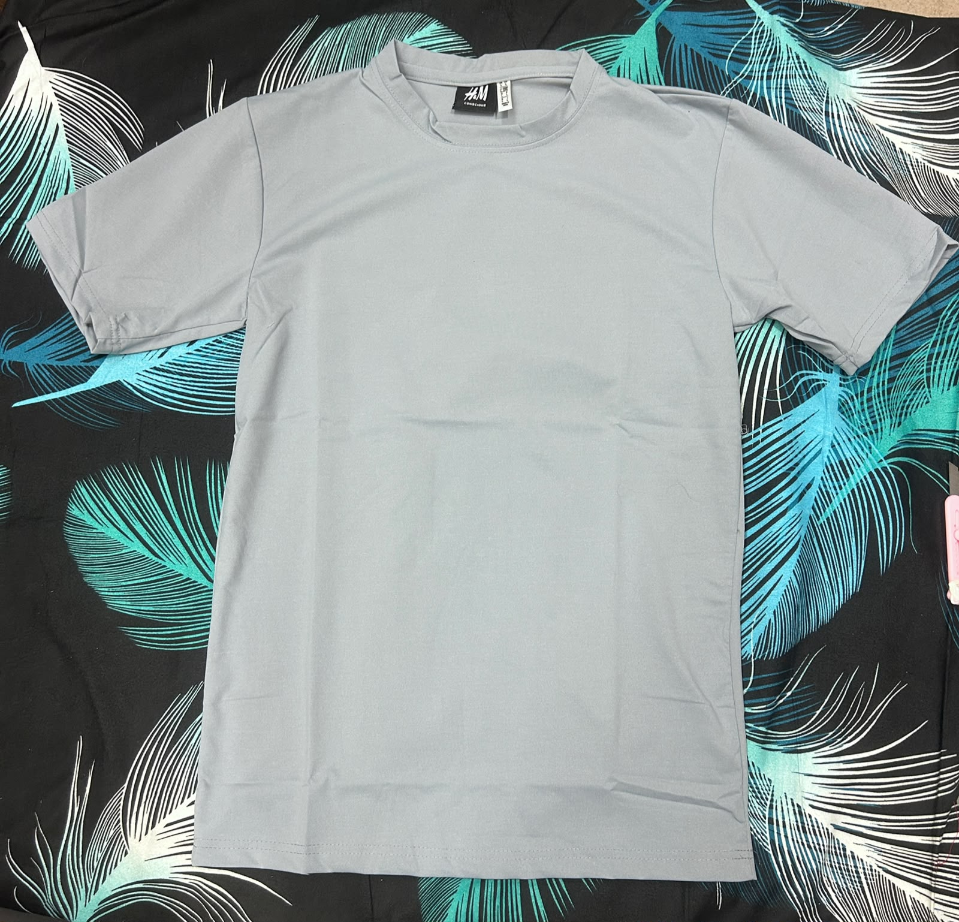  Grey plain T-shirt
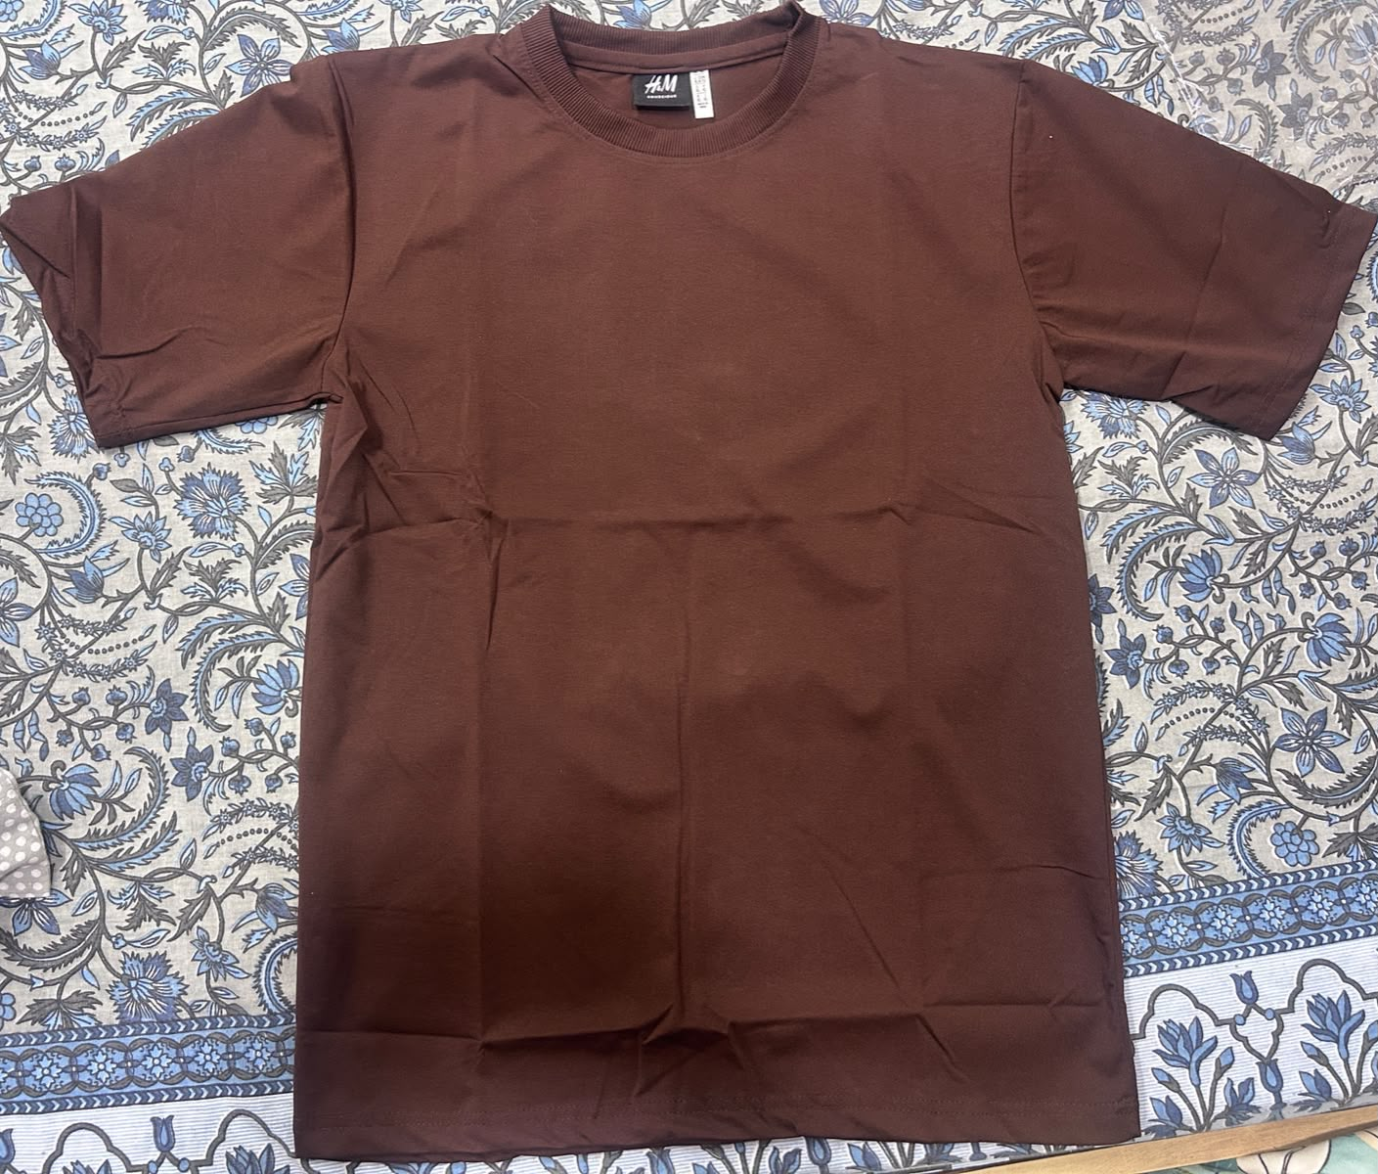  Brown plain T-shirt | 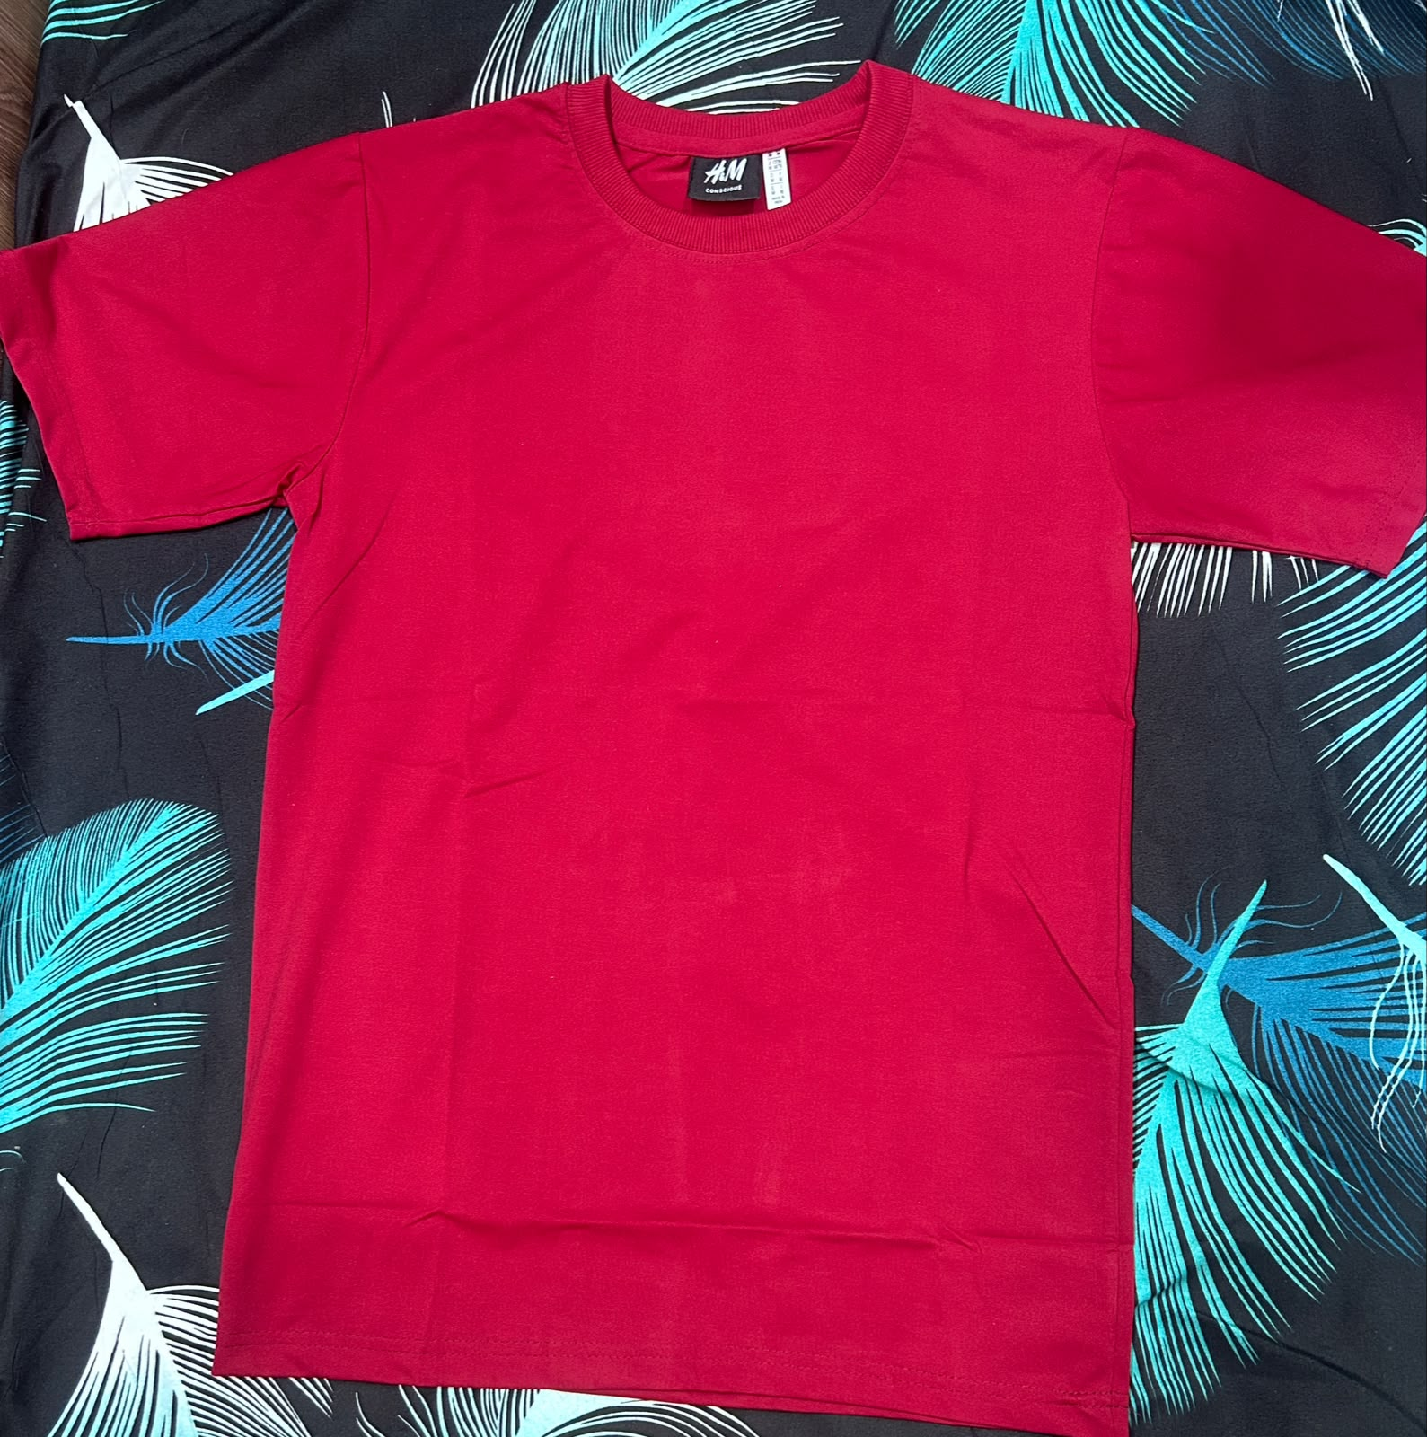  Red plain T-shirt

Figure 3 Actual plain products. Source: team photographs.
Plain T-shirts accounted for 39 of the 104 recorded units. Their contribution supports keeping basic colours available within the range alongside printed designs. [2]

Digital Presence and Engagement
Our digital promotion centred on WhatsApp communication and WhatsApp Status. We also created an Instagram profile for VYBE. Instagram activity remained at profile creation, with no posts, reels or stories published during the project. [5]

Platform and Page
WhatsApp and WhatsApp Status supported communication with our contacts. The Instagram profile established a presence for the brand. We do not attribute sales, reach or engagement to Instagram because no published activity or channel-level measurements were recorded.

Asset Quality
The brand assets include the original VYBE logo and actual photographs of the plain and printed T-shirts. These show the product range directly. A consistent logo, clear product images and accurate price information form the basis for future promotional material.

Content Variety
The formats used during the project were WhatsApp communication and Status updates. The report does not present Instagram post, reel or story examples as completed activities.

Copywriting
The tagline Wear Your Vibe links the product range with personal style. The following is suggested promotional wording, rather than a caption claimed to have been published:
“Plain or printed? Wear Your Vibe. Message VYBE to enquire.”

Audience Engagement
Classmates and personal contacts formed part of our outreach. Referrals and word of mouth helped us spread awareness through recommendations. The tracker records group sales totals, without identifying a marketing channel for each sale. Counts of reach, enquiries and conversions by channel are therefore not reported.

Customer Outreach and Sales Promotion
We used a combination of digital communication and our personal networks to market VYBE. The activities below reflect the methods confirmed by the team. They are not a claim of measured revenue attribution. [5]
Channel | Activity used | Marketing role
WhatsApp and WhatsApp Status | Promoted VYBE through WhatsApp communication and Status updates. | Digital promotion
Classmates and personal contacts | Reached buyers through classmates and the team’s personal networks. | Personal selling
Referrals and word of mouth | Used personal recommendations to spread awareness of VYBE. | Recommendations
Instagram profile | Created a profile for VYBE. No posts, reels or stories were published. | Brand setup

How the Methods Worked Together
WhatsApp offered a direct route to contacts, while Status updates provided another place to promote the brand. Classmates and personal contacts gave the team people to approach, and referrals extended the conversation to other potential buyers. These activities formed our outreach approach during the project.

Outcome and Measurement
The overall tracker result was ₹36,850 from 104 T-shirts across 80 sales entries. Those figures cannot show which marketing method generated a particular order because no channel field was recorded. The result supports reporting project sales, rather than ranking the channels by effectiveness. [2]

Proposed Improvement
For a future selling period, we could record how each buyer heard about VYBE and retain dated examples of WhatsApp promotion. A simple order-source field would help us compare enquiries and sales from contacts, referrals and digital promotion. Regular Instagram product content would be a future activity, not part of the completed campaign described here.

Revenue Generated and Financial Workings
VYBE’s recorded revenue exceeded the ₹20,000 group target. The figures below use every entry in the final tracker, including the records identified for checking on page 14. [1, 2]
Metric | Recorded result
Total revenue | ₹36,850
T-shirts sold | 104
Sales entries | 80
Total expenses | ₹10,630
Reported net profit | ₹26,220
Reported net profit margin | 71.15%
Revenue target achievement | 184.25%

Sales Tracker Blocks
Tracker block | Member name | Sales | Units
1 | Praharsha Reddy | ₹7,450 | 23
2 | Shivani Sethi | ₹9,200 | 23
3 | Glimina C Morais | ₹13,150 | 41
4 | Kunal | ₹7,050 | 17
Total |  | ₹36,850 | 104

The four blocks correspond to the contiguous sales sections in the tracker. Member names remain for the team to assign to the correct block.

Calculations
Recorded expenses = ₹8,240 stock + ₹1,890 transport + ₹500 packing = ₹10,630.
Reported net profit = ₹36,850 − ₹10,630 = ₹26,220.
Net profit margin = ₹26,220 ÷ ₹36,850 × 100 = 71.15%.
Target achievement = ₹36,850 ÷ ₹20,000 × 100 = 184.25%.
Revenue above target = ₹36,850 − ₹20,000 = ₹16,850.
The ₹20,000 requirement is a revenue target. The reported profit is the separate result after deducting recorded project expenses.

Financial Documentation and Record Checks

Expense Record
Tracker row | Date recorded | Expense | Amount
6 | 15 Sep 2026 | Initial T-shirt stock | ₹5,040
7 | 15 Sep 2026 | Transport from LPU to Ludhiana | ₹400
8 | 15 Sep 2026 | Transport from Ludhiana to LPU | ₹400
9 | 20 Sep 2026 | Transport from Ludhiana to Gandhi Nagar | ₹40
10 | 20 Oct 2026 | Transport from Gandhi Nagar to Tony Lot | ₹50
11 | 6 Sep 2026 | Transport from LPU to Ludhiana | ₹1,000
12 | 20 Sep 2026 | T-shirt restocking | ₹3,200
13 | 18 Sep 2026 | Packing | ₹500
Total |  |  | ₹10,630

Payment Documentation
The tracker has 80 populated payment-reference entries and 79 unique references. Complete receipts should be retained with their transaction references so the recorded sales can be matched to payment evidence. Cash sales do not qualify under the assignment instructions. [1, 2]
Receipts folder link- https://drive.google.com/file/d/1oq4wVhC4_Tj6-2-VNfSH3vJ9mkmXiucm/view?usp=sharing

Records Requiring Confirmation
Cell or record | Recorded detail | Check required
B11 | ₹300 sale dated 16 October | Confirm the sale date against the receipt. The date falls after the stated 15 October deadline.
H10 and H11 | Expenses dated 20 October and 6 September | Confirm the dates. They fall outside the approximate project period.
K84 and K86 | Same reference on two ₹400 printed T-shirt entries | Confirm whether one combined payment covers both rows or whether an entry is repeated.

The reported totals retain these entries. No date has been silently corrected and no sale has been removed. The Group Information sheet also retains 25 September as its submission date, while the final statement and project deadline use 15 October 2026.

Team Learning and References

Peer Rating
No | Student name | Registration number | Peer rating out of 10
1 | Shivani Sethi | 12613604 | 9/10
2 | Praharsha Reddy | 12605370 | 9/10
3 | Glimina C Morais | 12602119 | 10/10
4 | Kunal  (Section Q1P2655) | 12604088 | 7/10

Learning from the Project
The project gave us a chance to apply marketing concepts to an actual selling task. Offering plain and printed styles connected product choice with different customer preferences. WhatsApp and personal networks gave us routes to potential buyers, and the sales record showed how those efforts translated into an overall project result.
We also learned to separate revenue from profit and to account for transport and packing alongside stock purchases. The remaining record checks show the importance of entering dates correctly and matching every sale with its payment reference. In a future project, recording the source of each order would improve our ability to evaluate marketing methods.

Conclusion
VYBE recorded ₹36,850 in revenue against a ₹20,000 target and sold 104 T-shirts. After ₹10,630 in recorded expenses, reported net profit was ₹26,220. These results demonstrate the recorded outcome of our BrandSell venture, with the specific documentation checks retained in the report.

References
[1] VYBE BrandSell Final With Marketing presentation. Final 12-slide version, 15 October 2026.
[2] MKTM503 Financial Tracker 1 (1)(1).xlsx. Daily Record, Group Information and Consolidated Statement, supplied 15 October 2026.
[3] Decathlon India. Domyos Sportee grey fitness T-shirt. Reference listing retrieved for the presentation on 14 October 2026. https://www.decathlon.in/p/960565/men-s-fitness-cotton-t-shirt-100-sportee-grey
[4] H&M India. Regular Fit Printed T-shirt Black Shush. Reference listing retrieved for the presentation on 14 October 2026. https://www2.hm.com/en_in/productpage.0684021211.html
[5] Team confirmation of marketing activities and original VYBE logo and product photographs, shared 14 to 15 October 2026.

