**ANOVA ANALYSIS-**

* **Null Hypothesis (H0):** The mean response time is the same for all levels of Orientation Congruency.

**Alternative Hypothesis (H1):** There is a significant difference in the mean response time between at least two levels of Orientation Congruency.

* **Performing ANOVA-**

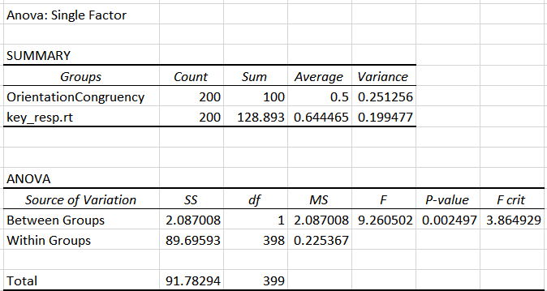

* **Interpretation-**
* **F (F-statistic):** The F-statistic is a measure of the ratio of the variability between groups to the variability within groups. In the context of ANOVA, a higher F-statistic (9.260501506 in our case) suggests that the means of these two groups are significantly different.
* **P-value (Significance Level):** The p-value is the probability that the observed F-statistic occurred by chance. In this case, the p-value is very close to zero (0.002496799), which is significantly smaller than the chosen significance level (0.05), indicating strong evidence against the null hypothesis.
* The ANOVA results suggest that there are significant differences in the means of response time for different levels of Orientation Congruency. The p-value (0.002496799) is much smaller than your chosen significance level (alpha), indicating strong evidence against the null hypothesis.
* Therefore, we can reject the Null Hypothesis and it can be said that there is difference in response time for different Orientation Congruency.