NMA 7th Assignment

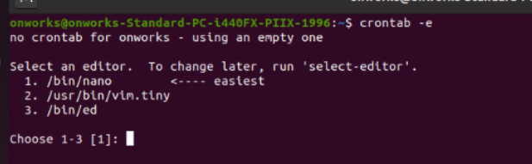

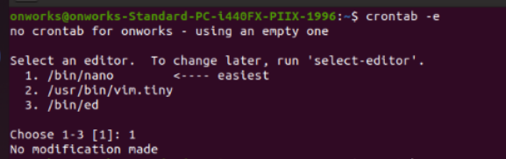

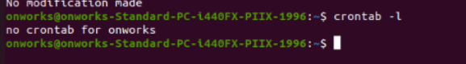

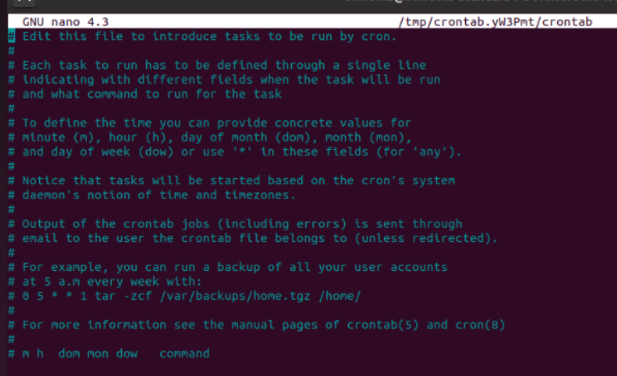

ST Assignment

Consider the following Program :

INPUT A & B

C = A + B

IF C>100

PRINT “ITS DONE”

END IF

IF A>50

PRINT “ITS PENDING”

END IF

|  |  |  |  |  |  |
| --- | --- | --- | --- | --- | --- |
| Test ID | Test Description | Test Data | Expected Result | Actual Result | Test Result |
| 1 | If A=40 and B=70 then all the lines of code will be executed. | A=40,  B=70 | A=40 and B=70 then all the lines of code will be executed. | All the lines of code is executed. | Pass |
| 2 | A=33, B=45 each and every line of the code is executed at least once. | A=33,  B=45 | Each and every line of the code is executed at least once. | Each and every line of the code is executed at least once. | Pass |
| 3 |  |  |  |  | Pass |
| 4 |  |  |  |  | Pass |
| 5 |  |  |  |  | Pass |
| 6 |  |  |  |  | Pass |
| 7 |  |  |  |  | Pass |
| 8 |  |  |  |  | Pass |
| 9 |  |  |  |  | Pass |
| 10 |  |  |  |  | Pass |