1. **Frontend steps**

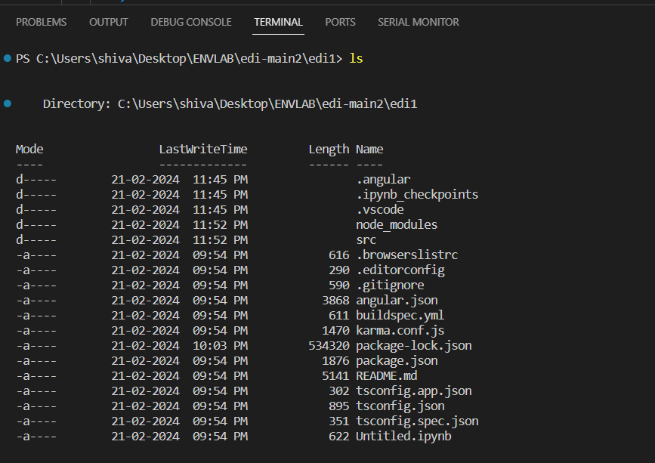

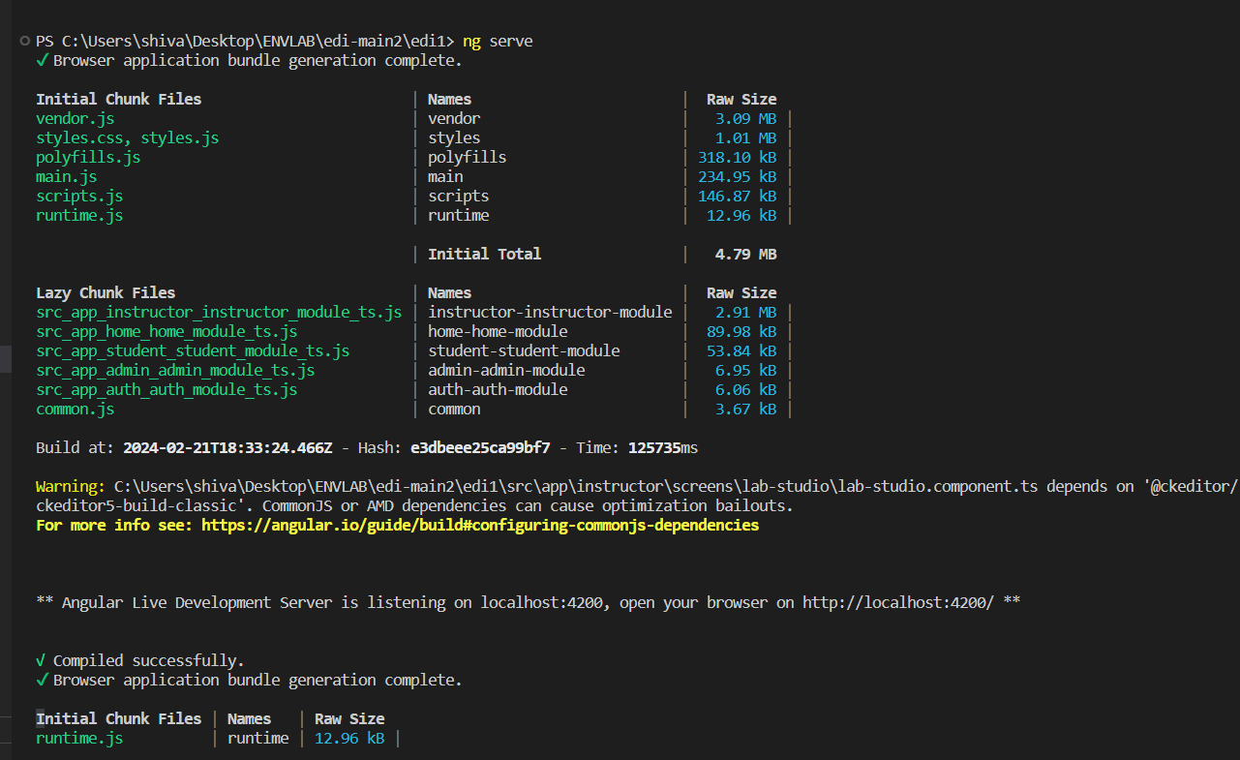

1. Backend steps

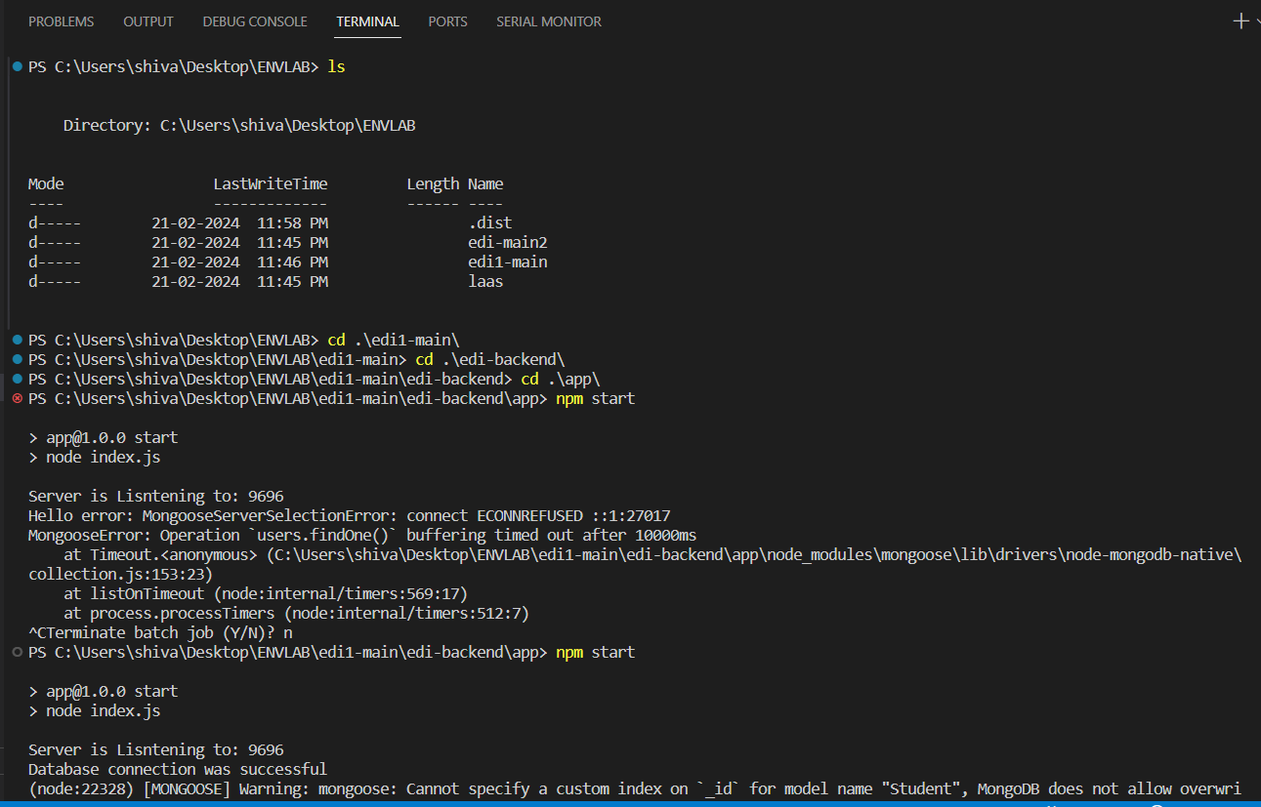

3. Lass Code editior

Run code studio container from docker desktop

OR

1. docker build -t code-studio .
2. docker run -p 8000:2727 -d code-studio