**__DevOps ASSIGNMENTS__**

* ***Install PostgreSQL and write a database backup script using bash.***

**After Successfull installation of postgres_**

-sudo -i -u postgres

-[sudo] password for webonise:

-postgres@webonise:~$ createdb Webonator

-postgres@webonise:~$ createdb Webonators

-postgres@webonise:~$ psql Webonators

-psql (14.1 (Ubuntu 14.1-2.pgdg20.04+1))

-Webonators=# create table Actor(Act_no integer primary key , Act_name varchar(40));

-CREATE TABLE

-Webonators=# \d Actor

**Table "public.actor"**

Column | Type | Collation | Nullable | Default

----------+-----------------------+-----------+----------+---------

act_no | integer | | not null |

act_name | character varying(40) | | |

Indexes:

"actor_pkey" PRIMARY KEY, btree (act_no)

-Webonators=# create table Movie ( Mov_no integer primary key, - Mov_name varchar (50) , Rel_year integer , A_no integer references Actor (Act_no));

-CREATE TABLE

-Webonators=# \d Movie

**Table "public.movie"**

Column | Type | Collation | Nullable | Default

----------+-----------------------+-----------+----------+---------

mov_no | integer | | not null |

mov_name | character varying(50) | | |

rel_year | integer | | |

a_no | integer | | |

-Indexes:

"movie_pkey" PRIMARY KEY, btree (mov_no)

Foreign-key constraints:

"movie_a_no_fkey" FOREIGN KEY (a_no) REFERENCES actor(act_no)

Webonators=# insert into Actor values (1, 'Amir');

INSERT 0 1

Webonators=# insert into Actor values (2, 'Salman');

INSERT 0 1

Webonators=# insert into Actor values (3, 'hritik');

INSERT 0 1

Webonators=# insert into Movie values (1, 'Dhoom', 2000, 1);

INSERT 0 1

Webonators=# insert into Movie values (2, 'Dhoom', 2000,2);

INSERT 0 1

Webonators=# insert into Movie values (3, 'Dabang', 2010,3);

INSERT 0 1

Webonators=# insert into Movie values (4, 'Baghi3', 2010,2);

INSERT 0 1

Webonators=# select * from Actor ;

act_no | act_name

--------+----------

1 | Amir

2 | Salman

3 | hritik

(3 rows)

Webonators=# select * from Movie;

mov_no | mov_name | rel_year | a_no

--------+----------+----------+------

1 | Dhoom | 2000 | 1

2 | Dhoom | 2000 | 2

3 | Dabang | 2010 | 3

4 | Baghi3 | 2010 | 2

(4 rows)

Webonators=# select count(*) from Movie where rel_year=2010;

count

-------

2

(1 row)

Webonators=# select Act_no,Act_name from Actor ,Movie where Mov_name='Dhoom' and Movie.a_no=Actor.Act_no;

act_no | act_name

--------+----------

1 | Amir

2 | Salman

(2 rows)

**Screenshots of DATABASES:**

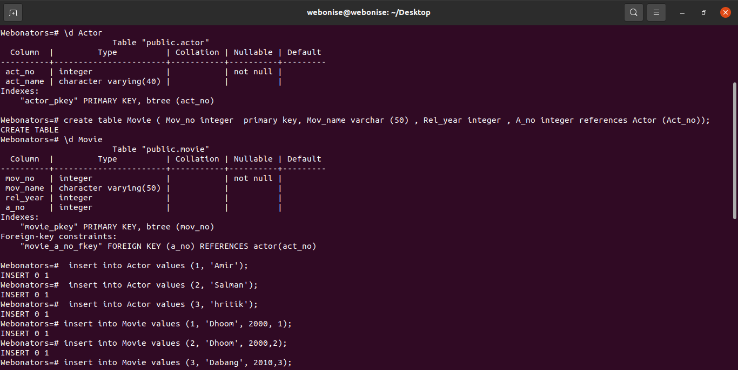

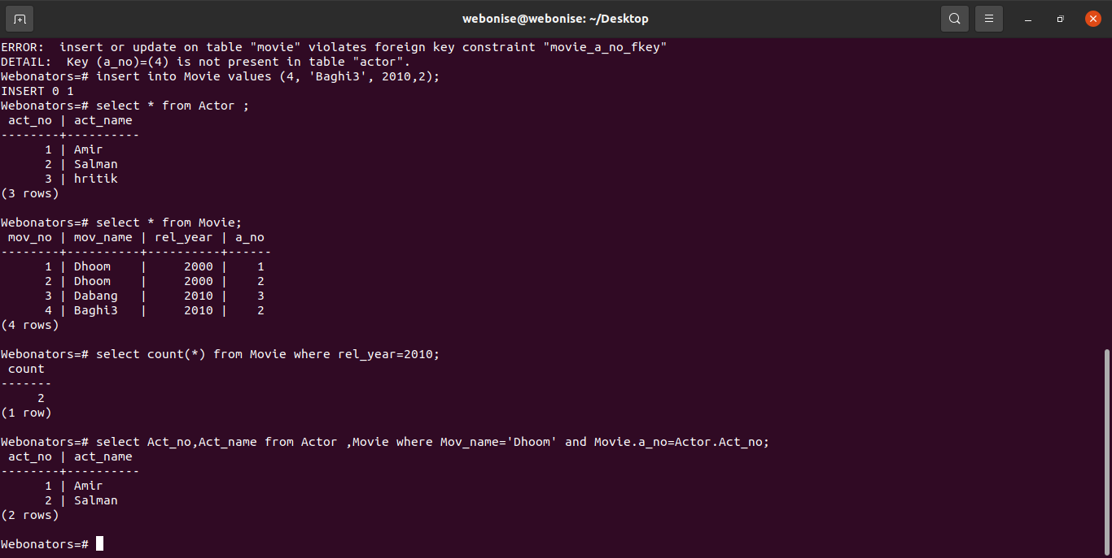

* ***Install Mysql and write a database backup script using bash.***

- sudo apt update -y (Updation)

- sudo apt install mysql-server -y (Installation of mysql server)

- sudo systemctl status mysql.service (Check the status of mysql if it is active/Running or not )

- sudo mysql_secure_installation (Set password here)

- mysql -u root -p ( Enter into Mysql monitor)

- SHOW DATABASES (It will show existing databses )

- CREATE DATABASE Database_name;

- SHOW DATABASES (It will show your created databse in list now)

- CREATE TABLE Table_name;

- INSERT INTO Table_name VALUES( “ ”, ,” ”);

- SELECT * FROM Table_name; (It will show All the inserted data into table)

**1st :-Creation of database**

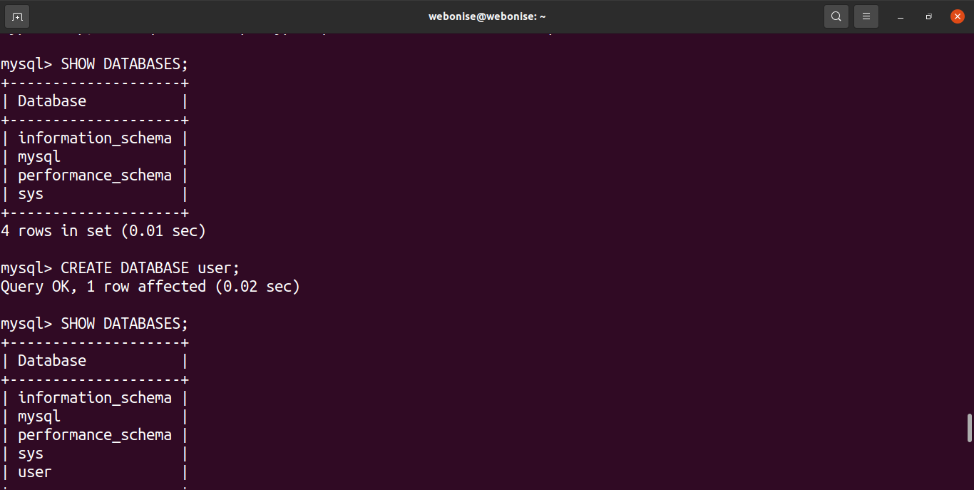

**2nd:Table creation**

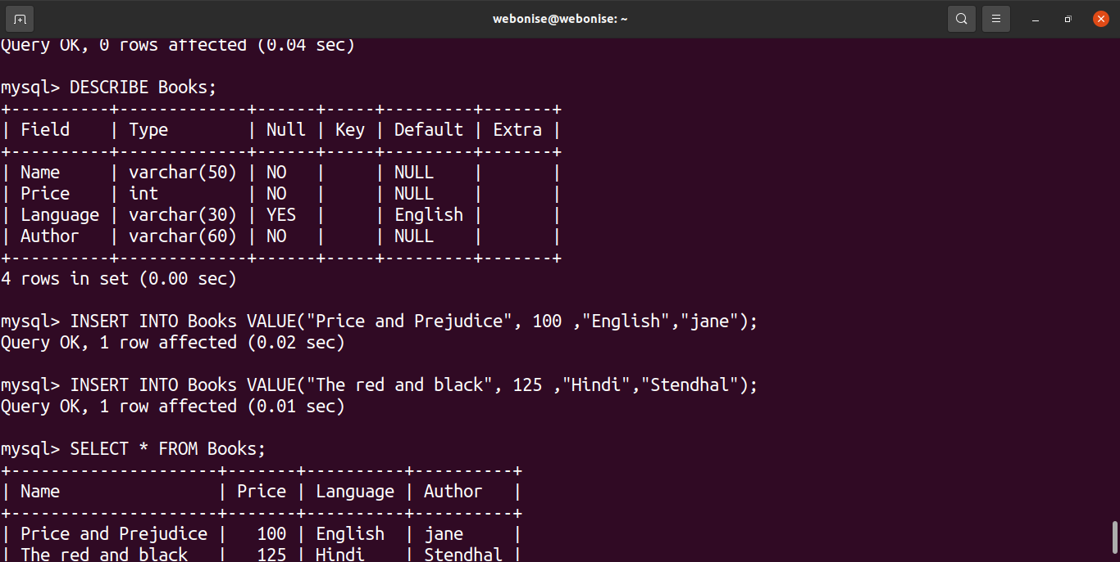

**3rd:Insertion of data into table:**

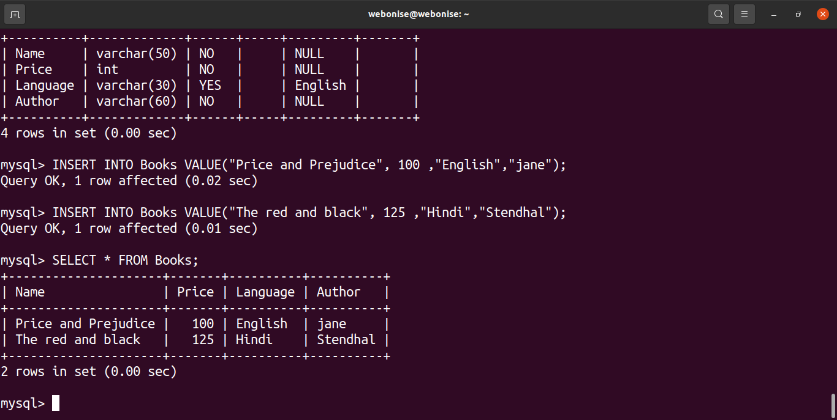

* ***Install & Configure Wordpress / Magento / Drupal / php / website with nginx proxy.***

- sudo apt update -y (updatation)

- sudo apt install nginx -y (To install nginx )

- sudo systemctl start nginx (To start the nginx service)

- sudo systemctl status nginx (To check status of nginx)

- ip a (Run this command it will show ip address ,copy that ip address and paste it at chrome it will display “Welcome to Nginx”)

- sudo apt install mysql-server mysql-client -y (Installation of mysql server)

- sudo systemctl start mysql (To start the mysql server)

- sudo systemctl status mysql (To check the status of mysql if it is active or not)

*-* sudo mysql_secure_installation (Set password here)

- sudo mysql -u root -p (Enter into mysql monitor)

- sudo apt install php7.4 php7.4-gd php7.4-mysql php7.4-zip php7.4- fpm -y (Installation of php7.4)

- wget <https://wordpress.org/latest.zip> (Installation of Wordpress)

- ls (Will show one file as latest.zip)

- unzip latest.zip (unzip the latest.zip file)

- ls (Will show one file namely “wordpress”)

- cd wordpress/ (Enter into wordpress directory)

- ls (Will show files inside wordpress directory )

- sudo cp -r * /var/www/html/

- sudo chown -R www-data:www-data /var/www/html/

- sudo systemctl restart nginx

- cd /etc/nginx/sites-enabled/

- ls (default)

- ls (WORDPRESS)

- sudo nano WORDPRESS

- sudo systemctl restart nginx (Again restart the nginx service)

- sudo nginx -t (It will check syntax of configurations )

- Now go to chrome and refresh the webpage showing “Welcome to nginx and it will show wordpress window . Click continue and then Run installation. Make changes as per created database. And continue at last it will show wordpress site home page as below.

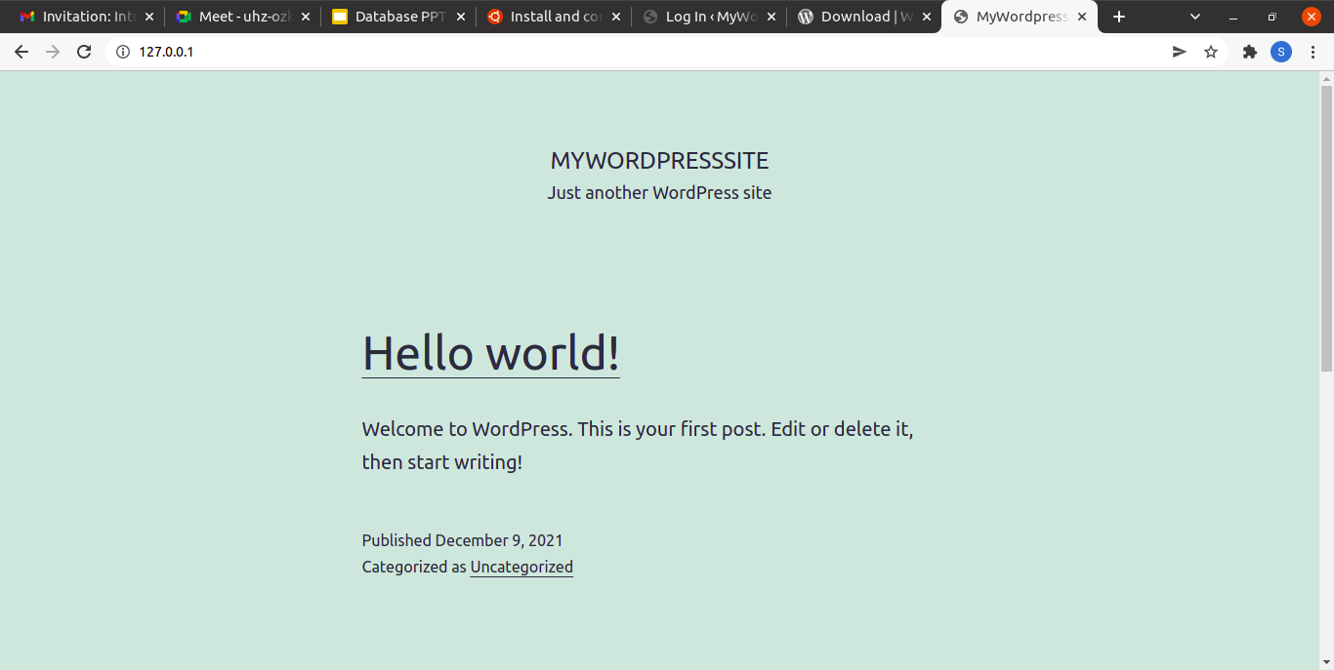

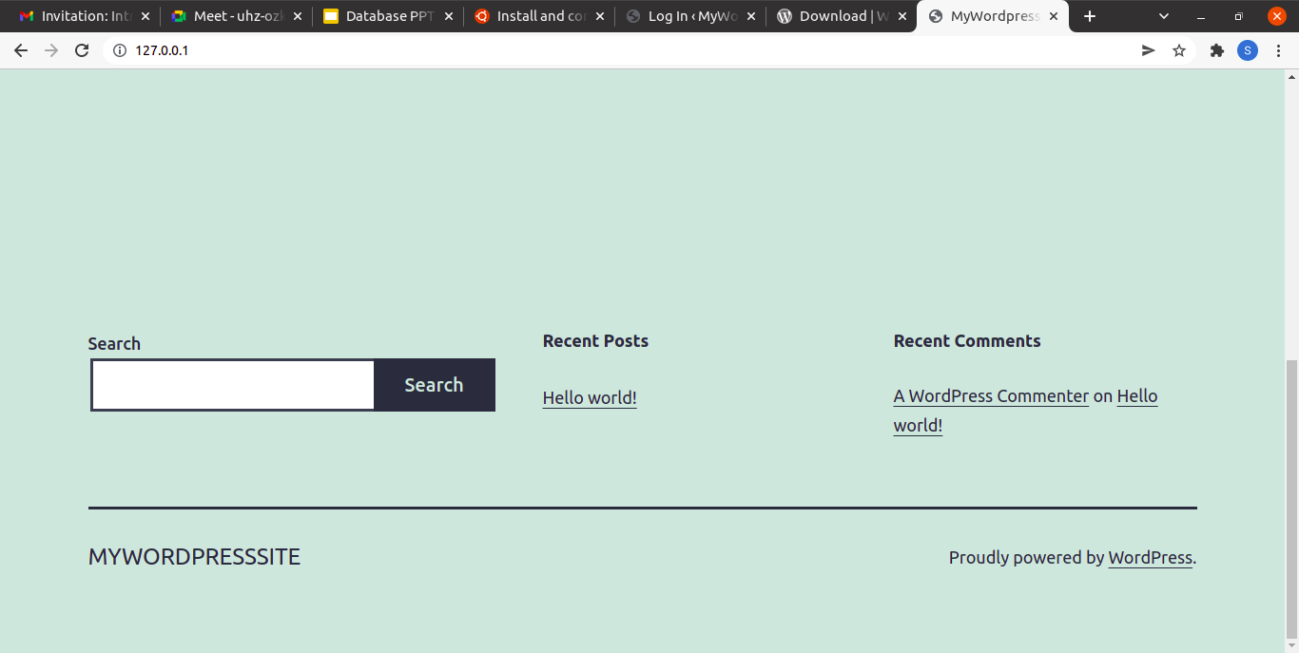

**Screenshots of Terminal while installation of Wordpress :**

**1st:**

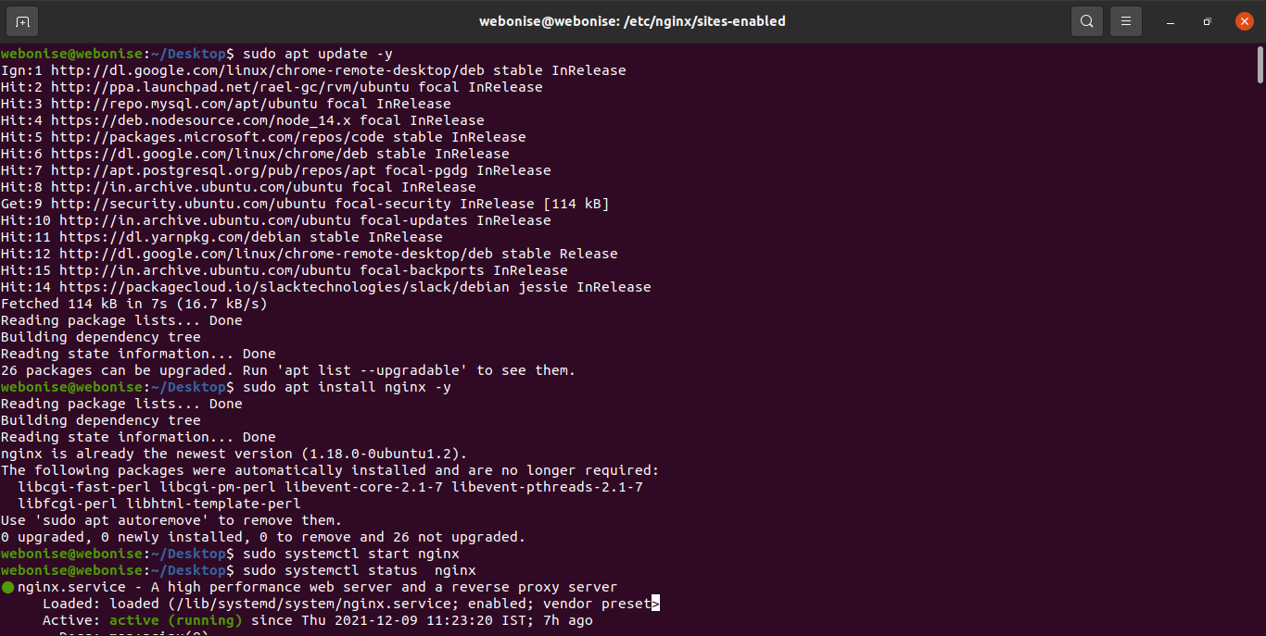

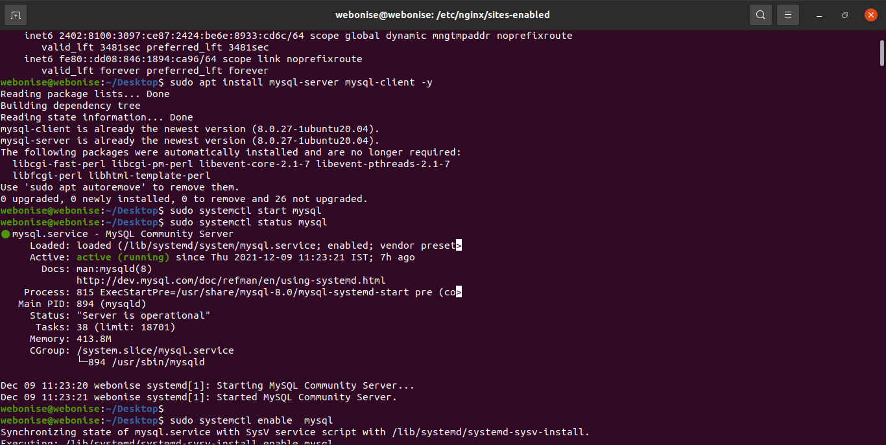**2nd:**

**3rd:**

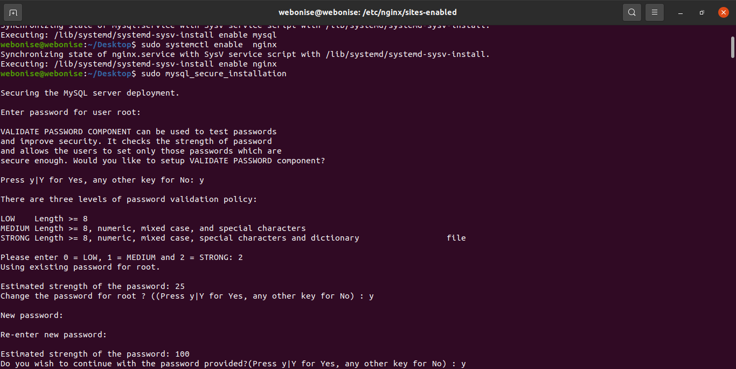

**4th:**

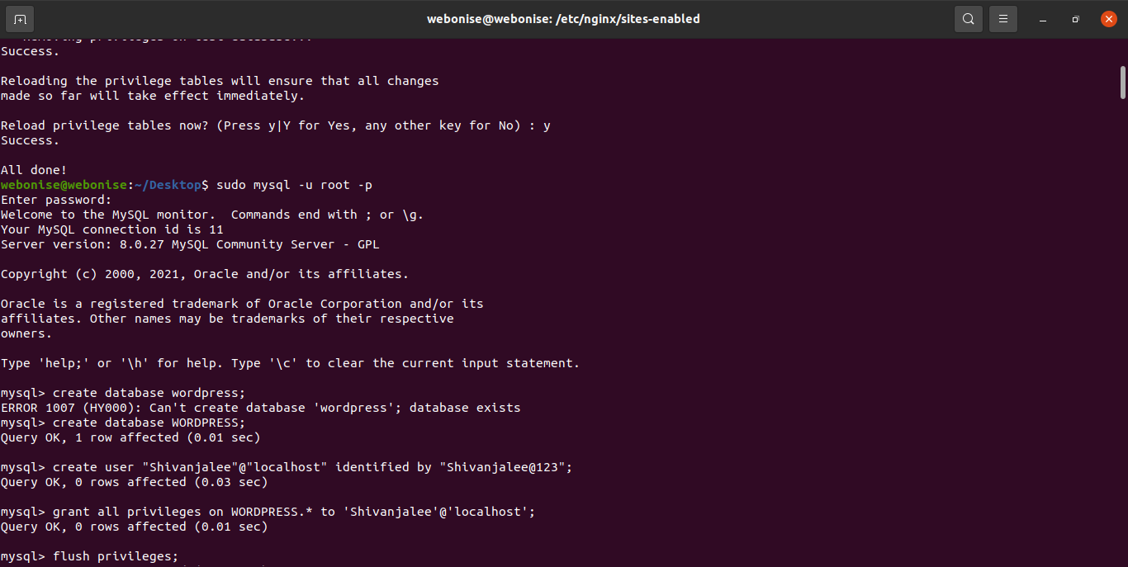

**5th:**

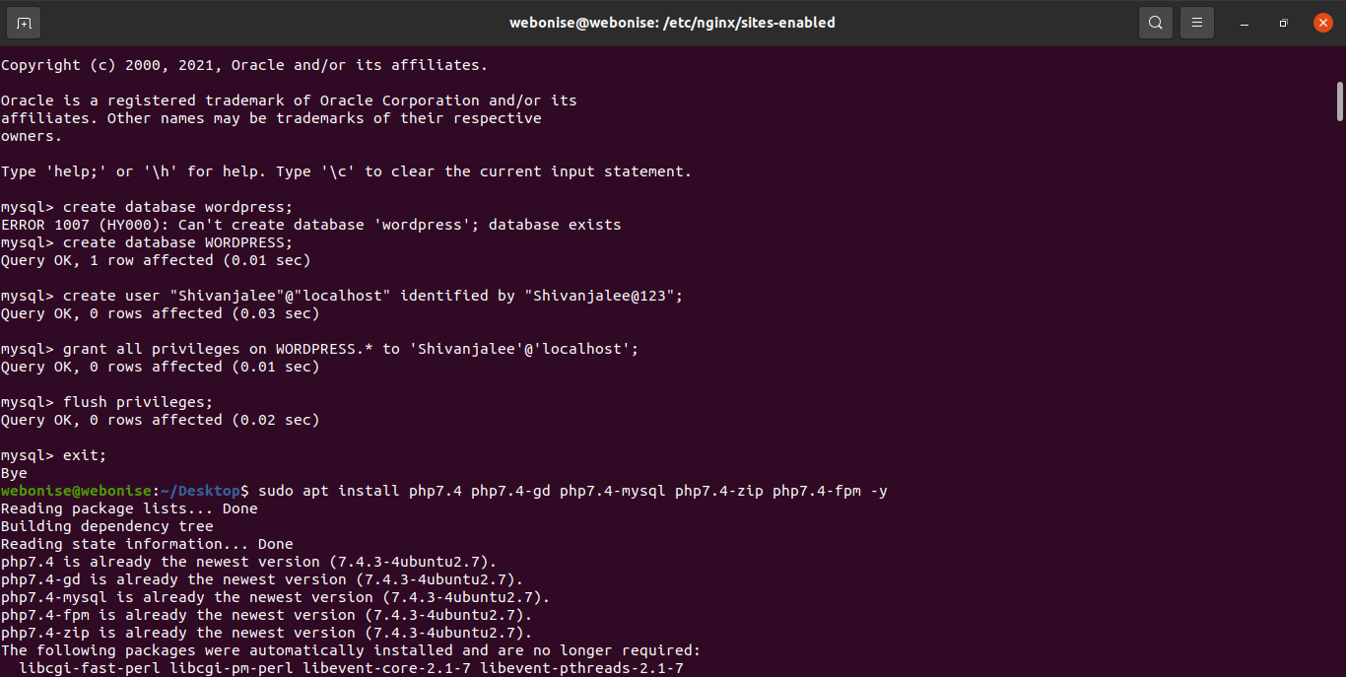

**6th:**

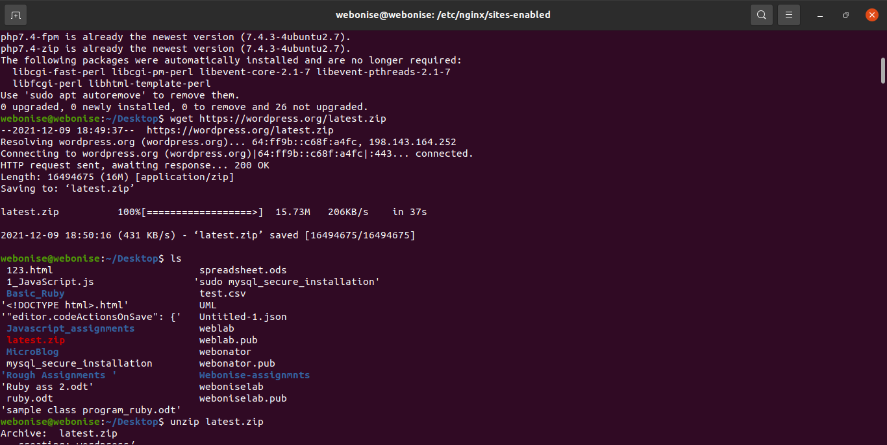

**7th:**

