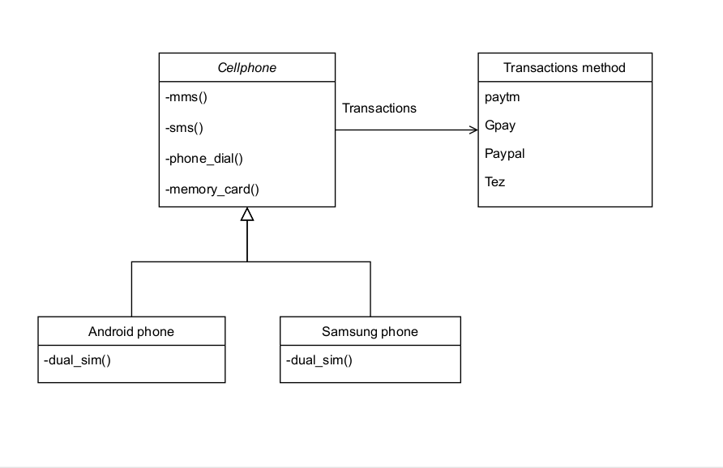**UML DIAGRAM**

**EXPLAINATION:**

1)Firstly declared main class as ***class cellphone –*** it includes 4 functions as ***void MMS() , void***

***SMS() , void phone_dial() , void memory_card()***

2)Two classes declared as ***void Android_phone() and void Samsung_phone()*** which will inherit

main class cellphone and produce hierarchial relationship between them and also includes

individual function as ***void dual_sim()***

3)Third thing is added apps for transactions which are added in switch cases in the program will be

able to interchangebly use.