**DevOps Assignment**

* **Install PostgreSQL and write a database backup script using bash.**

**After Successfull installation of postgres_**

-sudo -i -u postgres

-[sudo] password for webonise:

-postgres@webonise:~$ createdb Webonator

-postgres@webonise:~$ createdb Webonators

-postgres@webonise:~$ psql Webonators

-psql (14.1 (Ubuntu 14.1-2.pgdg20.04+1))

-Webonators=# create table Actor(Act_no integer primary key , Act_name varchar(40));

-CREATE TABLE

-Webonators=# \d Actor

**Table "public.actor"**

Column | Type | Collation | Nullable | Default

----------+-----------------------+-----------+----------+---------

act_no | integer | | not null |

act_name | character varying(40) | | |

Indexes:

"actor_pkey" PRIMARY KEY, btree (act_no)

-Webonators=# create table Movie ( Mov_no integer primary key, - Mov_name varchar (50) , Rel_year integer , A_no integer references Actor (Act_no));

-CREATE TABLE

-Webonators=# \d Movie

**Table "public.movie"**

Column | Type | Collation | Nullable | Default

----------+-----------------------+-----------+----------+---------

mov_no | integer | | not null |

mov_name | character varying(50) | | |

rel_year | integer | | |

a_no | integer | | |

-Indexes:

"movie_pkey" PRIMARY KEY, btree (mov_no)

Foreign-key constraints:

"movie_a_no_fkey" FOREIGN KEY (a_no) REFERENCES actor(act_no)

Webonators=# insert into Actor values (1, 'Amir');

INSERT 0 1

Webonators=# insert into Actor values (2, 'Salman');

INSERT 0 1

Webonators=# insert into Actor values (3, 'hritik');

INSERT 0 1

Webonators=# insert into Movie values (1, 'Dhoom', 2000, 1);

INSERT 0 1

Webonators=# insert into Movie values (2, 'Dhoom', 2000,2);

INSERT 0 1

Webonators=# insert into Movie values (3, 'Dabang', 2010,3);

INSERT 0 1

Webonators=# insert into Movie values (4, 'Baghi3', 2010,2);

INSERT 0 1

Webonators=# select * from Actor ;

act_no | act_name

--------+----------

1 | Amir

2 | Salman

3 | hritik

(3 rows)

Webonators=# select * from Movie;

mov_no | mov_name | rel_year | a_no

--------+----------+----------+------

1 | Dhoom | 2000 | 1

2 | Dhoom | 2000 | 2

3 | Dabang | 2010 | 3

4 | Baghi3 | 2010 | 2

(4 rows)

Webonators=# select count(*) from Movie where rel_year=2010;

count

-------

2

(1 row)

Webonators=# select Act_no,Act_name from Actor ,Movie where Mov_name='Dhoom' and Movie.a_no=Actor.Act_no;

act_no | act_name

--------+----------

1 | Amir

2 | Salman

(2 rows)

**Screenshots of DATABASES:**

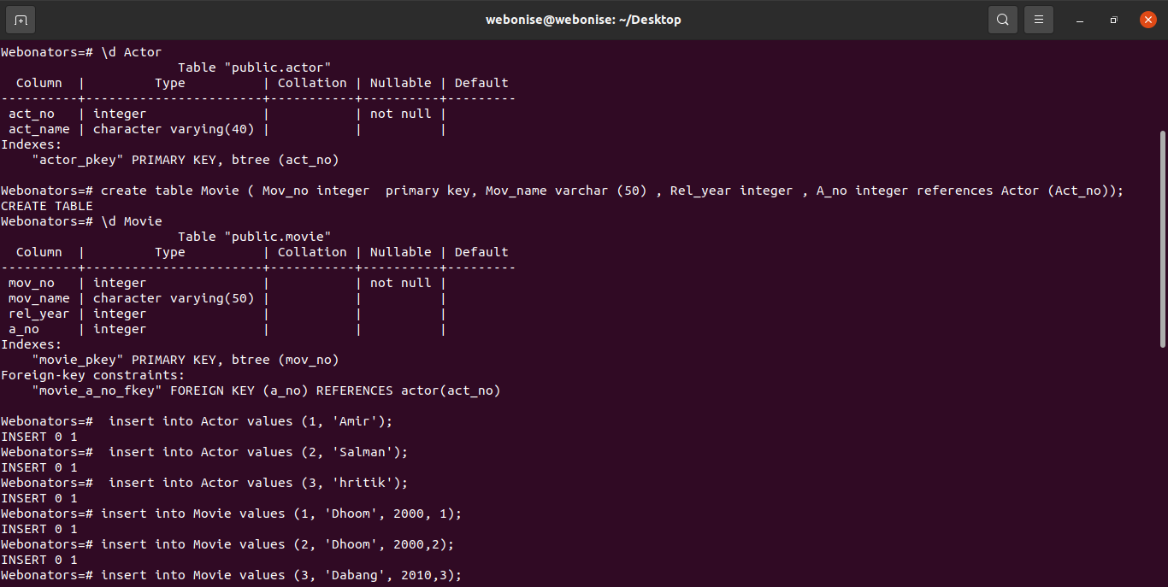

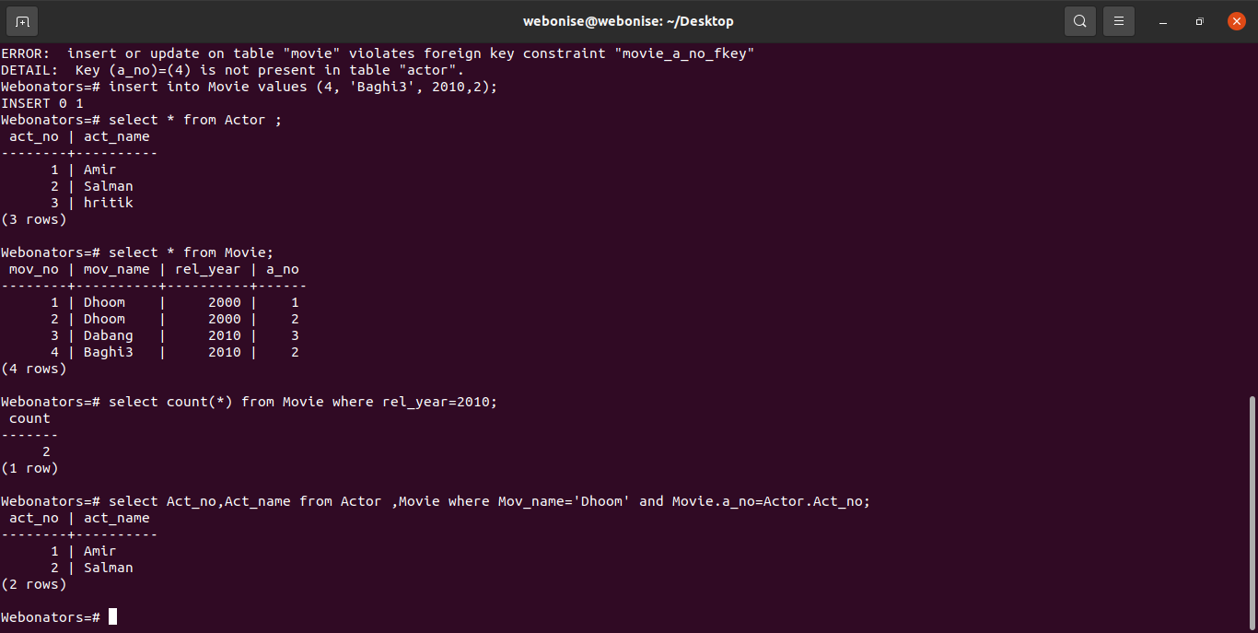

* Install Mysql and write a database backup script using bash.

-sudo apt update

-sudo apt install mysql-server -y

-sudo systemctl status mysql.servic

- sudo mysql_secure_installation

-mysql -u root -p

1st :-Creation of database

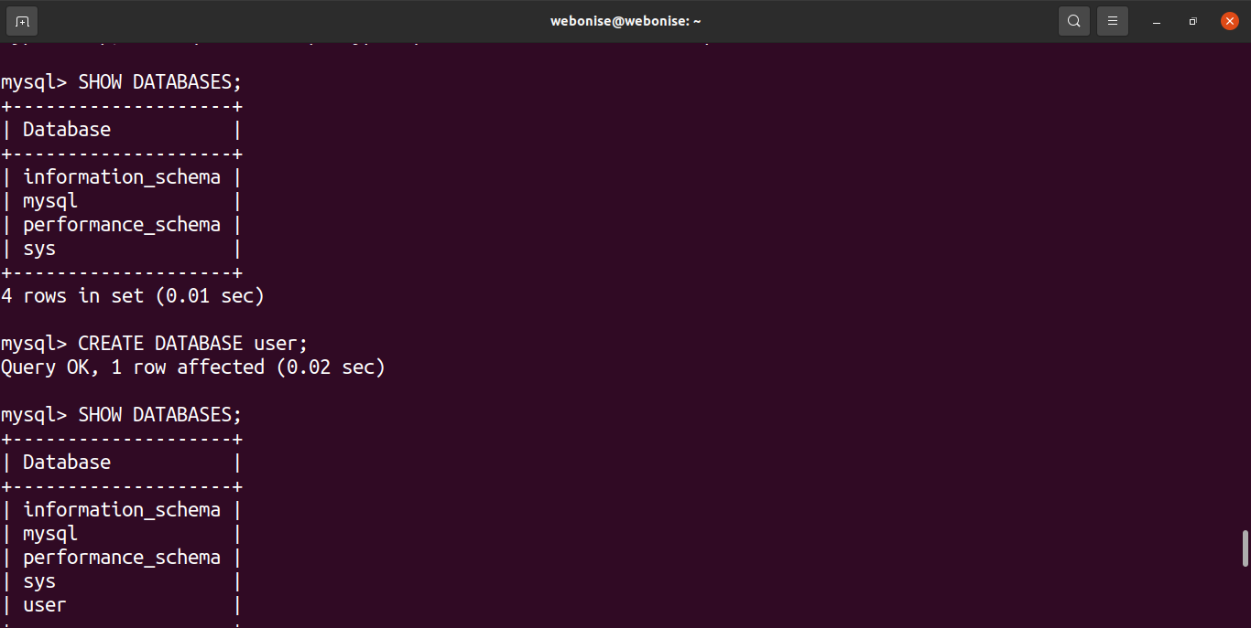

2nd:Table creation

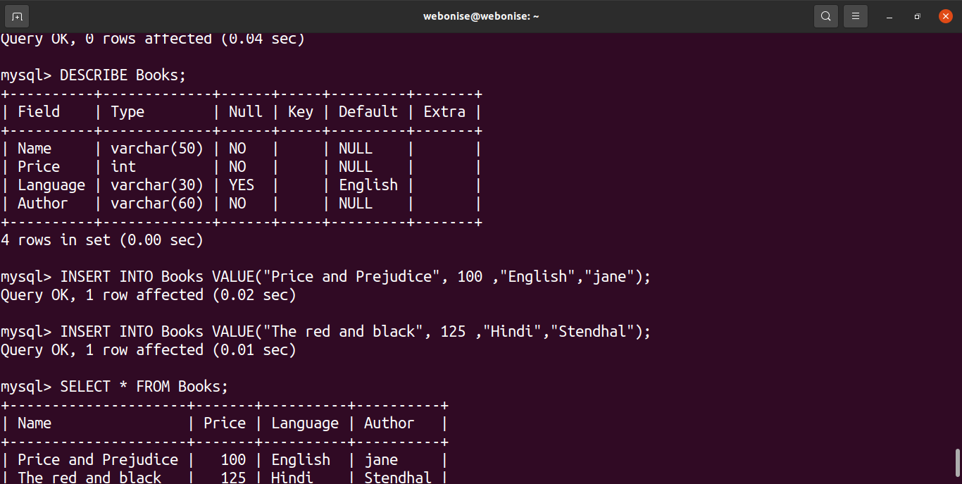

3rd:Insertion of data into table:

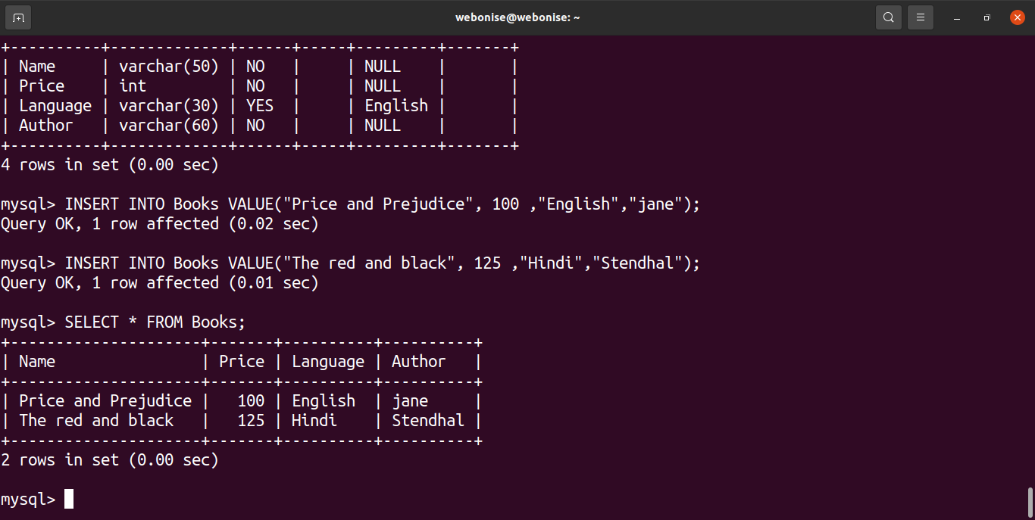

* Install & Configure Wordpress / Magento / Drupal / php / website with nginx proxy.

**Wordpress installation:**

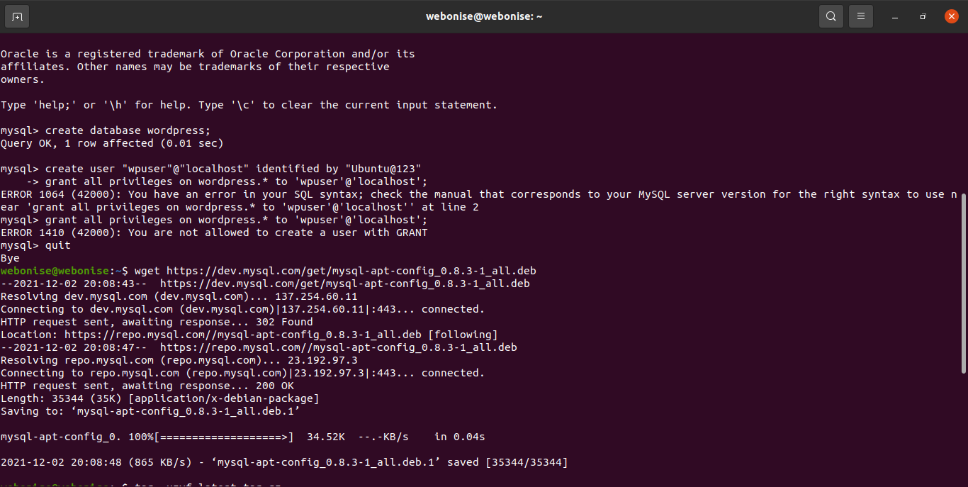

**Nginx installation done:**

