Number Plate Detection

Prathamesh Dhawale Shivanjay Wagh Saurabh Kshirsagar Pranit Jadhao

*Computer Department,* *Vishwakarma Institute of Technology (Affiliated to Savitribai Phule Pune University)*

*666, Upper Indira Nagar, Bibwewadi, Pune, Maharashtra, India*

[prathamesh.dhawale17@vit.edu](mailto:prathamesh.dhawale17@vit.edu)

[shivanjay.wagh17@vit.edu](mailto:shivanjay.wagh17@vit.edu)

[saurabh.kshirsagar17@vit.edu](mailto:saurabh.kshirsagar17@vit.edu)

[pranit.jadhao17@vit.edu](mailto:pranit.jadhao17@vit.edu)

***Abstract*—** **The scientific world is deploying research in intelligent transportation system which have a significant impact on people’s lives. Automatic License Plate Recognition is a computer vision technology to extract the license number of vehicles from images. By using that number we can get account details of vehicle owner.**

***Keywords***—**image processing, text recognition, number plate, image to string, database**

I. INTRODUCTION

# The scientific world is deploying research in intelligent transportation system which have a significant impact on people’s lives.

# Automatic License Plate Recognition is a computer vision technology to extract the license number of vehicles from images.

# By using that number we can get account details of vehicle owner.

# The toll booth fee will be automatically deducted from the vehicle owners bank account and will be credited into the bank account of the toll booth contractor.

# Making it a fully automated process

# Ease of access

1. *Saving Valuable Time:*

Instead of waiting at toll booths , vehicles can just keep moving without wasting any valuable time. The transaction process will be completely automated and wont require any manual input.

# Number plate detection

1.We read the image and convert it into a string. We store this string into a user defined variable. We then search this number throughout our pre defined database . we then segregate the aadhar number from which we get the information about his bank account.

After this we deduct the toll booth fee from the vehicle owners bank account and credit the same to the toll booth contractors bank account.

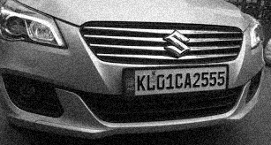

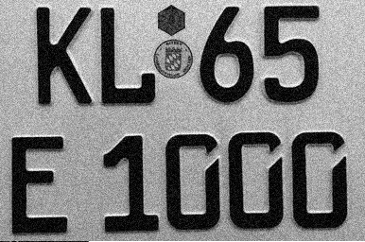

# CONCLUSIONS

The license plates were detected successfully in nearly all the images . The aim of the project was to familiarize oneself with the basics of image processing and gain experience in programming in python and opencv which was achieved successfully. Also we gained valuable experience in database handling and management.

# ACKNOWLEDGEMENT

We would like to express our special thanks to our guide Prof. Ashwini Shingare and head of our computer department. Prof. Vivek Deshpande who helped us in every possible way and resolved the problems we faced.

# REFERENCES

*[1]*[*https://www.youtube.com/watch?v=haHuVAUGY5Y*](https://www.youtube.com/watch?v=haHuVAUGY5Y)

*[2]* [*https://www.apachefriends.org/download.html*](https://www.apachefriends.org/download.html)

*[3]http://www.academia.edu/Documents/in/Automatic_License_Plate_Detection_Using_Image_Processing*