*Automated Toll Deduction System using Number Plate Detection*

Prathamesh Dhawale   
*Computer Department*

*Vishwakarma Institute of Technology (Affiliated to Savitribai Phule Pune University)*

Pune, India  
 prathamesh.dhawale17@vit.edu

Pranit Jadhao  
Computer Department  
  
*Vishwakarma Institute of Technology (Affiliated to Savitribai Phule Pune University)*

Pune,India  
pranit.jadhao17@vit.eduShivanjay Wagh  
Computer Department  
*Vishwakarma Institute of Technology (Affiliated to Savitribai Phule Pune University)*

Pune, India  
shivanjay.wagh17@vit.edu

Saurabh Kshirsagar  
Computer Department  
*Vishwakarma Institute of Technology (Affiliated to Savitribai Phule Pune University)*

Pune, India  
saurabh.kshirsagar17@vit.edu

*Abstract*— The scientific world is deploying research in intelligent transportation system which have a significant impact on people’s lives. Automatic License Plate Recognition is a computer vision technology to extract the license number of vehicles from images. By using that number plate, we can get account details of vehicle owner. Toll deduction will be done via accessing the database of vehicle owners.

Keywords—image processing, text recognition, number plate, image to string, database,

# Introduction

The scientific world is deploying research in intelligent transportation system which have a significant impact on people’s life.

Automatic license plate recognition is a computer vision technology to extract the number plate from vehicle images

By using that number, we can get account details on vehicle owner

The toll booth fee will be automatically deducted from the vehicle owners bank account and will be credited into bank account of toll booth contractor. Making it a fully automated process.

# Literature view

* *G. Naveen Balaji, D. Rajesh*, “*Smart Vehicle Number Plate Detection System for Different Countries Using an Improved Segmentation Method”, Imperial Journal of Interdisciplinary Research (IJIR) Vol-3, Issue-6, 2017 ISSN: 2454-1362, http://www.onlinejournal.in.* .This paper describes following features

Vehicle number plate detection and recognition is very important in transport systems. Researchers had used different techniques and methods to detect and recognize the vehicle number plate, by citing various journals, t transactions, books and conference papers, information is collected in the relevant field from previous works. There are four fundamental processing steps: enhancement of a digital image, license number plate region detection in the image and characters recognition. In first step we captured image from camera[2]

If captured image is not in required size then resized image by using imultis library.

* Chirag Patel, Dipti Shah, Atul Patel “Automatic Number Plate Recognition System (ANPR): A Survey”, International Journal of Computer Applications (0975 – 8887) Volume 69– No.9, May 2013.This paper describes following features

Removal of noise, brightness and contrast adjustment were made implicitly inside the canny function and then converted the input image into grayscale and then we got the binarized image. Sometimes first converting image to grayscale and later removing of noise was done.[1]

Then binarized image is passed through Canny’s edge detection function to obtain clear edges of image.[1]

* Bao, P., Zhang, L., Wu, X.: Canny Edge Detection Enhancement by Scale Multiplication. IEEE Trans. on PAMI 27(9), 1485–1490 (2005)

CrossRefGoogle Scholar. This paper describes following features

The output of the canny edge detection function is then fed to the morph dilation function which dilates or thickens the edges detected.[7]

Contours are drawn around the edges using the draw contour function of the open cv library . the region of the number plate is detected and isolated. This isolated image is now passed through the pytesseract library function which gives the string of the characters detected as output.

Detected number is search in database and then transaction is performed.

# Ease of Use

## Saving valuable time

Instead of waiting at toll booth, vehicles can just keep moving without wasting any valuable time. The transaction process will be completely automated and won’t require any manual input.

## Cashless transactions

Instead of paying the toll fee via cash, transactions will be done without cash.

III. METHODOLOGY

## Capturing the image of vehicle :-

While the vehicle passes through the toll booth, image of the vehicle will be captured and further processing will be done.

## Resizing the Image:-

If the captured image is less than 776 pixels in width then it is resized to 900 pixels using resize function of imutils library.

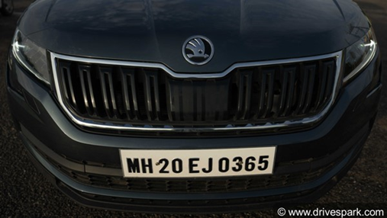

Fig.1(resized image)

## Grayscale Conversion:-

The resized image is then converted to a black and white image. This is done using a binary function named threshold which converts pixels above certain value to white pixels and below it to black pixels.

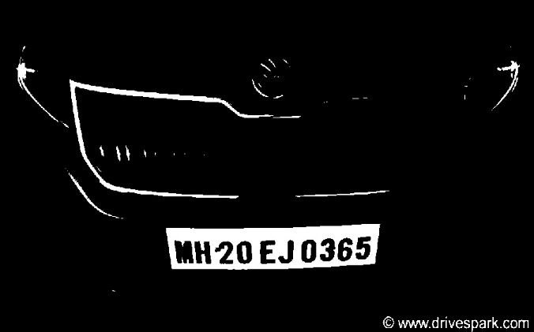

Fig 2(Greyscale conversion)

## Canny’s Edge Detection :- The edges of the image are then identified using Canny’s Edge Detection. Here, a kernel of min value 100 and max. value 200 is used to process the image.

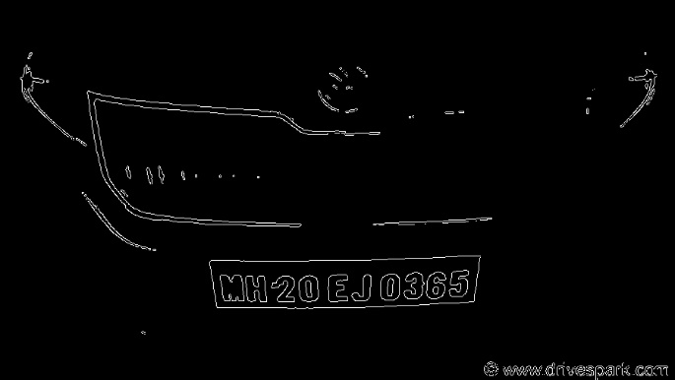

Fig 3(Canny image)

## Morph Dilation:- In general number plate is passed through a dilation process. This makes the edges pf the image thicker and hence it becomes easy to rrecognize the text in it.

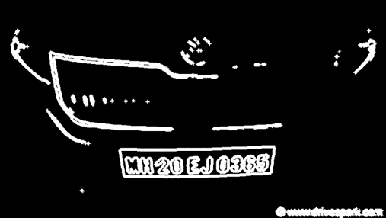

Fig 3 (Morphed image)

## Giving an approximatly nearby shape to contours: :- First of all, all the contours are found out from the image and then they are sorted in descending order and the top 10 of them are selected for further processing. Now, these selected contour, if not in proper shape, are shaped approximately

## Drawing Contours:-

Final step for identifying the number plate is drawing the contour around the number plate.

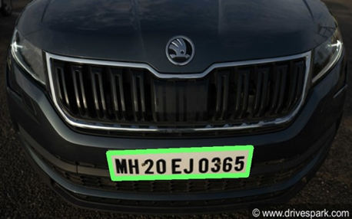

Fig 5 (Plate localization)

## Extracting Number Plate:-

Now, based on the contour drawn around the number plate, the number plate is extracted and used for further processing.

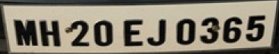

Fig 6 (Extracted Plate)

## Converting image contet to text:-

The extracted image is given as input to image-to-text function of pytesseract library, which is then converted to text and this vehicle number is stored in a variable for further transactions.

## Fetchinng the Owner’s Account From Database:- The obtained vehicle number is searched in the database of owners’ vehicle details. The Aadhar number of corresponding vehicle owner is obtained and then searched in the database of bank account details.

1. Deducting Toll Fee And Crediting The Same In The Contractor’s Account :-

Once the bank account of vehicle owner is fetched the required toll fee is deducted and further credited to the perspective toll booth contractor.

Acknowledgment

We would like to express our special thanks to our guide Prof. Ashwini Shingare and head of our Computer

Department. Prof. Vivek Deshpande who helped us in every possible way and resolved the problems we faced.

References

*[1 ]* *Chirag Patel, Dipti Shah, Atul Patel “Automatic Number Plate Recognition System (ANPR): A Survey”, International Journal of Computer Applications (0975 – 8887) Volume 69– No.9, May 2013*

*[2] G. Naveen Balaji, D. Rajesh*, “*Smart Vehicle Number Plate Detection System for Different Countries Using an Improved Segmentation Method”, Imperial Journal of Interdisciplinary Research (IJIR) Vol-3, Issue-6, 2017 ISSN: 2454-1362, http://www.onlinejournal.in*

*[3] Karwal .H, &Girdhar. A, "Vehicle Number Plate Detection System for Indian Vehicles", IEEE International Conference on Computational Intelligence & Communication Technology (CICT), 2015,February, pp. 8-12. [*

*[4]*[*https://www.researchgate.net/post/How_do_I_detect_and_recognize_vehicle_number_plates_from_images_taken_arbitrarily*](https://www.researchgate.net/post/How_do_I_detect_and_recognize_vehicle_number_plates_from_images_taken_arbitrarily)

*[5]*[*http://www.academia.edu/Documents/in/Automatic_License_Plate_Detection_Using_Image_Processing*](http://www.academia.edu/Documents/in/Automatic_License_Plate_Detection_Using_Image_Processing)

*[6]* *Sulaiman. N, Jalani. S. N. H. M, Mustafa. M, &Hawari. K, (2013, August). "Development of automatic vehicle plate detection system",IEEE 3rd International Conference on System Engineering and Technology (ICSET), 2014, July, pp. 130-135.*

*[7]* *Bao, P., Zhang, L., Wu, X.: Canny Edge Detection Enhancement by Scale Multiplication. IEEE Trans. on PAMI 27(9), 1485–1490 (2005)*

*CrossRefGoogle Scholar*

*]* Karwal .H, &Girdhar. A, "Vehicle Number

Plate Detection System for Indian Vehicles",

IEEE International Conference on

Computational Intelligence & Communication

Technology (CICT), 2015,February, pp. 8-12.

[