# Team Members

## Manthena Lohith Varma

## Parve Sharma

## Shivank Sharma

## Swathi Kasikala

## SOFTWARE REQUIREMENT SPECIFICATIONS

### INTRODUCTION

Games and Challenges are the best way to reduce the stress and to pass the time. The stress in the workplace and boring day increases the need for the way to get chilled either through games and funny challenges. [Our web app name] is a supportive web application that can be used by users to play the games and attempt funny challenges.

##### PURPOSE

The purpose of the project is to allow the users to enroll and attempt games and challenges through this portal. [Our web app name] is open to access for all internet users, and it also includes leader-board feature to compare the results with others.

##### SCOPE

Accessible by both Mobile/Desktop browser as it is a responsive design.

### OVERALL DESCRIPTION

##### PRODUCT PERSPECTIVE

The proposed [our app name] can be used at any time, and user can enroll as many games/challenges available and be able to give their attempt in the time in which the game/challenge is active. The scores will be reflected in leader-board at which the user can be able to compare his/her performance.

##### SOFTWARE REQUIREMENT

* + - Front-end: React JS
    - Back-end: Django

##### HARDWARE REQUIREMENT

* Any smartphone, tablet or a desktop with active Internet connection
* 2GB ram
* 1.2 GHz processor
* Intel i5

##### FUNCTIONAL REQUIREMENT

* **R.1: Sign-Up**
  + **Description**: The user can sign-up using their username, email and password
  + **Registration:** The users can provide their personal details like age through their profile in the dashboard to get the recommendations accordingly.

##### R.2: Login

* + **Input**: Registered users can login into their profiles
  + **Output**: User will be able to view their profile with the registered details

##### R.3: **Dashboard**

##### **User Profile**: The profile of the user will be shown at the top-right position which consists of the user info and helps the user to update the profile

##### **No. of Enrolled games/challenges:** The user can see how many number of challenges he enrolled

##### **Details of enrolled games/challenges:** The user can see the details of the each game/challenge he enrolled such as number of users enrolled to the game/challenge, start time, and option to attempt the game/challenge if it is active

##### R.4 Upcoming/Completed Challenges

* + - **Description:** These pages consists of the all the upcoming challenges and the challenges being attempted by the user
    - **Upcoming Challenges:** The user can see all the details of the upcoming challenges along with an option to enroll to that game/challenge
    - **Completed Challenges:** The user can see the details of the games/challenges that he/she participated and with an option to share the score and leader-board details with others
* **R.5 Profile Page**
  + - **Update Option:** The user can update the details using this feature
    - **Points/Rewards:** The user can see his total points achieved by attempting games/challenges
    - **Progress Bar:** The user can see how many enrolled games/challenges user is yet to attempt
    1. **NON FUNCTIONAL REQUIREMENTS**

##### Usability Requirement

The system shall allow the users to access the system from a smartphone, tablet or a desktop with a web browser and an active internet connection. The system uses a web browser as an interface.

Since all users are familiar with the general usage of internet browsing, no special training is required.

The user friendly interface makes the system easy to use.

##### Availability Requirement

The system is available at all times for the user and is used 24 hrs a day and 365 days a year. The system shall be operational 24 hours a day and 7 days a week.

##### Efficiency Requirement

Mean Time to Repair (MTTR) - Even if the system fails, the system will be recovered back up within very less time.

##### Accuracy

The system should accurately provide the results for each game/challenge as the leader-board feature is included.

* **Performance Requirement**

The system should respond to the user request to enroll or attempt any game/challenge. These responses to view information shall take no longer than 5 seconds to appear on the screen.

##### Reliability Requirement

The system has to be 100% reliable due to the importance of data and the damages to the fair-play that can be caused by incorrect data.

##### USER CHARACTERISTICS

[Our app name] has 2 level of users:

* + - User module: In the user module, the user can either enroll or attempt the games/challenges to reduce the stress
    - Organizer module: In the organizer module, the organizer can be able to manage the games/challenges

##### CONSTRAINTS

* The integration of the games/challenges into the application is the difficult part for our application
* Leader-board feature to compare the result scores

## Plan of action

**Goal: Working HashedIn Gaming/Challenges Platform App in 15 days**

|  |  |  |  |
| --- | --- | --- | --- |
| **Goal** | **Action Steps** | **Timeline** | **Potential Barriers** |
| **Front-end designing** | **Create Sign up and Login pages** | **1 day**  **(21-March-2022)** | * **Proper Validation** * **Exception handling** |
| **Create Dashboard** | **2 days**  **(22-March-2022 to 23-March-2022)** | * **Designing details for each challenge** |
| **Create Profile Page** | **1 day**  **(24-March-2022)** | * **Designing in such a way to easily populate the dynamic data** |
| **Improving User Interface** | **1 day**  **(25-March-2022)** | * **Responsive User Interface** * **Checking lint errors** |
| **Back end designing** | **Create Database for User Login/SignUp** | **2 days**  **(21-March-2022 to 22-March-2022)** | * **Maintaining roles as user/organizer** |
| **Creating back-end to get the details for games/challenges** | **2 days**  **(23-March-2022 to 25-March-2022)** | * **Working on scores and leader-board** |
| **Integrating everything** | I**ntegrating Front-end with Back-end** | **4 days**  **(28-March-2022 to 31-March-2022)** | * **Integration and data-flow** |
| **Testing** | **Unit Testing** | **1 day**  **(31-March-2022)** |  |
| **Integration Testing** | **1 day**  **(4-April-2022)** |  |

## Use cases

#### The user will be able to enroll to game/challenge

There will be an enroll option in upcoming challenges page to enroll to the respective game/challenge and upon enrolling the user can see it in the dashboard

#### The user will be able to attempt the enrolled games/challenges

In the dashboard, the user can be able to attempt the enrolled games/challenges by clicking on the start option on each in the active time and upon completion it should be added to the completed challenges page with the result scores in it.

# Architecture Diagram

# WORK-1

# 

## ROAD MAP

## WORK-2

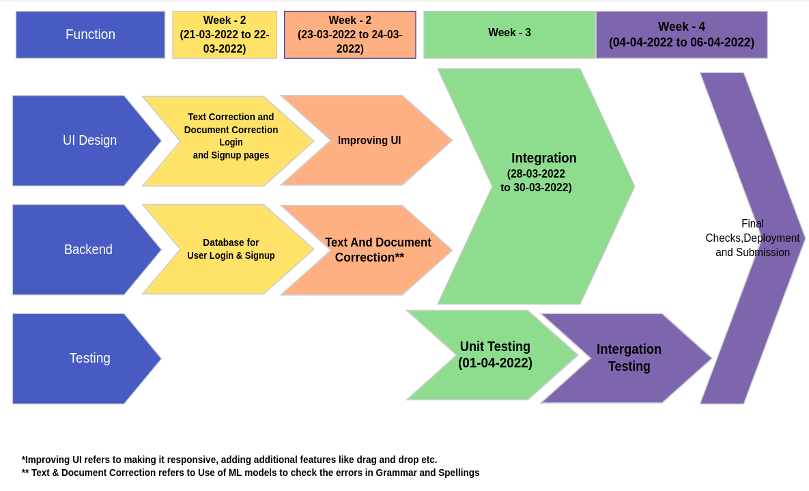

**DAILY DELIVERABLE**

|  |  |  |
| --- | --- | --- |
| **Date** | **Day** | **Deliverables** |
| **14-03-2022** | **Monday** | **Team Formation** |
| **15-03-2022** | **Tuesday** | **Project Discussion** |
| **16-03-2022** | **Wednesday** | **Wire-Frames and Design Plan** |
| **17-03-2022** | **Thursday** | **SRS Document and Django, React Setup** |
| **18-03-2022** | **Friday** | **- Holi** |
| **19-03-2022** | **Saturday** | **-** |
| **20-03-2022** | **Sunday** | **-** |
| **21-03-2022** | **Monday** | **UI for Login and SignUp Pages (React front-end)** |
| **22-03-2022** | **Tuesday** | **Database for User Login/SignUp(Django back-end)** |
| **23-03-2022** | **Wednesday** | **UI for Dashboard Page (React front-end)** |
| **24-03-2022** | **Thursday** | **UI for Profile Page (React front-end)** |
| **25-03-2022** | **Friday** | **Database to get the details for games/challenges (Django back-end)** |
| **26-03-2022** | **Saturday** | **-** |
| **27-03-2022** | **Sunday** | **-** |
| **28-03-2022** | **Monday** | **Integration of UI with Django** |
| **29-03-2022** | **Tuesday** | **Integration of UI with Django** |
| **30-03-2022** | **Wednesday** | **Integration of UI with Django** |
| **31-03-2022** | **Thursday** | **Integration of UI with Django** |
| **01-04-2022** | **Friday** | **Improving UI and Unit Testing** |
| **02-04-2022** | **Saturday** | **-** |
| **03-04-2022** | **Sunday** | **-** |
| **04-04-2022** | **Monday** | **Integration Testing** |
| **05-04-2022** | **Tuesday** | **Deployment and Demo** |
| **06-04-2022** | **Wednesday** | **Buffer And Final Checks** |
| **07-04-2022** | **Thursday** | **Submission** |

## Screen Listing:

6 screens totally

1. SignUp Page
2. Login Page
3. Dashboard
4. Upcoming Challenges
5. Completed Challenges
6. Profile Page
7. FAQ’s (optional)