1.How are inline and block elements different from each other?
Block level elements such as <p>, <div>, <section>, etc. expand to fill all the horizontal space available. The element following the block level element will display below that block level element.
Inline level elements are just that - inline. They take up only the horizontal space that is required based on their contents and applied CSS rules (padding, margin, etc).

2.Explain the difference between visibility:hidden and display:none
visibility:hidden leaves the element in the normal flow of the page such that is still occupies space.
display:none property removes the elements from the normal flow of the page allowing other elements to fill in.

3. Explain the clear and float properties.
The CSS float property specifies how an element should float.
The float property can have one of the following values:
- left - The element floats to the left of its container
- right - The element floats to the right of its container
- none - The element does not float (will be displayed just where it occurs in the text). This is default
- inherit - The element inherits the float value of its parent
The CSS clear property specifies what elements can float beside the cleared element and on which side.
The clear property can have one of the following values:
- none - Allows floating elements on both sides. This is default
- left - No floating elements allowed on the left side
- right- No floating elements allowed on the right side
- both - No floating elements allowed on either the left or the right side
- inherit - The element inherits the clear value of its parent

4. explain difference between absolute, relative,fixed and static.
Position : static :- html elements are positioned static by default. It is always positioned according to the normal flow the page.
Position : relative :- An element is positioned relative to its normal position. Setting the top, right, bottom, and left properties of a relatively-positioned element will cause it to be adjusted away from its normal position. Other content will not be adjusted to fit into any gap left by the element.
Position: fixed :- An element with position: fixed is poitioned relative to the viewport, which means it always stays in the same place even if the page is scrolled.A fixed element does not leave a gap in the page where it would normally have been located.
Position:absolute :- An element with position: absolute is positioned relative to the nearest positioned ancestor, if an absolute positioned element has no positioned ancestors, it uses the document body, and moves along with page scrolling.
5. Write the HTML code to create a table in which there are 4 columns( ID , Employee Name, Designation, Department) and at least 6 rows. Also do some styling to it.

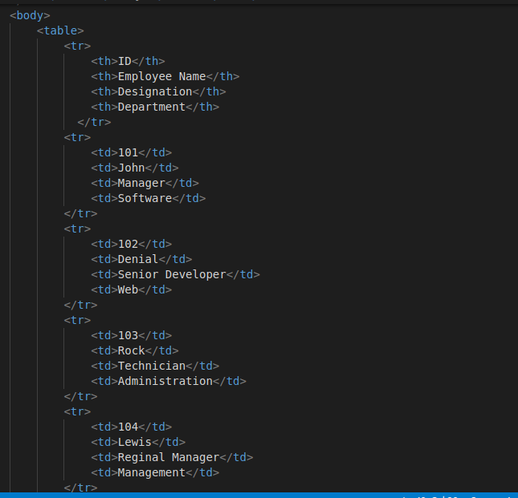
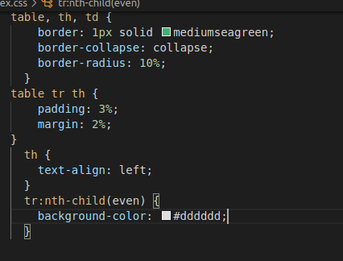
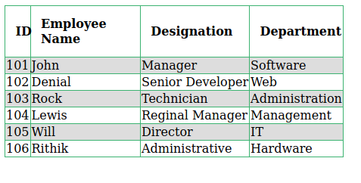

6. Why do we use meta tags?
Meta tags holds meta data, meta data is the deta that describes the data of any html document. Meta tags never be displayed over the html page. But it is use for search engines, Description of web page, Author of web page.
Syntex: <meta name=”<name of tag>” content=”<content of tag>”>
e.g. <meta name=”tothenew” content=”TTN is the company which provide the sarvice for software development.”>

7. Explain box model.
All HTML elements can be considered as boxes. In CSS, the term "box model" is used when talking about design and layout. The CSS box model is essentially a box that wraps around every HTML element. It consists of: margins, borders, padding, and the actual content.
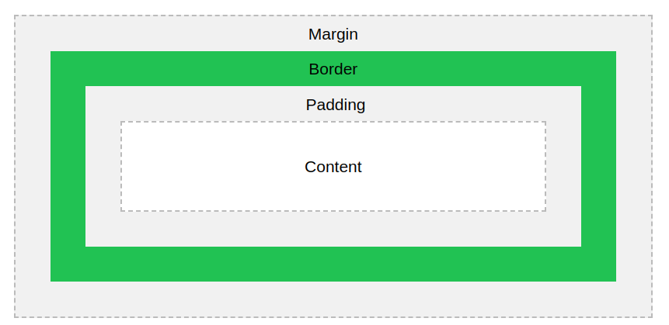

8. What are the different types of CSS Selectors?
In css there are different type of css selectors available these are -
- Universal Selector-Selects all child elements under the parent element. Here style is applied to every element under the parent element. Its weight is more and to be used with care.
- Class selector - Selects specified CSS class applied elements on the page. CSS class selector name starts with “.” followed by name.
- Id Selector - Selects element which has a specified ID name. CSS ID selector name starts with “#” followed by name.
- Element Selector - Select elements based on element type. We directly use it without any notation .
- Descedent Selector - Selects all specified descendant child elements under the parent element.
- Child Selector - Selects all specified immediate child elements under the parent element.
9. Define Doctype.
<!Doctype Html> is used in html page to represent this page is written in Html5.The <!DOCTYPE> declaration must be the very first thing in your HTML document, before the <html> tag.Always add the <!DOCTYPE> declaration to your HTML documents, so that the browser knows what type of document to expect.

10. Explain 5 HTML5 semantic tags.
<article>
<aside>
<details>
<figcaption>
<footer>
<header>
<main>
<mark>
<nav>
<section>
<summary>
<time>
These are the semantic tags which was added in html5.Elements such as <header>, <nav>, <section>, <article>, <aside>, and <footer> act more or less like <div> elements.

Question - 11 & 12 are in the files uploaded

