Billing System Application Design
Problem Statement
On a retail website, the following discounts apply:
- If the user is an employee of the store, he gets a 30% discount
- If the user is an affiliate of the store, he gets a 10% discount
- If the user has been a customer for over 2 years, he gets a 5% discount.
- For every $100 on the bill, there would be a $ 5 discount (e.g. for $ 990, you get $ 45 as a discount).
- The percentage based discounts do not apply on groceries.
- A user can get only one of the percentage based discounts on a bill.
Design Overview
The design requires the following application data stored in an external store like a database or file which can be changed at any point of time
- List Of Users and their type
- List of Items and their type
- Item Level Discount Information - % applicable on the combination of user type and item type
- Bill Level Discount Information - % applicable on the entire bill amount
- List of Bills and their corresponding Bill Items
List of Items and User are external store data. However the idea of making the discount information configurable and keeping it outside the application is to accommodate changing discount requirements.
The design consists of the following main players:
- Billing System: The Main executable class that takes in bill id and input type – xml or seeded and data file path
- System Manager: Interface to get various managers of this billing system. Implemented by supported
- Bill Manager: Manager to perform CRUD operations on bills. This is a layer over BillDAO so that any business level logic etc can be applied here independent of the data layer.
- User Manager: Manager to perform CRUD operations on users. This is a layer over UserDAO so that any business level logic, caching, etc can be applied here independent of the data layer.
- Item Manager: Manager to perform CRUD operations on items. This is a layer over Item DAO so that any business level logic, caching, etc can be applied here independent of the data layer
- Discount Manager: Manager to get Item level and Bill level discount information. Also methods to apply item and bill level discounts
- DAO Layer: Bill, Item, User and Discount level Data Access Layers currently supporting 2 implementations – XML and Seeded. Can add a database layer subsequently.
- Model Level objects: Bill, BillItem, User, Item, ItemDiscount, BillDiscount

Configuration
The idea is eventually all the data will go into database. Currently for implementation, the data is stored in XML files, the sample files are packaged in the application to look at the structure. The application accepts data from any other location as long as it conforms to the expected xml structure.
Moving the data into database will merely require adding another Data Access Layer for all main level players – User, Item, Discount and Bill.
Here’s a sequence diagram describing the flow involved in a billing system
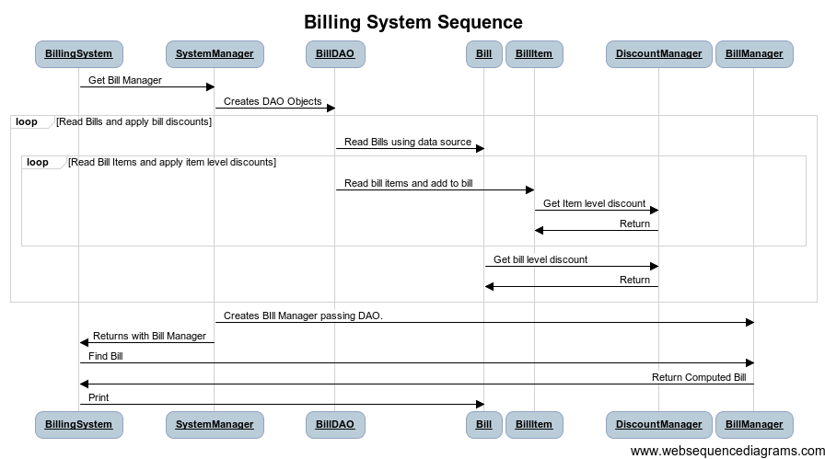

Here’s a brief class diagram for these main players.
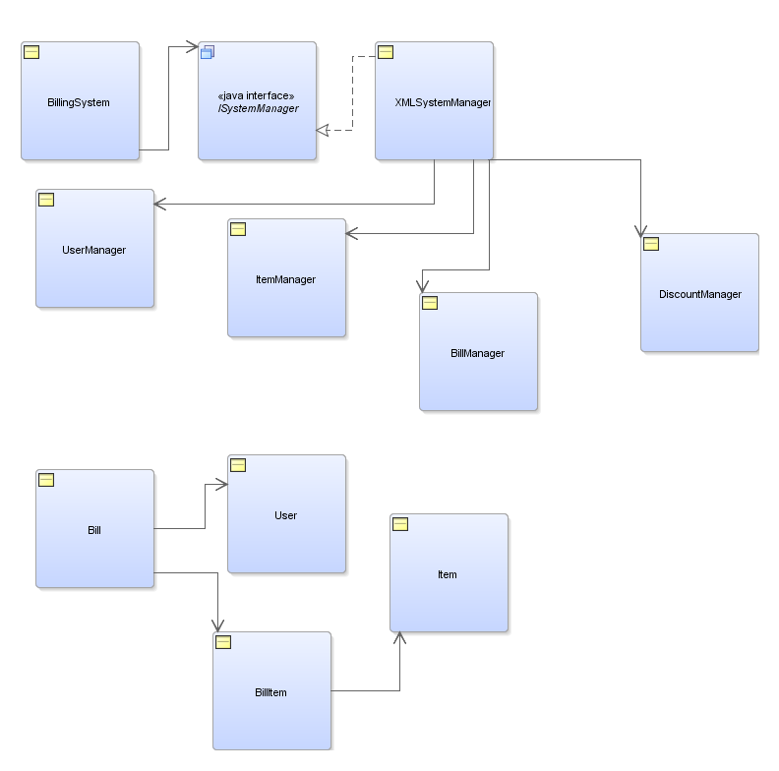

Unit Tests
The code has been supplemented with sufficient unit tests. EMMA coverage report indicates that code coverage is at 85%.
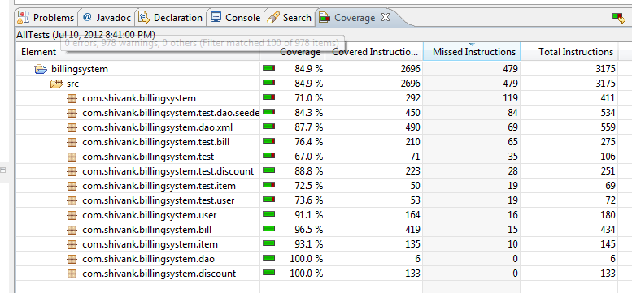

Extensibility

- Since the item level discounts and bill level discounts are maintained outside the code in config data, percentages can be changed at any point of time without having to change the application.
- New User, Item, Bill (and it’s Bill Items), Item Discount and Bill Discount can be added/changed at any point of time without having to change the application.
- Currently supported user types are customer, affiliate and employee. Adding a new user type is changing the user metadata, discount metadata if discounts are applicable for the user types and updating the UserType ENUM.
- Currently supported item types are grocery, apparel, books and others. Adding a new item type is changing the item metadata, discount metadata if discounts are applicable on those item types and updating the ItemType ENUM.

