Assignment 3 - Part B: Structural Aspects (UML Class Diagram)
Automated Root Cause Analysis Platform (ARCA)

1. Reference Use-Case Diagram
The following use-case diagram is used to derive classes and relationships.
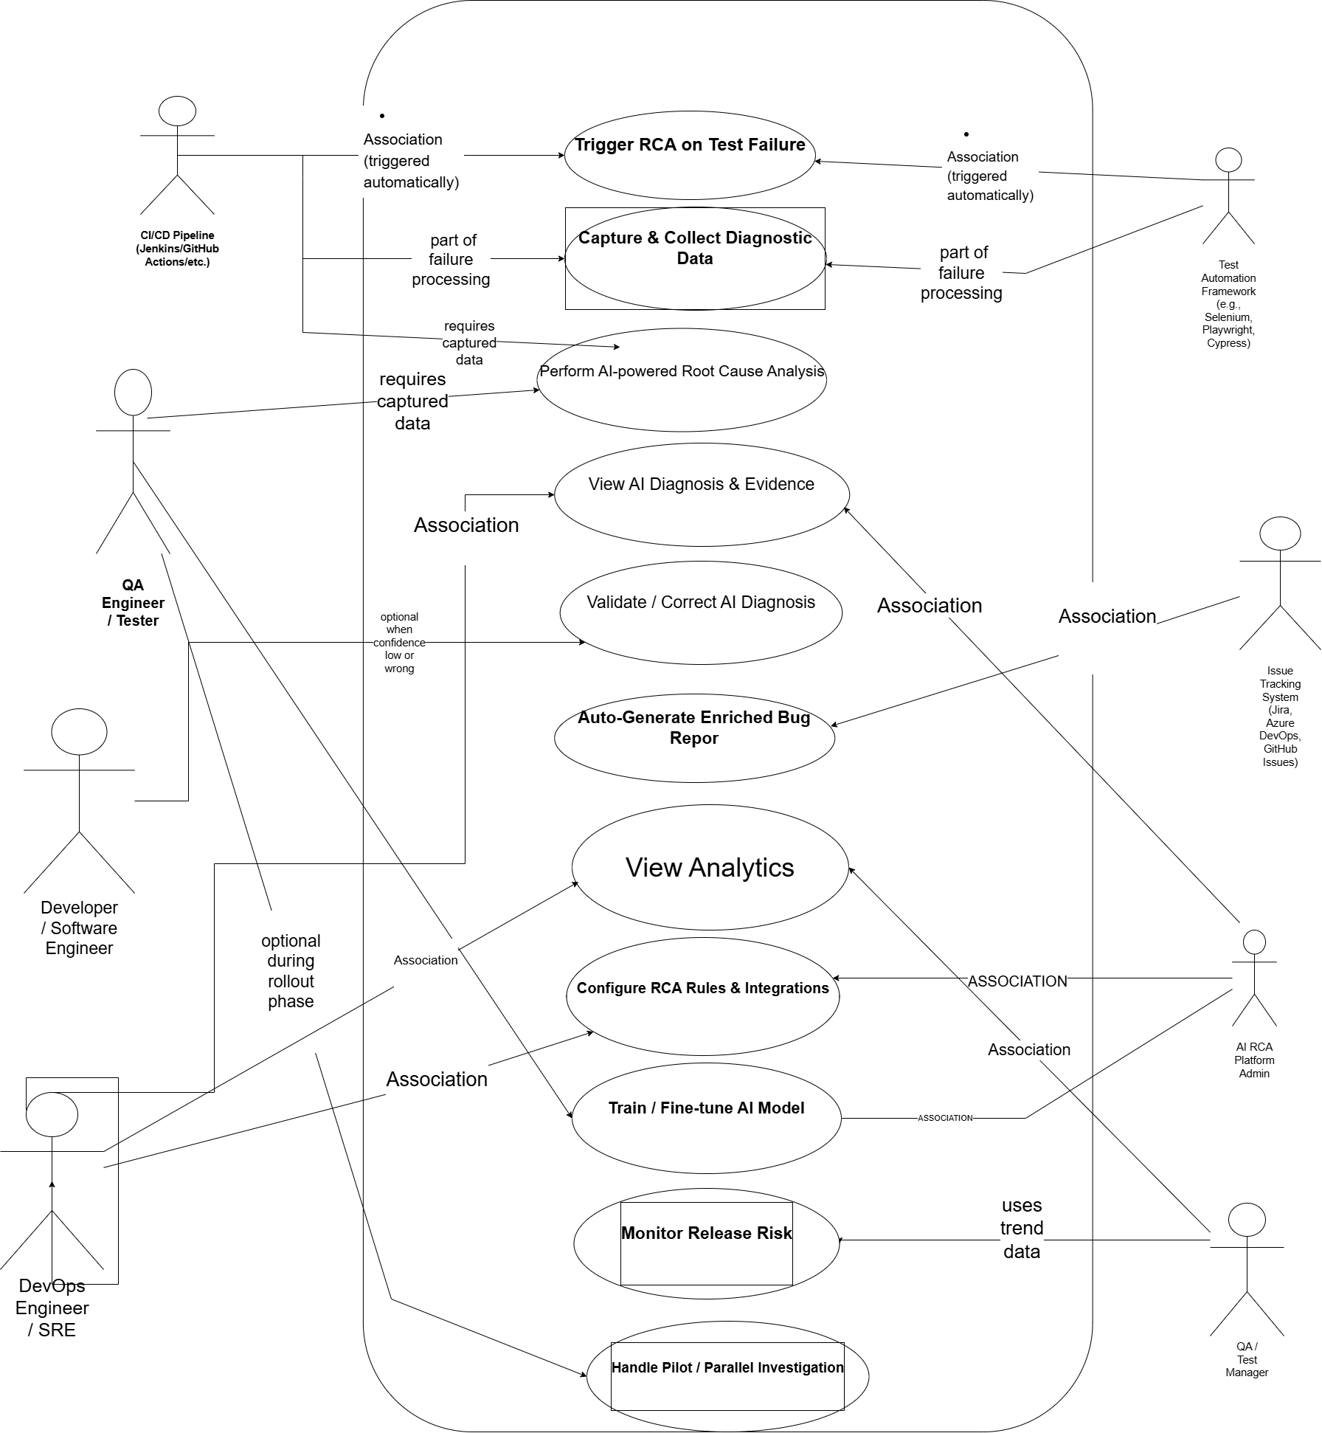

2. Identified Classes with Attributes and Methods
Visibility: + Public, - Private, # Protected

User
Attributes | Methods
- userId:String | + login()
- name:String | + logout()
- email:String | + viewDashboard()
- role:String

Developer
Attributes | Methods
- assignedBugs:List<BugReport> | + reviewDiagnosis()
 | + validateDiagnosis()
 | + submitFeedback()
 | + startParallelInvestigation()

Admin
Attributes | Methods
- configurationRules:RuleSet | + configureRCA()
 | + integrateTools()
 | + trainModel()
 | + monitorReleaseRisk()

FailureEvent
Attributes | Methods
- eventId:String | + triggerRCA()
- timestamp:DateTime | + recordFailure()
- severity:int
- testCaseName:String

LogCollector
Attributes | Methods
- logSource:String | + captureLogs()
- logData:String | + filterLogs()
 | + storeLogs()

AIAnalyzer
Attributes | Methods
- modelVersion:String | + analyzeRootCause()
- confidenceScore:double | + detectAnomaly()
# trainingDataset:Dataset | + generateEvidence()
 | + predictFutureFailure()

DiagnosisReport
Attributes | Methods
- reportId:String | + generateReport()
- rootCause:String | + updateReport()
- evidence:String | + showEvidence()
- confidence:double

BugReport
Attributes | Methods
- bugId:String | + createBug()
- priority:String | + sendToTracker()
- description:String | + updateStatus()
- status:String

AnalyticsEngine
Attributes | Methods
- trendData:Dataset | + generateAnalytics()
- riskScore:double | + monitorReleaseRisk()

ModelTrainer
Attributes | Methods
- trainingData:Dataset | + trainModel()
 | + fineTuneModel()

3. Class Relationships and Cardinality
Inheritance: User is the parent class of Developer and Admin.
Association: FailureEvent -> LogCollector (1..1)
Association: LogCollector -> AIAnalyzer (1..1)
Association: AIAnalyzer -> DiagnosisReport (1..*)
Association: Developer -> DiagnosisReport (1..*)
Composition: DiagnosisReport contains BugReport (1..1 strong ownership).
Aggregation: AnalyticsEngine uses DiagnosisReport (1..* weak ownership).
Dependency: ModelTrainer updates AIAnalyzer model.

4. UML Class Diagram
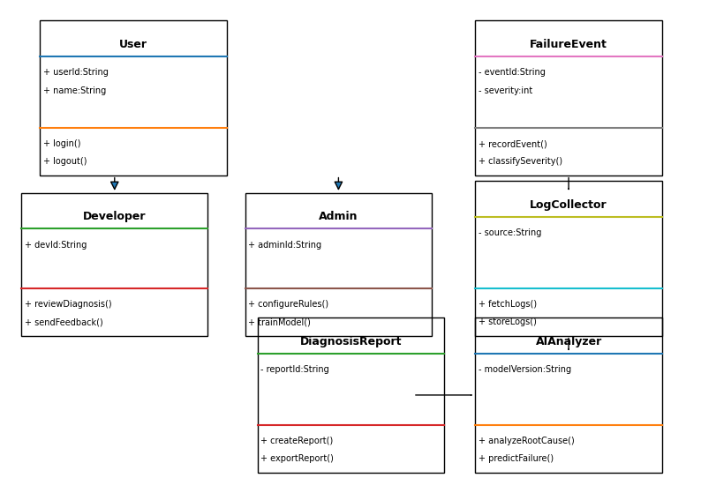

5. Relationship Symbols Reference
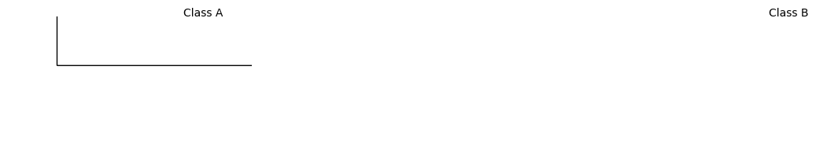
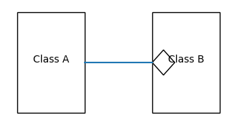
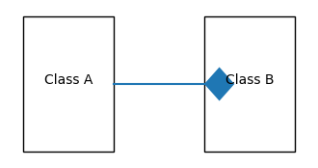

6. Explanation of Composition Choice
Composition is used between DiagnosisReport and BugReport because BugReport cannot exist independently. It is generated from a diagnosis report and becomes invalid if the report is deleted.

