CHAPTER 1: INTRODUCTION

1.1 Background and Importance of Collaborative Drawing
Evolution of Visual Collaboration Collaborative drawing facilitates the simultaneous creation and modification of graphical content by multiple users within a shared workspace. Historically, visual collaboration was constrained to physical proximity, relying on analog tools such as whiteboards, flip charts, and paper. However, the paradigm shift toward distributed teams and remote education has necessitated digital equivalents that transcend geographical boundaries.
Visual communication—encompassing diagrams, workflows, and rough sketches—remains a critical component of complex problem-solving. While text conveys information, visual aids facilitate rapid ideation and structural understanding. As organizations and educational institutions increasingly adopt hybrid models, the ability to "draw together" in real-time has transitioned from a luxury to a functional requirement.
Technological Imperative From a software engineering perspective, collaborative drawing systems serve as a benchmark for Real-Time Web Technologies. They require a departure from traditional request-response HTTP cycles, necessitating the use of persistent connections and event-driven architectures.
- Latency Sensitivity: Unlike standard web forms, drawing applications require millisecond-level synchronization to maintain the illusion of seamless interactivity.
- State Management: The system must manage a shared state (the canvas) across distributed clients, handling concurrency without data loss.
This project leverages these principles using Socket.io for bi-directional communication and the HTML5 Canvas API for rendering. This approach ensures platform independence, allowing users to collaborate directly through a browser without proprietary software installations.
Gap Analysis & Project Motivation Current market solutions for digital whiteboarding often suffer from "feature bloat," requiring mandatory account registration, paid subscriptions, or heavy resource usage. These barriers inhibit spontaneous collaboration.
The proposed system addresses this gap by offering a lightweight, room-based architecture. By strictly utilizing the WebSocket protocol for data transmission and a custom Express server for orchestration, the project delivers a high-performance, accessible tool focused purely on the mechanics of synchronized visual collaboration.

Feature | Physical Whiteboards | Legacy Digital Tools | Proposed Lightweight System
Accessibility | High (Requires physical presence) | Low (Requires installs/accounts) | High (Browser-based URL)
Latency | Zero (Instant) | Variable (Server polling) | Low (WebSocket event-driven)
Persistence | Low (Erased after use) | High (Cloud storage) | Session-based (Room isolation)
Concurrency | Limited by physical space | Limited by lock mechanisms | Multi-user concurrent streams
Table 1.1 Evolution of Collaborative Spaces

1.2 Problem Statement
1.2.1 Operational Friction in Visual Collaboration
While the paradigm of remote work and education has matured, the supporting infrastructure for synchronous visual collaboration remains inefficient. The primary problem is the high "barrier to entry" imposed by existing commercial solutions. Most digital whiteboarding platforms operate as "walled gardens," necessitating mandatory user authentication, proprietary software installations, or paid subscriptions before interaction can begin. This friction creates a bottleneck for spontaneous collaboration, rendering these tools unsuitable for rapid brainstorming or quick classroom demonstrations where immediacy is paramount.
1.2.2 Latency and State Synchronization
From a technical standpoint, many browser-based alternatives suffer from significant latency issues. Maintaining a consistent shared state across distributed clients is computationally expensive.
- High Latency: Traditional HTTP-request-based systems cannot handle the high-frequency updates required for drawing (hundreds of coordinate points per second), resulting in "laggy" strokes and disjointed user experiences.
- System Overhead: Feature-heavy platforms often utilize excessive DOM manipulation or heavy libraries, alienating users with limited system resources or unstable internet connections.
1.2.3 The Accessibility Gap
There is a distinct lack of lightweight, event-driven solutions that prioritize speed over feature density. The gap exists for a system that leverages standard web technologies (HTML5 Canvas) to provide a "zero-setup" environment. The inability to share a URL and immediately begin drawing without logistical hurdles significantly reduces productivity in professional teams and limits interactive capabilities in educational settings.

Problem Domain | Current Industry Standard | Impact on Collaboration
Access Control | Mandatory Login / Paywalls | Prevents spontaneous or anonymous participation.
Data Transport | High-overhead HTTP Polling | Causes visible delay in drawing synchronization.
Resource Usage | Heavy Client-Side Rendering | Excludes low-end devices; drains battery life.
Complexity | Feature-bloated Interfaces | Steep learning curve distracts from the core task.
Table 1.2 Analysis of Current Market Deficiencies

1.3 Objective of the project
1.3.1 Primary Goal
The primary objective of this project is to develop a Realtime Whiteboard System, a browser-based application that enables multiple users to collaborate visually in a shared digital space. The core focus is to eliminate the friction of traditional software by providing an instant, "click-and-draw" experience without requiring user authentication, software installation, or complex configuration.
1.3.2 Technical Objectives
To achieve a high-performance collaboration environment, the system focuses on the following technical milestones:
- Real-Time Synchronization: To implement a bi-directional communication protocol using Socket.io. The system aims to capture vector coordinates (startX, startY) from a user's mouse and broadcast them immediately to all other clients in the room to ensure consistency.
- Latency Minimization: To utilize an event-driven architecture where state changes are pushed to clients instantly, rather than waiting for server polling. This ensures that drawing strokes appear smooth and synchronized across different screens.
- Room-Based Isolation: To design a routing logic that separates users into distinct "rooms" (identified by a roomId). This ensures that multiple teams can use the platform simultaneously without their data overlapping or interfering with one another.
- Responsive Canvas Rendering: To leverage the HTML5 Canvas API for high-performance 2D rendering. The objective is to handle dynamic resizing and coordinate mapping so the whiteboard works accurately on screens of different sizes.
1.3.3 Functional & Operational Objectives
Beyond the code, the project aims to deliver specific user benefits:
- Accessibility: To ensure the application is platform-agnostic, functioning seamlessly on any device with a modern web browser (Chrome, Firefox, Safari) via standard URL access.
- Simplicity: To provide a minimal user interface that maximizes the drawing area and removes "feature bloat," allowing users to focus entirely on visual communication.
- Cost-Effectiveness: To prove that robust collaboration tools can be built using open-source technologies (Next.js, Express) without the need for expensive proprietary software licenses.

Objective | Technical Solution | Implementation Reference
Instant Data Sync | WebSocket Protocol | socket.emit('drawing') & socket.broadcast
Drawing Capability | HTML5 Canvas API | canvas.getContext('2d') & context.stroke()
Session Management | Dynamic Routing | params.roomId & socket.join(roomId)
User Interface | Component-Based UI | React Functional Components & Tailwind CSS
Table 1.3 Objective Implementation Strategy

1.4 Scope of the project
1.4.1 Functional Scope
The scope of this project is strictly defined as the design and implementation of a browser-based, real-time collaborative whiteboard. The system is engineered to serve educational and small-scale professional environments where immediate visual communication is required.
The core functional deliverables include:
- Session Management: Implementation of dynamic room creation, allowing users to generate unique URLs (e.g., /room/123) to create isolated collaboration spaces.
- Collaborative Canvas: A shared drawing surface that captures freehand input events (mousedown, mousemove) and renders them as continuous strokes.
- Real-Time Synchronization: Utilization of persistent WebSocket connections to broadcast drawing coordinates to all connected peers in a room with millisecond-level latency.
- Responsive Interface: A fluid user interface built with Tailwind CSS that adapts the canvas size to the user's viewport.
1.4.2 Technical Scope
The technical boundary of the project is limited to the MERN-adjacent stack (specifically Next.js, Express, and Node.js) and the WebSocket protocol.
- Client-Side: The scope includes handling HTML5 Canvas API contexts, stroke styling (line caps, stroke width), and event listeners for mouse interaction.
- Server-Side: The scope covers a custom Express server configured to handle HTTP upgrades for Socket.io traffic and basic routing logic.
1.4.3 Limitations and Exclusions (Out of Scope)
To ensure lightweight performance and architectural simplicity, the following features are explicitly excluded from the current project scope:
- Data Persistence: The system operates entirely in-memory. Drawing data is not stored in a database (SQL/NoSQL); once a session ends or the browser is refreshed, the canvas state is reset.
- Authentication & Authorization: There is no implementation of user login systems (e.g., OAuth, JWT). Access is controlled solely by possession of the Room ID URL.
- Complex Tooling: Advanced vector tools (shapes, text insertion, image upload) and "undo/redo" history stacks are omitted to prioritize core synchronization stability.
- Native Mobile Apps: The project is scoped as a Responsive Web Application (RWA), not a native iOS or Android application.
Feature Category | Included in Scope | Excluded from Scope
Connectivity | Real-time WebSockets (Socket.io) | Offline Mode / P2P WebRTC Video
User Management | Anonymous Guest Access via URL | Registered Accounts / Profiles
Drawing Tools | Freehand Pen (Black, Round Cap) | Eraser, Shapes, Text Box, Layers
Storage | Ephemeral (Session-based) | Cloud Storage / Database Save
Deployment | Localhost / Single Node | Load Balanced / Enterprise Scale
Table 1.4 Scope Matrix
1.4.4 Target Audience & Deployment Environment
The system is designed for moderate concurrency, targeting small groups (e.g., 2-10 users per room) rather than enterprise-level deployment with thousands of concurrent connections. Testing and validation will be conducted in a controlled environment (Localhost/LAN) to verify synchronization accuracy and connection stability.

CHAPTER 2: LITERATURE REVIEW

2.1 Traditional Collaboration Methods
2.1.1 Analog Visual Communication
Historically, visual collaboration has been anchored in physical proximity, utilizing analog mediums such as whiteboards, blackboards, flip charts, and paper. These tools function as the primary interface for "face-to-face" interaction, offering distinct advantages in terms of accessibility and immediacy.
- Intuitive Interface: Physical markers and surfaces require zero technical training, allowing participants to focus entirely on the content.
- Zero Latency: Analog interaction offers immediate visual feedback, fostering spontaneous idea exchange and natural group dynamics.
2.1.2 Usage Scenarios In educational sectors
Physical whiteboards are instrumental for instructional delivery, allowing educators to deconstruct complex concepts through real-time diagramming and equation solving. Similarly, in professional environments, they serve as the central hub for "Stand-up" meetings, system design brainstorming, and workflow planning. The tangible nature of these tools encourages active group participation and facilitates a shared mental model among co-located participants.
2.1.3 Structural Limitations in Modern Contexts
Despite their efficacy in local settings, traditional methods possess inherent structural limitations that render them obsolete for distributed workflows.
- Geographical Constraint (The "Co-presence" Requirement): Physical tools mandate that all contributors occupy the same physical space. This restriction effectively eliminates collaboration opportunities for remote teams, distance learning programs, and distributed organizations.
- Data Transience (Lack of Persistence): Content generated on physical surfaces is ephemeral. Unless manually photographed or transcribed, the data is lost once the surface is erased. There is no version control, "undo" capability, or digital archiving, making information retrieval impossible.
- Scalability Barriers: Physical workspaces have finite physical dimensions, limiting the number of active participants. They cannot scale to accommodate large groups or broadcast visual data to multiple locations simultaneously.
2.1.4 The Digital Imperative
The inability of traditional methods to support asynchronous access or remote interaction creates a functional gap. As organizations transition to digital-first workflows, the demand shifts toward solutions that preserve the spontaneity of the physical whiteboard while eliminating its geographical and temporal constraints. This necessitates the development of web-based systems like the one proposed in this project—that replicate these interactions virtually.

2.2 Existing Digital Whiteboard Systems
2.2.1 The Commercial SaaS Landscape
The rapid expansion of remote infrastructure has catalyzed the development of numerous digital whiteboard platforms (e.g., Miro, Mural, Google Jamboard). These systems function as comprehensive productivity ecosystems, offering extensive toolsets that include vector shape libraries, file integration, and integrated video conferencing. They are designed primarily for enterprise-scale project management and persistent workflow tracking.
2.2.2 Operational and Technical Limitations
While functionally rich, these commercial platforms introduce significant friction for lightweight or spontaneous use cases. A critical analysis reveals three primary deficiencies:
- Access Barriers (Authentication & Paywalls): The majority of existing solutions enforce mandatory user registration or tiered subscription models. This "Gatekeeping" architecture impedes rapid access, making them unsuitable for quick, ad-hoc collaboration sessions where anonymity or speed is required.
- Resource Intensity (Bloatware): Commercial platforms often rely on heavy client-side frameworks to support their extensive feature sets. This results in high memory consumption and slow initial load times, alienating users on low-end hardware or limited bandwidth connections.
- Synchronization Latency: Many web-based whiteboards utilize HTTP polling or inefficient state management strategies, leading to perceptible input lag. When multiple users interact simultaneously, the delay between a user's stroke and its rendering on remote screens can disrupt the cognitive flow of collaboration.
2.2.4 The Minimalist Alternative
These limitations underscore a significant gap in the market for a Lightweight, Real-Time Collaboration Tool. Unlike heavy commercial alternatives, the proposed system prioritizes immediate access and low latency by stripping away non-essential features (accounts, persistence) and focusing purely on the efficiency of the WebSocket transport layer.

Feature | Commercial Platforms (Miro, etc.) | Proposed Project (Lightweight)
Architecture | Monolithic / Microservices (Complex) | Micro-kernel (Next.js + Express)
Data Transport | Mixed (HTTP Polling + Sockets) | Pure WebSocket Event Stream
Access Model | OAuth / Email Login Required | Instant Room URL (No Auth)
Focus | Persistence & Project Management | Ephemeral Real-time Interaction
Table 2.1 Architecture Comparison

2.3 Real time web-based collaboration technologies
2.3.1 Paradigm Shift: The Event-Driven Model
Modern collaborative applications necessitate a departure from the traditional stateless HTTP request-response cycle, which creates latency through repeated TCP handshakes and header overhead. Real-time interaction requires an Event-Driven Architecture, where state changes are pushed immediately to clients rather than pulled via polling. This shift is critical for maintaining the "illusion" of instantaneity in collaborative drawing systems.
2.3.2 Core Enabling Technologies
This project relies on a triad of technologies to achieve synchronous collaboration:
- WebSocket Protocol (Full-Duplex Communication): At the transport layer, WebSockets facilitate a persistent, low-latency connection between the client and server. Unlike HTTP, which closes after a response, a WebSocket remains open, allowing for bidirectional data transfer. This enables the server to broadcast drawing coordinates to all connected clients immediately upon receipt, without the overhead of establishing new connections.
- HTML5 Canvas API (Client-Side Rasterization): For rendering, the application utilizes the HTML5 Canvas API, which provides a low-level, immediate-mode graphics system. This allows the browser to dynamically render 2D raster graphics via JavaScript. By manipulating the canvas context (canvas.getContext('2d')), the application can render high-frequency stroke updates (hundreds per second) directly to the DOM without external plugins.
- Node.js Runtime (Non-Blocking I/O): The server-side infrastructure is built on Node.js, chosen for its event loop and non-blocking I/O model. This architecture is uniquely coupled with real-time applications, as it can efficiently handle thousands of concurrent socket connections on a single thread, routing messages between users with minimal overhead.

Technology Component | Role in Project | Implementation Detail
Transport Layer | Real-time Data Transfer | socket.io (WebSocket wrapper)
Rendering Engine | Visual Output | <canvas> Element & 2D Context
Server Runtime | Event Orchestration | Express.js on Node.js
Frontend Framework | Component Management | Next.js (React)
Table 2.2 Technology Stack Analysis

CHAPTER 3: System Overview and Design

3.1 Proposed System Description
3.1.1 System Overview
The proposed system is a Room-Based Realtime Whiteboard application designed to facilitate synchronous visual collaboration. Unlike traditional monolithic applications, this system operates as a distributed web application where the "state" of the drawing is transient and synchronized across multiple clients in real-time.
The core functionality revolves around "Sessions" (identified by unique Room IDs). Users entering a specific URL (e.g., /room/101) are logically grouped together, allowing for private, isolated collaboration channels within a public-facing application.
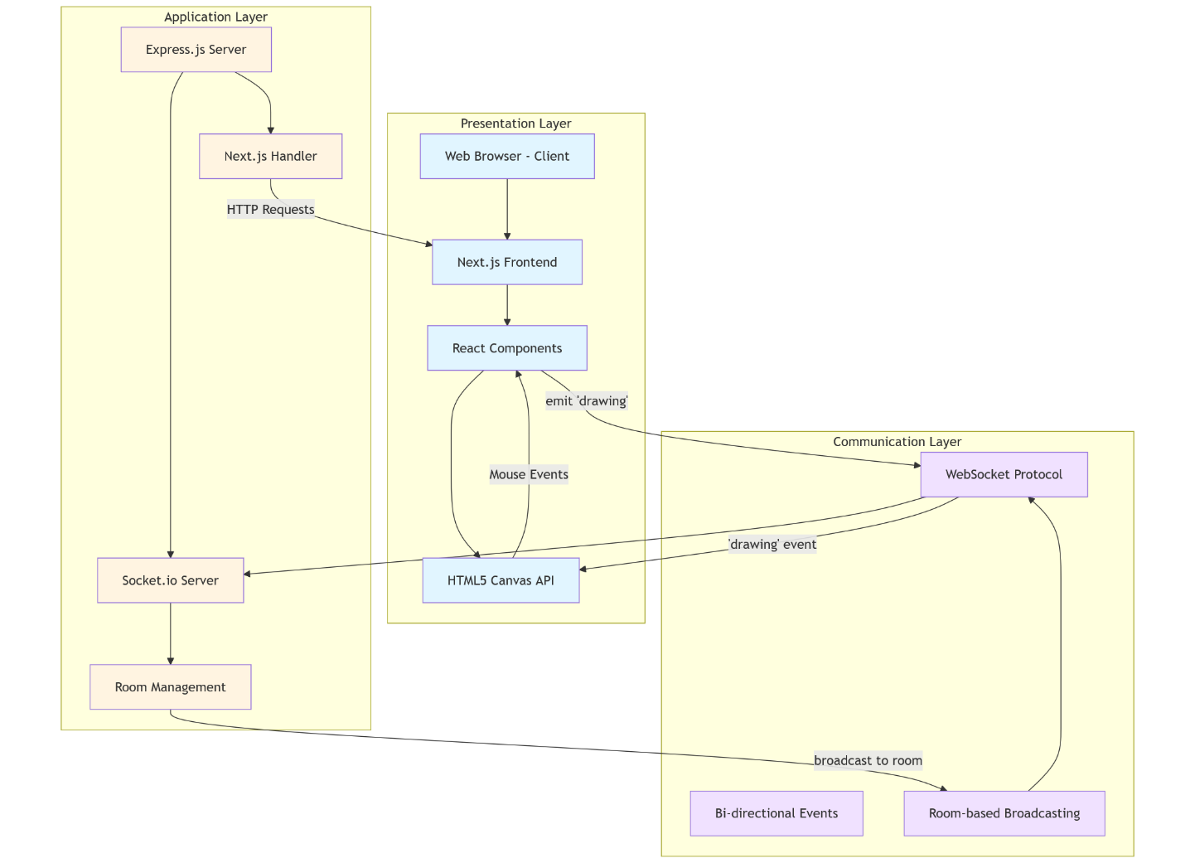
Figure 3.1 Three tier architecture
3.1.2 Architectural Paradigm
The system implements a Decoupled Client-Server Architecture utilizing the WebSocket protocol for full-duplex communication.
- The Client (Frontend): Built with Next.js and React, the client is responsible for two primary tasks:
  - Input Capture: It utilizes the HTML5 <canvas> API to track distinct mouse events (mousedown, mousemove, mouseup).
  - Local Rendering: To ensure zero perceived latency for the drawer, strokes are rendered locally on the canvas immediately while simultaneously being emitted to the network.
- The Server (Backend): The backend is a lightweight Express.js server acting as an Event Relay. It does not interpret or rasterize image data. Instead, it functions as a "broadcaster," receiving coordinate packets from one client and immediately distributing them to all other sockets subscribed to the same roomId.

3.2 High-level Architecture
3.2.1 Architectural Pattern
The system employs a Centralized Client-Server Architecture augmented by an Event-Driven Communication Model. Unlike traditional RESTful applications that rely on stateless request-response cycles, this system maintains stateful, persistent connections to facilitate real-time synchronization.
The architecture is divided into three logical layers:
1. The Presentation Layer (Client-Side) The client interface is built using Next.js (React) and serves as the primary entry point for user interaction.
- Input Capture: The application listens for DOM events (mousedown, mousemove, mouseup) on the HTML5 <canvas> element to capture vector coordinates.
- Optimistic Rendering: To eliminate perceived latency, the client renders strokes locally immediately upon user input, without waiting for server confirmation. This ensures a fluid drawing experience for the active user.
2. The Transport Layer (Communication) Data transmission is handled via Socket.io, which wraps the WebSocket protocol. This layer provides a full-duplex communication channel, allowing the server to push updates to clients asynchronously.
- Protocol Upgrade: The connection initiates as a standard HTTP handshake and upgrades to a persistent WebSocket connection, reducing header overhead for subsequent messages.
3. The Coordination Layer (Server-Side) The backend, built on Node.js and Express, acts as a lightweight message broker.
- Room Isolation: The server logically groups socket connections into "rooms" using socket.join(roomId). This ensures that drawing events are broadcast only to relevant peers, maintaining data privacy between concurrent sessions.
- Event Propagation: The server operates on a "pass-through" basis; it receives JSON payloads containing drawing coordinates and immediately broadcasts them via io.in(roomId).emit().

Layer | Technology Stack | Key Function | Code Reference
Client | Next.js / React | Rendering UI & Canvas Graphics | page.js (Room Component)
Transport | Socket.io Client/Server | Bidirectional Event Stream | socket.emit(), socket.on()
Server | Express.js | Route Handling & Broadcasting | server.js (Custom Server)
Styling | Tailwind CSS | Responsive Layout Management | globals.css
Table 3.1 Architectural Component Definition

Module | Core Function | Input Trigger | Output Action
Input Handler | Capture user gesture | onMouseDown / onMouseMove | Update isDrawing state; Draw locally
Network Client | Sync data | Mouse movement detected | socket.emit('drawing', data)
Network Server | Route data | 'drawing' event received | io.in(roomId).emit('drawing', data)
Remote Render | Draw peer strokes | 'drawing' event received | context.stroke() on local canvas
Table 3.2 Module Functionality Specification

3.3 System Design
3.3.1 Modular Design Philosophy
The system adopts a modular design strategy to ensure maintainability and separation of concerns. The application logic is compartmentalized into three distinct functional modules: the Client Interaction Module, the Communication Bridge, and the Server Coordination Module. This loose coupling allows for independent debugging and scalability of the frontend and backend components.
3.3.2 Client-Side Interaction Module (Frontend)
The frontend module, implemented within the Room component, is responsible for capturing user intent and rendering visual feedback.
- Event Listeners: The system attaches specific event handlers (onMouseDown, onMouseMove, onMouseUp) to the canvas element. These listeners track the coordinate state of the pointer to determine when a stroke begins and ends.
- State Management: React's useState hook manages the boolean state isDrawing, acting as a gatekeeper to prevent unintended drawing when the mouse is simply moving without being pressed.
- Vector Construction: As the user draws, the module constructs a "Stroke Object" containing the vector coordinates (startX, startY, endX, endY) needed to replicate the line segment remotely.
3.3.3 The Communication Bridge
This module serves as the real-time data pipeline, implemented using the socket.io-client library.
- Connection Lifecycle: Upon initialization, the module establishes a persistent WebSocket connection to the server. It listens for lifecycle events such as connect and connect_error to manage network stability.
- Event Emitting: It functions as a transmitter, converting the local "Stroke Objects" into network packets and emitting them via the drawing event channel.
- Event Listening: Simultaneously, it acts as a receiver, listening for incoming drawing events from the server to trigger the remote rendering logic.
3.3.4 Server-Side Coordination Module
The backend module, residing in the custom Express server, acts strictly as an event router.
- Room Management: The module handles the joinRoom event, utilizing the socket.join() method to logically segregate connections into isolated channels. This ensures that data from "Room A" never leaks into "Room B".
- Broadcast Logic: The core function of this module is the broadcast loop. Upon receiving a drawing packet, it identifies the sender's room and immediately relays the packet to all other clients in that specific room using io.in(roomId).emit().

3.4 Data Flow Description
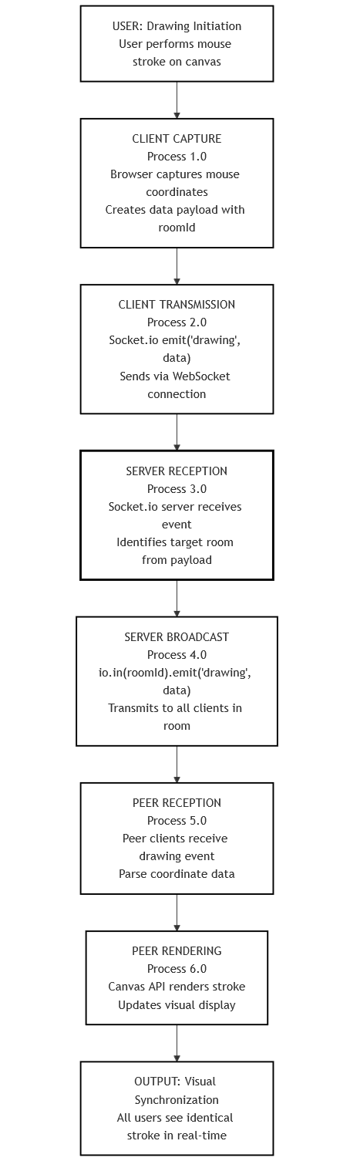
Figure 3.2 Data flow diagram
3.4.1 Event-Driven Topology
The system architecture relies on a unidirectional data broadcast model (per event) to maintain state consistency across distributed clients. The data flow is strictly event-driven, meaning network activity is only triggered by explicit user interaction (drawing strokes) rather than periodic polling. This minimizes bandwidth usage and ensures near-real-time latency.
3.4.2 The Lifecycle of a Drawing Event
The propagation of a drawing stroke follows a precise five-step sequence:
- Input Capture (Originating Client):
  - Action: A user interacts with the canvas. The draw function is triggered by the mousemove event.
  - Local Rendering: The system immediately renders the line segment locally using context.lineTo() to provide instant visual feedback (Optimistic UI).
  - Data Serialization: The client captures the current mouse coordinates (offsetX, offsetY) and creates a JSON payload representing the vector path.
- Transmission (Upstream):
  - Action: The structured payload is transmitted to the server via the persistent WebSocket connection.
  - Method: socket.emit('drawing', payload).
- Server Routing (Relay Node):
  - Action: The Node.js/Express server acts as a stateless message broker. It receives the drawing event and inspects the payload for the roomId.
  - Broadcasting: The server executes io.in(data.roomId).emit('drawing', data), relaying the exact payload to all other clients subscribed to that specific room channel.
- Reception (Downstream):
  - Action: Remote clients listen for the incoming drawing event.
  - Handling: The handleRemoteDrawing function is triggered automatically upon receipt of the data packet.
- Remote Rendering (Destination Client):
  - Action: The receiving client accesses the 2D canvas context and executes the drawing commands (beginPath, moveTo, lineTo, stroke) using the received coordinates (startX, startY, endX, endY).
  - Result: The stroke appears on the remote screen, mirroring the originator's action.

Data Field | Data Type | Description | Source
roomId | String | Identifies the isolation channel for the broadcast. | page.js
startX | Number | The horizontal coordinate where the stroke began. | page.js
startY | Number | The vertical coordinate where the stroke began. | page.js
endX | Number | The horizontal coordinate where the stroke ended. | page.js
endY | Number | The vertical coordinate where the stroke ended. | page.js
Table 3.3 Data Payload Definition

CHAPTER 4: TOOLS AND TECHNOLOGIES

4.1 Programming Language
4.1.1 Unified Language Strategy
The project utilizes JavaScript as the singular programming language across the entire application stack (Full Stack JavaScript). This "Isomorphic" or "Universal" approach ensures seamless interoperability between the client interface and the server runtime, reducing development complexity and preventing context-switching overhead.
4.1.2 Client-Side Implementation
On the frontend, the application leverages modern JavaScript (ES6+) syntax within the Next.js framework.
- Event Handling: JavaScript event listeners (onMouseDown, onMouseMove) are used to intercept DOM events and translate physical user actions into digital vector coordinates.
- Graphics Manipulation: The language directly interfaces with the HTML5 Canvas API context (canvas.getContext('2d')) to programmatically render strokes and manage visual properties like line width and color.
- State Management: React-specific JavaScript hooks (useState, useRef) are employed to manage local component states, such as tracking whether the user is currently drawing (isDrawing).
4.1.3 Server-Side Runtime
On the backend, JavaScript runs within the Node.js environment. Unlike the browser-based implementation, server-side JavaScript focuses on I/O operations and event orchestration.
- Asynchronous Concurrency: The project capitalizes on Node.js's non-blocking, event-driven architecture to handle multiple concurrent WebSocket connections on a single thread. This is critical for the socket.io library to broadcast messages efficiently without system blocking.
- Logic Execution: Custom scripts (server.js) utilize standard JavaScript control structures to manage routing logic and room isolation.
4.1.4 Justification for Selection
JavaScript was selected not merely for convenience, but for its unique suitability for real-time applications:
- Event Loop: Its native event loop model perfectly matches the asynchronous nature of WebSocket communication.
- JSON Native: Data transmission is natively handled in JSON format (socket.emit sends JSON objects), eliminating the need for complex XML parsing or serialization layers.
- Ecosystem: The vast npm ecosystem provided access to essential libraries like socket.io and express.

4.2 Framework and Runtime Environment
4.2.1 Frontend Framework: Next.js & React
The application user interface is constructed using Next.js (v15.5), a robust production framework for React (v18.2). This combination provides a modular, component-based architecture essential for managing the complex state of a collaborative application.
- Component Architecture: The UI is encapsulated within functional components (e.g., Room), promoting code reusability and isolation of concerns.
- State Management Hooks: React’s useState hook tracks dynamic variables like the drawing status (isDrawing), while the useRef hook maintains a persistent reference to the HTML canvas element without triggering unnecessary re-renders.
- Client-Side Rendering: The application utilizes the 'use client' directive to opt into client-side rendering, which is mandatory for accessing browser-specific APIs like window and document required for canvas manipulation.
4.2.2 Backend Framework: Express.js
The server-side logic is orchestrated using Express.js (v4.21), a minimal and flexible Node.js web application framework. In this project, Express serves a specialized role as a custom server handler.
- Custom Server Integration: Unlike standard Next.js deployments, this project implements a custom server.js entry point. Express is used to initialize the HTTP server (http.createServer(app)) that listens for both standard web requests and WebSocket upgrade requests.
- Routing Control: It manages the underlying routing infrastructure, delegating standard page requests to the Next.js handler (nextHandler) while reserving specific channels for real-time traffic.
4.2.3 Real-Time Engine: Socket.io
The core collaborative functionality is powered by Socket.io (v4.8), a library that enables low-latency, bidirectional, and event-based communication.
- Event Handling: The library abstracts the complexities of the WebSocket protocol, allowing the system to define custom event channels such as 'drawing', 'joinRoom', and 'roomJoined'.
- Room Architecture: Socket.io's built-in "Rooms" feature is utilized to isolate users into private sessions (socket.join(roomId)), ensuring that drawing data is broadcast exclusively to relevant peers rather than globally.
- Resilience: The library provides automatic reconnection logic and fallback mechanisms (transports: ['websocket']) to ensure connection stability across different network environments.

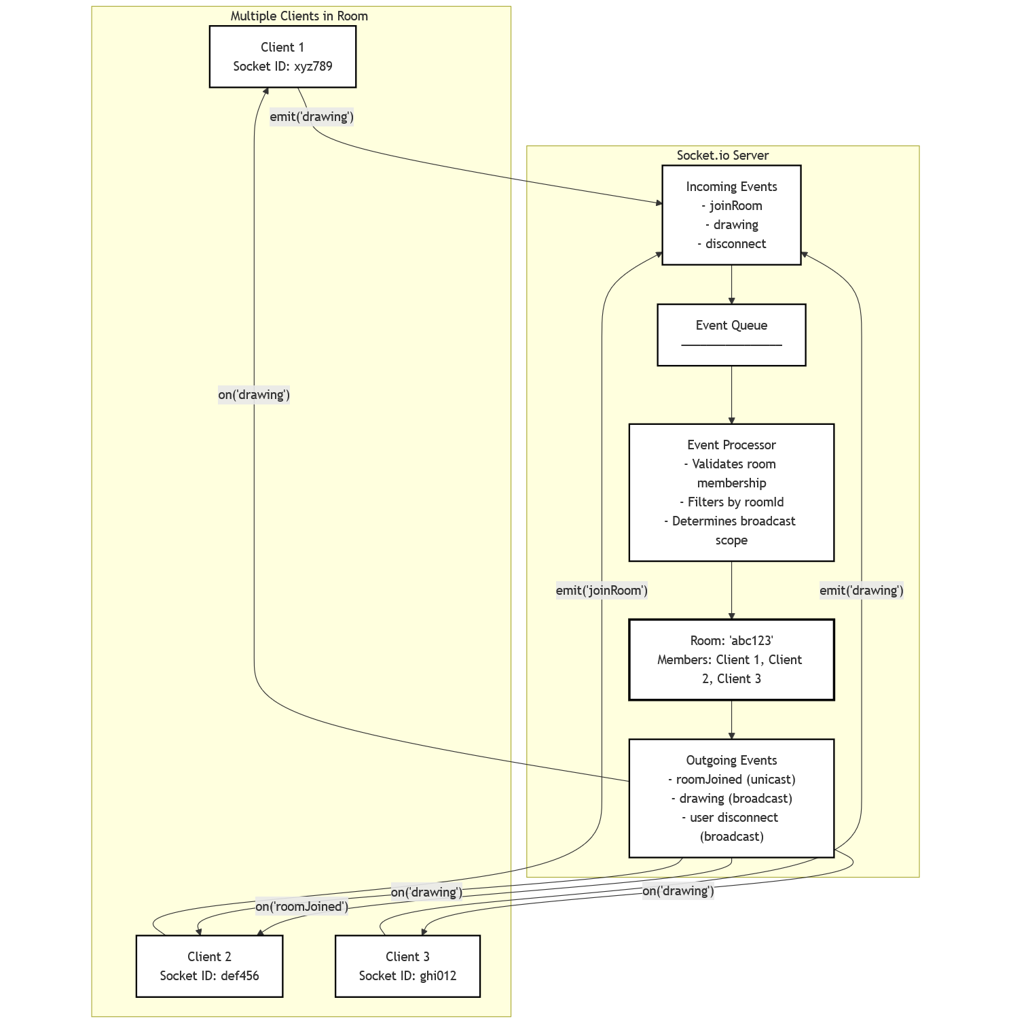
Figure 4.1 SocketIO architecture
4.2.4 Styling Utility: Tailwind CSS
Styling is implemented using Tailwind CSS (v3.4), a utility-first CSS framework that enables rapid UI development directly within the JSX markup.
- Responsive Design: Utility classes (e.g., flex, min-h-screen, w-full) are used to create a responsive layout that centers the canvas and adapts to the viewport dimensions.
- Theme Consistency: Global styles are defined in globals.css, ensuring consistent color schemes (--background, --foreground) and typography across the application.

Library/Framework | Version | Purpose | Component Integration
Next.js | 15.5.6 | Framework Core | layout.js, page.js
React | 18.2.0 | UI Library | useState, useEffect
Express | 4.21.2 | Server Runtime | server.js
Socket.io | 4.8.1 | WebSocket Logic | io(), socket.on()
Tailwind CSS | 3.4.1 | Styling Engine | className="bg-gray-100"
Table 4.1: Dependency Specification

4.3 Deployment Environment
The project is deployed as a web-based application with a simple client–server setup.
The server runs on a Node.js environment, started using the project’s configuration files. It handles real-time connections and message broadcasting and can be deployed on a local machine, college server, or any basic cloud platform that supports Node.js.
The client runs entirely in the web browser. Users only need a modern browser to access the application—no installation or setup is required. This makes the system platform-independent and easy to demonstrate.
The deployment process is straightforward:
- Install dependencies using the package configuration
- Start the server
- Access the application through a browser
This lightweight deployment approach keeps the system easy to host, easy to scale for demos, and suitable for academic evaluation without complex infrastructure.

CHAPTER 5: CORE ALGORITHM AND EXECUTION DESIGN

The system implements a Distributed Event-Driven Execution Model, prioritizing low-latency synchronization over centralized state storage. Unlike strict consistency models (e.g., locking), this system employs an Optimistic UI pattern. The local client executes rendering instructions immediately upon user input, assuming the network transmission will succeed. This ensures zero "perceived latency" for the active user.
The core execution flow is cyclical and consists of three distinct phases:
- Input Capture & Local Rasterization: The browser intercepts hardware interrupts (mouse movement), translating them into 2D vector coordinates.
- Asynchronous Dispatch: State changes are serialized into JSON payloads and pushed to the transport layer via a persistent WebSocket connection.
- Broadcast & Replication: The server acts as a stateless relay, broadcasting the payload to peer clients who execute the mirrored rendering logic locally.

5.1 Architecture Overview
The system architecture follows a Thin-Server, Fat-Client topology optimized for real-time collaboration.
5.1.1 Client-Side Responsibility (The "Fat" Client)
The client, built on Next.js, bears the computational load. It manages the entire application state and rendering logic.
- Input Handling: Listens for mousedown (start), mousemove (continue), and mouseup (stop) events.
- Graphics Engine: Utilizes the HTML5 Canvas API (CanvasRenderingContext2D) to rasterize vector paths. It maintains stroke properties such as lineCap and lineWidth.
- State Management: Tracks the isDrawing boolean flag to differentiate between cursor movement and active drawing gestures.
5.1.2 Server-Side Responsibility (The "Thin" Server)
The server, running on Node.js/Express, functions strictly as a Message Broker.
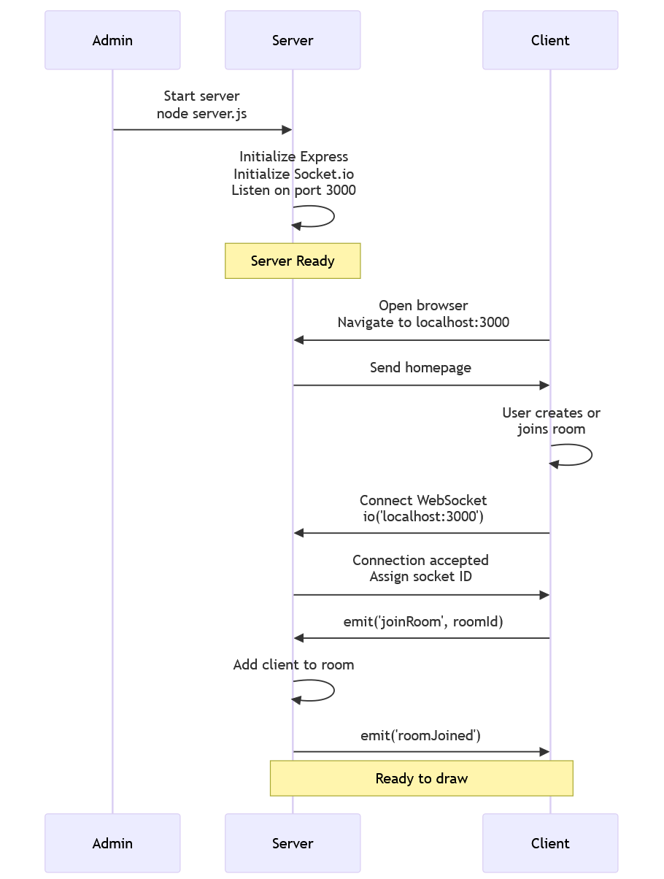
Figure 5.1 System startup sequence diagram

- Connection Multiplexing: Manages concurrent socket connections using socket.io, assigning unique session IDs (socket.id).
- Room Routing: Enforces logical isolation by grouping sockets into rooms via socket.join(roomId). This ensures that events are only broadcast to the relevant subset of connected users.
- Stateless Operation: The server does not store the canvas bitmap or history. It operates in memory, relaying data packets immediately upon receipt.

5.2 Algorithm Design
The synchronization algorithm relies on a Coordinate broadcasting approach. Instead of streaming video or heavy bitmaps, the system transmits lightweight vector coordinates.
5.2.1 The Drawing Algorithm (Client-Side)
The drawing logic is encapsulated in the draw function within page.js.
- Condition Check: The function first validates the isDrawing flag. If false, the execution aborts.
- Coordinate Calculation: It retrieves the cursor's current position (offsetX, offsetY) relative to the canvas DOM element.
- Rasterization:
  - context.lineTo(offsetX, offsetY) creates a path from the last recorded point.
  - context.stroke() renders the line on the screen.
- Emission: The algorithm constructs a data packet and emits it to the network layer:
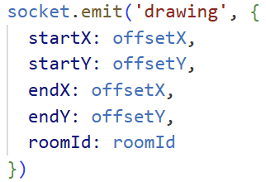
5.2.2 The Relay Algorithm (Server-Side)
The server executes a simple broadcast loop upon receiving data:
- Event Detection: Listens for the 'drawing' event.
- Target Resolution: Extracts the roomId from the payload.
- Broadcast: Forwards the packet to all clients in roomId except the sender.
5.2.3 The Replication Algorithm (Peer-Side)
Upon receiving a broadcast, the peer client triggers handleRemoteDrawing:
- Context Access: Acquires the 2D drawing context.
- Path Reconstruction:
  - beginPath() starts a new stroke sequence.
  - moveTo(startX, startY) positions the "virtual pen."
  - lineTo(endX, endY) traces the vector.
  - stroke() applies ink to the canvas.

Step | Actor | Action Description | Code Function
1 | User | Presses mouse button down. | startDrawing()
2 | Client A | Sets isDrawing = true; begins path. | context.moveTo()
3 | Client A | Moves mouse; renders line locally. | draw()
4 | Client A | Emits vector data to server. | socket.emit('drawing')
5 | Server | Receives data; identifies room. | socket.on('drawing')
6 | Server | Broadcasts data to Room B. | io.in(roomId).emit()
7 | Client B | Receives data; renders vector. | handleRemoteDrawing()
Table 5.1: Algorithm Step-by-Step Execution

5.3 Key Components
Logical Component | Physical Implementation | Responsibility Description
Client Interface | page.js (Room Component) | Manages the isDrawing state and captures mousemove events to trigger rendering.
Rendering Engine | page.js (Canvas API) | A useRef hook accessing the DOM <canvas> element to execute 2D rasterization (strokes).
Relay Server | server.js (Express/Node) | A custom Express handler that initializes the HTTP server and upgrades it for WebSocket traffic.
Transport Layer | socket.io-client | Maintains the persistent connection, configured strictly for 'websocket' transport to ensure low latency.
Table 5.1 Key components

5.4 Execution Configuration
The execution environment is configured to prioritize immediate consistency (Live-Streaming) over data retention.
5.4.1 Initialization Sequence Upon execution of the startup command (npm run dev or node server.js), the Node.js runtime initializes the Express application.
- Port Allocation: The server binds to process.env.PORT or defaults to Port 3000 if no environment variable is set.
- Socket Binding: The Socket.io instance attaches to the HTTP server, enabling it to intercept upgrade requests on the same port.
- Client Boot: On the frontend, the useEffect hook initializes the socket client immediately upon component mount, attempting to connect to http://localhost:3000.
5.4.2 Operational Parameters
The system operates under a "Stateless Real-Time" configuration:
- Zero-Buffer Transmission: Drawing events are emitted immediately (socket.emit) without client-side batching. This "fire-and-forget" model minimizes input lag.
- Concurrency Handling: The Node.js event loop handles concurrency natively. There are no explicit thread pools or blocking locks configured, allowing the server to handle multiple overlapping drawing streams asynchronously.
- Session Continuity: Execution is continuous for the lifespan of the WebSocket connection. There are no timeouts or "session expiry" logic; the session remains active as long as the browser tab is open.

5.5 Complexity and Performance Trade-off
5.5.1 Simplicity over Complexity
The system is built to be fast and simple rather than feature-heavy.
- How it works in the code: The server script (server.js) does not calculate shapes, process images, or save files. It simply receives a message from User A and immediately forwards it to User B.
- The Result: This keeps the server "lightweight." It doesn't get bogged down doing heavy math, so it can handle messages very quickly.
5.5.2 Performance Benefits
Because the server does so little work, the system gains specific advantages:
- Speed (Low Latency): Since the server doesn't "think" about the data—it just passes it along—the time between you drawing and your friend seeing it is minimal.
- Distributed Work: The heavy lifting (actually drawing the pixels on the screen) happens on the user's computer (the Client), not the server. This prevents the server from crashing if many people draw at once.
5.5.3 The Trade-offs (What we sacrificed)
To get this speed, we accepted two main limitations:
- No "Save" Button: Since the server doesn't store data in a database, all drawings are lost the moment you refresh the page or close the tab. This is a direct trade-off for not having a complex database.
- No Perfect Ordering: If two users draw over the exact same spot at the exact same millisecond, the system just displays whichever message arrives first. We don't have a complex "referee" system to decide who drew first, because that would slow everything down.

CHAPTER 6: IMPLEMENTATION DETAILS

6.1 Client-side implementation
The client-side logic is implemented using Next.js and React, focusing on state management and direct DOM manipulation for graphics rendering.
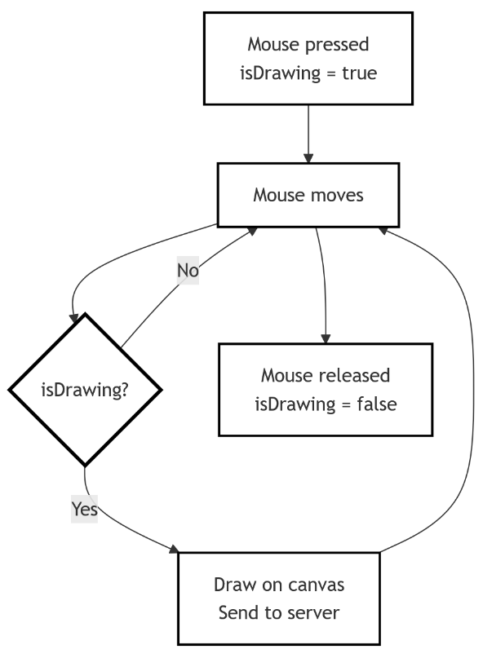
Figure 6.1 Client-side logic
6.1.1 Canvas Initialization and Configuration
The drawing surface is initialized using the useRef hook (canvasRef) to gain direct access to the HTML5 <canvas> DOM element.
- Context Setup: Upon the component mounting (useEffect), the system retrieves the 2D rendering context (canvas.getContext('2d')) and configures global stroke properties, setting the lineCap to 'round' and strokeStyle to 'black'.
- Responsive Scaling: An event listener is attached to the window's resize event. This function dynamically recalculates the canvas width and height (canvas.offsetWidth, canvas.offsetHeight) to match the parent container, ensuring the drawing coordinate system remains accurate across different screen sizes.
6.1.2 Drawing State Logic
User interaction is managed through React state and native mouse event handlers:
- State Tracking: A boolean state variable, isDrawing, determines the active drawing mode. It is toggled to true on mousedown and false on mouseup or mouseout.
- Vector Rendering: The draw function executes the rendering logic. It takes the mouse's current coordinates (offsetX, offsetY), executes context.lineTo(), and immediately commits the stroke to the screen with context.stroke().

6.2 Server-side implementation
The backend implementation uses a custom Express.js server to handle the specific requirements of the WebSocket protocol, rather than the default Next.js server.
6.2.1 Server Initialization
The server entry point (server.js) initializes an HTTP server using http.createServer(app).
- Protocol Upgrade: The Socket.io server instance is attached to this HTTP server. It is configured with cors (Cross-Origin Resource Sharing) policies to allow connections from the client origin (http://localhost:3000).
6.2.2 Event Broadcasting Logic
The server logic is intentionally stateless, functioning as a high-throughput message relay.
- Room Joining: When a client emits joinRoom, the server executes socket.join(roomId). This logically isolates the socket, ensuring subsequent messages are scoped only to that specific room.
- Broadcasting: Upon receiving a drawing event, the server identifies the sender's room and broadcasts the data using io.in(data.roomId).emit('drawing', data). Crucially, this method relays the data to all other clients in the room without storing it.
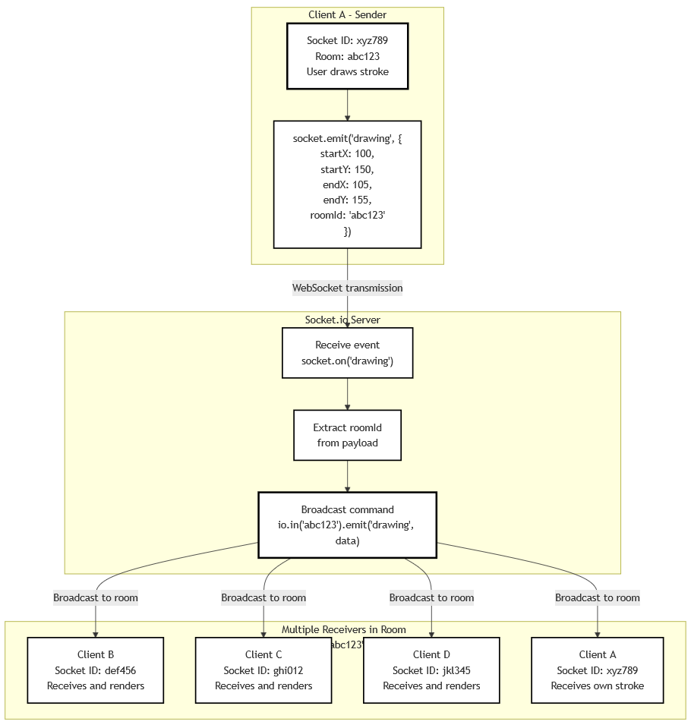
Figure 6.2 SocketIO broadcast architecture
6.3 Real-time Communication Handling
The system relies on a persistent, bidirectional communication model to achieve sub-second latency.
6.3.1 The Event Lifecycle
Real-time synchronization follows a strict four-step propagation cycle:
- Emission (Client A): As the user draws, the client constructs a JSON payload containing the vector coordinates (startX, startY, endX, endY) and emits it via socket.emit('drawing').
- Relay (Server): The server receives the payload and immediately forwards it to the target room using the broadcast channel.
- Reception (Client B): The peer client listens for the drawing event. A dedicated handler, handleRemoteDrawing, is triggered upon receipt.
- Replication (Client B): The handler unpacks the coordinate data and programmatically draws the stroke on the local canvas, effectively mirroring the original action.
6.3.2 Connection Stability
To ensure robustness, the client explicitly handles connection lifecycle events. It logs connection success (connect) and errors (connect_error) to the console for debugging purposes. Additionally, cleanup functions in the useEffect hook ensure listeners are removed (socket.off) when the component unmounts to prevent memory leaks.

6.4 Error Handling and Control Mechanism
6.4.1 Client-Side Safeguards
The client interface prevents common drawing errors through event management:
- Boundary Control: The stopDrawing function is triggered by the onMouseOut event. This immediately halts the drawing state if the cursor leaves the canvas, preventing "stuck" strokes when re-entering.
- Leak Prevention: The useEffect hook utilizes a cleanup function to close the socket connection and remove event listeners when the component unmounts, preventing memory leaks.
- Connection Logging: Network failures are caught by the connect_error listener, which logs diagnostics to the console for easier debugging.
6.4.2 Server-Side Stability
The server implementation focuses on resilience through statelessness:
- Graceful Disconnects: The server listens for disconnect events to cleanly terminate socket sessions without leaving "zombie" connections open.
- Stateless Fault Tolerance: Since the server does not store drawing history in a database, a restart or crash does not corrupt any data. Clients simply reconnect and continue drawing on their local canvas.

CHAPTER 7: EVALUATION AND ANALYSIS

The evaluation of the collaborative drawing system is based on practical, usage-oriented metrics rather than numerical accuracy measures, since the project focuses on real-time interaction and user experience.

7.1 Evaluation Metrics
7.1.1 Latency and Perceived Delay Latency is measured in two dimensions:
- Perceived Latency (Local): Due to the "Optimistic UI" pattern (client-side rendering), the active user experiences zero latency. The stroke appears instantly upon input.
- Synchronization Latency (Remote): This is the time delta between the sender's emission and the receiver's rendering. In standard LAN environments, this is negligible (<50ms), facilitated by the persistent WebSocket connection.
7.1.2 Concurrency Limits
Concurrency is evaluated by the server's ability to multiplex socket connections. The Node.js runtime efficiently handles multiple simultaneous connections. However, performance is bound by the Broadcast Complexity (), where is the number of users in a room. As increases, the number of events processed per second rises linearly.
7.1.3 Sampling Rate Artifacts
An observed limitation is the "broken stroke" phenomenon during rapid cursor movement. This is a technical constraint of the browser's mousemove event polling rate (typically 60Hz). If a user moves the mouse faster than the sampling rate, the distance between coordinates increases, resulting in linear gaps rather than smooth curves. This confirms the system faithfully replicates raw input events without complex interpolation algorithms.
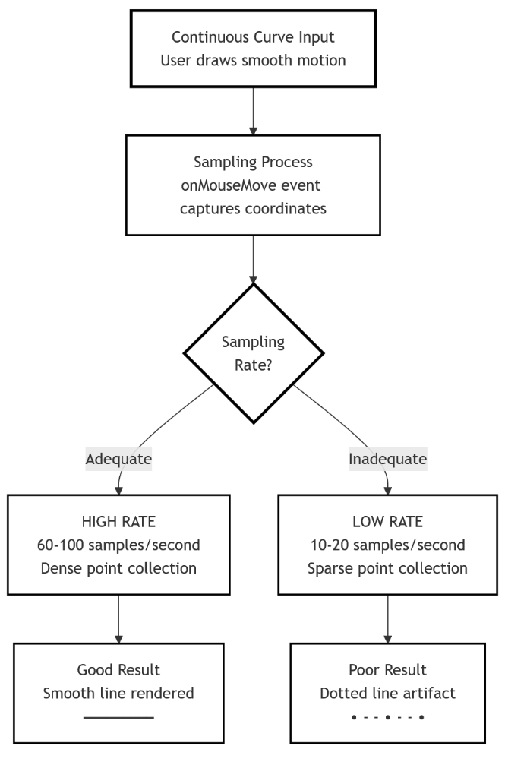
Figure 7.1 Signal sampling rate artifacts

7.2 Performance Analysis
7.2.1 Client-Side Responsiveness
Client performance is decoupled from network conditions. Because rendering logic (context.lineTo) executes on the main thread immediately, the application remains responsive even if the server lags. Heavy drawing load primarily impacts the client's CPU usage for rasterization.
7.2.2 Network Efficiency
Network bandwidth consumption is minimized through Payload Optimization. Each event consists solely of four integer coordinates and a short string ID. This lightweight JSON structure ensures that even poor internet connections can sustain the synchronization stream without packet loss.
7.2.3 Server Resource Utilization
The server maintains a Constant Memory Footprint relative to the drawing complexity. Since it stores no history and performs no image processing, RAM usage scales only with the number of active socket objects (connections), not with the amount of data drawn. This validates the "Stateless Relay" architecture as a scalable solution for real-time collaboration.

7.3 Error Analysis and Operational Challenges
7.3.1 Sampling Rate Artifacts (The "Dotted Line" Effect) A primary visual artifact occurs during high-velocity cursor movements, where strokes appear segmented or "dotted" rather than continuous.
- Cause: This is a limitation of the browser's mousemove event sampling rate (typically 60Hz). If the user moves the mouse faster than the browser can fire events, the distance between captured coordinates increases.
- System Behavior: Since the rendering engine in page.js uses simple linear interpolation (lineTo), it connects these sparse points with straight lines, creating visible gaps or sharp angles.
7.3.2 Network Reliability & Packet Loss
The system operates on a "Fire-and-Forget" messaging model.
- Issue: In unstable network environments, WebSocket frames may be dropped or delayed.
- Consequence: Because the system does not implement an "Acknowledgement (ACK)" or "Retry" queue, a lost packet results in a missing stroke segment for remote users. The local user remains unaffected due to client-side rendering.
7.3.3 Volatility of State
The absence of a persistent storage layer results in total state loss upon interruption.
- Scenario: If a user refreshes the browser page (F5) or suffers a temporary internet disconnect.
- Result: The WebSocket connection is severed and re-established as a new session. Since the server does not store the drawing history, the canvas resets to blank, and previous data cannot be recovered.

7.4 Strengths and Limitations
7.4.1 System Strengths
- Zero-Latency Feel (Optimistic UI): The system renders strokes on the local client immediately (context.lineTo), ensuring the user feels no delay even if the network is slow.
- Architectural Simplicity: By enforcing a stateless server design, the codebase avoids complex database management, locking mechanisms, or conflict resolution algorithms, making it highly maintainable.
- Platform Independence: The application utilizes standard Web APIs (HTML5 Canvas, WebSockets), allowing it to function natively on any modern device (Tablets, Laptops, Desktops) without installation.
- Resource Efficiency: The "Event Relay" model ensures the server CPU and memory usage remain low, as it processes small JSON payloads rather than heavy image data.
7.4.2 System Limitations
- Ephemeral Data (No Persistence): The most significant functional limitation is the lack of a "Save" or "History" feature. All collaboration is transient and exists only in the RAM of the active browser tab.
- Lack of Smoothing Algorithms: The drawing engine lacks advanced curve smoothing (e.g., Bezier curves). This keeps the code simple but results in jagged lines when drawing curves rapidly.
- Scalability Constraints: The current single-node architecture (one Express server) broadcasts to all users in a room. Performance may degrade if hundreds of users attempt to draw in a single room simultaneously.

CHAPTER 8: APPLICATIONS AND IMPACT

8.1 Application Domains
The system’s architecture—prioritizing lightweight transmission and platform independence—makes it applicable across several distinct sectors where visual latency is a critical factor.
- Education and Virtual Classrooms: The system serves as a synchronous visual aid for remote instruction. Instructors can use the shared canvas to solve mathematical problems or diagram scientific concepts in real-time, bridging the engagement gap found in static video lectures. Its browser-based nature ensures access for students on varied devices (Chromebooks, Tablets) without software installation.
- Software Engineering & System Design: Development teams can utilize the platform for "napkin sketching" system architectures, entity-relationship diagrams (ERDs), and UI wireframes. The immediate synchronization allows distributed engineers to point out flaws or suggest improvements on a shared schematic instantly.
- Corporate Agility: For agile teams, the application supports "Stand-up" meetings and retrospective brainstorming. The lack of mandatory login/authentication eliminates the "setup tax" (time wasted logging in), allowing teams to jump straight into collaboration during time-boxed meetings.
- Creative Ideation: Graphic designers and illustrators can use the tool for rough concept sketching. While it lacks advanced layer management, its speed makes it ideal for rapid, ephemeral idea generation before moving to heavier tools like Photoshop.

8.2 Deployment Scenarios
The system's minimal dependency tree (Node.js + Express) allows for flexible deployment strategies suited to different organizational needs.
- Local Area Network (LAN) Deployment: In academic labs or secure corporate intranets, the system can be hosted on a local server instance. By binding the Express server to the local IP address, organizations can keep data traffic entirely within their firewall, ensuring privacy without external internet access.
- Cloud-Based Ephemeral Hosting: For remote teams, the application is optimized for containerized deployment (e.g., Docker, Vercel, or Heroku). The stateless architecture means instances can be spun up or down automatically based on demand without risking data loss, as no persistent database is attached.
- Ad-Hoc Workshop Environments: The "Room ID" logic makes the system perfect for temporary workshops. A facilitator can generate a unique URL (e.g., /room/workshop-group-1), share it, and then discard the session immediately after the event. There is no administrative burden to delete users or clean up storage.

8.3 Societal and Business Impact
8.3.1 Societal Impact: Digital Inclusion
The project democratizes access to digital collaboration tools. By removing the barriers of cost (it is free/open-source) and hardware requirements (it runs on low-end browsers), it enables users in resource-constrained environments to participate in digital workflows. This is particularly impactful for distance learning in developing regions where high-bandwidth video streaming is not feasible, but lightweight vector data transmission is sustainable.
8.3.2 Business Impact: Operational Efficiency
From a business standpoint, the system offers a Low-Overhead Alternative to enterprise SaaS platforms.
- Cost Reduction: It eliminates per-seat licensing fees associated with commercial whiteboarding tools.
- Friction Reduction: It reduces the "Time-to-Collaboration." Teams can start a visual session in seconds rather than minutes, cumulatively saving significant man-hours across an organization.

CHAPTER 9: CONCLUSION AND FUTURE SCOPE

9.1 Conclusion
This project successfully demonstrates the design and implementation of a Real-Time Collaborative Whiteboard using the MERN-adjacent stack (Next.js, Express, Socket.io). The primary objective—to create a lightweight, low-latency environment for visual collaboration—was achieved through a strict Event-Driven Architecture.
By decoupling the client-side rendering engine from the server-side broadcast logic, the system ensures distinct separation of concerns. The Client handles the computational load of rasterizing vector paths, while the Server functions as a high-throughput stateless relay. This approach validated that modern web protocols (WebSockets) can replicate the responsiveness of native desktop applications without the overhead of heavy software installation.
While the system prioritizes speed and simplicity over feature density, it effectively addresses the core need for spontaneous, platform-agnostic collaboration. It stands as a robust proof-of-concept for how Isomorphic JavaScript can be utilized to build scalable, real-time communication tools.

9.2 Future Enhancements
To evolve the system from a prototype into a sustainable product, several functional upgrades are proposed to address user retention and experience management.
9.2.1 Active Participant Management (User Presence)
Currently, users are anonymous and invisible until they draw. Future updates will introduce a "Live Session Roster" sidebar.
- Visual Identity: Upon joining, users will be auto-assigned a "Random Avatar Card" or unique color code. This allows participants to visually distinguish who is drawing which stroke on the canvas.
- Member Tracking: The UI will display a real-time list of connected socket.id aliases, giving users awareness of exactly who is currently in the room.
9.2.2 Concurrency Thresholds (Room Limits)
To prevent the "mess" of overcrowding and maintain rendering performance, the system will implement Room Capacity Enforcement.
- Logic: The server will check the socket count for a specific roomId before allowing a new connection.
- Constraint: A hard limit (e.g., maximum 10 users per room) will be set. If a room is full, new users will be redirected to a queue or prompted to create a new room. This ensures the canvas remains readable and the experience remains clutter-free.
9.2.3 User Retention Strategy: Hybrid Authentication
While the current "No Login" approach maximizes initial accessibility, it limits user tracking and engagement (retention). To address this, a Hybrid Authentication Model will be integrated:
- Guest Access: "Click-and-Draw" anonymous access will remain for quick, one-off sessions to ensure low friction.
- OAuth Integration (Google Login): An optional login layer using Google OAuth 2.0 will be added. This serves two critical purposes:
  - Identity Persistence: Logged-in users can be "called out" or identified by name rather than anonymous IDs.
  - Engagement Loops: By capturing user emails, the system can implement retention strategies, such as sending notifications about feature updates or providing a dashboard of past drawing sessions. This solves the challenge of re-engaging users who would otherwise leave the platform permanently.

CHAPTER 10: REFERENCES

Technical Documentation and Standards
[1] Socket.IO, "Broadcasting Events," Socket.IO Documentation, v4.x, 2024. [Online]. Available: https://socket.io/docs/v4/broadcasting-events/. [Accessed: Dec. 28, 2025].
[2] Mozilla Developer Network, "Canvas API," MDN Web Docs, 2025. [Online]. Available: https://developer.mozilla.org/en-US/docs/Web/API/Canvas_API. [Accessed: Dec. 28, 2025].
[3] Vercel, "Data Fetching and Client-Side Rendering (CSR)," Next.js Documentation, 2025. [Online]. Available: https://nextjs.org/docs. [Accessed: Dec. 28, 2025].
[4] OpenJS Foundation, "Events and Asynchronous I/O Concepts," Node.js Documentation, 2025. [Online]. Available: https://nodejs.org/en/docs/. [Accessed: Dec. 28, 2025].
Engineering Case Studies
[5] E. Rastogi, "How Figma’s Multiplayer Technology Works," Figma Engineering Blog, Oct. 17, 2017. [Online]. Available: https://www.figma.com/blog/how-figmas-multiplayer-technology-works/. [Accessed: Dec. 28, 2025].
[6] C. Chedeau, "Excalidraw: Architecture of a Virtual Whiteboard," Vjeux Blog, Jan. 1, 2020. [Online]. Available: https://blog.vjeux.com/. [Accessed: Dec. 28, 2025].
[7] Socket.IO Team, "Reliability and Packet Buffering," Socket.IO Blog, 2021. [Online]. Available: https://socket.io/blog/. [Accessed: Dec. 28, 2025].
Books and Publications
[8] I. Grigorik, High Performance Browser Networking, 1st ed. Sebastopol, CA: O'Reilly Media, 2013, ch. 17.
[9] M. Casciaro and L. Mammino, Node.js Design Patterns, 3rd ed. Birmingham, UK: Packt Publishing, 2020.
[10] A. Banks and E. Porcello, Learning React: Modern Patterns for Developing React Apps, 2nd ed. Sebastopol, CA: O'Reilly Media, 2020.

