LIVE PROJECT: IV & INDUSTRIAL VISIT
Group Doodle: An event-driven, real-time canvas for multi-user collaboration
Submitted in partial fulfilment of the requirement for the award of the degree of
BACHELOR of Technology
Computer Science and Engineering
Supervisor: Submitted By/roll No:
Ms. Neetu Mayank Arya 11022210015
SRM University Shivankur Sharma 11022210033
Divyansh Lather 11022210045

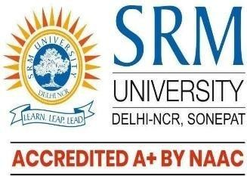
SRM UNIVERSITY, DELHI-NCR, SONEPAT, HARYANA
Plot No. 39, Rajiv Gandhi Education City, Sonepat, Haryana 131029
Aug 2025 - Dec 2025

