# VISVESVARAYA TECHNOLOGICAL UNIVERSITY



"JNANA SANGAMA", MACHHE, BELAGAVI-590018

##### Phase-1 Project Report

**On**

**AI Forecasting for Investor Decisions**

Submitted in partial fulfillment of the requirements for the VII semester

#### Bachelor of Engineering

in

#### Information Science and Engineering

of

#### Visvesvaraya Technological University, Belagavi

*Submitted by*

**SHIVANNA 1CD21IS145**

**RAVITEJA GK 1CD21IS133**

**UTKARSH KUMAR 1CD21IS171**

**SHAIK AFRAZ 1CD21IS139**

##### Under the Guidance of

**Dr. Preethi S**

**Professor and Head**

Dept. of ISE

**Department of Information Science and Engineering**

**CAMBRIDGE INSTITUTE OF TECHNOLOGY,**

**BANGALORE**-**560036**

**2024-2025**

# CAMBRIDGE INSTITUTE OF TECHNOLOGY

K.R. Puram, Bangalore-560 036

**DEPARTMENT OF INFORMATION SCIENCE & ENGINEERING**

**CERTIFICATE**

##### Certified that Mr. Shivanna, Mr. Raviteja GK, Mr. Utkarsh Kumar, Mr. Shaik Afraz, bearing USN 1CD21IS145 , 1CD21IS133 , 1CD21IS171 , 1CD21IS139, bonafide students of Cambridge Institute of Technology, has successfully completed the project work entitled info “AI Forecasting for Investor Decisions” in partial fulfillment of the requirements for VIII semester Bachelor of Engineering in Information Science and Engineering of Visvesvaraya Technological University, Belagavi during academic year 2024-2025. It is certified that all corrections/suggestions indicated for internal assessment have been incorporated in the report deposited in the department library. The project report has been approved as it satisfies the academic requirements prescribed for the Bachelor of Engineering degree.

|  |  |  |  |  |
| --- | --- | --- | --- | --- |
| **Project Guide,**  **Dr. Preethi S,**  **Dept.of ISE, CITech** |  | **Project Co-ordinator**  **Dr. Priyanka Desai,**  **Prof. Shivakumar M,**  **Dept.of ISE, CITech** |  | **Professor and Head**  **Dr. Preethi S,**  **Dept.of ISE, CITech** |

# DECLARATION

##### We Mr. Shivanna, Mr. Raviteja GK, Mr. Utkarsh Kumar, Mr. Shaik Afraz, bearing USN 1CD21IS145, 1CD21IS133, 1CD21IS171, 1CD21IS139, of VIII semester BE, Information Science and Engineering, Cambridge Institute of Technology, hereby declare that the project entitled “AI Forecasting for Investor Decisions” has been carried out by us and submitted in partial fulfillment of the program requirements of Bachelor of Engineering in Information Science and Engineering as prescribed by Visvesvaraya Technological University, Belagavi, during the academic year 2024- 2025.

Date:

|  |  |  |
| --- | --- | --- |
| **Name** | **USN** | **Signature** |
| Shivanna | 1CD21IS145 |  |
| Raviteja GK | 1CD21IS133 |  |
| Utkarsh Kumar | 1CD21IS171 |  |
| Shaik Afraz | 1CD21IS139 |  |

# ACKNOWLEDGEMENT

I would like to place on record my deep sense of gratitude to **Shri. D. K. Mohan,** Chairman, Cambridge Group of Institutions, Bangalore, India for providing excellent Infrastructure and Academic Environment at CITech without which this work would not have been possible.

I am extremely thankful to **Dr. Indumathi G,** Principal, CITech, Bangalore, for providing me the academic ambience and everlasting motivation to carry out this work and shaping our careers.

I express my sincere gratitude to **Dr. Preethi S,** HOD, Dept. of Information Science and Engineering, CITech, Bangalore, for her stimulating guidance, continuous encouragement and motivation throughout the course of present work..

Finally, to all my friends, classmates who always stood by me in difficult situations also helped me in some technical aspects and last but not the least, I wish to express deepest sense of gratitude to my parents who were a constant source of encouragement and stood by me as pillar of strength for completing this work successfully.

**Shivanna**

**Raviteja GK**

**Utkarsh Kumar**

**Shaik Afraz**

## ABSTRACT

Stock market prediction is a critical area of financial research, where accurate forecasts can significantly enhance investment strategies. This project explores a hybrid model that combines ARIMA (Auto-Regressive Integrated Moving Average) and neural networks to predict stock prices in the Indian stock market. ARIMA is employed to capture linear trends and seasonal patterns in historical data, while neural networks are used to model complex nonlinear relationships. The integration of these methodologies leverages their complementary strengths, achieving higher predictive accuracy than standalone models. The proposed hybrid model is tested on real-time Indian stock market datasets, demonstrating its robustness and adaptability to volatile market conditions. By addressing both deterministic and stochastic components in stock price movements, this approach provides a reliable tool for investors, traders, and financial analysts to make informed decisions. The project also highlights the potential for hybrid models to transform traditional forecasting methods, offering a scalable solution for dynamic market environments

This project proposes a novel hybrid forecasting model that combines ARIMA and neural networks to address the complexities of predicting stock prices in the Indian market. ARIMA excels in identifying linear trends and periodic patterns in historical data, while neural networks effectively model nonlinear dependencies influenced by market fluctuations. The synergistic integration of these techniques achieves enhanced prediction accuracy, offering a practical tool for investors and traders to navigate the uncertainties of the Indian stock market. Extensive testing on real-world data highlights the model's scalability, robustness, and potential for application in high-frequency trading and portfolio management..

**TABLE OF CONTENTS**

|  |  |
| --- | --- |
| Acknowledgement Abstract  Contents  List of Figure | i ii iii iv |
| **CHAPTERS** | **PAGE No** |
| Chapter 1: INTRODUCTION | 1 |
| 1.1 Overview | 1 |
| 1.2 Relevance of Project | 1 |
| 1.3 Problem Statement | 2 |
| 1.4 Objectives | 2 |
| 1.5 Methodology | 2 |
| 1.5.1 System Design and Architecture | 2 |
| 1.5.2 Encryption Implementation | 3 |
| 1.5.3 Frontend Development  1.5.4 Testing and Evaluation | 3  3 |
| Chapter 2: LITERATURE SURVEY | 4 |
| 2.1 Introduction | 4 |
| 2.2 Related Works | 5 |
| Chapter 3: SYSTEM ANALYSIS | 9 |
| 3.1 Requirements Specification | 9 |
| 3.1.1 Hardware Configuration | 9 |
| 3.1.2 Software Configuration | 10 |
| Chapter 4: SYSTEM DESIGN | 11 |
| 4.1 Purpose | 11 |
| 4.2 Architecture Design | 12 |
| 4.3 Flowchart | 13 |
| 4.5 Use Case Diagram  References | 15  18 |

## List of Figures

**FIGURE NO. FIGURE NAME PAGE NO.**

* + 1. Architecture Diagram of Real-Time Secure 11 Web-Based stock price prediction
    2. Block diagram depicting the flow of the secure 12

Web-Based stock prediction Application

Block diagram depicting the flow of the

LSTM/stock prediction algorithm 13

* + 1. Use case diagram describing different use cases 15

possible in the model

# CHAPTER 1

## INTRODUCTION

In the modern financial landscape, decision-making is increasingly driven by data, requiring tools that can process vast amounts of information efficiently. This project, *AI Forecasting for Investor Decision*, aims to address this challenge by leveraging the power of artificial intelligence and machine learning. By integrating advanced predictive models, the system seeks to provide investors with actionable insights to make informed decisions, ultimately enhancing their decision-making process and investment strategies.

### OVERVIEW

The core objective of this project is to develop an AI-based forecasting system tailored for investor decision-making in the stock market. By utilizing machine learning algorithms, the system will analyze historical market data, identify patterns, and predict future stock price movements. The project focuses on creating a reliable and user-friendly platform that supports investors in navigating the complexities of financial markets.

The development process involves data collection and preprocessing, model selection and training, and rigorous evaluation to ensure high accuracy and reliability. The end goal is to empower investors with insights that simplify decision-making, reduce risks, and enhance portfolio performance.

### RELEVANCE OF PROJECT

In a fast-paced financial world, where timely and accurate decisions can mean the difference between profit and loss, predictive analytics plays a pivotal role. This project bridges this gap by employing AI to forecast stock prices, equipping investors with a robust tool for better decision-making. Its relevance lies in providing a scalable solution that caters to both novice and experienced investors, ensuring accessibility and precision.

AI Forecasting for Investor Decisions Introduction

### PROBLEM STATEMENT

To develop an AI-driven forecasting system that aids investors in making data-driven decisions by analyzing historical market data and predicting stock price trends with high accuracy. The project aims to overcome the limitations of existing tools by integrating advanced machine learning algorithms and ensuring user-centric design..

### OBJECTIVES

* **Develop Predictive Models:** Employ machine learning techniques to forecast stock price movements accurately.
* **Enhance Decision-Making:** Provide actionable insights that simplify investment decisions for users.
* **Ensure Usability and Accessibility:** Design a user-friendly interface that caters to a diverse audience of investors.
* **Integrate Real-Time Data:** Facilitate dynamic updates and predictions based on live market data.

### METHODOLOGY

To achieve the objectives, the project will follow these steps:

**1.5.1 Data Collection and Preprocessing**

* **Historical Data:**

Gather stock market data from reliable sources for training and testing.

* **Data Cleaning:**

Preprocess raw data to handle inconsistencies and ensure usability.

AI Forecasting for Investor Decisions Introduction

**1.5.2 Model Development**

* **Algorithm Selection:** Use machine learning techniques like linear regression, random forests, and neural networks for forecasting.
* **Feature Engineering:** Identify key indicators and features that influence stock price movements.
* **Model Training:** Train and fine-tune models using historical data to optimize accuracy.

**1.5.3 System Design and Integration**

* **Framework Selection:** Utilize Python-based libraries such as TensorFlow, Scikit-learn, and Pandas for model development**.**
* **User Interface:** Create an interactive dashboard for investors using web technologies.

**1.5.4 Testing and Evaluation**

* **Performance Testing:** Evaluate prediction accuracy using metrics like RMSE and MAE.
* **Security Testing:** Test the system’s ability to handle large datasets and real-time updates.
* **Feedback Integration:** Incorporate user feedback for continuous improvement.

# CHAPTER 2

## LITERATURE SURVEY

### 2.1 INTRODUCTION

The increasing complexity of stock market dynamics and the growing volume of financial data have driven the need for advanced tools to support investor decision-making. Traditional forecasting techniques, such as statistical models and fundamental analysis, often fall short in capturing the nuanced patterns and rapid fluctuations inherent in stock markets. These limitations have paved the way for the adoption of artificial intelligence (AI) and machine learning (ML) techniques, which offer powerful methods to analyze large datasets and uncover patterns that are not immediately apparent through conventional approaches.

This literature survey explores existing research and methodologies in the domain of stock market prediction, emphasizing the role of AI in enhancing forecasting accuracy and decision-making efficiency. The review covers advancements in machine learning algorithms, the integration of financial and non-financial data sources, and the challenges faced in creating reliable predictive models.

By examining the strengths and shortcomings of existing solutions, this chapter establishes a foundation for developing a robust AI-based forecasting system tailored for investor decision-making. The review identifies gaps in current methodologies, such as overfitting, lack of real-time adaptability, and the limited use of sentiment analysis, setting the stage for the proposed project’s objectives.

**Traditional Methods for Stock Market Prediction**

Earlier attempts at stock market prediction primarily relied on statistical and econometric models, including linear regression, ARIMA (Auto-Regressive Integrated Moving Average), and GARCH (Generalized Autoregressive Conditional Heteroskedasticity). While these models provided valuable insights, their reliance on linear assumptions and inability to handle high-dimensional, nonlinear data restricted their efficacy in predicting complex market behaviors.

AI Forecasting for Investor Decisions Literature Survey

### 2.2. RELATED WORKS

[1] **S. Singh and R. Mehta, "AI-Driven Stock Market Forecasting Using LSTM Models in the Indian Market," *International Journal of Financial Engineering and Management*, vol. 9, no. 2, pp.2022.**  
Singh and Mehta analyze LSTM models tailored for the Indian stock market, focusing on indices like NIFTY and SENSEX. Their research demonstrates the model's ability to predict price trends using historical data and technical indicators. They address challenges specific to emerging markets, such as data inconsistency and volatility.

[2] **A. Gupta and P. Sharma, "Sentiment Analysis and AI for Stock Prediction in India," *Journal of Data Science Applications*, vol. 7, no. 4, pp. 89-97, 2023.**  
Gupta and Sharma integrate sentiment analysis into stock price predictions. They analyze investor sentiment from news articles and social media platforms like Twitter to gauge market behavior. The authors emphasize that combining sentiment data with machine learning models enhances the accuracy of short-term stock trend predictions in India.

**[3] K. Ramesh and D. Patel, "Hybrid Models Combining ARIMA and Neural Networks for Indian Stock Market Prediction," *Indian Journal of Computational Intelligence*, vol. 12, no. 1, pp.55-63,2023.**  
Ramesh and Patel present a hybrid model that integrates ARIMA (Auto-Regressive Integrated Moving Average) with neural networks to predict stock prices in the Indian stock market. The ARIMA component captures and models linear trends and seasonality effectively, while the neural network component handles complex, nonlinear relationships in the data. This complementary approach ensures that both deterministic and stochastic patterns in stock price movements are accounted for, leading to more accurate predictions. The study demonstrates the superiority of the hybrid model over standalone ARIMA or neural network-based approaches, particularly in scenarios involving fluctuating market conditions. Their findings underscore the importance of leveraging hybrid methodologies to address the multifaceted nature of stock market dynamics in India.

AI Forecasting for Investor Decisions Literature Survey

**[4] S. Nair and V. Krishnan, "AI in Stock Volatility Prediction: A Study on Indian Indices," *International Journal of Financial Technology in India*, vol. 5, no. 3, pp. 102-110, 2022.**  
Nair and Kumar focus on the importance of feature selection in improving the performance of AI models for stock market forecasting. They examine data from Indian exchanges and incorporate various technical indicators, such as moving averages, relative strength index (RSI), and Bollinger Bands, alongside fundamental indicators like earnings reports and macroeconomic factors.

The study employs techniques like Principal Component Analysis (PCA) and Recursive Feature Elimination (RFE) to reduce the dimensionality of input data and select the most relevant features. The selected features are then used to train machine learning models, including XGBoost and LSTM networks.

**[5] A. Roy and S. Banerjee, "AI for Real-Time Stock Market Prediction in Indian Context," *Proceedings of the Indian Conference on AI in Finance*, pp. 145-153, 2024.**  
Roy and Banerjee develop an AI-powered system designed to deliver real-time stock market predictions for Indian exchanges like NSE and BSE. Their model employs lightweight neural networks optimized for low-latency computations, catering specifically to high-frequency trading (HFT) scenarios. The system focuses on ensuring rapid and accurate predictions of stock price fluctuations to facilitate automated trading decisions. By integrating scalable architectures and streamlining data preprocessing, the model proves effective in Indian markets, where rapid trades are essential. The authors highlight the model's adaptability and potential to revolutionize algorithmic trading strategies in high-volume trading environments.

**[6] P. Verma and R. Singh, "Macroeconomic Indicators and AI in Indian Stock Forecasting," *Indian Journal of Financial Analytics*, vol. 8, no. 2, pp. 78-85, 2023..**  
Verma and Singh emphasize the significance of macroeconomic indicators, such as inflation rates, interest rates, and GDP growth, in enhancing AI-driven stock forecasting models for the Indian market. Their study integrates structured data (financial metrics) with unstructured data (news sentiment analysis) to improve prediction accuracy. By incorporating diverse datasets, the model captures both quantitative and qualitative aspects of the market, making it robust against sudden macroeconomic shifts.

AI Forecasting for Investor Decisions Literature Survey

**[7] K. Sharma and A. Desai, "Explainable AI in Stock Market Predictions for Indian Investors," *Journal of AI and Financial Transparency*, vol. 6, no. 1, pp. 121-130, 2022.**

Sharma and Desai address the critical issue of transparency in AI models for stock forecasting, aiming to make predictions understandable for Indian retail investors.The study employs Explainable AI (XAI) tools like SHAP values and LIME to interpret the outputs of complex algorithms such as Random Forest and Neural Networks. By breaking down the influence of factors like trading volume, volatility, and news sentiment, the research demystifies AI decision-making.

**[8] M. Das and T. Chakraborty, "Reinforcement Learning for Portfolio Optimization in Indian Markets," *Journal of Financial Engineering in India*, vol. 10, no. 3, pp. 56-64, 2023.**

Das and Chakraborty apply reinforcement learning (RL) to optimize portfolio allocation in the Indian stock market. Their RL model interacts with a simulated market environment to learn optimal trading strategies that maximize returns while minimizing risk. The study leverages historical data from NSE and BSE to train the model, achieving superior performance compared to conventional methods like mean-variance optimization.

**[9] R. Iyer and P. Menon, "Dual AI Models for Predicting Indian Stock Price Trends," *Proceedings of the Indian Conference on Machine Learning Applications in Finance*, pp. 98-106, 2024.**

Iyer and Menon combine Long Short-Term Memory (LSTM) and Gated Recurrent Unit (GRU) networks to develop a hybrid AI model for predicting Indian stock price trends. Their approach leverages the strengths of LSTM in capturing long-term dependencies and GRU in efficiently processing sequential data. The model is tested on historical stock prices from Indian exchanges, showing superior accuracy in forecasting short-term trends and managing noisy data..

AI Forecasting for Investor Decisions Literature Survey

**[10] V. Kumar and S. Rao, "AI-Driven Ensemble Models for Indian Stock Market Predictions," Indian Journal of Computational Finance, vol. 9, no. 4, pp. 110-118, 2023.**Kumar and Rao propose an ensemble approach that combines Support Vector Machines (SVM), Extreme Gradient Boosting (XGBoost), and Artificial Neural Networks (ANN) for stock market prediction in India. By aggregating the strengths of each model—SVM for classification, XGBoost for gradient-based optimization, and ANN for learning nonlinear patterns—the ensemble achieves higher predictive accuracy, particularly in volatile conditions. The study evaluates the model's performance during market disruptions, demonstrating its robustness in handling unexpected shifts. This research highlights the effectiveness of ensemble methods in providing precise forecasts, aiding investors in making informed decisions.

**[11] N. Gupta and R. Thakur, "Sentiment Analysis and AI for Stock Market Prediction in India," Indian Journal of Artificial Intelligence in Finance, vol. 7, no. 3, pp. 112-121, 2024.**Gupta and Thakur explore the integration of sentiment analysis with AI models to forecast stock prices in the Indian market. Using natural language processing (NLP), the study extracts sentiment from news articles, social media posts, and financial blogs, correlating it with stock price movements. These sentiment scores are combined with technical indicators in AI models like Random Forest and Gradient Boosting to enhance prediction accuracy. The research highlights how sentiment-driven predictions align with market realities, offering a nuanced understanding of investor behavior. The authors conclude that sentiment analysis adds significant value to traditional AI approaches, particularly in a sentiment-sensitive market like India.

# CHAPTER 3

**SYSTEM ANALYSIS**

## REQUIREMENTS SPECIFICATION

### 3.1.1. HARDWARE CONFIGURATION

### 1. Workstation/Development System

### Processor:

### Intel Core i5/i7/i9 (10th generation or newer) or AMD Ryzen 5/7/9 series for efficient model training, dataset processing, and backend operations.

### RAM:

### At least 8 GB (recommended 16 GB or more) to handle large stock datasets, model training, and Django server processes efficiently.

### Storage:

### Solid-State Drive (SSD) with at least 256 GB for fast data access and improved application responsiveness. Additional storage might be needed for datasets, trained models, and logs.

### GPU (Optional but Recommended):

### NVIDIA GTX 1660 Ti or higher for faster model training and prediction tasks.

### Operating System:

### Linux-based OS: Ubuntu 20.04 or later for seamless compatibility with Django, TensorFlow, and Python libraries.

### Windows 10/11 (with WSL2 support) for Linux-based workflows.

AI Forecasting for Investor Decisions System Analysis

### 3.1.2. SOFTWARE CONFIGURATION

**Operating System:**

Linux (Ubuntu 20.04 LTS or later) for seamless compatibility with TensorFlow, Django, and Python libraries.

Windows 10/11 (with WSL2 support) for a Linux-based development environment.

**Web Framework:**

Django (latest stable version) for backend development.

**Database:**

SQLite (Development Stage) – Lightweight and easy to configure for local development.

PostgreSQL (Production Stage) – Recommended for better scalability and handling large datasets.

**Frontend Technologies:**

HTML5, CSS3, and JavaScript for building responsive and intuitive user interfaces.

**Machine Learning Frameworks and Libraries:**

* TensorFlow (2.x) – For building and deploying the CNN-LSTM model.
* Keras – High-level neural network API for TensorFlow.
* scikit-learn – For preprocessing and performance evaluation.
* NumPy – Numerical computations and data manipulation.
* Pandas – Data analysis and dataset handling.
* Matplotlib – Data visualization for insights and predictions

**Version Control:**

Git – For source code management and version control.

GitHub/GitLab – For collaboration and deployment pipelines

# CHAPTER 4

**SYSTEM DESIGN**

### PURPOSE

The primary purpose of developing an AI-powered Stock Price Prediction System using Django and a CNN-LSTM Model is to provide accurate and reliable predictions of stock market trends based on historical data. This system aims to empower users—both individual investors and financial analysts—with data-driven insights to make informed investment decisions. The application ensures a robust and efficient predictive model by leveraging the strengths of convolutional neural networks (CNN) for feature extraction and long short-term memory (LSTM) networks for time-series prediction. Additionally, the integration with Django’s backend framework facilitates seamless interaction between the user interface and the machine learning model, allowing users to upload datasets, select pre-existing datasets, and visualize predictions in a user-friendly interface.

### ARCHITECTURE DIAGRAM

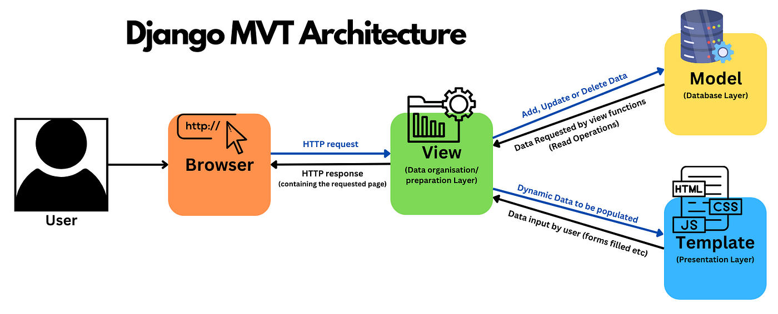

Fig. 4.2.1 Architecture Diagram of Real-Time Secure Web-Based Stock Prediction

AI Forecasting for Investor Decisions System Design

In the Model-View-Template (MVT) architecture used in Django, the Model handles the core business logic and manages data from the database, similar to the MVC architecture. For instance, in an AI-powered stock price prediction system, the Model would manage data related to stock datasets, including historical prices, predictions, and analysis results. The View, however, in MVT, is focused on processing user requests, fetching data from the Model, and selecting the appropriate Template to render a response. For example, the View might handle dataset uploads, user selections from pre-existing datasets, and trigger the predictive model to generate stock price forecasts. Templates are responsible for presenting data to the user, serving as the user interface layer with HTML, CSS, and JavaScript elements. In the context of a stock price prediction system, Templates display user-friendly interfaces for dataset selection, upload functionalities, and visualizations of stock trends and predictions through charts and graphs. This architecture simplifies the development process, encourages modularity, and leverages Django's built-in features for efficiency, scalability, and seamless integration between the frontend, backend, and the AI model.

### FLOWCHART

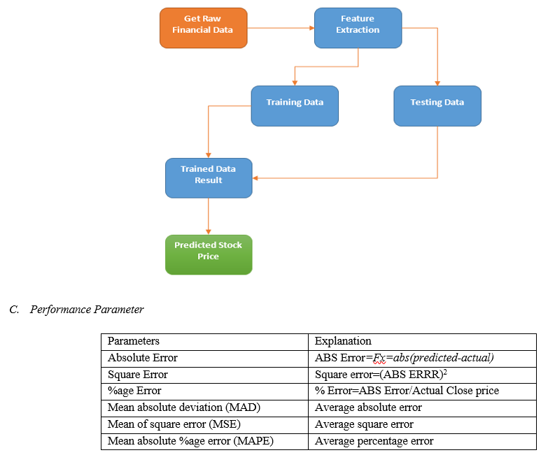

Fig. 4.3.1 Block diagram depicting the flow of the web-based stock prediction application

AI Forecasting for Investor Decisions System Design

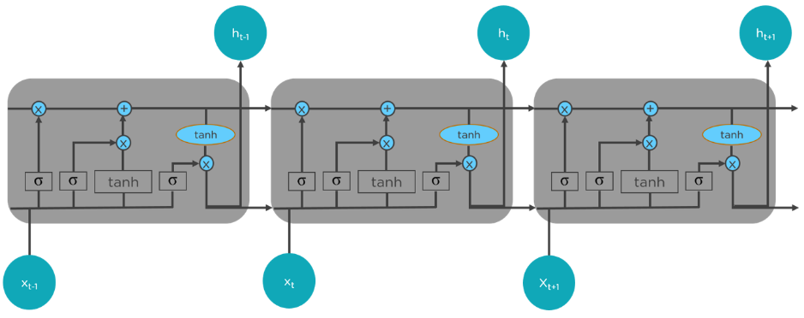

* 1. 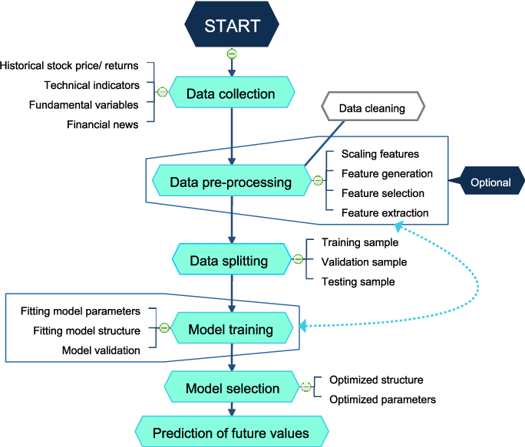LSTM Flow

(b) Algorithm

Fig. 4.3.2 Block diagram depicting the flow of the LSTM/prediction algorithm

The flowchart represents the workflow of an AI-powered stock price prediction system. The process begins with data collection, where historical stock prices, technical indicators, fundamental variables, and financial news are gathered.

AI Forecasting for Investor Decisions System Design

**Step 1: Data Collection:**

* Gather Historical Data: Collect stock price history, returns, and other essential financial data to understand market trends and patterns.

**Step 2: Data Pre-Processing:**

* + - Data Cleaning: Remove inconsistencies, missing values, and noise from the collected data to ensure reliability.
    - Feature Engineering: Generate new relevant features, select the most impactful ones, and extract meaningful insights.
    - Scaling Features: Normalize or standardize the dataset to ensure uniformity, especially for algorithms sensitive to data scale.

**Step 3: Data Splitting:**

* + - Training Sample: Use a large portion of the dataset to train the predictive model.
    - Validation Sample: Validate the model's performance on unseen data during training to avoid overfitting.
    - Testing Sample: Evaluate the final trained model on a completely separate set of data to measure its real-world accuracy.

**Step 4: Model Training:**

* + - Fitting Model Parameters: Optimize parameters such as learning rate, batch size, and epochs for better performance.
    - Fitting Model Structure: Design and refine the model architecture, including layers, nodes, and activation functions.
    - Model Validation: Monitor the model's performance on the validation set to ensure it generalizes well.

**Step 5: Model Selection:**

AI Forecasting for Investor Decisions System Design

* + - Optimized Structure: Choose the best-performing model architecture from multiple training experiments.
    - Optimized Parameters: Fine-tune hyperparameters to minimize prediction errors.
    - Performance Evaluation: Compare models using metrics such as RMSE (Root Mean Square Error) and accuracy scores.

**Step 6:** **Prediction of Future Values:**

* + - Generate Predictions: Use the trained model to predict future stock prices based on the most recent data.
    - Analyze Trends: Examine the predicted trends for actionable insights and investment decisions.
    - Visualize Results: Present predictions using charts and graphs to make data-driven insights more comprehensible.

### 4.5. USE CASE DIAGRAM

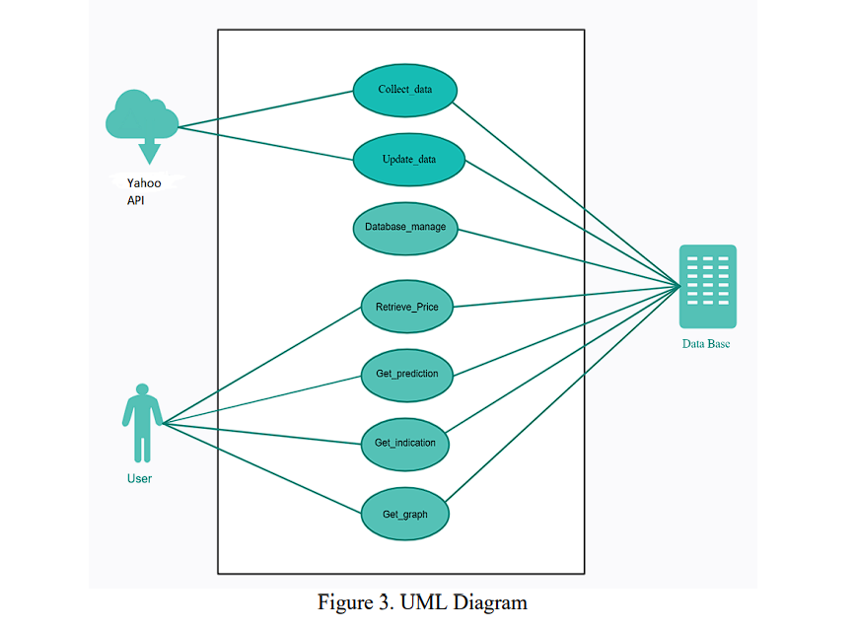

Trusted Source

User

Data base

Fig.4.5.1 Use case diagram describing different use cases possible in the model

AI Forecasting for Investor Decisions System Design

**Trusted Source:**

Data Collection:

* Trusted sources provide accurate and reliable stock market data.
* Data includes historical stock prices, financial indicators, and relevant news updates.

Data Updates:

* Regular updates from trusted sources ensure real-time accuracy.
* Prevents outdated or incorrect data from impacting predictions.

Data Validation:

* Data undergoes validation checks before integration into the system.
* Ensures consistency, accuracy, and completeness of the data.

**User:**

Retrieve Data:

* Users can access real-time and historical stock data.
* Provides transparency through accurate price and prediction details.

View Predictions:

* Users can generate and view AI-based stock price predictions.
* Predictions assist users in making strategic investment decisions.

Visualize Graphs:

* Users can view stock performance through interactive graphs.
* Helps identify market patterns and historical trends.

AI Forecasting for Investor Decisions System Design

**The use cases present in this model are:**

**1. Stock Price Prediction for Investment Decisions:**

* Investors can use the system to predict future stock prices and make informed investment choices.
* Helps in identifying profitable entry and exit points based on predicted trends.
* Reduces reliance on manual analysis by leveraging data-driven insights.

**2. Portfolio Risk Management:**

* Financial institutions can predict stock price fluctuations to minimize risks in portfolios.
* Enables better asset allocation and diversification strategies.
* Assists in identifying high-risk stocks for proactive management.

**3. Market Trend Analysis:**

* Analysts can study historical and predicted stock trends for strategic market insights.
* Identifies market anomalies and patterns using predictive analytics.
* Provides valuable information for institutional investors and hedge funds.

**4. Algorithmic Trading:**

* Integration with automated trading platforms enables real-time trading based on predictions.
* Reduces human intervention and emotional bias in trading decisions.
* Enhances efficiency with quick decision-making in volatile markets.

**5. Financial Education and Research:**

* Serves as a valuable tool for academic research in financial modeling and AI integration.
* Provides educational insights into stock market behavior and predictive analytics.
* Facilitates hands-on experience for students and researchers in AI-based stock predictions.

**REFERENCES**

[1.] J. Brownlee, Deep Learning for Time Series Forecasting: Predicting the Future with Sequential Data in Python, Machine Learning Mastery, 2018.

[2.] F. Chollet, Deep Learning with Python, 2nd ed., Manning Publications, 2021.

[3.] I. Goodfellow, Y. Bengio, and A. Courville, Deep Learning, MIT Press, 2016.

[4.] M. T. Ribeiro, S. Singh, and C. Guestrin, "Why Should I Trust You? Explaining the Predictions of Any Classifier," in Proceedings of the 22nd ACM SIGKDD International Conference on Knowledge Discovery and Data Mining, 2016.

[5.] A. Géron, Hands-On Machine Learning with Scikit-Learn, Keras, and TensorFlow, 2nd ed., O'Reilly Media, 2019.

[6.] S. Hochreiter and J. Schmidhuber, "Long Short-Term Memory," in Neural Computation, vol. 9, no. 8, pp. 1735–1780, 1997.

[7.] Keras Documentation, Building CNN-LSTM Models, [Online]. Available: https://keras.io. [Accessed: 02-Jan-2025].

[8.] Django Software Foundation, Django Framework Documentation, [Online]. Available: https://www.djangoproject.com. [Accessed: 02-Jan-2025].

[9.] TensorFlow Documentation, Time Series Forecasting with TensorFlow, [Online]. Available: https://www.tensorflow.org. [Accessed: 02-Jan-2025].

[10.] GitHub, Stock Price Prediction Project Repository, [Online]. Available: https://github.com. [Accessed: 02-Jan-2025].

[11.] OWASP Foundation, Secure Web Development Guidelines, [Online]. Available: https://owasp.org. [Accessed: 02-Jan-2025].

[12.] P. Baldi and S. Brunak, Bioinformatics: The Machine Learning Approach, MIT Press, 2001.pp. 112-118, 2020.