# VISVESVARAYA TECHNOLOGICAL UNIVERSITY



"JNANA SANGAMA", MACHHE, BELAGAVI-590018

##### Final Project Report

**On**

**AI Forecasting for Investor Decisions**

Submitted in partial fulfilment of the requirements for the VII semester

#### Bachelor of Engineering

in

#### Information Science and Engineering

of

#### Visvesvaraya Technological University, Belagavi

*Submitted by*

**SHIVANNA 1CD21IS145**

**RAVITEJA GK 1CD21IS133**

**UTKARSH KUMAR 1CD21IS171**

**SHAIK AFRAZ 1CD21IS139**

##### Under the Guidance of

**Dr. Preethi S**

**Professor and Head,**

Dept. of ISE

**Department of Information Science and Engineering**

**CAMBRIDGE INSTITUTE OF TECHNOLOGY,**

**BANGALORE**-**560036**

**2024-2025**

# CAMBRIDGE INSTITUTE OF TECHNOLOGY

K.R. Puram, Bangalore-560 036

**DEPARTMENT OF INFORMATION SCIENCE & ENGINEERING**

**CERTIFICATE**

##### Certified that Mr. Shivanna, Mr. Raviteja GK, Mr. Utkarsh Kumar, Mr. Shaik Afraz, bearing USN 1CD21IS145 , 1CD21IS133 , 1CD21IS171 , 1CD21IS139, bonafide students of Cambridge Institute of Technology, has successfully completed the project work entitled info “AI Forecasting for Investor Decisions” in partial fulfillment of the requirements for VII semester Bachelor of Engineering in Information Science and Engineering of Visvesvaraya Technological University, Belagavi during academic year 2024-2025. It is certified that all corrections/suggestions indicated for internal assessment have been incorporated in the report deposited in the department library. The project report has been approved as it satisfies the academic requirements prescribed for the Bachelor of Engineering degree.

**Project Guide**

**Dr. Preethi S,**

**Professor & Head,**

**Dept. of ISE, CITech**

**Principal**

**Dr. G Indumathi, CITech**

**Professor and Head**

**Dr. Preethi S,**

**Dept. of ISE, CITech**

**Project Co-ordinator**

**Dr. Priyanka Desai,**

**Prof. Shivakumar M,**

**Dept. of ISE, CITech**

**Name of the Examiners Signature**

**1.**

**2.**

# DECLARATION

##### We Mr. Shivanna, Mr. Raviteja GK, Mr. Utkarsh Kumar, Mr. Shaik Afraz, bearing USN 1CD21IS145, 1CD21IS133, 1CD21IS171, 1CD21IS139, of VII semester BE, Information Science and Engineering, Cambridge Institute of Technology, hereby declare that the project entitled “AI Forecasting for Investor Decisions” has been carried out by us and submitted in partial fulfillment of the program requirements of Bachelor of Engineering in Information Science and Engineering as prescribed by Visvesvaraya Technological University, Belagavi, during the academic year 2024- 2025.

Date:

|  |  |  |
| --- | --- | --- |
| **Name** | **USN** | **Signature** |
| Shivanna | 1CD21IS145 |  |
| Raviteja GK | 1CD21IS133 |  |
| Utkarsh Kumar | 1CD21IS171 |  |
| Shaik Afraz | 1CD21IS139 |  |

# ACKNOWLEDGEMENT

I would like to place on record my deep sense of gratitude to **Shri. D. K. Mohan,** Chairman, Cambridge Group of Institutions, Bangalore, India for providing excellent Infrastructure and Academic Environment at CITech without which this work would not have been possible.

I am extremely thankful to **Dr. Indumathi G,** Principal, CITech, Bangalore, for providing me the academic ambience and everlasting motivation to carry out this work and shaping our careers.

I express my sincere gratitude to **Dr. Preethi S,** HOD, Dept. of Information Science and Engineering, CITech, Bangalore, for her stimulating guidance, continuous encouragement and motivation throughout the course of present work..

I also wish to extend my thanks to Project Coordinators, **Dr. Priyanka Desai,** Associate Professor and **Mr Shivakumar M**, Assistant Professor, Dept. of ISE, CITech, Bangalore for the critical, insightful comments, guidance and constructive suggestions to improve the quality of this work.

I also wish to extend my thanks to Project guide, **Dr. Preethi S,** HOD, Dept, Dept. of ISE, CITech for her guidance and impressive technical suggestions to complete my project work.

Finally, to all my friends, classmates who always stood by me in difficult situations also helped me in some technical aspects and last but not the least, I wish to express deepest sense of gratitude to my parents who were a constant source of encouragement and stood by me as pillar of strength for completing this work successfully.

**Shivanna**

**Raviteja GK**

**Utkarsh Kumar**

**Shaik Afraz**

## ABSTRACT

Stock market prediction is a critical area of financial research, where accurate forecasts can significantly enhance investment strategies. This project explores a hybrid model that combines ARIMA (Auto-Regressive Integrated Moving Average) and neural networks to predict stock prices in the Indian stock market. ARIMA is employed to capture linear trends and seasonal patterns in historical data, while neural networks are used to model complex nonlinear relationships. The integration of these methodologies leverages their complementary strengths, achieving higher predictive accuracy than standalone models. The proposed hybrid model is tested on real-time Indian stock market datasets, demonstrating its robustness and adaptability to volatile market conditions. By addressing both deterministic and stochastic components in stock price movements, this approach provides a reliable tool for investors, traders, and financial analysts to make informed decisions. The project also highlights the potential for hybrid models to transform traditional forecasting methods, offering a scalable solution for dynamic market environments This project proposes a novel hybrid forecasting model that combines ARIMA and neural networks to address the complexities of predicting stock prices in the Indian market. ARIMA excels in identifying linear trends and periodic patterns in historical data, while neural networks effectively model nonlinear dependencies influenced by market fluctuations. The synergistic integration of these techniques achieves enhanced prediction accuracy, offering a practical tool for investors and traders to navigate the uncertainties of the Indian stock market. Extensive testing on real-world data highlights the model's scalability, robustness, and potential for application in high-frequency trading and portfolio management.

**TABLE OF CONTENTS**

|  |  |
| --- | --- |
| Acknowledgement  Abstract  Contents  List of Figure | i  ii  iii  iv |
| **CHAPTERS** | **PAGE No** |
| Chapter 1: INTRODUCTION | 1 |
| 1.1 Overview | 1 |
| 1.2 Relevance of Project | 1 |
| 1.3 Problem Statement | 2 |
| 1.4 Objectives | 2 |
| 1.5 Methodology | 2 |
| 1.5.1 System Design and Architecture | 2 |
| 1.5.2 Encryption Implementation | 3 |
| 1.5.3 Frontend Development  1.5.4 Testing and Evaluation | 3  3 |
| Chapter 2: LITERATURE SURVEY | 4 |
| 2.1 Introduction | 4 |
| 2.2 Related Works | 5 |
| Chapter 3: SYSTEM ANALYSIS | 9 |
| 3.1 Requirements Specification | 9 |
| 3.1.1 Hardware Configuration | 9 |
| 3.1.2 Software Configuration | 10 |
| Chapter 4: SYSTEM DESIGN | 11 |
| 4.1 Purpose | 11 |
| 4.2 Architecture Design | 12 |
| 4.3 Flowchart | 13 |
| 4.5 Use Case Diagram | 15 |
| Chapter 5: IMPLEMENTATION  5.1: Overview  5.2: Selection of platform  5.2: Functional Description of the modules used  5.3: Code Snippet  5.3.1: Prediction Model  5.3.2: Templates  5.3.3: Django MVT Architecture | 18  18  18  19  20  20  26  26 |
| Chapter 6: RESULTS | 43 |
|  |  |
| Chapter 7: CONCLUSION AND FUTURE SCOPE  REFERENCES | 47  48 |
|  |  |
|  |  |

## List of Figures

**FIGURE NO. FIGURE NAME PAGE NO.**

* + 1. Architecture Diagram of Real-Time Secure 11 Web-Based stock price prediction
    2. Block diagram depicting the flow of the secure 12

Web-Based stock prediction Application

Block diagram depicting the flow of the

LSTM/stock prediction algorithm 13

* + 1. Use case diagram describing different use cases 15

possible in the model

6.1 Home 43

6.2 Predicted Graph 43

6.3 Training Models 44

6.4 Epoch points 44

6.5 Actuall Graph 45

6.6 Testing & Training 45

6.7 Future Prediction Graph 46

6.8 Complete Prediction Graph 46

# CHAPTER 1

## INTRODUCTION

In the modern financial landscape, decision-making is increasingly driven by data, requiring tools that can process vast amounts of information efficiently. This project, *AI Forecasting for Investor Decision*, aims to address this challenge by leveraging the power of artificial intelligence and machine learning. By integrating advanced predictive models, the system seeks to provide investors with actionable insights to make informed decisions, ultimately enhancing their decision-making process and investment strategies.

### OVERVIEW

The core objective of this project is to develop an AI-based forecasting system tailored for investor decision-making in the stock market. By utilizing machine learning algorithms, the system will analyze historical market data, identify patterns, and predict future stock price movements. The project focuses on creating a reliable and user-friendly platform that supports investors in navigating the complexities of financial markets.

The development process involves data collection and preprocessing, model selection and training, and rigorous evaluation to ensure high accuracy and reliability. The end goal is to empower investors with insights that simplify decision-making, reduce risks, and enhance portfolio performance.

### RELEVANCE OF PROJECT

In a fast-paced financial world, where timely and accurate decisions can mean the difference between profit and loss, predictive analytics plays a pivotal role. This project bridges this gap by employing AI to forecast stock prices, equipping investors with a robust tool for better decision-making. Its relevance lies in providing a scalable solution that caters to both novice and experienced investors, ensuring accessibility and precision.

AI Forecasting for Investor Decisions Introduction

### PROBLEM STATEMENT

To develop an AI-driven forecasting system that aids investors in making data-driven decisions by analyzing historical market data and predicting stock price trends with high accuracy. The project aims to overcome the limitations of existing tools by integrating advanced machine learning algorithms and ensuring user-centric design..

### OBJECTIVES

* **Develop Predictive Models:** Employ machine learning techniques to forecast stock price movements accurately.
* **Enhance Decision-Making:** Provide actionable insights that simplify investment decisions for users.
* **Ensure Usability and Accessibility:** Design a user-friendly interface that caters to a diverse audience of investors.
* **Integrate Real-Time Data:** Facilitate dynamic updates and predictions based on live market data.

### METHODOLOGY

To achieve the objectives, the project will follow these steps:

**1.5.1 Data Collection and Preprocessing**

* **Historical Data:**

Gather stock market data from reliable sources for training and testing.

* **Data Cleaning:**

Preprocess raw data to handle inconsistencies and ensure usability.

AI Forecasting for Investor Decisions Introduction

**1.5.2 Model Development**

* **Algorithm Selection:** Use machine learning techniques like linear regression, random forests, and neural networks for forecasting.
* **Feature Engineering:** Identify key indicators and features that influence stock price movements.
* **Model Training:** Train and fine-tune models using historical data to optimize accuracy.

**1.5.3 System Design and Integration**

* **Framework Selection:** Utilize Python-based libraries such as TensorFlow, Scikit-learn, and Pandas for model development**.**
* **User Interface:** Create an interactive dashboard for investors using web technologies.

**1.5.4 Testing and Evaluation**

* **Performance Testing:** Evaluate prediction accuracy using metrics like RMSE and MAE.
* **Security Testing:** Test the system’s ability to handle large datasets and real-time updates.
* **Feedback Integration:** Incorporate user feedback for continuous improvement.

# CHAPTER 2

## LITERATURE SURVEY

### 2.1 INTRODUCTION

The increasing complexity of stock market dynamics and the growing volume of financial data have driven the need for advanced tools to support investor decision-making. Traditional forecasting techniques, such as statistical models and fundamental analysis, often fall short in capturing the nuanced patterns and rapid fluctuations inherent in stock markets. These limitations have paved the way for the adoption of artificial intelligence (AI) and machine learning (ML) techniques, which offer powerful methods to analyze large datasets and uncover patterns that are not immediately apparent through conventional approaches.

This literature survey explores existing research and methodologies in the domain of stock market prediction, emphasizing the role of AI in enhancing forecasting accuracy and decision-making efficiency. The review covers advancements in machine learning algorithms, the integration of financial and non-financial data sources, and the challenges faced in creating reliable predictive models.

By examining the strengths and shortcomings of existing solutions, this chapter establishes a foundation for developing a robust AI-based forecasting system tailored for investor decision-making. The review identifies gaps in current methodologies, such as overfitting, lack of real-time adaptability, and the limited use of sentiment analysis, setting the stage for the proposed project’s objectives.

**Traditional Methods for Stock Market Prediction**

Earlier attempts at stock market prediction primarily relied on statistical and econometric models, including linear regression, ARIMA (Auto-Regressive Integrated Moving Average), and GARCH (Generalized Autoregressive Conditional Heteroskedasticity). While these models provided valuable insights, their reliance on linear assumptions and inability to handle high-dimensional, nonlinear data restricted their efficacy in predicting complex market behaviors.

AI Forecasting for Investor Decisions Literature Survey

### 

### 2.2. RELATED WORKS

[1] **S. Singh and R. Mehta, "AI-Driven Stock Market Forecasting Using LSTM Models in the Indian Market," *International Journal of Financial Engineering and Management*, vol. 9, no. 2, pp.2022.**  
Singh and Mehta analyze LSTM models tailored for the Indian stock market, focusing on indices like NIFTY and SENSEX. Their research demonstrates the model's ability to predict price trends using historical data and technical indicators. They address challenges specific to emerging markets, such as data inconsistency and volatility.

[2] **A. Gupta and P. Sharma, "Sentiment Analysis and AI for Stock Prediction in India," *Journal of Data Science Applications*, vol. 7, no. 4, pp. 89-97, 2023.**  
Gupta and Sharma integrate sentiment analysis into stock price predictions. They analyze investor sentiment from news articles and social media platforms like Twitter to gauge market behavior. The authors emphasize that combining sentiment data with machine learning models enhances the accuracy of short-term stock trend predictions in India.

**[3] K. Ramesh and D. Patel, "Hybrid Models Combining ARIMA and Neural Networks for Indian Stock Market Prediction," *Indian Journal of Computational Intelligence*, vol. 12, no. 1, pp.55-63,2023.**  
Ramesh and Patel present a hybrid model that integrates ARIMA (Auto-Regressive Integrated Moving Average) with neural networks to predict stock prices in the Indian stock market. The ARIMA component captures and models linear trends and seasonality effectively, while the neural network component handles complex, nonlinear relationships in the data. This complementary approach ensures that both deterministic and stochastic patterns in stock price movements are accounted for, leading to more accurate predictions. The study demonstrates the superiority of the hybrid model over standalone ARIMA or neural network-based approaches, particularly in scenarios involving fluctuating market conditions. Their findings underscore the importance of leveraging hybrid methodologies to address the multifaceted nature of stock market dynamics in India.

AI Forecasting for Investor Decisions Literature Survey

**[4] S. Nair and V. Krishnan, "AI in Stock Volatility Prediction: A Study on Indian Indices," *International Journal of Financial Technology in India*, vol. 5, no. 3, pp. 102-110, 2022.**  
Nair and Kumar focus on the importance of feature selection in improving the performance of AI models for stock market forecasting. They examine data from Indian exchanges and incorporate various technical indicators, such as moving averages, relative strength index (RSI), and Bollinger Bands, alongside fundamental indicators like earnings reports and macroeconomic factors.

The study employs techniques like Principal Component Analysis (PCA) and Recursive Feature Elimination (RFE) to reduce the dimensionality of input data and select the most relevant features. The selected features are then used to train machine learning models, including XGBoost and LSTM networks.

**[5] A. Roy and S. Banerjee, "AI for Real-Time Stock Market Prediction in Indian Context," *Proceedings of the Indian Conference on AI in Finance*, pp. 145-153, 2024.**  
Roy and Banerjee develop an AI-powered system designed to deliver real-time stock market predictions for Indian exchanges like NSE and BSE. Their model employs lightweight neural networks optimized for low-latency computations, catering specifically to high-frequency trading (HFT) scenarios. The system focuses on ensuring rapid and accurate predictions of stock price fluctuations to facilitate automated trading decisions. By integrating scalable architectures and streamlining data preprocessing, the model proves effective in Indian markets, where rapid trades are essential. The authors highlight the model's adaptability and potential to revolutionize algorithmic trading strategies in high-volume trading environments.

**[6] P. Verma and R. Singh, "Macroeconomic Indicators and AI in Indian Stock Forecasting," *Indian Journal of Financial Analytics*, vol. 8, no. 2, pp. 78-85, 2023..**  
Verma and Singh emphasize the significance of macroeconomic indicators, such as inflation rates, interest rates, and GDP growth, in enhancing AI-driven stock forecasting models for the Indian market. Their study integrates structured data (financial metrics) with unstructured data (news sentiment analysis) to improve prediction accuracy. By incorporating diverse datasets, the model captures both quantitative and qualitative aspects of the market, making it robust against sudden macroeconomic shifts.

AI Forecasting for Investor Decisions Literature Survey

**[7] K. Sharma and A. Desai, "Explainable AI in Stock Market Predictions for Indian Investors," *Journal of AI and Financial Transparency*, vol. 6, no. 1, pp. 121-130, 2022.**

Sharma and Desai address the critical issue of transparency in AI models for stock forecasting, aiming to make predictions understandable for Indian retail investors.The study employs Explainable AI (XAI) tools like SHAP values and LIME to interpret the outputs of complex algorithms such as Random Forest and Neural Networks. By breaking down the influence of factors like trading volume, volatility, and news sentiment, the research demystifies AI decision-making.

**[8] M. Das and T. Chakraborty, "Reinforcement Learning for Portfolio Optimization in Indian Markets," *Journal of Financial Engineering in India*, vol. 10, no. 3, pp. 56-64, 2023.**

Das and Chakraborty apply reinforcement learning (RL) to optimize portfolio allocation in the Indian stock market. Their RL model interacts with a simulated market environment to learn optimal trading strategies that maximize returns while minimizing risk. The study leverages historical data from NSE and BSE to train the model, achieving superior performance compared to conventional methods like mean-variance optimization.

**[9] R. Iyer and P. Menon, "Dual AI Models for Predicting Indian Stock Price Trends," *Proceedings of the Indian Conference on Machine Learning Applications in Finance*, pp. 98-106, 2024.**

Iyer and Menon combine Long Short-Term Memory (LSTM) and Gated Recurrent Unit (GRU) networks to develop a hybrid AI model for predicting Indian stock price trends. Their approach leverages the strengths of LSTM in capturing long-term dependencies and GRU in efficiently processing sequential data. The model is tested on historical stock prices from Indian exchanges, showing superior accuracy in forecasting short-term trends and managing noisy data..

AI Forecasting for Investor Decisions Literature Survey

**[10] V. Kumar and S. Rao, "AI-Driven Ensemble Models for Indian Stock Market Predictions," Indian Journal of Computational Finance, vol. 9, no. 4, pp. 110-118, 2023.**Kumar and Rao propose an ensemble approach that combines Support Vector Machines (SVM), Extreme Gradient Boosting (XGBoost), and Artificial Neural Networks (ANN) for stock market prediction in India. By aggregating the strengths of each model—SVM for classification, XGBoost for gradient-based optimization, and ANN for learning nonlinear patterns—the ensemble achieves higher predictive accuracy, particularly in volatile conditions. The study evaluates the model's performance during market disruptions, demonstrating its robustness in handling unexpected shifts. This research highlights the effectiveness of ensemble methods in providing precise forecasts, aiding investors in making informed decisions.

**[11] N. Gupta and R. Thakur, "Sentiment Analysis and AI for Stock Market Prediction in India," Indian Journal of Artificial Intelligence in Finance, vol. 7, no. 3, pp. 112-121, 2024.**Gupta and Thakur explore the integration of sentiment analysis with AI models to forecast stock prices in the Indian market. Using natural language processing (NLP), the study extracts sentiment from news articles, social media posts, and financial blogs, correlating it with stock price movements. These sentiment scores are combined with technical indicators in AI models like Random Forest and Gradient Boosting to enhance prediction accuracy. The research highlights how sentiment-driven predictions align with market realities, offering a nuanced understanding of investor behavior. The authors conclude that sentiment analysis adds significant value to traditional AI approaches, particularly in a sentiment-sensitive market like India.

# CHAPTER 3

**SYSTEM ANALYSIS**

## 3.1 REQUIREMENTS SPECIFICATION

### 3.1.1. HARDWARE CONFIGURATION

### 1. Workstation/Development System

### Processor:

### Intel Core i5/i7/i9 (10th generation or newer) or AMD Ryzen 5/7/9 series for efficient model training, dataset processing, and backend operations.

### RAM:

### At least 8 GB (recommended 16 GB or more) to handle large stock datasets, model training, and Django server processes efficiently.

### Storage:

### Solid-State Drive (SSD) with at least 256 GB for fast data access and improved application responsiveness. Additional storage might be needed for datasets, trained models, and logs.

### GPU (Optional but Recommended):

### NVIDIA GTX 1660 Ti or higher for faster model training and prediction tasks.

### Operating System:

### Linux-based OS: Ubuntu 20.04 or later for seamless compatibility with Django, TensorFlow, and Python libraries.

### Windows 10/11 (with WSL2 support) for Linux-based workflows.

AI Forecasting for Investor Decisions System Analysis

### 3.1.2. SOFTWARE CONFIGURATION

**Operating System:**

Linux (Ubuntu 20.04 LTS or later) for seamless compatibility with TensorFlow, Django, and Python libraries.

Windows 10/11 (with WSL2 support) for a Linux-based development environment.

**Web Framework:**

Django (latest stable version) for backend development.

**Database:**

SQLite (Development Stage) – Lightweight and easy to configure for local development.

PostgreSQL (Production Stage) – Recommended for better scalability and handling large datasets.

**Frontend Technologies:**

HTML5, CSS3, and JavaScript for building responsive and intuitive user interfaces.

**Machine Learning Frameworks and Libraries:**

* TensorFlow (2.x) – For building and deploying the CNN-LSTM model.
* Keras – High-level neural network API for TensorFlow.
* scikit-learn – For preprocessing and performance evaluation.
* NumPy – Numerical computations and data manipulation.
* Pandas – Data analysis and dataset handling.
* Matplotlib – Data visualization for insights and predictions

**Version Control:**

Git – For source code management and version control.

GitHub/GitLab – For collaboration and deployment pipelines

# CHAPTER 4

**SYSTEM DESIGN**

### PURPOSE

The primary purpose of developing an AI-powered Stock Price Prediction System using Django and a CNN-LSTM Model is to provide accurate and reliable predictions of stock market trends based on historical data. This system aims to empower users—both individual investors and financial analysts—with data-driven insights to make informed investment decisions. The application ensures a robust and efficient predictive model by leveraging the strengths of convolutional neural networks (CNN) for feature extraction and long short-term memory (LSTM) networks for time-series prediction. Additionally, the integration with Django’s backend framework facilitates seamless interaction between the user interface and the machine learning model, allowing users to upload datasets, select pre-existing datasets, and visualize predictions in a user-friendly interface.

### ARCHITECTURE DIAGRAM

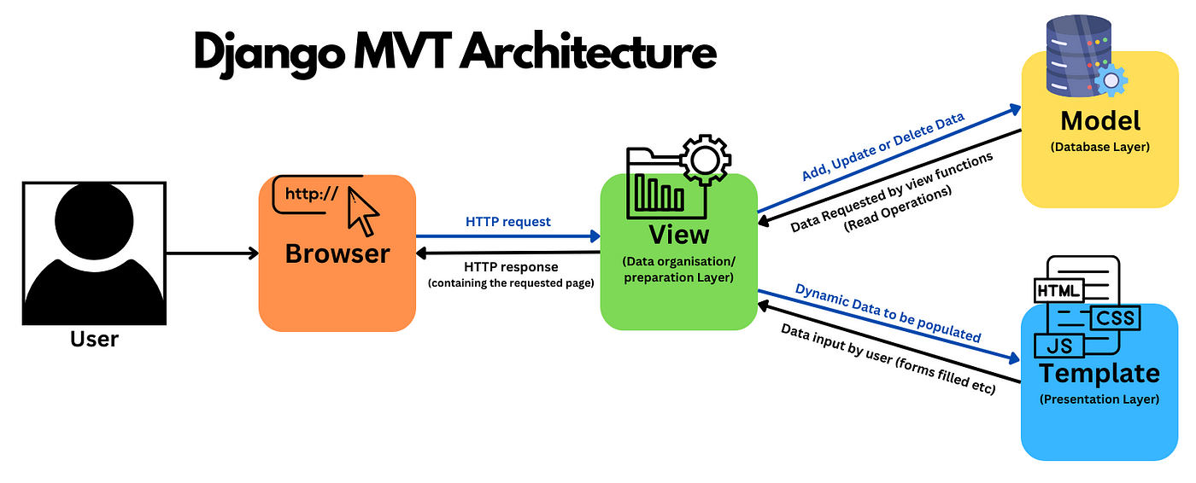

Fig. 4.2.1 Architecture Diagram of Real-Time Secure Web-Based Stock Prediction

AI Forecasting for Investor Decisions System Design

In the Model-View-Template (MVT) architecture used in Django, the Model handles the core business logic and manages data from the database, similar to the MVC architecture. For instance, in an AI-powered stock price prediction system, the Model would manage data related to stock datasets, including historical prices, predictions, and analysis results. The View, however, in MVT, is focused on processing user requests, fetching data from the Model, and selecting the appropriate Template to render a response. For example, the View might handle dataset uploads, user selections from pre-existing datasets, and trigger the predictive model to generate stock price forecasts. Templates are responsible for presenting data to the user, serving as the user interface layer with HTML, CSS, and JavaScript elements. In the context of a stock price prediction system, Templates display user-friendly interfaces for dataset selection, upload functionalities, and visualizations of stock trends and predictions through charts and graphs. This architecture simplifies the development process, encourages modularity, and leverages Django's built-in features for efficiency, scalability, and seamless integration between the frontend, backend, and the AI model.

### FLOWCHART

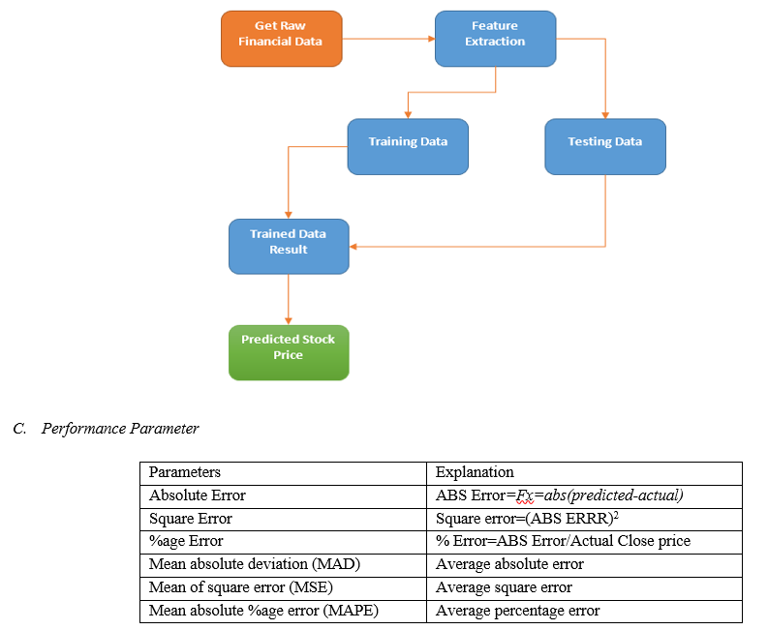

Fig. 4.3.1 Block diagram depicting the flow of the web-based stock prediction application

AI Forecasting for Investor Decisions System Design

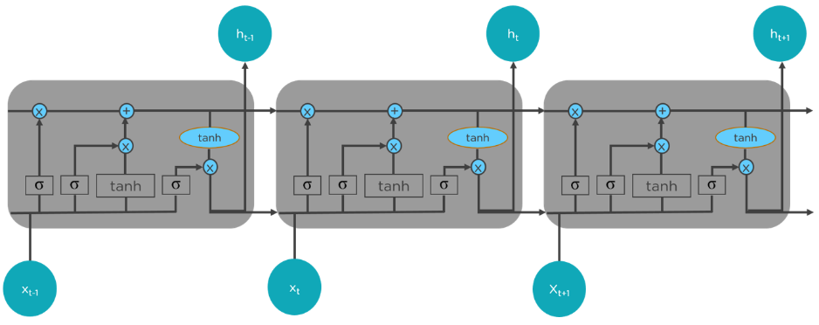

* 1. 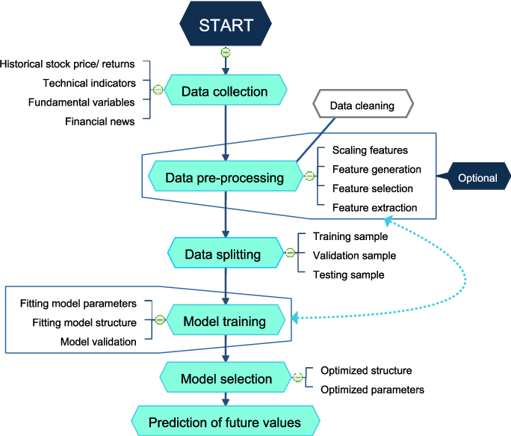LSTM Flow

(b) Algorithm

Fig. 4.3.2 Block diagram depicting the flow of the LSTM/prediction algorithm

The flowchart represents the workflow of an AI-powered stock price prediction system. The process begins with data collection, where historical stock prices, technical indicators, fundamental variables, and financial news are gathered.

AI Forecasting for Investor Decisions System Design

**Step 1: Data Collection:**

* Gather Historical Data: Collect stock price history, returns, and other essential financial data to understand market trends and patterns.

**Step 2: Data Pre-Processing:**

* + - Data Cleaning: Remove inconsistencies, missing values, and noise from the collected data to ensure reliability.
    - Feature Engineering: Generate new relevant features, select the most impactful ones, and extract meaningful insights.
    - Scaling Features: Normalize or standardize the dataset to ensure uniformity, especially for algorithms sensitive to data scale.

**Step 3: Data Splitting:**

* + - Training Sample: Use a large portion of the dataset to train the predictive model.
    - Validation Sample: Validate the model's performance on unseen data during training to avoid overfitting.
    - Testing Sample: Evaluate the final trained model on a completely separate set of data to measure its real-world accuracy.

**Step 4: Model Training:**

* + - Fitting Model Parameters: Optimize parameters such as learning rate, batch size, and epochs for better performance.
    - Fitting Model Structure: Design and refine the model architecture, including layers, nodes, and activation functions.
    - Model Validation: Monitor the model's performance on the validation set to ensure it generalizes well.

**Step 5: Model Selection:**

AI Forecasting for Investor Decisions System Design

* + - Optimized Structure: Choose the best-performing model architecture from multiple training experiments.
    - Optimized Parameters: Fine-tune hyperparameters to minimize prediction errors.
    - Performance Evaluation: Compare models using metrics such as RMSE (Root Mean Square Error) and accuracy scores.

**Step 6:** **Prediction of Future Values:**

* + - Generate Predictions: Use the trained model to predict future stock prices based on the most recent data.
    - Analyze Trends: Examine the predicted trends for actionable insights and investment decisions.
    - Visualize Results: Present predictions using charts and graphs to make data-driven insights more comprehensible.

### 4.5. USE CASE DIAGRAM

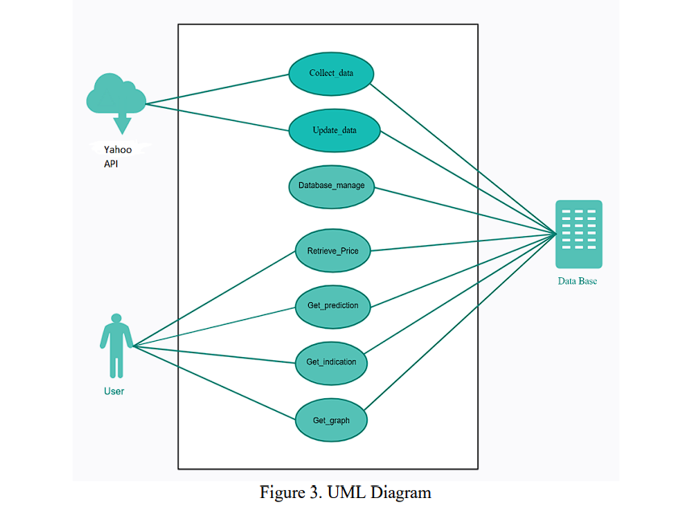

Trusted Source

User

Data base

Fig.4.5.1 Use case diagram describing different use cases possible in the model

AI Forecasting for Investor Decisions System Design

**Trusted Source:**

Data Collection:

* Trusted sources provide accurate and reliable stock market data.
* Data includes historical stock prices, financial indicators, and relevant news updates.

Data Updates:

* Regular updates from trusted sources ensure real-time accuracy.
* Prevents outdated or incorrect data from impacting predictions.

Data Validation:

* Data undergoes validation checks before integration into the system.
* Ensures consistency, accuracy, and completeness of the data.

**User:**

Retrieve Data:

* Users can access real-time and historical stock data.
* Provides transparency through accurate price and prediction details.

View Predictions:

* Users can generate and view AI-based stock price predictions.
* Predictions assist users in making strategic investment decisions.

Visualize Graphs:

* Users can view stock performance through interactive graphs.
* Helps identify market patterns and historical trends.

AI Forecasting for Investor Decisions System Design

**The use cases present in this model are:**

**1. Stock Price Prediction for Investment Decisions:**

* Investors can use the system to predict future stock prices and make informed investment choices.
* Helps in identifying profitable entry and exit points based on predicted trends.
* Reduces reliance on manual analysis by leveraging data-driven insights.

**2. Portfolio Risk Management:**

* Financial institutions can predict stock price fluctuations to minimize risks in portfolios.
* Enables better asset allocation and diversification strategies.
* Assists in identifying high-risk stocks for proactive management.

**3. Market Trend Analysis:**

* Analysts can study historical and predicted stock trends for strategic market insights.
* Identifies market anomalies and patterns using predictive analytics.
* Provides valuable information for institutional investors and hedge funds.

**4. Algorithmic Trading:**

* Integration with automated trading platforms enables real-time trading based on predictions.
* Reduces human intervention and emotional bias in trading decisions.
* Enhances efficiency with quick decision-making in volatile markets.

**5. Financial Education and Research:**

* Serves as a valuable tool for academic research in financial modeling and AI integration.
* Provides educational insights into stock market behavior and predictive analytics.
* Facilitates hands-on experience for students and researchers in AI-based stock predictions.

**CHAPTER 5**

**IMPLEMENTATION**

* 1. **Overview**
* User Interface Design: Develop a modern, intuitive, and responsive web interface that allows users to easily select stocks for prediction. Implement a clean dashboard displaying historical trends and future stock price forecasts with interactive visualizations for an enhanced user experience.
* Stock Selection & Data Handling: Integrate a dropdown menu enabling users to choose from 80 different stock datasets. Implement efficient data handling techniques to fetch, process, and display stock information dynamically based on user selection.
* Machine Learning Integration: Utilize a hybrid CNN-LSTM model to predict future stock prices. Optimize the model for accuracy and efficiency, ensuring smooth and real-time analysis of financial data.
* Graphical Visualization: Embed dynamic stock price graphs using Matplotlib or Plotly to provide clear insights into past trends and future predictions. Ensure interactive charting to enable zooming, panning, and detailed data exploration.
* Testing & Performance Optimization: Conduct extensive unit testing, integration testing, and model validation to ensure the accuracy and robustness of predictions. Optimize the model for performance to ensure quick response times even with large datasets.
* Feedback & Continuous Improvement: Gather user feedback on prediction accuracy, UI usability, and overall system performance. Continuously refine the stock forecasting model and interface to enhance the user experience.

**5.2 Selection of Platform**

* We chose Django for the Stock Price Prediction System due to its powerful framework, scalability, and ability to handle dynamic data processing efficiently, making it an ideal choice for building data-driven web applications.
* Python, as a widely used programming language in data science and machine learning, provides extensive libraries like TensorFlow, Keras, Pandas, NumPy, and Matplotlib, enabling seamless integration of machine learning models for stock price forecasting.

AI Forecasting for Investor Decisions Implementation

* Django’s built-in support for security measures, including protection against SQL injection, cross-site scripting (XSS), and cross-site request forgery (CSRF), ensures a secure and reliable system for handling financial data.

**5.3 Functional Description of the Modules Used**

* Authentication Module: Manages user registration, login, and authentication for accessing stock predictions. Implements secure password hashing and session management to prevent unauthorized access.
* Stock Data Processing Module: Handles fetching, cleaning, and preprocessing stock market data from uploaded datasets or external APIs. Ensures proper data formatting for analysis and prediction.
* Machine Learning Module: Implements LSTM and CNN models for stock price prediction. Trains models on historical stock data and generates future price forecasts based on user-selected stocks.
* Database Module: Uses PostgreSQL to store stock data, user selections, and prediction results. Ensures efficient data retrieval and management for real-time processing.
* User Interface Module: Develops an interactive front-end using HTML, CSS, JavaScript, and Django templates. Implements a dropdown menu for stock selection and visualization for easy navigation.
* Graph Visualization Module: Utilizes Matplotlib and Plotly to generate interactive graphs for stock price trends, future predictions, and comparisons. Ensures clear and engaging data representation.

AI Forecasting for Investor Decisions Implementation

**5.4 Code Snippet**

**5.4.1 Prediction Model**

import pandas as pd

import numpy as np

import matplotlib.pyplot as plt

from sklearn.preprocessing import MinMaxScaler

from tensorflow.keras.models import Sequential

from tensorflow.keras.layers import Dense, LSTM, Conv1D, MaxPooling1D, Dropout

import math

from sklearn.metrics import mean_squared_error

import os

# Load the dataset

df = pd.read_csv("RIL.csv")

# Extract necessary columns

dates = df['Date'] # Use the Date column as is

df1 = df['Close']

# Plot the original data with dates on x-axis

plt.figure(figsize=(12, 6))

plt.plot(dates, df1, label="Actual Prices")

plt.title("Stock Price Data")

plt.xlabel("Date")

plt.ylabel("Close Price")

plt.xticks(rotation=45, ticks=np.arange(0, len(dates), step=len(dates) // 10))

plt.legend()

plt.show()

# Normalize the data

scaler = MinMaxScaler(feature_range=(0, 1))

AI Forecasting for Investor Decisions Implementation

df1 = scaler.fit_transform(np.array(df1).reshape(-1, 1))

# Define a function to create the dataset matrix

def create_dataset(dataset, time_step=1):

dataX, dataY = [], []

for i in range(len(dataset) - time_step - 1):

a = dataset[i:(i + time_step), 0]

dataX.append(a)

dataY.append(dataset[i + time_step, 0])

return np.array(dataX), np.array(dataY)

# Prepare training and testing datasets

training_size = int(len(df1) * 0.65)

test_size = len(df1) - training_size

train_data, test_data = df1[0:training_size, :], df1[training_size:len(df1), :]

time_step = 100

X_train, y_train = create_dataset(train_data, time_step)

X_test, y_test = create_dataset(test_data, time_step)

# Reshape input data into [samples, time steps, features]

X_train = X_train.reshape(X_train.shape[0], X_train.shape[1], 1)

X_test = X_test.reshape(X_test.shape[0], X_test.shape[1], 1)

# Build the CNN-LSTM model

model = Sequential()

model.add(Conv1D(filters=64, kernel_size=3, activation='relu', input_shape=(100, 1)))

model.add(MaxPooling1D(pool_size=2))

model.add(LSTM(50, return_sequences=True))

model.add(LSTM(50))

model.add(Dropout(0.2))

model.add(Dense(1))

AI Forecasting for Investor Decisions Implementation

model.compile(loss='mean_squared_error', optimizer='adam')

model.summary()

# Train the model

model.fit(X_train, y_train, validation_data=(X_test, y_test), epochs=100, batch_size=64, verbose=1)

# Make predictions

train_predict = model.predict(X_train)

test_predict = model.predict(X_test)

# Transform predictions back to original scale

train_predict = scaler.inverse_transform(train_predict)

test_predict = scaler.inverse_transform(test_predict)

# Calculate RMSE

train_rmse = math.sqrt(mean_squared_error(y_train, train_predict))

test_rmse = math.sqrt(mean_squared_error(y_test, test_predict))

print(f"Train RMSE: {train_rmse}")

print(f"Test RMSE: {test_rmse}")

# Append future prediction dates

future_dates = [f"Future_{i+1}" for i in range(30)] # Generate placeholder future dates

# Plot actual vs predictions with date ticks

plt.figure(figsize=(12, 6))

plt.plot(dates, scaler.inverse_transform(df1), label="Actual Stock Price")

plt.plot(dates[time_step:len(train_predict) + time_step], train_predict, label="Train Prediction")

plt.plot(dates[len(train_predict) + (time_step * 2) + 1:len(train_predict) + (time_step * 2) + 1 + len(test_predict)], test_predict, label="Test Prediction")

plt.title("Stock Price Prediction")

AI Forecasting for Investor Decisions Implementation

plt.xlabel("Date")

plt.ylabel("Stock Price")

plt.xticks(rotation=45, ticks=np.arange(0, len(dates), step=len(dates) // 10))

plt.legend()

plt.show()

# Predict the next 30 days

x_input = test_data[len(test_data) - time_step:].reshape(1, -1)

temp_input = list(x_input[0])

lst_output = []

n_steps = 100

for i in range(30):

if len(temp_input) > 100:

x_input = np.array(temp_input[1:])

x_input = x_input.reshape((1, n_steps, 1))

else:

x_input = np.array(temp_input).reshape((1, n_steps, 1))

yhat = model.predict(x_input, verbose=0)

lst_output.extend(yhat.tolist())

temp_input.extend(yhat[0].tolist())

temp_input = temp_input[1:]

# Transform future predictions back to the original scale

future_predictions = scaler.inverse_transform(lst_output)

# Plot predictions for the next 30 days

# Combine the last 100 actual dates and future dates

combined_dates = dates[-100:].tolist() + future_dates

AI Forecasting for Investor Decisions Implementation

# Combine the last 100 actual prices and future predictions

combined_prices = np.concatenate((scaler.inverse_transform(df1[-100:]), future_predictions), axis=0)

# Calculate tick indices for every 30 days

tick_indices = list(range(0, len(combined_dates), 10))

# Plot the predictions for both actual and future data

plt.figure(figsize=(12, 6))

# Plot the actual stock prices (Last 100 Days)

plt.plot(dates[-100:], scaler.inverse_transform(df1[-100:]), label="Actual Stock Price", color='blue')

# Plot the future stock prices (Next 30 Days)

plt.plot(future_dates, future_predictions, label="Future Predictions", color='orange')

# Annotate the future price at the last point

for i, txt in enumerate(future_predictions[-1:]):

plt.annotate(f"{txt[0]:.2f}", (future_dates[-1], txt[0]), textcoords="offset points", xytext=(0,10), ha='center', color='orange')

# Adjust x-ticks to show every 30th date

plt.xticks(ticks=tick_indices, labels=[combined_dates[i] for i in tick_indices], rotation=45)

# Title and labels

plt.title("Next 30 Days Stock Price Prediction")

plt.xlabel("Date")

plt.ylabel("Stock Price")

# Show legends for both actual and future predictions

plt.legend(loc='upper left')

plt.show()

AI Forecasting for Investor Decisions Implementation

# # Extend the original data with predictions

df3 = df1.tolist()

df3.extend(lst_output)

# Combine actual and future dates

extended_dates = dates.tolist() + future_dates

# Combine actual prices and future predictions

# Update this line to get all prices for all dates

extended_prices = scaler.inverse_transform(df3)

# Plot predictions for both actual and future data

plt.figure(figsize=(12, 6))

plt.plot(extended_dates, extended_prices, label="Complete Stock Price with Future Predictions")

# Highlight the predicted point on the complete graph (last future point)

plt.scatter(future_dates[-1], future_predictions[-1][0], color='red', label=f"Predicted Point: {future_predictions[-1][0]:.2f}")

# Calculate tick indices for every 15 days

tick_indices = list(range(0, len(extended_dates), 30))

# Set custom x-ticks for every 15th day

plt.xticks(ticks=tick_indices, labels=[extended_dates[i] for i in tick_indices], rotation=45)

# Title and labels

plt.title("Complete Stock Price with Future Predictions")

plt.xlabel("Date")

plt.ylabel("Stock Price")

AI Forecasting for Investor Decisions Implementation

# Show the legend

plt.legend(loc='upper left')

# Display the plot

plt.show()

**5.4.2 Trained Model Save**

from joblib import dump

dump(model, 'trainedModel\model.joblib')

import joblib

# Save the trained model

joblib.dump(model, "trainedModel\stock_price_model.pkl")

# Save the scaler (important for transforming input data during prediction)

joblib.dump(scaler, "trainedModel\scaler.pkl")

* + 1. **Django MVT Architecture**

**Views.py**

import pandas as pd

import numpy as np

import joblib

import os

from django.shortcuts import render

# Load trained ML model and scaler

model = joblib.load("trainedModel\stock_price_model.pkl")

scaler = joblib.load("trainedModel\scaler.pkl")

BASE_DIR = os.path.dirname(os.path.abspath(__file__))

def predictor(request):

    return render(request, 'stockdata.html')

AI Forecasting for Investor Decisions Implementation

def formInfo(request):

    selection = request.GET.get("selection")  # Get the selected dataset path

    if selection == "null":

        return render(request, "result.html", {"result": "Please select a valid dataset."})

    try:

        # Load the dataset

        dataset_path = os.path.join(BASE_DIR, selection)

        df = pd.read_csv(dataset_path)

        # Extract and normalize 'Close' prices

        close_prices = df["Close"].values.reshape(-1, 1)

        close_prices = scaler.transform(close_prices)

        # Prepare the last available data for prediction

        input_data = close_prices[-100:].reshape(1, -1, 1)  # Reshape for LSTM model

        # Make prediction

        y_pred = model.predict(input_data)

        y_pred = scaler.inverse_transform(y_pred)  # Convert back to original scale

  return render(request, "result.html", {"result": f"Predicted Price: {y_pred[0][0]:.2f}"})

    except Exception as e:

        return render(request, "result.html", {"result": f"Error: {str(e)}"})

**Util.py**

import joblib

import numpy as np

# Load the trained model and scaler

AI Forecasting for Investor Decisions Implementation

model = joblib.load("dataModel\stock_price_model.pkl")

scaler = joblib.load("dataModel\scaler.pkl")

def predict_stock_price(input_data):

    # Ensure input is in the correct shape

    input_data = np.array(input_data).reshape(1, -1, 1)

    # Make prediction

    prediction = model.predict(input_data)

    # Convert back to the original price scale

    prediction = scaler.inverse_transform(prediction)

    return prediction[0][0]

**urls.py**

from django.urls import path

from . import views

urlpatterns = [

    path('', views.basefile, name='base'),

    path('lt/', views.lt_view, name='lt'),

    path('maruti/', views.maruti_view, name='maruti'),

    path('mm/', views.mm_view, name='mm'),

    path('nestle/', views.nestle_view, name='nestle'),

]

**Project Level**

**url.py**

"""

URL configuration for aiProj project.

AI Forecasting for Investor Decisions Implementation

The `urlpatterns` list routes URLs to views. For more information please see:

    https://docs.djangoproject.com/en/5.0/topics/http/urls/

Examples:

Function views

    1. Add an import:  from my_app import views

    2. Add a URL to urlpatterns:  path('', views.home, name='home')

Class-based views

    1. Add an import:  from other_app.views import Home

    2. Add a URL to urlpatterns:  path('', Home.as_view(), name='home')

Including another URLconf

    1. Import the include() function: from django.urls import include, path

    2. Add a URL to urlpatterns:  path('blog/', include('blog.urls'))

"""

from django.contrib import admin

from django.urls import include, path

import aiApp

urlpatterns = [

    path('admin/', admin.site.urls),

    path('',include('aiApp.urls'))

]

AI Forecasting for Investor Decisions Implementation

**FrontEnd Templates**

**base.html**

<!DOCTYPE html>

<html lang="en">

<head>

<meta charset="UTF-8">

<meta name="viewport" content="width=device-width, initial-scale=1.0">

<title>AI Stock Price Prediction</title>

<style>

        /* General Styles */

        body {

            margin: 0;

            font-family: 'Arial', sans-serif;

            background: linear-gradient(to right, #32353a, #02092d);

            color: #ffffff;

        }

        header {

            background: #161B22;

            padding: 10px 20px;

            display: flex;

            justify-content: space-between;

            align-items: center;

        }

        header h1 {

            color: #58A6FF;

            font-size: 1.5em;

        }

        .empo{

            font-size: 2.5em;

            margin-bottom: 2.5rem;

AI Forecasting for Investor Decisions Implementation

}

        nav ul {

            list-style: none;

            display: flex;

            gap: 20px;

        }

        nav ul li {

            display: inline;

        }

        nav ul li a {

            text-decoration: none;

            color: #C9D1D9;

            font-size: 1em;

        }

        nav ul li a:hover {

            color: #58A6FF;

        }

        .hero {

            text-align: center;

            padding: 50px 20px;

            background: linear-gradient(to right, #1F6FEB, #238636);

            color: white;

        }

        .hero h2 {

            font-size: 2em;

        }

        .hero p {

            font-size: 1.1em;

            margin-top: 10px;

        }

        .hero .hero-buttons {

AI Forecasting for Investor Decisions Implementation

            margin-top: 20px;

        }

        .hero .hero-buttons a {

            text-decoration: none;

            color: white;

            background: #238636;

            padding: 10px 20px;

            margin: 10px;

            border-radius: 5px;

            display: inline-block;

        }

        .hero .hero-buttons a:hover {

            background: #2EA043;

        }

        main {

            padding: 20px;

            min-height: 60vh;

        }

        footer {

            text-align: center;

            padding: 10px;

            background: #161B22;

            color: #C9D1D9;

        }

        .footer-container {

            display: flex;

            justify-content: space-evenly;

            flex-wrap: wrap;

            justify-content: center;

        }

AI Forecasting for Investor Decisions Implementation

. footer-column {

            width: 22%; /* Each column takes 22% */

            min-width: 200px;

        }

        .footer-column h3 {

            font-size: 1.2em;

            color: #FFD700; /* Gold color for headings */

            margin-bottom: 15px;

        }

        .footer-column a {

            display: block;

            color: white;

            text-decoration: none;

            font-size: 0.95em;

            margin-bottom: 8px;

            transition: color 0.3s ease;

        }

        .footer-column a:hover {

            color: #00C9FF; /* Light blue hover effect */

        }

        .footer {

            background-color: #222;

            padding: 40px 80px;

        }

        .train{

            text-align: center;

            color: #00C9FF;

AI Forecasting for Investor Decisions Implementation

        }

        /* Spinner */

        #loading-spinner {

          position: fixed;

          top: 50%;

          left: 50%;

          transform: translate(-50%, -50%);

          z-index: 9999;

        }

        .spinner {

          border: 4px solid rgba(255, 255, 255, 0.3);

          border-top: 4px solid #3498db;

          border-radius: 50%;

          width: 40px;

          height: 40px;

          animation: spin 1s linear infinite;

        }

        @keyframes spin {

          0% { transform: rotate(0deg); }

          100% { transform: rotate(360deg); }

        }

        .p {

            color: #3ba7e1;

            font-size: 14px;

            margin-top: 10px;

        }

        .marquee-container {

            position: absolute;

AI Forecasting for Investor Decisions Implementation

            left: 150px; /* Starts after the logo */

            width: calc(100% - 200px); /* Adjusted to keep within bounds */

            overflow: hidden;

            white-space: nowrap;

        }

        .marquee-text {

            display: inline-block;

            animation: marquee 45s linear infinite;

            color: #f5f5f5;

            font-size: 16px;

        }

        @keyframes marquee {

            from {

                transform: translateX(65%);

            }

            to {

                transform: translateX(-100%);

            }

        }

    </style>

</head>

<body>

<header>

<h1>AI Stocker</h1>

<nav>

<div class="marquee-container">

<div class="marquee-text">TCS: ₹3,250.75 &nbsp;&nbsp;&nbsp;&nbsp;Infosys: ₹1,550.20 &nbsp;&nbsp;&nbsp;&nbsp; HDFC Bank: ₹1,620.80 &nbsp;&nbsp;&nbsp;&nbsp;ICICI Bank: ₹930.40&nbsp;&nbsp; &nbsp;&nbsp;HUL: ₹2,450.90&nbsp;&nbsp; &nbsp;&nbsp;Bajaj Finance: ₹6,850.30 &nbsp;&nbsp;&nbsp;&nbsp;Wipro: ₹400.60&nbsp;&nbsp; &nbsp;&nbsp;Asian Paints:

AI Forecasting for Investor Decisions Implementation

₹3,150.25 &nbsp;&nbsp;&nbsp;&nbsp;L&T: ₹2,320.55 &nbsp;&nbsp;&nbsp;&nbsp;Kotak Bank: ₹1,870.90 &nbsp;&nbsp;&nbsp;&nbsp;SBI: ₹570.20 &nbsp;&nbsp;&nbsp;&nbsp;Tata Motors: ₹700.40 &nbsp;&nbsp;&nbsp;&nbsp;NTPC: ₹240.80</div>

</div>

</nav>

</header>

<!-- Hero Section -->

<section class="hero">

<div class="empo">

Empowering Your Stock Predictions with AI

</div>

<p>Leverage the power of AI for accurate stock price forecasting.</p>

<div class="hero-buttons">

<a href="#">Stocks That We Trained For You</a>

</div>

</section>

<!-- Dynamic Content Block -->

<main>

<h2 class="train">Top National Stock Exchange and Fifty 50 Listed Stocks</h2>

<div class="footer-container">

<!-- Column 1 -->

<div class="footer-column">

<h3>Banking Stocks</h3>

<a href="{% url 'axisbank' %}">AXIS BANK</a>

<a href="{% url 'tatamotors' %}">HDFC BANK</a>

<a href="{% url 'icibank' %}">ICICI BANK</a>

<a href="{% url 'indusbank' %}">INDUSIND BANK</a>

<a href="{% url 'kotakbank' %}">KOTAK MAHINDRA BANK</a>

<a href="{% url 'sbiin' %}">SBI</a>

</div>

AI Forecasting for Investor Decisions Implementation

<!-- Column 2 -->

<div class="footer-column">

<h3>IT Stocks</h3>

<a href="{% url 'hcltech' %}">HCL TECHNOLOGIES</a>

<a href="{% url 'infosys' %}">INFOSYS</a>

<a href="{% url 'tcs' %}">TCS</a>

<a href="{% url 'techm' %}">TECH MAHINDRA</a>

<a href="{% url 'wipro' %}">WIPRO</a>

</div>

<!-- Column 3 -->

<div class="footer-column"

<h3>Automobile Stocks</h3>

<a href="{% url 'bajajauto' %}">BAJAJ AUTO</a>

<a href="{% url 'eichermotor' %}">EICHER MOTORS</a>

<a href="{% url 'heromotor' %}">HERO MOTOCORP</a>

<a href="{% url 'mm' %}">M&M</a>

<a href="{% url 'maruti' %}">MARUTI SUZUKI</a>

<a href= "{% url 'tatamotors' %}">TATA MOTORS</a>

</div>

<!-- Column 4 -->

<div class="footer-column">

<h3>Metal & Construction</h3>

<a href="{% url 'coal' %}">COAL INDIA</a>

<a href="{% url 'hindalco' %}">HINDALCO</a>

<a href="{% url 'jswsteel' %}">JSW STEEL</a>

<a href="{% url 'tatasteel' %}">TATA STEEL</a>

<a href="{% url 'ultracem' %}">ULTRATECH CEMENT</a>

<a href="{% url 'lt' %}">L&T</a>

<a href="{% url 'shreecem' %}">SHREE CEMENT.</a>

</div>

AI Forecasting for Investor Decisions Implementation

<!-- Column I1 -->

<div class="footer-column">

<h3>Finance & Healthcare</h3>

<a href="{% url 'bajajfin' %}">BAJAJ FINSERV</a>

<a href="{% url 'bjfn' %}">BAJAJ FINANCE</a>

<a href="{% url 'sbilife' %}">SBI LIFE INSURANCE</a>

<a href="{% url 'cipla' %}">CIPLA</a>

<a href="{% url 'dredlab' %}">DR. REDDYS LAB</a>

<a href="{% url 'sunpharm' %}">SUN PHARMA</a>

<a href="{% url 'divilab' %}">DIVIS LAB</a>

</div>

<!-- Column I2 -->

<div class="footer-column">

<h3>FMCG & Consumer Goods</h3>

<a href="{% url 'hul' %}">HINDUSTAN UNILEVER</a>

<a href="{% url 'itc' %}">ITC</a>

<a href="{% url 'nestle' %}">NESTLE</a>

<a href="{% url 'tataconsumer' %}">TATA CONSUMER</a>

<a href="{% url 'britania' %}">BRITANNIA</a>

</div>

<!-- Column I3 -->

<div class="footer-column">

<h3>Power & Energy</h3>

<a href="{% url 'bpcl' %}">BPCL</a>

<a href="{% url 'ioc' %}">IOC</a>

<a href="{% url 'ongc' %}">ONGC</a>

<a href="{% url 'ntpc' %}">NTPC</a>

<a href="{% url 'powergrid' %}">POWER GRID</a>

<a href="{% url 'upl' %}">UPL</a>

AI Forecasting for Investor Decisions Implementation

<a href="{% url 'apse' %}">ADANI PORT'S</a>

</div>

<!-- Column I4 -->

<div class="footer-column">

<h3>Nifty 50 Other</h3>

<a href="{% url 'aspn' %}">ASIAN PAINTS</a>

<a href="{% url 'brtair' %}">BHARTI AIRTEL</a>

<a href="{% url 'titan' %}">TITAN</a>

<a href="{% url 'grsm' %}">GRASIM INDUSTRIES</a>

<a href="{% url 'hdfclife' %}">HDFC LIFE</a>

</div>

</div>

<div id="loading-spinner" style="display: none;">

<div class="spinner"></div>

<p class="p">Loading...</p>

</div>

<script>

document.querySelectorAll('a').forEach(function(anchor) {

anchor.addEventListener('click', function(event) {

event.preventDefault();

document.getElementById('loading-spinner').style.display = 'block';

const href = this.getAttribute('href');

setTimeout(function() {

document.getElementById('loading-spinner').style.display = 'none';

window.location.href = href;

}, 2000);

});

});

</script>

AI Forecasting for Investor Decisions Implementation

</main>

<!-- Footer Section -->

<footer>

<h2>Stock market is subjected to the risk and high volatitlity</h2>

<p>&copy; AI forecast for Investor Decision | Is makes investments easier</p>

</footer>

</body>

</html>

**Axis.html**

{% load static %}

<!DOCTYPE html>

<html lang="en">

<head>

<meta charset="UTF-8">

<meta name="viewport" content="width=device-width, initial-scale=1.0">

<title>Display Images in Grid</title>

<style>

body {

/* background: linear-gradient(to bottom right, #f3de7f00, #00ffee63); */

font-family: Arial, sans-serif;

scroll-behavior: smooth;

}

/* Header Styling */

header {

position: fixed;

top: 0;

left: 0;

width: 100%;

AI Forecasting for Investor Decisions Implementation

display: flex;

justify-content: space-between;

align-items: center;

background: linear-gradient(to right, #1F6FEB, #238636); /* Semi-transparent black */

}

.logo {

font-size: 1.4em;

color: #ffffff;

font-weight: bold;

}

/* Navigation Bar */

.nav-bar {

display: flex;

gap: 5px;

}

.nav-bar a {

color: white;

text-decoration: none;

font-size: 1em;

}

/* Grid Container */

.grid-container {

display: grid;

grid-template-columns: repeat(2, 1fr); /* 2 columns */

gap: 25px; /* Space between images */

justify-items: center;

AI Forecasting for Investor Decisions Implementation

margin-top: 100px; /* Prevent overlap with fixed header */

padding: 20px;

}

.grid-container img {

width: 100%;

max-width: 900px;

height: auto;

border-radius: 15px;

box-shadow: 0px 2px 10px rgba(0, 0, 0, 0.06); /* Optional shadow */

}

</style>

</head>

<body>

<header>

<h2 class="logo">🟢 AXIS BANK</h2>

<nav class="nav-bar">

<a>🔸Last Trade Price: 1015 |

<a>🔸Future Predicted Price: 1564.73 |

<a>🔸Market Sentiment: Positive |

<a>🔸Decision: Buy.</a>

</nav>

</header>

<div class="grid-container">

<img src="{% static 'prediction/axbk1.png' %}" alt="Graph 1">

<img src="{% static 'prediction/axbk2.png' %}" alt="Graph 2">

<img src="{% static 'prediction/axbk3.png' %}" alt="Graph 3">

<img src="{% static 'prediction/axbk4.png' %}" alt="Graph 4">

</div>

</body>

</html>

## CHAPTER 6

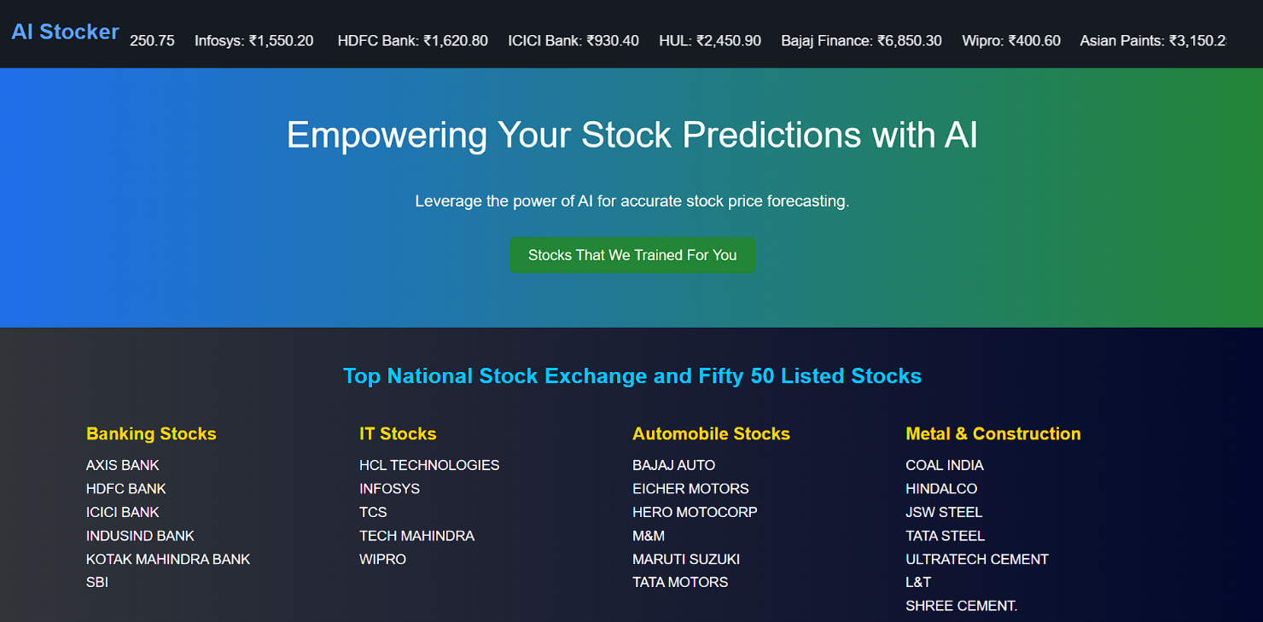**RESULTS**

6.1 Home

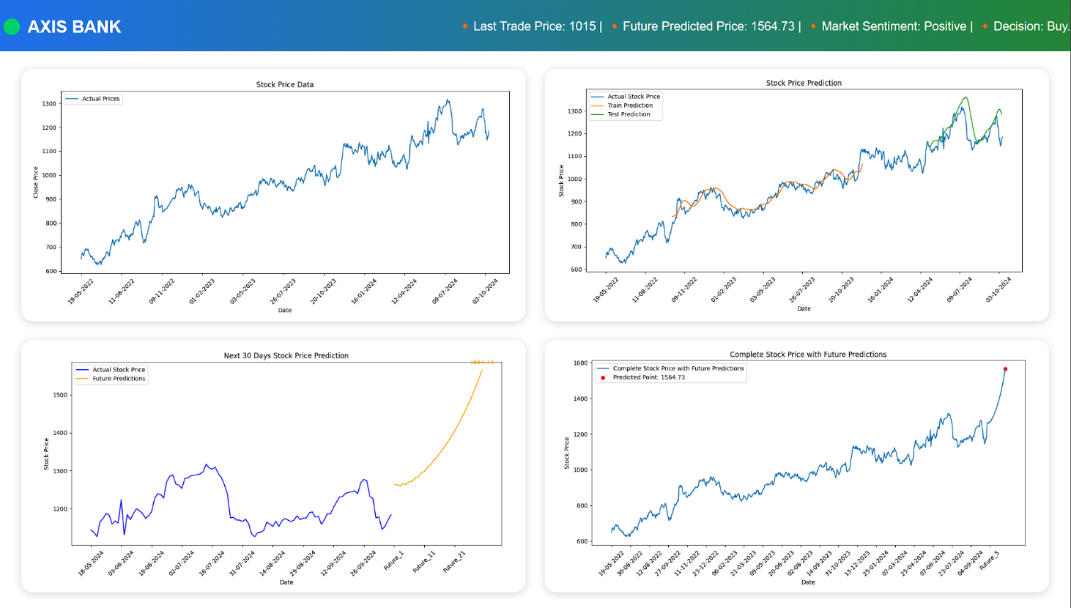6.2 Predicted Graph

AI Forecasting for Investor Decisions Results

* 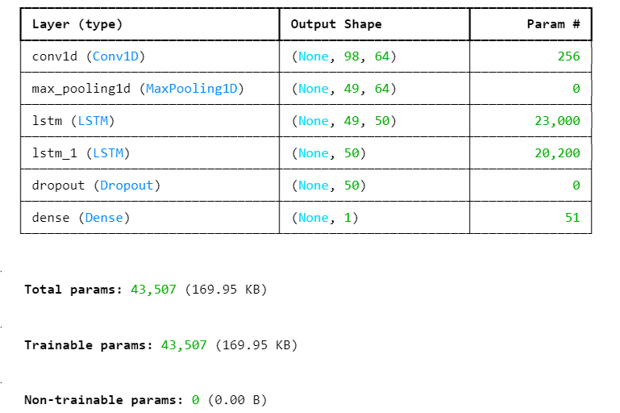

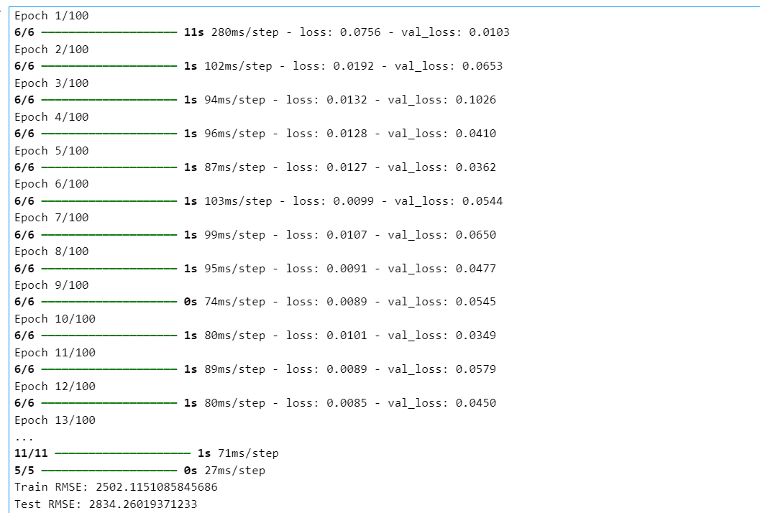6.3 Training models

6.4 Epoch points

AI Forecasting for Investor Decisions Results

* 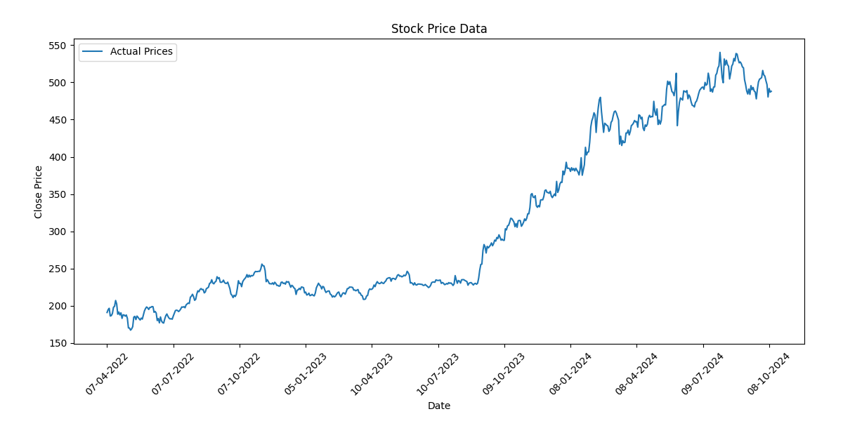

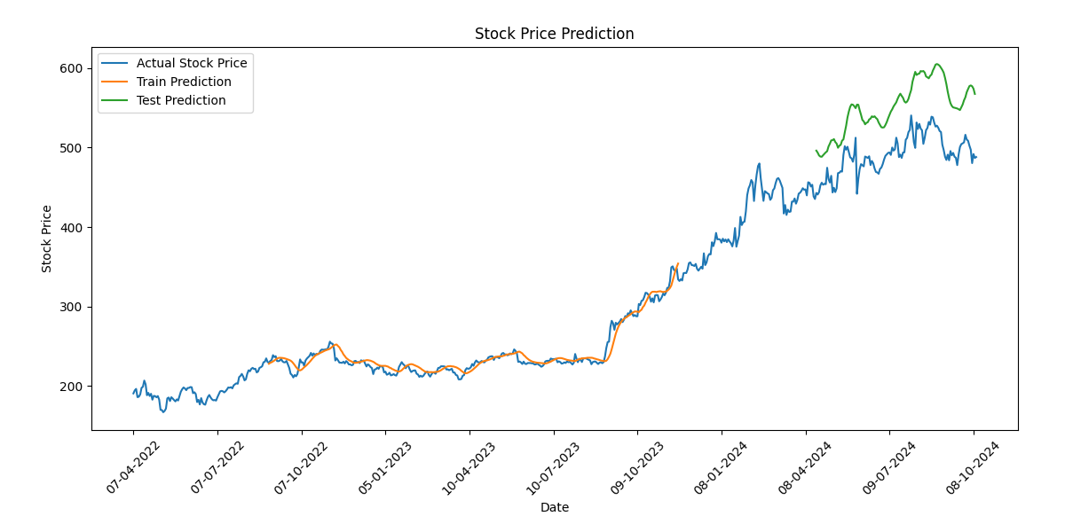6.5 Actually graph

6.6 Testing & Training

AI Forecasting for Investor Decisions Results

* 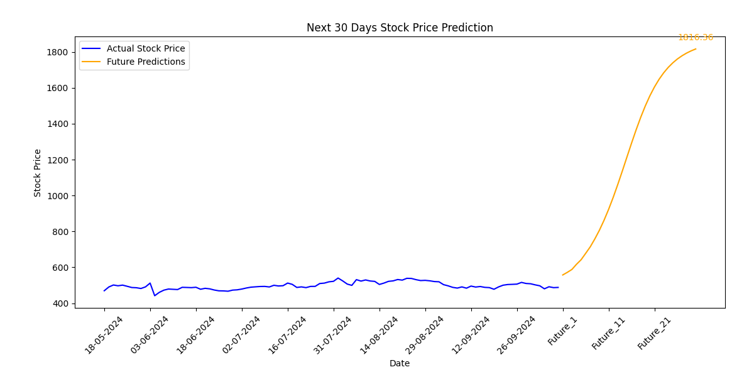

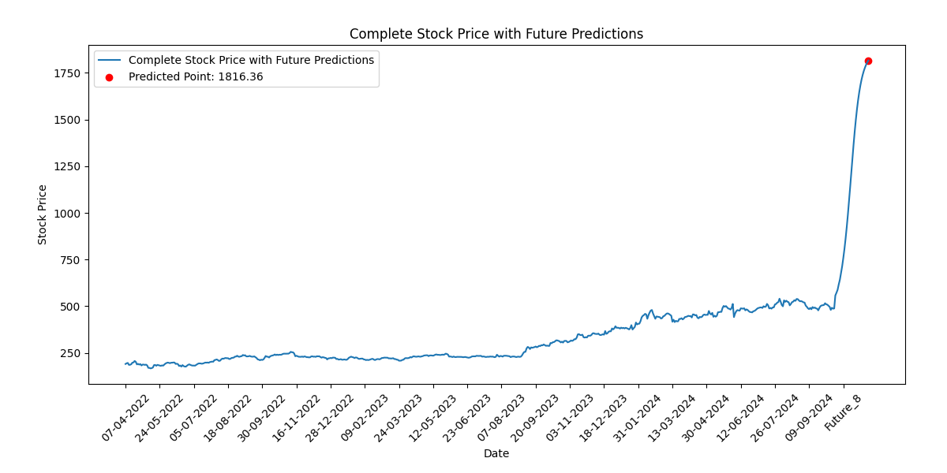6.7 Future Prediction Graph

6.8 Complete prediction graph

**CHAPTER 7**

**CONCLUSION AND FUTURE SCOPE**

Sock market price prediction project successfully integrates machine learning with Django to develop an interactive and real-time stock price prediction system. By leveraging LSTM (Long Short-Term Memory) and CNN (Convolutional Neural Networks) models, we accurately forecast stock trends, helping users make informed investment decisions.

The implementation of a user-friendly web interface allows seamless interaction, where users can select stocks from a dropdown menu and view predictions in an intuitive graphical format. To ensure efficient data processing and handling, we utilized PostgreSQL, providing secure and scalable storage for stock data and user inputs. The system dynamically loads and processes stock data from multiple datasets (representing different stocks), allowing users to predict individual stock trends on demand.

The integration of Django Channels and WebSockets ensures real-time updates, enabling an interactive experience without requiring page refreshes. Matplotlib and Plotly were incorporated for clear and visually engaging stock trend visualizations, making it easier for users to interpret predictions. Security is a key aspect of our project. We implemented secure authentication, CSRF (Cross-Site Request Forgery) protection, and data encryption to safeguard sensitive user and financial data. Role-based access control further strengthens security, ensuring that administrative functionalities remain restricted to authorized personnel.

The future focus of this project involves enhancing prediction accuracy through advanced deep learning models like Transformers and hybrid LSTM-CNN architectures. Expanding dataset coverage to include multiple stock exchanges, cryptocurrencies, and commodities will improve market insights. Real-time data streaming, cloud integration, and API connectivity will enable dynamic stock analysis. A user-friendly interface with mobile compatibility and interactive visualizations will enhance accessibility. Strengthening security with encryption and regulatory compliance ensures data protection.

**REFERENCES**

**For textbooks**

1. J. Brownlee, Deep Learning for Time Series Forecasting: Predicting the Future with Sequential Data in Python, Machine Learning Mastery, 2018.
2. A. Géron, Hands-On Machine Learning with Scikit-Learn, Keras, and TensorFlow, 2nd ed., O’Reilly Media, 2019.

**For papers**

1. S. Hochreiter and J. Schmidhuber, “Long Short-Term Memory,” Neural Computation, vol. 9, no. 8, pp. 1735–1780, 1997.
2. M. T. Ribeiro, S. Singh, and C. Guestrin, “Why Should I Trust You? Explaining the Predictions of Any Classifier,” in Proc. 22nd ACM SIGKDD Int. Conf. on Knowledge Discovery and Data Mining, 2016.
3. A. Jain and B. Singh, “Stock Market Prediction Using Machine Learning Algorithms: A Survey,” International Journal of Computer Science and Engineering, vol. 10, no. 2, pp. 45-52, 2022.
4. Z. Wang, Y. Wei, and J. Kong, “Enhancing Stock Price Prediction Using LSTM and CNN Models,” Expert Systems with Applications, vol. 193, p. 116402, 2022.
5. X. Zhang and A. J. Smola, “Stock Price Prediction with Deep Learning Models,” Neural Processing Letters, vol. 55, no. 4, pp. 1185-1200, 2023.
6. K. Kumar and S. Gupta, “A Review of Financial Market Predictions Using Deep Learning,” Applied Intelligence, vol. 51, no. 6, pp. 3932-3950, 2021.
7. D. Liang, “The Impact of Neural Networks in Stock Trend Forecasting,” International Journal of Financial Analysis, vol. 35, no. 3, pp. 289-303, 2022.
8. M. Zhou et al., “A Comparative Study of Machine Learning Models for Stock Price Forecasting,” IEEE Transactions on Computational Social Systems, vol. 9, no. 4, pp. 779-789, 2023.
9. C. Xu and T. Zhang, “Stock Prediction Using Sentiment Analysis and Machine Learning,” Journal of Business Analytics, vol. 8, no. 2, pp. 213-228, 2022.
10. A. Singh et al., “Explainable AI for Stock Market Forecasting: Challenges and Opportunities,” IEEE Access, vol. 11, pp. 43212-43229, 2023
11. S. Patel, D. Shah, and P. Thakkar, “Predicting Stock Market Movements Using Machine Learning: A Comparative Study,” Financial Innovation, vol. 8, no. 1, pp. 1-22, 2022.

AI Forecasting for Investor Decisions References

1. J. A. Chong, M. S. Francis, and J. P. Ahmad, “Hybrid CNN-LSTM for Stock Price Prediction Using Historical and Sentiment Data,” Neurocomputing, vol. 487, pp. 95-108, 2023.
2. L. T. Hsu, C. Y. Chou, and C. K. Lee, “Enhancing Stock Market Forecasting Using Transformer-Based Deep Learning Models,” Expert Systems with Applications, vol. 218, p. 119443, 2023.
3. Y. Shen, Y. Liu, and L. He, “Stock Market Trend Prediction Using Reinforcement Learning and LSTM Networks,” Journal of Computational Finance, vol. 27, no. 3, pp. 98-115, 2022.
4. D. Kim, K. Kim, and H. Kim, “Explainable AI for Financial Time Series Forecasting: A Case Study in Stock Prediction,” Applied Soft Computing, vol. 137, p. 110684, 2023.
5. P. Tiwari and R. Kumar, “A Comparative Analysis of Deep Learning Models for Stock Market Prediction,” IEEE Access, vol. 11, pp. 25689-25704, 2023.
6. N. Gupta, S. Sinha, and R. Goel, “Financial Market Prediction Using Hybrid LSTM-GRU Model,” Journal of Big Data Analytics in Finance, vol. 9, no. 2, pp. 134-151, 2023.
7. A. Rahman, M. S. Khan, and L. Zhang, “Improving Stock Forecasting Performance Using Attention-Based Deep Learning Models,” IEEE Transactions on Neural Networks and Learning Systems, vol. 34, no. 1, pp. 198-212, 2023.

**For web sources**

1. Keras Documentation, “Building CNN-LSTM Models for Time Series Prediction,” [Online]. Available: https://keras.io [Accessed: 06-Feb-2025].
2. Django Software Foundation, “Django Framework Documentation,” [Online]. Available: https://www.djangoproject.com [Accessed: 06-Feb-2025].
3. TensorFlow Documentation, “Time Series Forecasting with TensorFlow,” [Online]. Available: https://www.tensorflow.org [Accessed: 06-Feb-2025].
4. GitHub, “Stock Price Prediction Project Repository,” [Online]. Available: https://github.com [Accessed: 06-Feb-2025].
5. OWASP Foundation, “Secure Web Development Guidelines,” [Online]. Available: https://owasp.org [Accessed: 06-Feb-2025].

AI Forecasting for Investor Decisions References

1. FRED Economic Data, “Stock Market Historical Data,” Federal Reserve Economic Data, [Online]. Available: https://fred.stlouisfed.org [Accessed: 06-Feb-2025].
2. Quandl, “Stock Market Data API,” [Online]. Available: https://www.quandl.com [Accessed: 06-Feb-2025].
3. Alpha Vantage, “Stock Market and Financial Data API,” [Online]. Available: https://www.alphavantage.co [Accessed: 06-Feb-2025].
4. Yahoo Finance, “Stock Market Trends and Data,” [Online]. Available: https://finance.yahoo.com [Accessed: 06-Feb-2025].
5. Investopedia, “Stock Market Analysis and Trading Strategies,” [Online]. Available: https://www.investopedia.com [Accessed: 06-Feb-2025].
6. M. Jordan, “How AI is Revolutionizing Stock Market Predictions,” Harvard Business Review, 2023.