

**THROUGHPUT UNDER CHANNEL LOAD**

**PREPARED FOR** Netgear

**PREPARED BY**

Candela India Pvt Ltd

July 22, 2021

**Netgear Scripting Project**

# EXECUTIVE SUMMARY

The Throughput under Channel Load Test is designed to check the throughput feature of the Netgear AP under channel load. This feature utilizes channel with Load by running Layer 3 traffic on some clients which are connected through VAP after the channel is utilized with x% script creates clients on Netgear AP based on user inputs to check whether the overall throughput meets the expected data rate, based on which the automated script is designed.

The THROUGHPUT UNDER CHANNEL LOAD Test script is designed to test and make sure that the AP can successfully be getting the expected data rate per client based on overall throughput getting by connected clients after the channel meets the certain load and will provide clear PASS/FAIL results after the test is finished.

**Netgear Scripting Project:**

[22-07-2021]]

## 1. Project Overview

## The THROUGHPUT UNDER CHANNEL Load Test is designed to test the Performance of the Netgear Access Point. The goal of this test is to make sure that the AP can successfully be getting the expected data rate per client based on overall throughput getting by connected clients after the channel meets the certain load.

## 2. Test Procedure.

1. Script will create VAP on one of lanforge radio and few clients are created using different radio.

2. Layer 3 traffic is running between VAP and VAP clients with a certain data rate till the channel is utilized with expected.

3. Now, stations will create on Netgear ap and Layer 3 traffic will running with upload or download data rate for further created clients to monitor the throughput of connected clients.

**3. How to use Script?**

1. Open the Mate terminal in your lanforge.

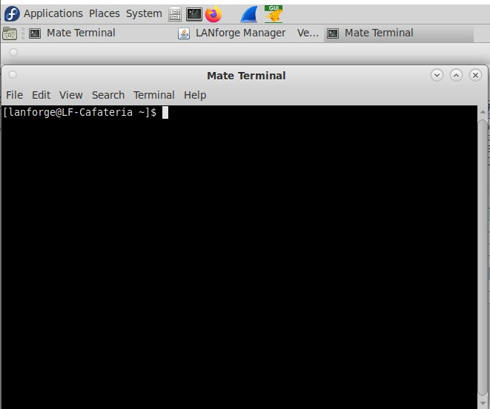

1. Change the directory to “throughput”

Command: cd home/lanforge/CandelaAutomationScripts/throughput

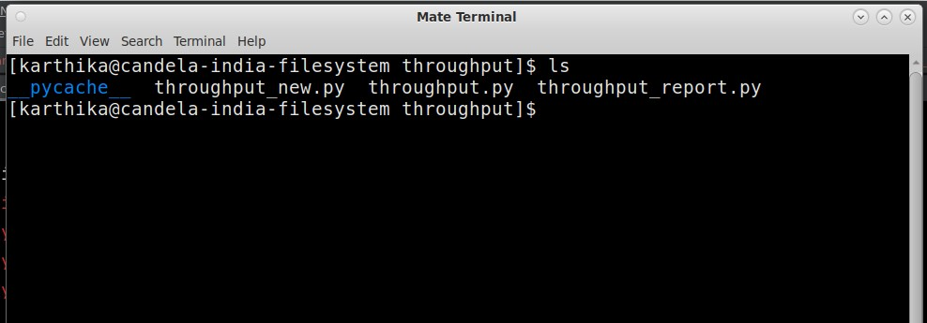

1. Use following cli to execute test-

~ **python3 throughput_new.py –ap_ip 192.168.208.196 –ap_name root –ap_password**

**Password@123xzsawq@! --mgr localhost –mgr_port 8080 --ssid loadbalance --passwd** **[BLANK] --security open --radio wiphy3 –vap_radio wiphy1 –vap_channel 36 – num_stations 40 –util 20-2000000 40-5000000 60-10000000 –upload 2000000 –download 2000000 –mode 9 –upstream_port eth1 –test_duration 5**

Here

**--ap_ip -** AP ip

**--ap_name** - AP webpage login/username

**--ap_password -** AP webpage password

**--mgr** - LANforge ip address but if you are running script inside lanforge use “localhost”

**--mgr_port** - port Lanforge GUI HTTP service is running on

**--ssid** - ssid for clients

**--passwd** - password to connect to ssid if open security use [BLANK]

**--security** - security type used by ssid default open

**--radio** - radio at which client will be connected

**--vap_radio** - radio at which VAP will be connected

**--upstream** - provide upstream name like eth1/eth2 by default eth1 is used

**--vap_channel -** channel of AP from where the VAP will be created

**--util** - Channel Utilization to load the channel with data rate

**--mode** – used to force mode of station

**--test_duration** – set the duration of the test in minutes.

**--upload** – upload bps rate minimum for side_a of netgear

**--download** - download bps rate minimum for side_b of netgear

**--num_station** – number of stations to create

9. After execution of script, results can be seen in html-reports directory at location /home/lanforge/html-reports

Pdf report (throughput_channel_load.pdf) and html reports (throughput_channel_load.html) can be found inside Throughput_Under_Channel_Load folder as per execution date

## 4. Results

Screenshot of pdf report generation is shown below

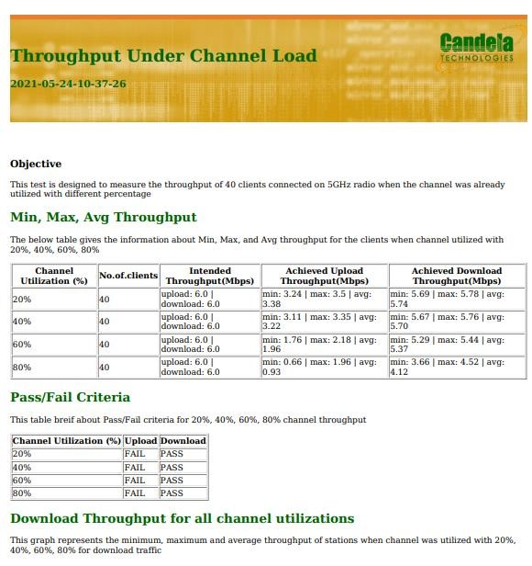

**5**

**. Contact**

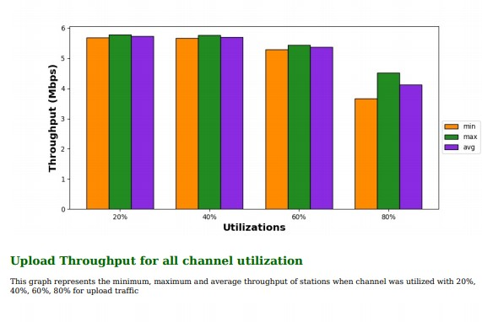

Visit -<https://www.candelatech.com/>

For any support related help contact - support@candelatech.com