

**VIDEO STREAMING**

**PREPARED FOR** Netgear

**PREPARED BY**

Candela India Pvt Ltd

July 22, 2021

**Netgear Scripting Project**

# EXECUTIVE SUMMARY

Video streaming test feature is designed to measure video quality of experience on connected clients to DUT over 2.4Ghz/5Ghz band by calculating key performance indicators for video parameters such as Stalled counts and Throughput for station.

This Automation script will take the inputs like file size, emulation rate, buffer intervals and throughput from script/user and execute the process and generate the report with Pass/Fail results.

**Netgear Scripting Project:**

[22-07-2021]]

## 1. Project Overview

The VIDEO STREAMING Test is designed to test the Performance of the Netgear Access Point. The goal of this test is to make sure that the AP is able to successfully downlaod the file within expected number of video stalls.

## 2. Test Procedure

1. Test will create clients on lanforge radios and associate to DUT.
2. Once IP was assigned to stations, Layer 4-7 traffic will run between lanforge and AP
3. Clients can connect to any of the band (2.4/5) and run traffic for all emulation rates.
4. Script will calculate the throughput and number of stalls for all the stations
5. All the collected values will be plotted in the graph.

**3. How to use Script?**

1. Open Mate terminal in your lanforge.

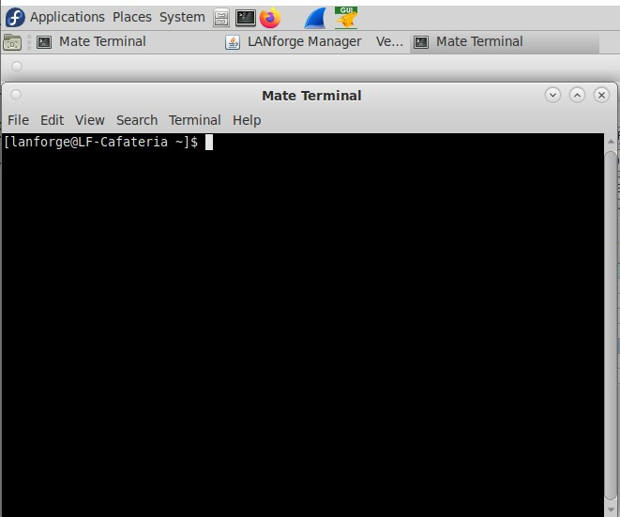

1. Change directory to video_streaming

Command: cd home/lanforge/CandelaAutomationScripts/video_streaming

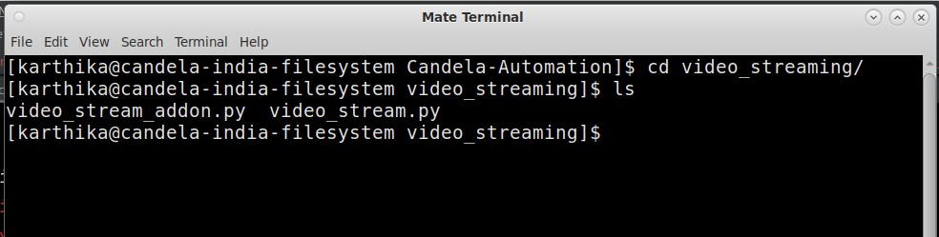

1. Use following cli to execute test-

~**python3 video_stream_ver_2.py --ap_name WAC505 --mgr localhost --mgr_port 8080   
--ssid loadbalance --passwd [BLANK] --lanforge_passwd lanforge --security open   
--bands_with_radio 2.4g-wiphy3 5g-wiphy0 5g+2.4g-wiphy0,wiphy1 --file_size 30Mb   
--emulation_rate 6 4k “hd 720p” --buffer_interval 5 --num_stations 40 --expected_stalls 6 --url 192.168.212.94/video.mp4 --threshold 70 --upstream_port eth1 --duration 5**

**--ap_name** - AP webpage login/username

**--mgr** - LANforge ip address but if you are running script inside lanforge use “localhost”

**--mgr_port** - port Lanforge GUI HTTP service is running on

**--ssid** - ssid for clients

**--passwd** - Password to connect to ssid if open security use [BLANK]

**--lanforge_passwd** – Password of lanforge to create file

**--security** - security type used by ssid default open

**--bands-with-radio** - choose the band as well as radio for that band

**--file_size** - size of file which is going to download

**--upstream** - provide upstream name like eth1/eth2 by default eth1 is used

**--emulation_rate -** video emulation rate per client to run traffic

**--buffer_interval** - buffer size

**-- duration** - set the duration of the test in minutes.

**--expected_stalls -** expected number of stalls per station

**--url** - url on eth1 to test HTTP

**--num_station** - number of stations to create

**--threshold** – threshold in percentage

After execution of script, results can be seen in html-reports directory at location /home/lanforge/html-reports

Pdf report (video_stream.pdf) and html reports (video_stream.html) can be found inside Video_streaming folder as per execution date

## 4. Results

Attached a screenshot of generated report as per execution date

**5**

**. Contact**

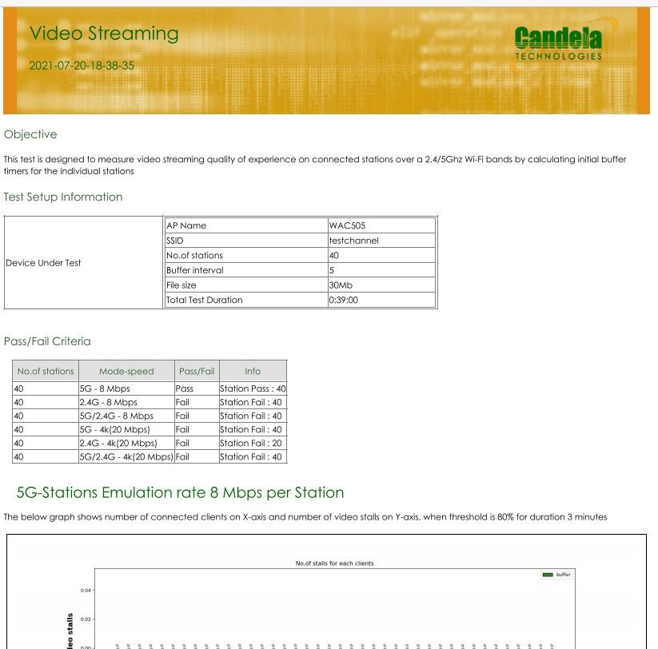

Visit -<https://www.candelatech.com/>

For any support related help contact - support@candelatech.com