

**IPERF-3**

**PREPARED FOR** Netgear

**PREPARED BY**

Candela India Pvt Ltd

July 22, 2021

**Netgear Scripting Project**

# EXECUTIVE SUMMARY

Iperf-3 is a tool for network performance measurement and tuning. The aim of this test to verify that aggregate throughput and per client throughput meets the expectation.

**Netgear Scripting Project:**

[22-07-2021]

## 1. Test Procedure

1. Script will are create mac-vlan and clients in port-mgr tab
2. Create generic-eth and generic-sta in generic tab
3. Run the uplink, downlink in generic tab
4. For bi-direction, station will flow the traffic in layer 3 tab
5. All the collected values will be ploted in the graph.

**3. How to use Script?**

1. Open the Mate terminal in your lanforge.

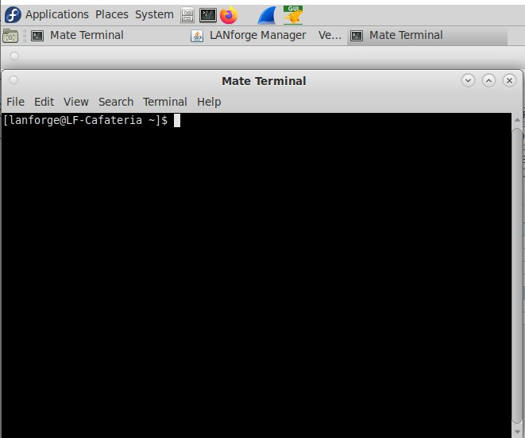

1. Change the directory to “cd home/lanforge/CandelaAutomationScripts/Iperf3”
2. execute the python test eg -
3. **Run uplink test for 2.4GHz** = python iperf3_test.py --mgr 192.168.200.12 --mgr_port 8080 --ssid portal --passwd [Blank] --sec open --radio0 wiphy0 --radio1 wiphy1 --macvlan eth1 --mode0 6 --mode1 10 --num_ports 2 --tx_rate 5000 --time 60 --side_a_min_speed 5000000 --side_b_min_speed 500000 --test_2G 1 --test_2G_up 1 --resource 2
4. **Run all test for all scenario** = python iperf3_test.py --mgr 192.168.200.12 --mgr_port 8080 --ssid portal --passwd [Blank] --sec open --radio0 wiphy0 --radio1 wiphy1 --macvlan eth1 --mode0 6 --mode1 10 --num_ports 2 --tx_rate 5000 --time 60 --side_a_min_speed 5000000 --side_b_min_speed 500000 --all_test 1
5. **Run downlink and bi-dir test for 5GHz** = python iperf3_test.py --mgr 192.168.200.12 --mgr_port 8080 --ssid portal --passwd [Blank] --sec open --radio0 wiphy0 --radio1 wiphy1 --macvlan eth1 --mode0 6 --mode1 10 --num_ports 2 --tx_rate 5000 --time 60 --side_a_min_speed 5000000 --side_b_min_speed 500000 --test_5G 1 --test_5G_dw 1 --test_5G_bi 1
6. **Run bi for 2+5 GHz scenario** = python iperf3_test.py --mgr 192.168.200.12 --mgr_port 8080 --ssid portal --passwd [Blank] --sec open --radio0 wiphy0 --radio1 wiphy1 --macvlan eth1 --mode0 6 --mode1 10 --num_ports 2 --tx_rate 5000 --time 60 --side_a_min_speed 5000000 --side_b_min_speed 500000 --test_both 1 --test_both_bi 1

optional arguments:

-h, --help show this help message and exit

--ssid SSID SSID for stations to associate to

--passwd PASSWD Number of stations to create

--security SECURITY security type to use for ssid { wep | wpa | wpa2 | wpa3 | open }

--radio0 RADIO0 radio EID for 2.4 GHz, e.g: 1.wiphy2

--radio1 RADIO1 radio EID for 5 GHz, e.g: 1.wiphy2

--mode0 MODE0 select bssid for 2.4 GHz, e.g: 6

--mode1 MODE1 select bssid for 5 GHz, e.g: 10

--macvlan_parent MACVLAN_PARENT specifies parent port for macvlan creation

--num_ports NUM_PORTS number of ports to create

--tx_rate TX_RATE Enter the tx rate in Kbps eg. 10Mbps=10000k

--time TIME Enter the run time in sec

--side_a_min_speed SIDE_A_MIN_SPEED --speed you want to monitor traffic with (max is 10G)

--side_b_min_speed SIDE_B_MIN_SPEED --speed you want to monitor traffic with (max is 10G)

--all_test ALL_TEST --run all scenario

--all_test_up ALL_TEST_UP --run uplink test for all scenario

--all_test_dw ALL_TEST_DW --run downlink test for all scenario

--all_test_bi ALL_TEST_BI --run bi-directional test for all scenario

--test_2G TEST_2G --run 2.4 GHz scenario

--test_2G_up TEST_2G_UP --run uplink for 2.4 GHz scenario

--test_2G_dw TEST_2G_DW --run downlink for 2.4 GHz scenario

--test_2G_bi TEST_2G_BI --run bi-directional for 2.4 GHz scenario

--test_5G TEST_5G --run 5 GHz scenario

--test_5G_up TEST_5G_UP --run uplink for 5 GHz scenario

--test_5G_dw TEST_5G_DW --run downlink for 5 GHz scenario

--test_5G_bi TEST_5G_BI --run bi-directional for 5 GHz scenario

--test_both TEST_BOTH --run 2+5 GHz scenario

--test_both_up TEST_BOTH_UP --run uplink for 2+5 GHz scenario

--test_both_dw TEST_BOTH_DW --run downlink for 2+5 GHz scenario

--test_both_bi TEST_BOTH_BI --run bi-directional for 2+5 GHz scenario

--ap_ip AP_IP --Enter the AP Ip Address

--user USER --Enter the username

--resource RESOURCE --Enter the resource

.

After execution of script results can be seen on the html-reports directory

`~ /home/lanforge/html-reports

Log files can be seen in py-jsonfolder

Pdf report (output.pdf) and html reports (output.html) can be found inside py- json folder

## 4. Results

Screenshot of pdf report generation is shown below

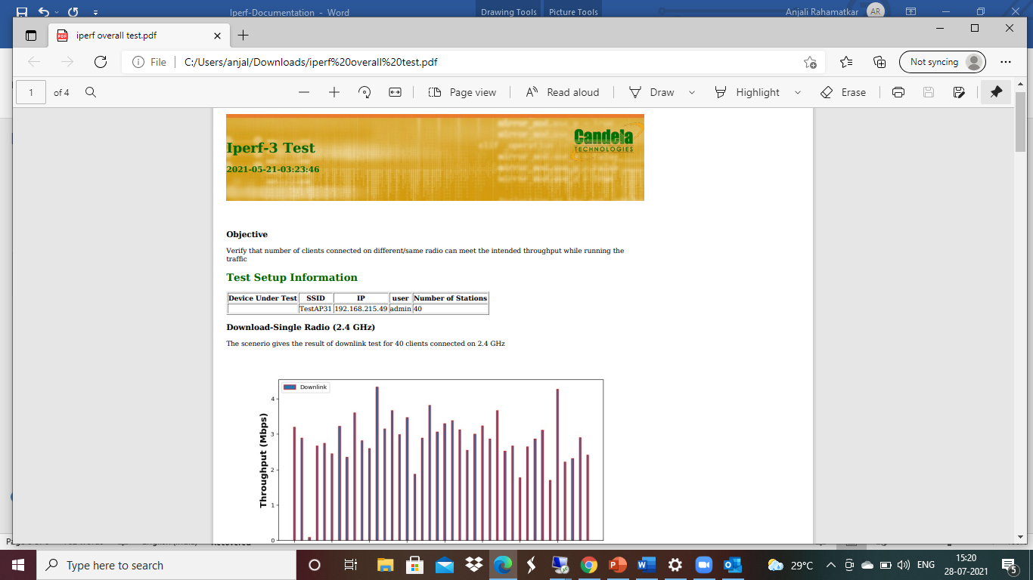

Visit -<https://www.candelatech.com/>

For any support related help contact - support@candelatech.com