TRAFFIC SIGNAL

**ABSTRACT**

1. Main aim of this project is to illustrate the concepts and usage of pre-built functions in openGL.

2. Simulation of a traffic signal is being done using computer graphics. 3. We have used keyboard to interact with the program.

**SYSTEM SPECIFICATIONS**

***SOFTWARE REQUIREMENTS:***

*OPENGL*

*CODEBLOCKS*

**HARDWARE REQUIREMENT:**

*GRAPHICS SYSTEM*

**Introduction to openGL**

As a software interface for graphics hardware, OpenGL's main purpose is to render two- and three-dimensional objects into a frame buffer. These objects are described as sequences of vertices or pixels. OpenGL performs several processing steps on this data to convert it to pixels to form the final desired image in the frame buffer.

**Interaction with program**

Press R -> For Red Light

Press O ->Orange Light

Press G ->Green Light

Press Escape for exit

**Various functions used in this program**

**glutInit()** : interaction between the windowing system and OPENGL is initiated

**glutInitDisplayMode()** : used when double buffering is required and depth information is required

**glutCreateWindow()** : this opens the OPENGL window and displays the title at top of the window

**glutInitWindowSize()** : specifies the size of the window

**glutInitWindowPosition()** : specifies the position of the window in screen co-ordinates

**glutKeyboardFunc()** : handles normal ascii symbols

**glutSpecialFunc()** : handles special keyboard keys

**glutReshapeFunc()** : sets up the callback function for reshaping the window

**glutIdleFunc()** : this handles the processing of the background **glutDisplayFunc()** : this handles redrawing of the window **glutMainLoop()** : this starts the main loop, it never returns **glViewport()** : used to set up the viewport

**glVertex3fv()** : used to set up the points or vertices in three dimensions

**OUTPUT-:**

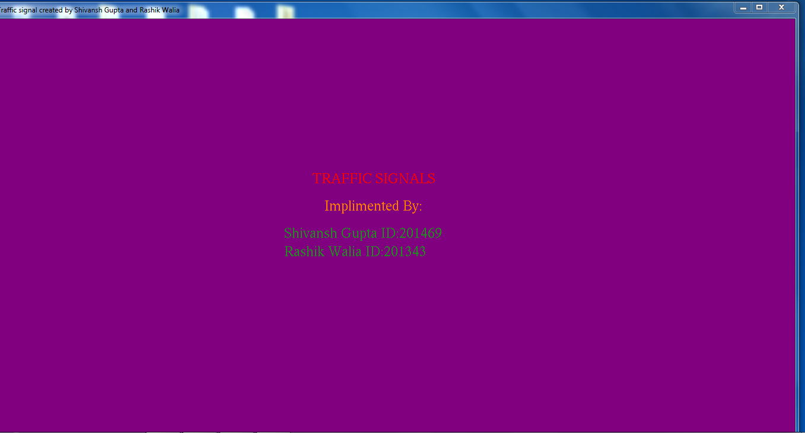

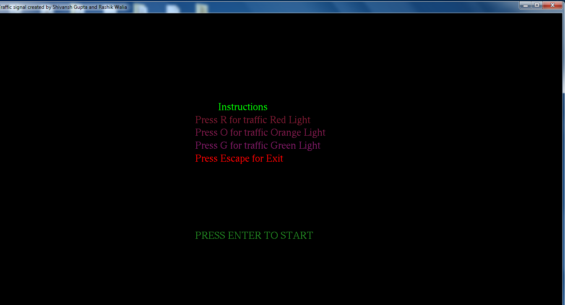

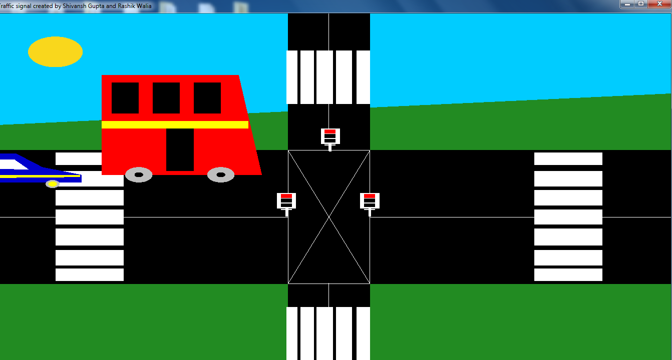

**Conclusions**

The project “Traffic Signal” clearly demonstrates the simulation of traffic signal

using OpenGL.

Finally we conclude that this program clearly illustrate the traffic signal using

openGL and has been completed successfully and is ready to be demonstrated.