### **Solar Tracking Device**

### **Project Report**

# *Submitted in partial fulfillment of the requirements*

# *for the completion of course*

### **Electronics System Design**

### **In**

### **ICT**

### By

**Aman Dave** (1741003)

**Aditya Shah**(1741007)

**Shivansh Nautiyal**(1741037)

**Param Shah**(1741019)

Under the guidance of

Mentor Name

Prof. Jaina Mehta

### **School of Engineering and Applied Science**

### **Ahmedabad University**

### **Ahmedabad - 380009**

### **November 2017**

**ABSTRACT**

In our project, we have tried to increase the efficiency of a normal solar panel. We have used 4 Light Dependent Resistors (LDR) to detect the movement of the sun throughout the day and have tried to move the solar panel accordingly. With the use of two servo motors to rotate the solar panel we could achieve almost 360 degree rotation of the solar panel. With this project we hope the upcoming solar panels have a solar tracking device inbuilt with them.

**ACKNOWLEDGEMENT**

First of all,we would like to acknowledge SEAS,Ahmedabad University for being an institution which promotes project based learning,through which students like us get theory as well as practical knowledge .

We would like to thank our mentor Prof. Jaina ma’am for motivating us to keep working on the problem despite facing difficulties and solving our doubts.

We would like to then thank our subject instructor Prof. Ashok Ranade for making our subject base clear.

We would also like to then thank Parth Sir for helping us in every way possible. At last, we would like to thank lab supervisor Mr. Govind Prajapati and Mr. Amar for allowing us to use all the lab resources and all providing us with project requirements.

Index

|  |  |  |  |  |  |
| --- | --- | --- | --- | --- | --- |
| **Chapter No.** | **Title** | | **Page No.** | | |
|  | **Abstract** | | **i** | | |
|  | **Acknowledgement** | | **ii** | | |
| **1** | **Background and Motivation** | | 1 | | |
|  | 1.1 |  | |  | |
|  | 1.2 |  | |  | |
| **2** | **System Architecture** | | | 2 | |
|  | 2.1 |  | |  | |
|  | 2.2 |  | |  | |
| **3** | **System Requirements and Specifications** | | | 3 | |
|  | 3.1 |  | |  | |
|  | 3.2 |  | |  | |
| **4** | **System Design** | | | 4 | |
|  |  |  | |  | |
|  |  |  | |  | |
| **4** | **Project outcomes, learning and challenges faced** | | 5 | | |
| **5** | **Project Cost** | | 6 | | |
| **6** | **Conclusion** | | 7 | | |
| **7** | **References** | | 8 | | |

**Chapter 1**

**Background and Motivation**

We were asked to come up with an idea so as to save electricity using Arduino Board. The first thing we did, we jotted down various reason where electricity was being used. While doing this research, we came across an article stating that 41% of CO2 emissions were caused by Electricity and Heating.So we thought of some ways to decrease this usage. Another thought that came to the mind was, a penny saved was a penny earned. So, if we somehow manage to increase efficiency of some device which can generate electricity we would be able to save electricity indirectly. And from this we came to the idea of increasing the efficiency of a Solar Panel by rotating as the sun moves. And hence, our product, Solar Tracking Device was made.

**Chapter 2**

**System Architecture**

**2.1 Block Diagram**

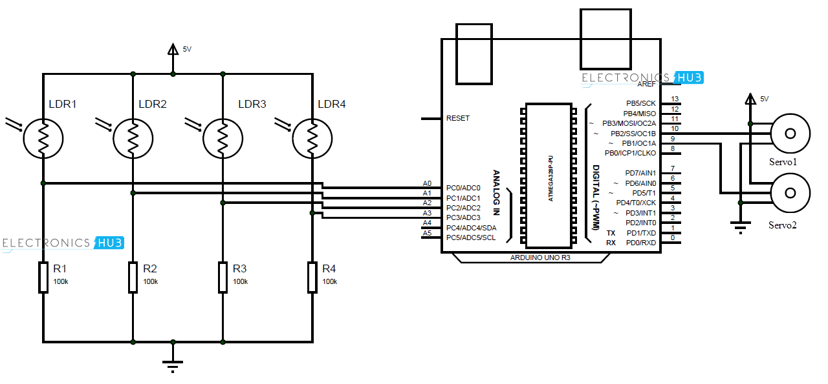

**2.2 Flowchart**

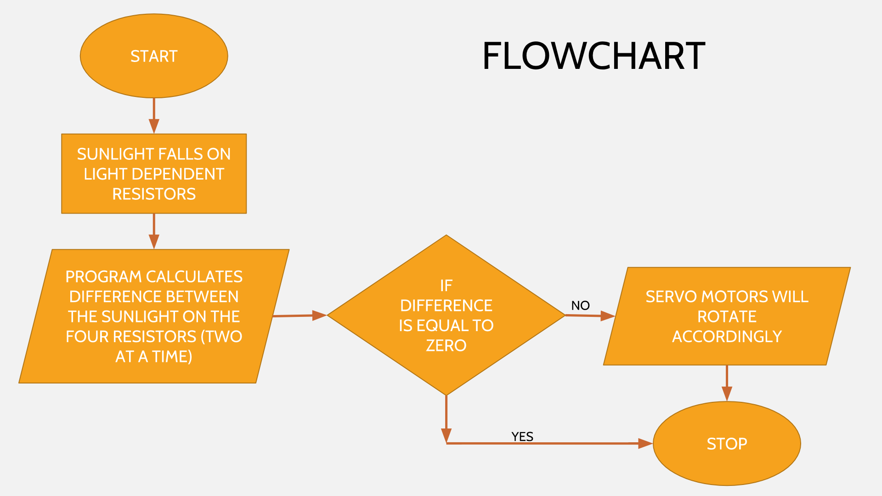

**Chapter 3**

**3.1 System Requirements**

* Arduino Uno Board
* Servo Motor(SG 90)
* Solar Panel
* LDR (x4)
* 1K Resistors(x4)
* Battery
* Buck Converter
* Capacitor

**3.2 Specifications**

* Servo Motor
  + Modulation :Analog
  + Torque :1.8 kg/cm
  + Weight :9g
  + Length :23mm
  + Width :12.2mm
  + Height :23mm
* Solar Panel
  + Maximum power :0.3W
  + Maximum power voltage :4V
  + Maximum power current :75mA
* Light Dependent Resistor
  + Maximum voltage @0lux :200V
  + Peak wavelength : 600nm
  + Minimum resistance @10lux :1.8kohm
  + Maximum resistance @10lux :4.5kohm

**Chapter 4**

4.1 System Design

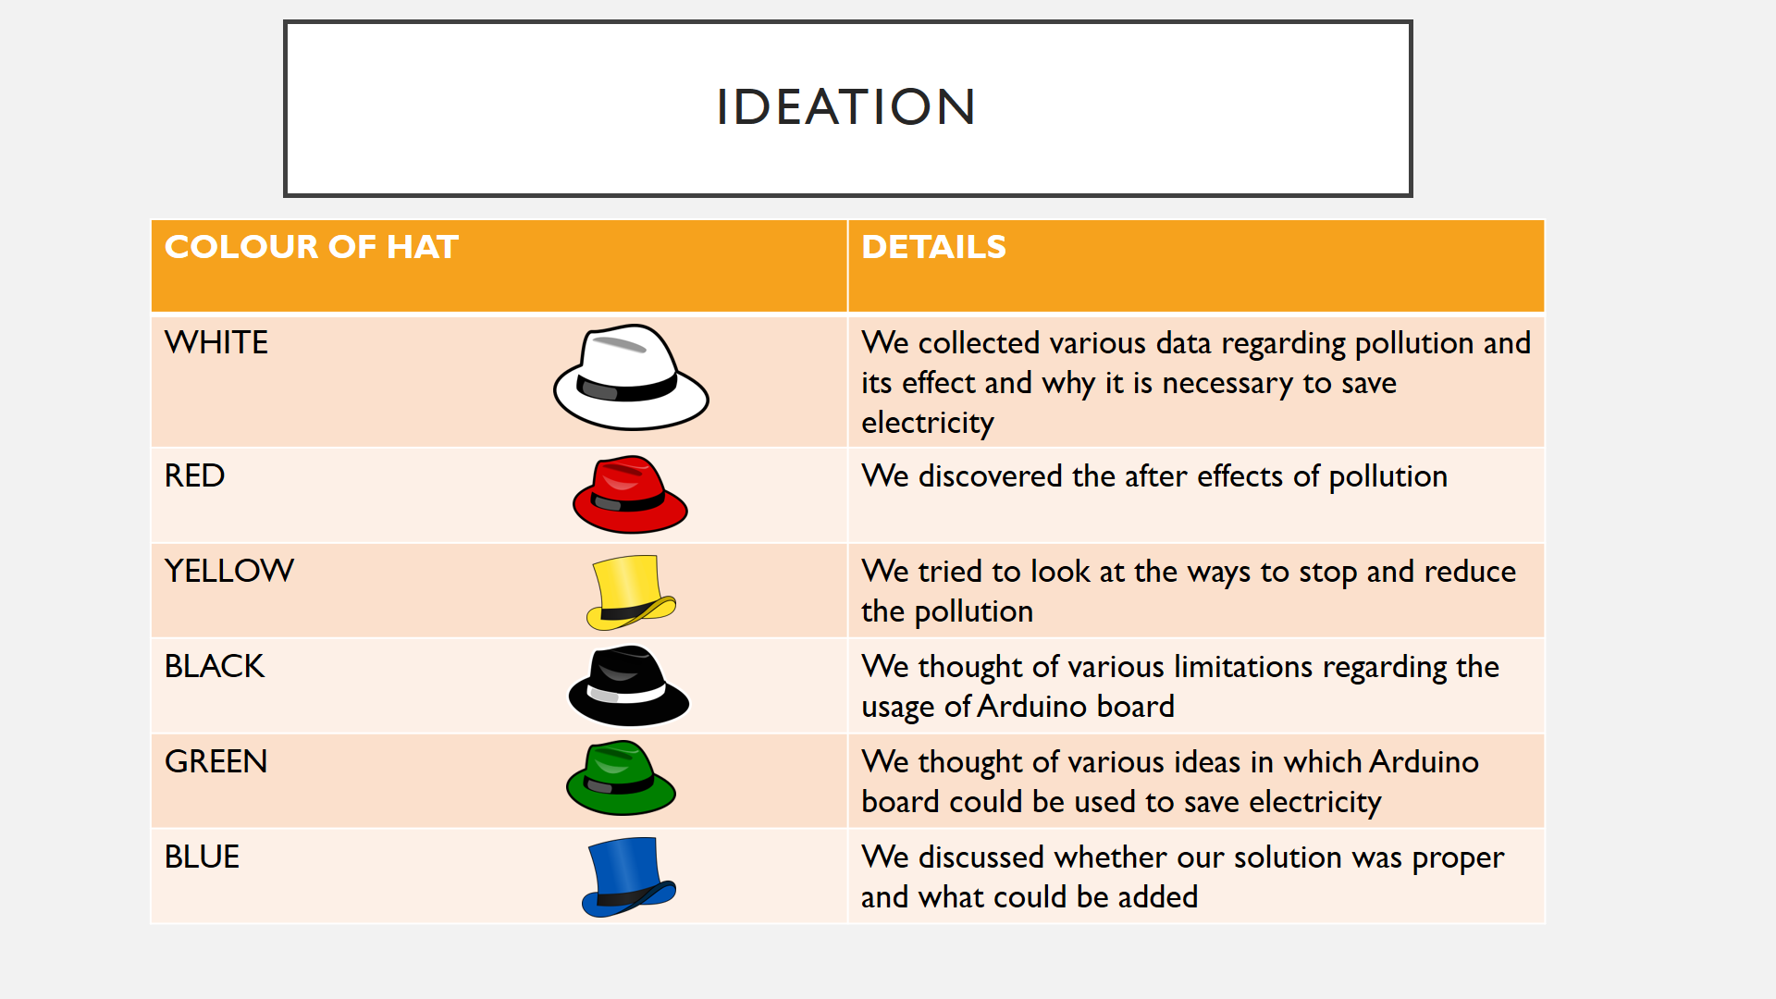

4.2 Project Outcomes, Learning and Challenges Faced

4.2.1 Project Outcomes

We could come with a device which could track the movement of sun as it moves. The device worked with more than 95% efficiency.

4.2.2 Project learning

The most important thing we learnt was how to debug any code and how to have neat connections of wires. Our mentor Prof. Jaina guided us in depth about various way to debug a code and how to handle neat connections. We also learnt about Servo libraries and using buck converters to store energy.

4.2.4 Challenges Faced

The foremost challenged we faced was coming together as a team. Most of the time, at least(!) one of us would be absent. Getting work done from each other was another challenged we faced.

One of the technical challenge we faced was to come up with a solution that could track the sun movement and move motors accordingly.We tried various ways, and after some brainstorming we came up that taking average of all the LDRs would solve our problem.

**Chapter 5**

**Project Cost**

|  |  |  |  |  |  |
| --- | --- | --- | --- | --- | --- |
| Sr.  No | Name of Component | Detailed Specifications | No of Quantity | Cost per Quantity (Approx.) | Total |
| *1.* | *Servo Motor* | *SG 90* | *2* | *184* | *368* |
| *2.* | *Arduino Board* | *Arduino UNO* | *1* | *459* | *459* |
| *3.* | *Solar Panel* | *SKU#735_4* | *1* | *176* | *176* |
| *4.* | *LDR* | *NPN* | *4* | *18* | *72* |
|  | *Resistors* | *1K Ohm* | *10* | *1* | *10* |
| *6.* | *9V Battery* | *HW001* | *1* | *30* | *30* |
| *7.* | *Voltage Regulator* | *LM317* | *1* | *70* | *70* |
| *8.* | *Diode* | *1N4007* | *1* | *10* | *10* |
| *9.* | *Capacitor* | *0.1uF* | *1* | *10* | *10* |
| *10.* | *Schottkey*  *Diode* | *1N5819* | *1* | *30* | *30* |
| *11.* | *Potentiometer* | *2K Ohm* | *1* | *510* | *510* |
| *12.* | *DC Buck Converter* | *LM2596* | *1* | *175* | *175* |

Total : 1920

**Chapter 6**

**Conclusion**

One of the myth among people is that Sun sets and rises from the same position irrespective of the season. But the truth is there is a major difference of 23.5 degrees between the sun rising in summer and sun rising in winter.

With the help of our Solar Tracking Device we can track this change of angle and move the Solar panel accordingly.

All our research during the time concluded that, if we can move the solar panel according to the movement of the sun, its efficiency can be increased by 30-40%

**Chapter 7**

**References**

* For circuit diagrams and block diagrams:
  + <https://circuitdigest.com/microcontroller-projects/arduino-solar-panel-tracker>
  + <http://www.electronicshub.org/arduino-solar-tracker/#Project_Code>
* For price analysis:
  + amazon.in
  + ebay.in
* For various facts and figures
  + CO2 Emissions from Fuel Combustion (2012), International Energy Agency.
  + <http://www.homeintheearth.com/tech_notes/basics-of-earthsheltering/passive-solar/>
  + <https://www.solarpowerworldonline.com/2016/05/advantages-disadvantages-solar-tracker-system/>