OLA Bookings Data Analysis Report
Comprehensive Analysis of 70,000+ Ride Bookings

Executive Summary
This report presents a comprehensive analysis of OLA ride-hailing booking data comprising 71,201 records. The analysis covers booking patterns, vehicle preferences, revenue metrics, payment methods, and customer satisfaction ratings.

Key Performance Metrics
Total Bookings | 71,201
Successful Rides | 44,271
Success Rate | 62.2%
Total Revenue | ₹24,216,619
Average Booking Value | ₹547.01
Average Ride Distance | 22.8 km
Average Rating | 4.00/5.0

1. Booking Status Analysis
Out of 71,201 total bookings, 44,271 were successfully completed, representing a success rate of 62.2%. The remaining bookings were either canceled by drivers (12,728), canceled by customers (7,214), or drivers were not found (6,988).
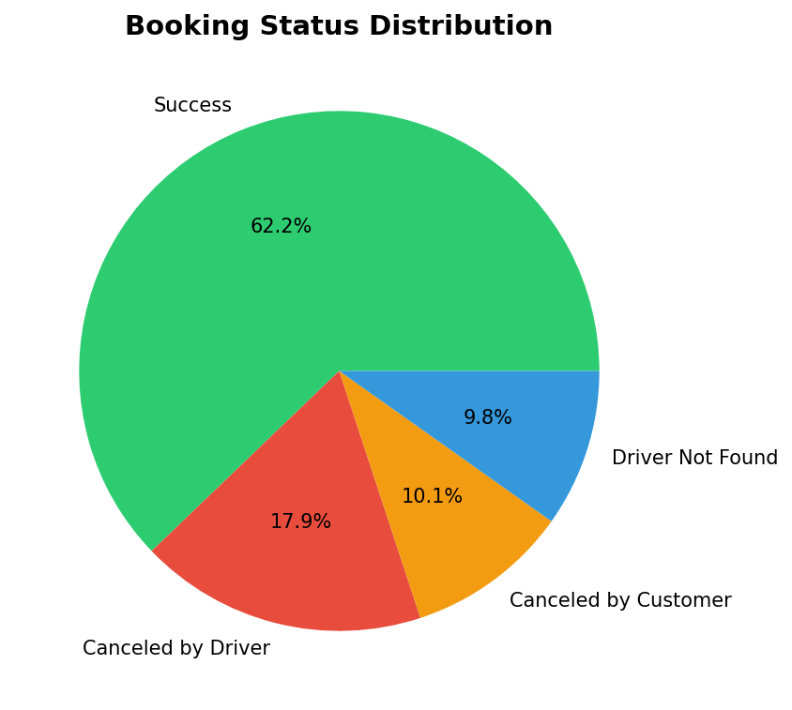

2. Vehicle Type Analysis
The distribution of bookings across vehicle types shows a fairly even spread. eBike leads with 10,271 bookings, followed by Prime Sedan (10,260) and Bike (10,193).
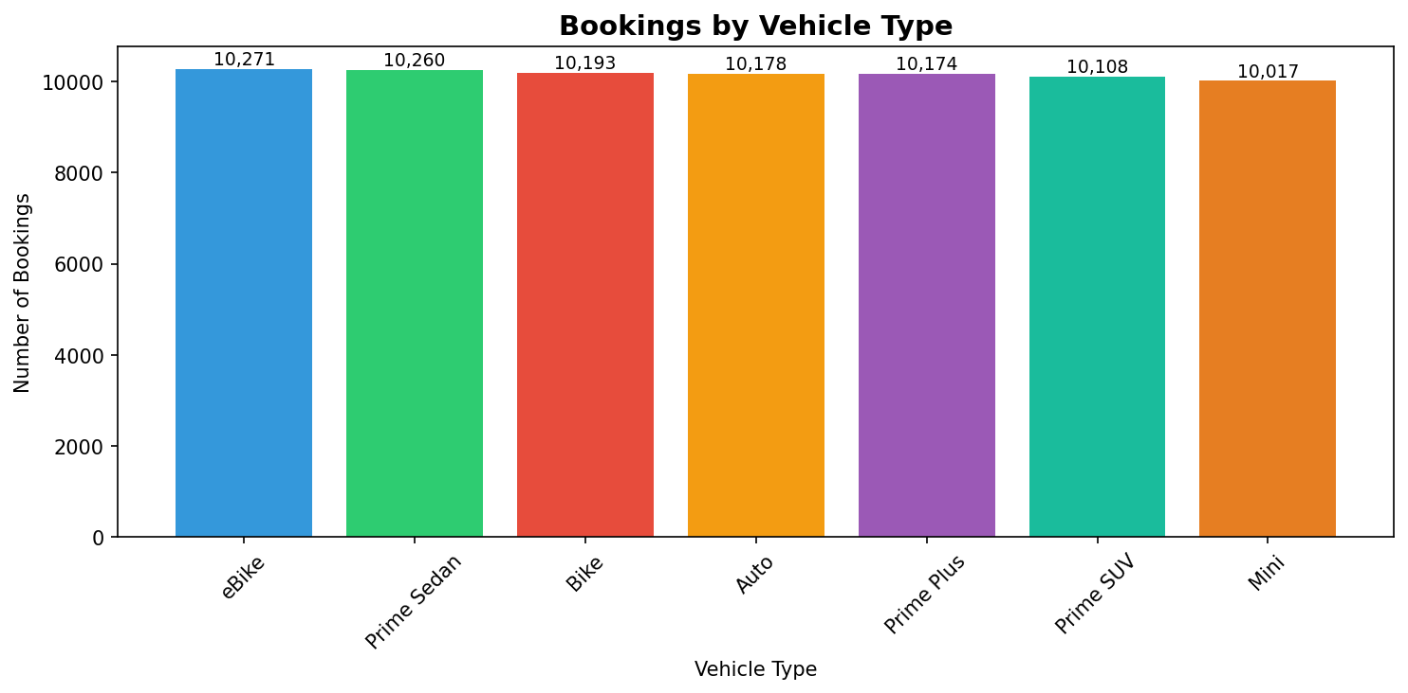

3. Revenue & Payment Analysis
Total revenue generated from successful rides amounts to ₹24,216,619, with an average booking value of ₹547.01. Cash remains the dominant payment method, followed by UPI transactions.
Revenue by Payment Method:
Payment Method | Revenue | Rides
Cash | ₹13,259,198 | 24,166
Credit Card | ₹900,354 | 1,683
Debit Card | ₹239,672 | 448
UPI | ₹9,817,395 | 17,974

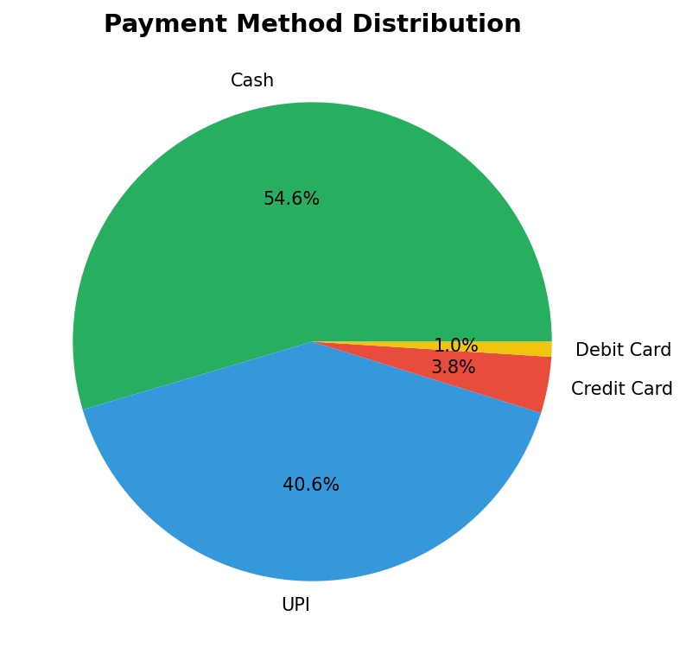

4. Customer & Driver Ratings
Both driver and customer ratings average around 4.00/5.0, indicating generally positive experiences. The distribution shows ratings concentrated between 3.0 and 5.0, with a notable peak at 5.0 stars.
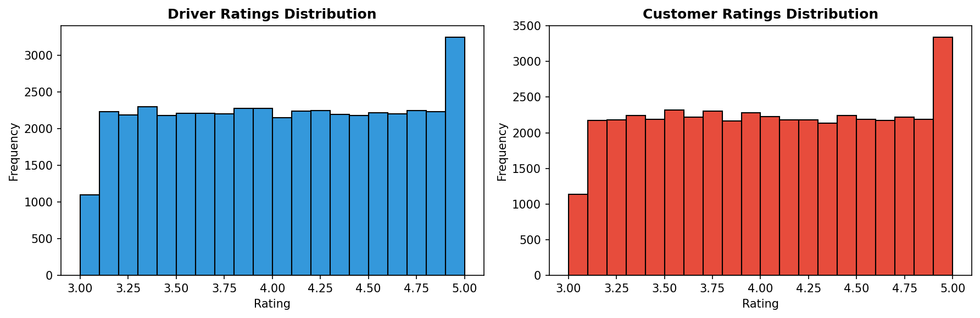

5. Key Findings & Recommendations
- Success Rate Concern: At 62.2%, nearly 38% of bookings fail - focus on driver availability
- Driver Cancellations: 12,728 cancellations need attention
- Payment Preference: Cash (54.6%) dominates - opportunity to promote digital payments
- Service Quality: Average rating of 4.0/5 is good but has room for improvement
- Vehicle Balance: Even distribution suggests healthy fleet management

____________________________________________________________
Report Generated: November 2025 | Data Source: OLA Bookings Dataset

