OLA BOOKINGS

Data Analysis Report

Comprehensive Analysis of Ride-Hailing Operations

Dataset: 71,201 Booking Records
Period: July 2024
Report Date: November 2025

Table of Contents
- 1. Executive Summary
- 2. Key Performance Indicators (KPIs)
- 3. Booking Status Analysis
- 4. Vehicle Type Analysis
- 5. Revenue & Financial Analysis
- 6. Payment Methods Analysis
- 7. Cancellation Analysis
- 8. Geographic Analysis
- 9. Time-Based Analysis
- 10. Customer & Driver Ratings
- 11. Key Findings & Insights
- 12. Strategic Recommendations
- 13. Conclusion

1. Executive Summary
This comprehensive report presents an in-depth analysis of OLA ride-hailing booking data, encompassing 71,201 individual booking records collected during July 2024. The analysis provides actionable insights into operational efficiency, customer behavior, revenue patterns, and service quality metrics that are critical for strategic decision-making.

1.1 Scope of Analysis
The analysis covers the following key dimensions:
- Booking success and failure patterns across different booking statuses
- Vehicle type preferences and their impact on business metrics
- Revenue generation and payment method distribution
- Cancellation trends and root cause analysis
- Geographic distribution of rides across pickup locations
- Time-based patterns including hourly and daily trends
- Customer and driver satisfaction through rating analysis

1.2 Key Highlights
• Success Rate: 62.2% of all bookings completed successfully
• Total Revenue: ₹24,216,619 generated from 44,271 successful rides
• Average Booking: ₹547.01 per successful ride
• Service Quality: 4.00/5.0 average driver rating
• Primary Payment: Cash transactions dominate at 54.6%

2. Key Performance Indicators (KPIs)
The following table summarizes the critical performance metrics derived from the dataset analysis:
Category | Metric | Value
Volume | Total Bookings | 71,201
Volume | Successful Rides | 44,271
Volume | Failed Bookings | 26,930
Performance | Success Rate | 62.2%
Performance | Cancellation Rate | 37.8%
Financial | Total Revenue | ₹24,216,619
Financial | Average Booking Value | ₹547.01
Financial | Revenue per Day | ₹807,221
Operations | Average Ride Distance | 22.8 km
Operations | Total Distance Covered | 1,011,524 km
Quality | Average Driver Rating | 4.00/5.0

2.1 KPI Interpretation
The success rate of 62.2% indicates that approximately 4 out of every 10 booking attempts do not result in a completed ride. This represents a significant opportunity for operational improvement. The daily revenue average of ₹807,221 suggests consistent demand, though addressing the 37.8% booking failure rate could substantially increase revenue.

3. Booking Status Analysis

3.1 Overview
Understanding the distribution of booking outcomes is crucial for identifying operational bottlenecks. The analysis reveals four distinct booking statuses, each representing different customer journey endpoints.
Status | Count | Percentage | Impact
Success | 44,271 | 62.2% | Positive - Revenue Generated
Canceled by Driver | 12,728 | 17.9% | Negative - Customer Dissatisfaction
Canceled by Customer | 7,214 | 10.1% | Neutral - Customer Choice
Driver Not Found | 6,988 | 9.8% | Negative - Supply Issue

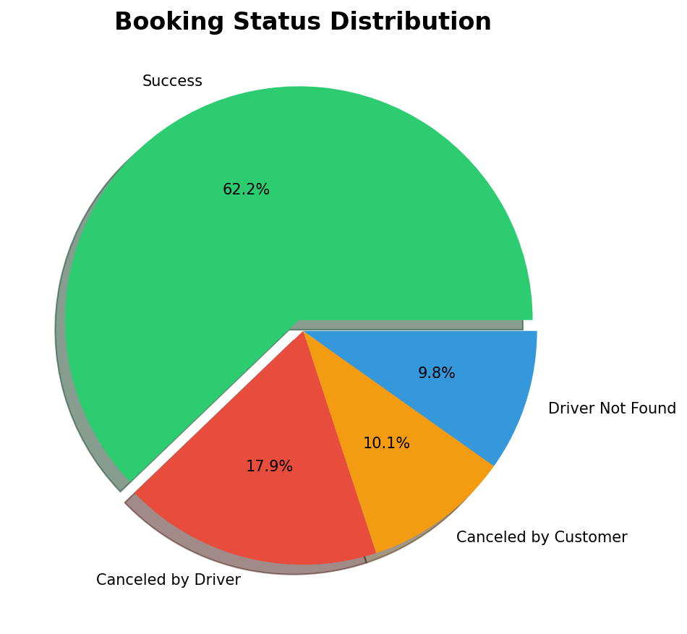
Figure 3.1: Distribution of Booking Statuses

3.2 Analysis of Failed Bookings
A total of 26,930 bookings (37.8%) did not complete successfully. This is broken down as follows:
- • Driver Cancellations: 12,728 bookings (17.9%) - This is the largest category of failed bookings and represents a critical area for improvement. Driver cancellations directly impact customer trust and platform reliability.
- • Customer Cancellations: 7,214 bookings (10.1%) - While customer cancellations are often unavoidable, understanding the reasons can help reduce this number.
- • Driver Not Found: 6,988 bookings (9.8%) - This indicates supply-demand imbalance in certain areas or times, requiring fleet optimization.

4. Vehicle Type Analysis

4.1 Fleet Composition
OLA operates a diverse fleet of 7 vehicle categories, each catering to different customer segments and price points. The distribution of bookings across vehicle types provides insights into customer preferences and market demand.
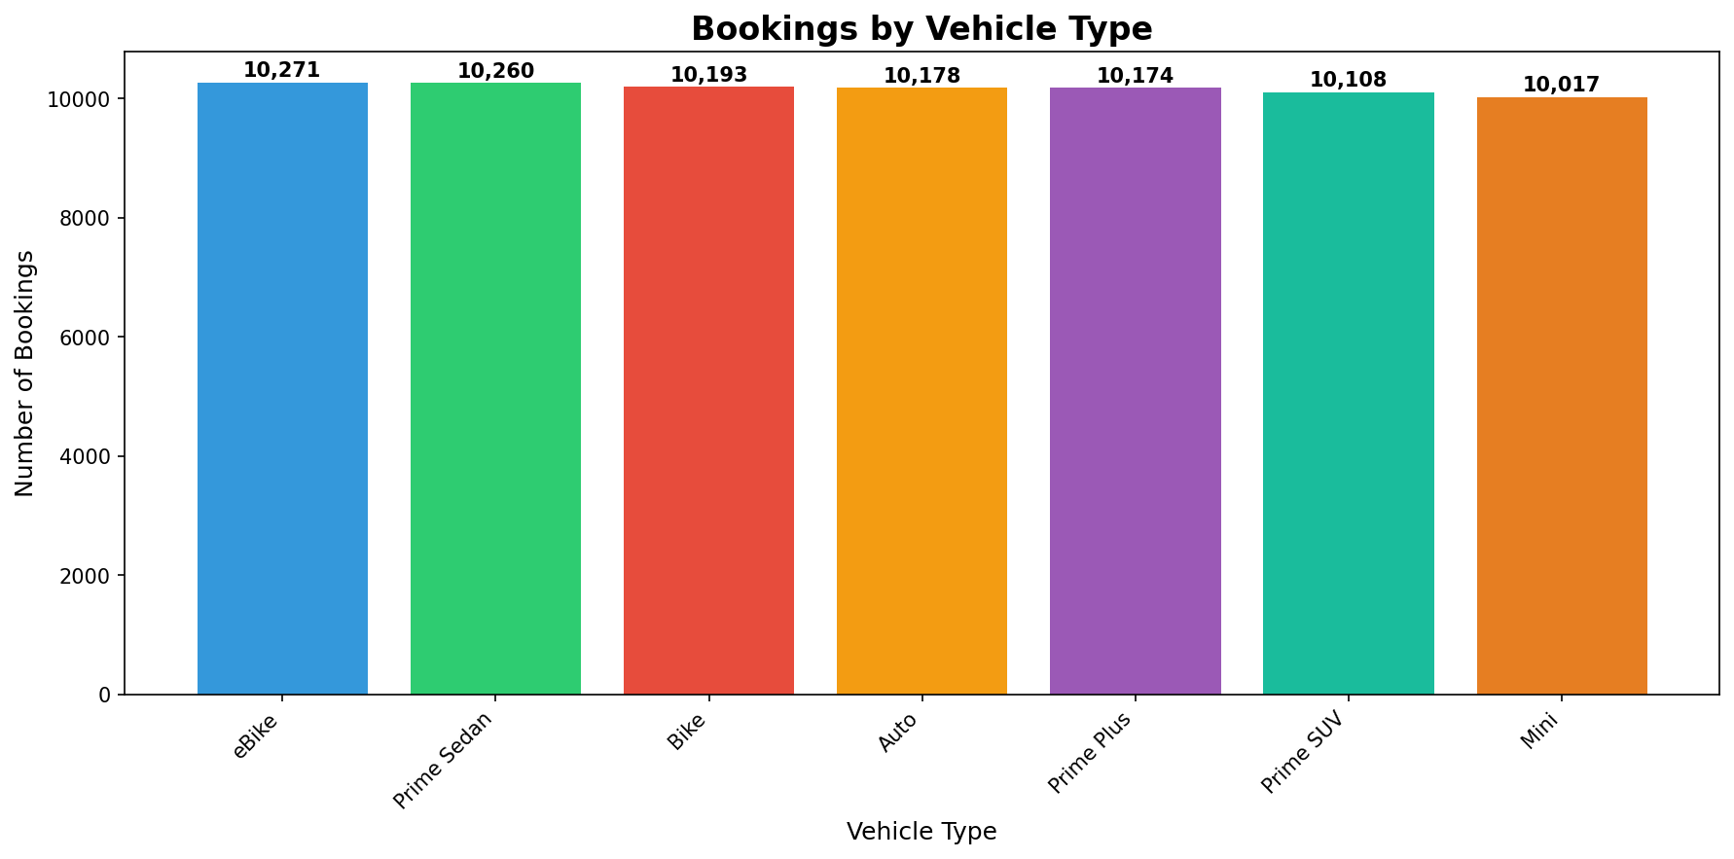
Figure 4.1: Booking Distribution by Vehicle Type

4.2 Vehicle-wise Breakdown
Vehicle Type | Bookings | Market Share | Category
eBike | 10,271 | 14.4% | Economy
Prime Sedan | 10,260 | 14.4% | Premium
Bike | 10,193 | 14.3% | Economy
Auto | 10,178 | 14.3% | Economy
Prime Plus | 10,174 | 14.3% | Premium
Prime SUV | 10,108 | 14.2% | Luxury
Mini | 10,017 | 14.1% | Standard

4.3 Success Rate by Vehicle Type
Different vehicle types exhibit varying success rates, which may be influenced by driver availability, pricing, and customer behavior specific to each segment.
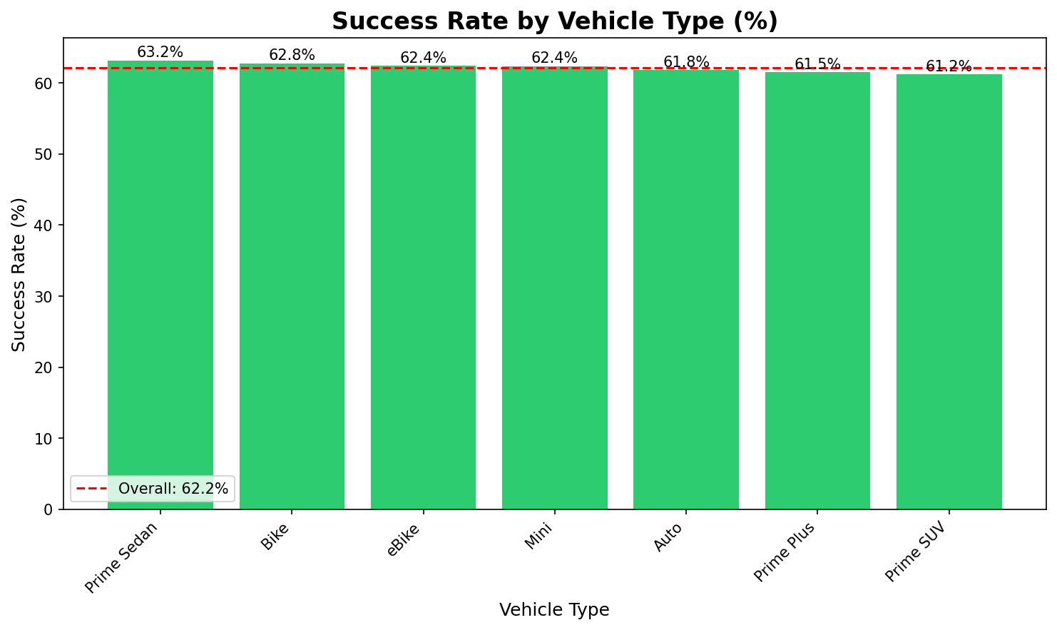
Figure 4.2: Success Rate Comparison by Vehicle Type

5. Revenue & Financial Analysis

5.1 Revenue Overview
The platform generated a total revenue of ₹24,216,619 from 44,271 successful rides during the analysis period. This translates to:
- Average Revenue per Ride: ₹547.01
- Daily Average Revenue: ₹807,221 (assuming 30-day period)
- Revenue per Kilometer: ₹23.94
- Potential Lost Revenue (from failed bookings): Estimated ₹14,730,942

5.2 Revenue by Vehicle Type
Analyzing revenue contribution by vehicle type helps identify the most profitable segments and informs fleet allocation decisions.
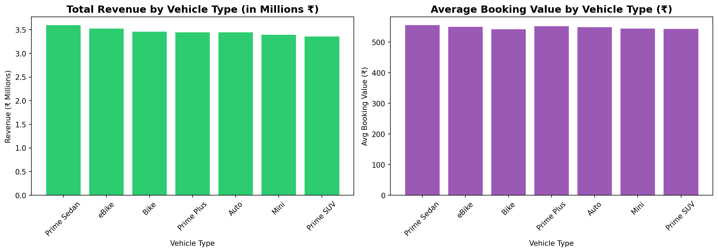
Figure 5.1: Revenue Analysis by Vehicle Type

Vehicle Type | Total Revenue | Avg Booking | Rides
Prime Sedan | ₹3,594,005 | ₹554.37 | 6,483
eBike | ₹3,522,526 | ₹549.54 | 6,410
Bike | ₹3,459,571 | ₹540.64 | 6,399
Prime Plus | ₹3,445,660 | ₹550.78 | 6,256
Auto | ₹3,445,075 | ₹547.79 | 6,289
Mini | ₹3,392,188 | ₹543.10 | 6,246
Prime SUV | ₹3,357,594 | ₹542.60 | 6,188

6. Payment Methods Analysis

6.1 Payment Distribution
Understanding payment preferences is crucial for optimizing the checkout experience and planning financial operations. The analysis reveals clear customer preferences:
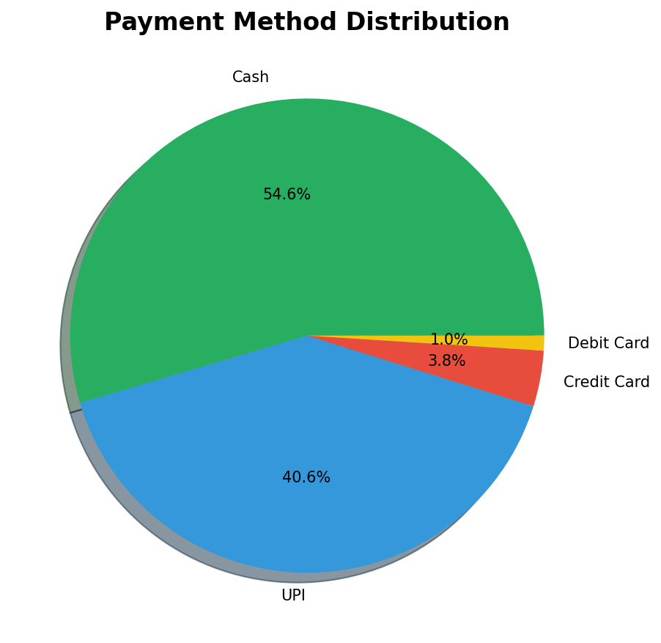
Figure 6.1: Payment Method Distribution

6.2 Detailed Breakdown
Payment Method | Revenue | Transactions | Avg Transaction
Cash | ₹13,259,198 | 24,166 | ₹548.67
Credit Card | ₹900,354 | 1,683 | ₹534.97
Debit Card | ₹239,672 | 448 | ₹534.98
UPI | ₹9,817,395 | 17,974 | ₹546.20

6.3 Key Observations
- • Cash dominates with 54.6% of transactions, indicating customer preference for physical payment or limited digital payment adoption in certain demographics.
- • UPI accounts for 40.6% of payments, showing growing adoption of digital payment methods.
- • Digital payments (UPI + Cards) together constitute 45.4% of transactions, presenting an opportunity for promoting cashless rides through incentives.

7. Cancellation Analysis

7.1 Cancellation Overview
Cancellations represent a significant operational challenge, with 19,942 rides (28.0%) being canceled either by drivers or customers. Understanding the root causes is essential for improving completion rates.

7.2 Cancellation Reasons
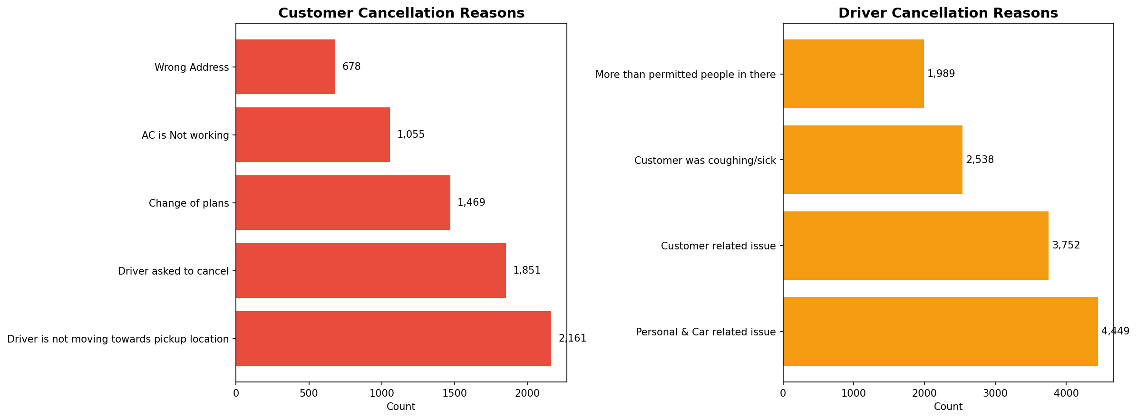
Figure 7.1: Analysis of Cancellation Reasons

7.3 Customer Cancellation Analysis
Customers canceled 7,214 bookings for the following reasons:
- Driver is not moving towards pickup location: 2,161 (30.0%)
- Driver asked to cancel: 1,851 (25.7%)
- Change of plans: 1,469 (20.4%)
- AC is Not working: 1,055 (14.6%)
- Wrong Address: 678 (9.4%)

7.4 Driver Cancellation Analysis
Drivers canceled 12,728 bookings for the following reasons:
- Personal & Car related issue: 4,449 (35.0%)
- Customer related issue: 3,752 (29.5%)
- Customer was coughing/sick: 2,538 (19.9%)
- More than permitted people in there: 1,989 (15.6%)

8. Geographic Analysis

8.1 Top Pickup Locations
Analyzing pickup locations helps identify high-demand areas and optimize driver positioning. The top 10 pickup locations account for a significant portion of total bookings.
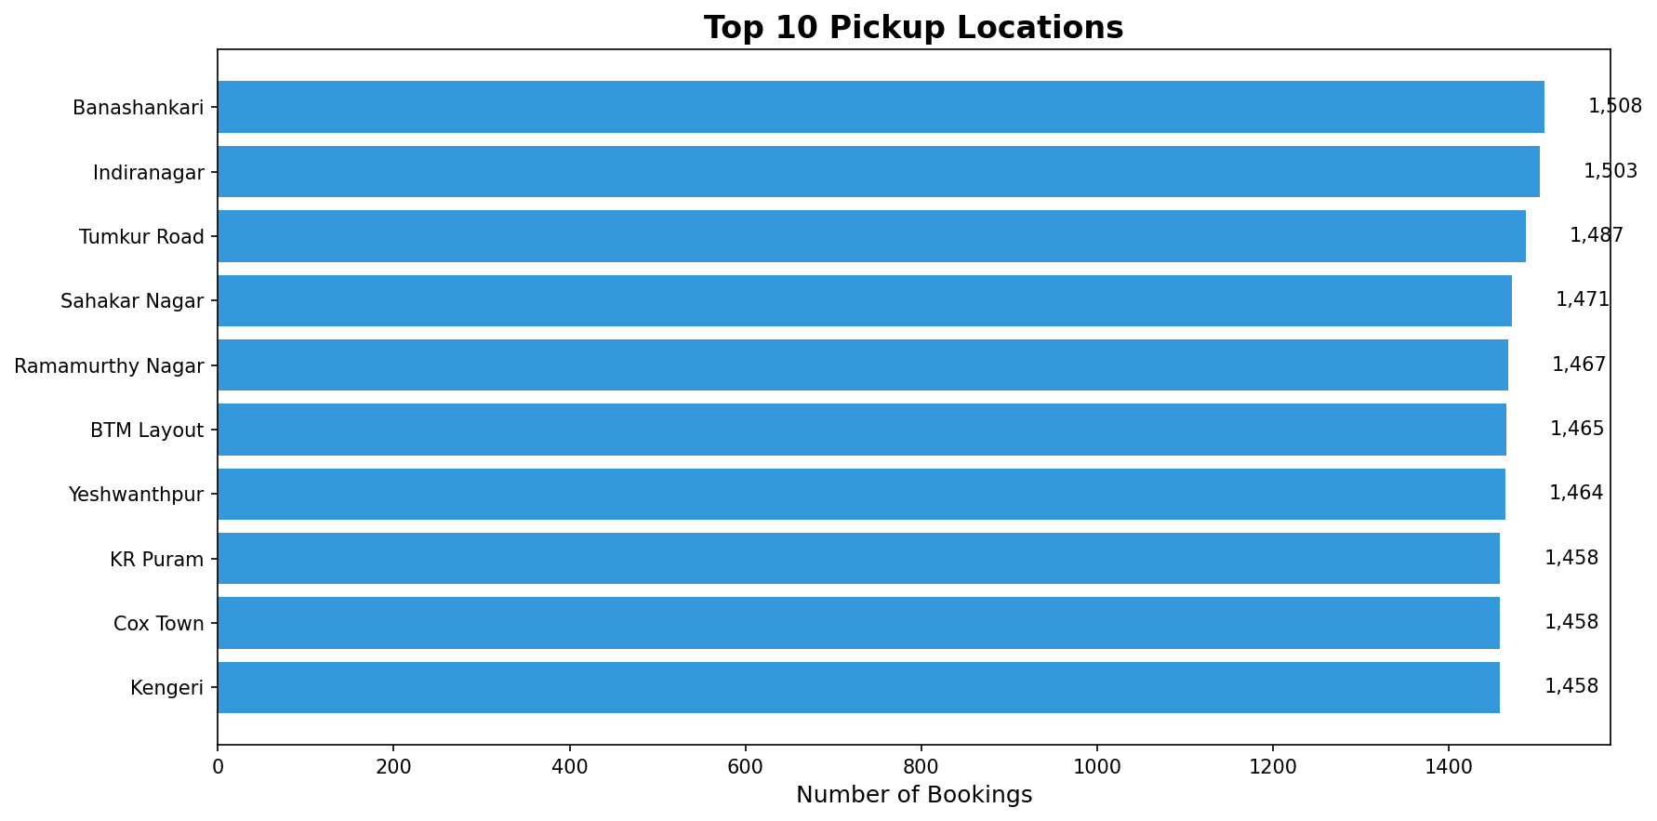
Figure 8.1: Top 10 Pickup Locations by Booking Volume

8.2 Location Statistics
- • Total Unique Pickup Locations: 50
- • Total Unique Drop Locations: 50
- • Average Bookings per Location: 1424
- • Top Location Share: 2.1% of all bookings

9. Time-Based Analysis

9.1 Hourly Booking Pattern
Understanding when customers book rides helps optimize driver supply and implement surge pricing effectively. The hourly distribution reveals clear patterns aligned with commute times and daily activities.
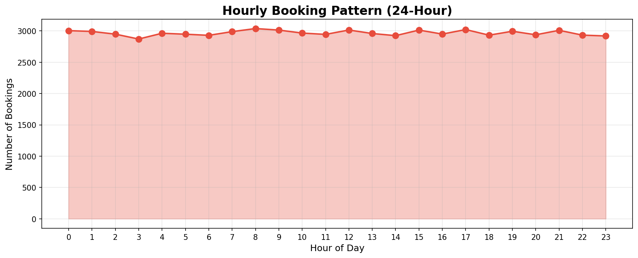
Figure 9.1: 24-Hour Booking Distribution

9.2 Peak Hours Analysis
- • Peak Hour: 8:00 with 3,037 bookings
- • Off-Peak Hour: 3:00 with 2,870 bookings
- • Peak to Off-Peak Ratio: 1.1x
- • Morning Rush (7-10 AM): 12,003 bookings
- • Evening Rush (5-9 PM): 14,894 bookings

10. Customer & Driver Ratings

10.1 Rating Overview
Service quality is measured through mutual ratings between customers and drivers. Both metrics average around 4.00/5.0, indicating generally satisfactory service levels.
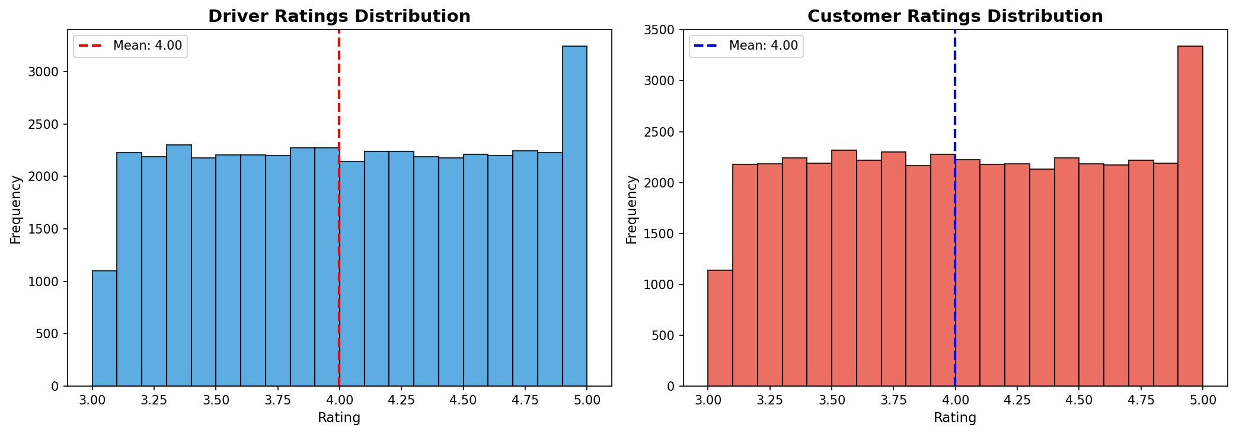
Figure 10.1: Rating Distribution for Drivers and Customers

10.2 Rating Statistics
Metric | Driver Rating | Customer Rating
Average | 4.00 | 4.00
Median | 4.00 | 4.00
Std Deviation | 0.58 | 0.58
5-Star Ratings | 1,061 (2.4%) | 1,064 (2.4%)

10.3 Distance Analysis
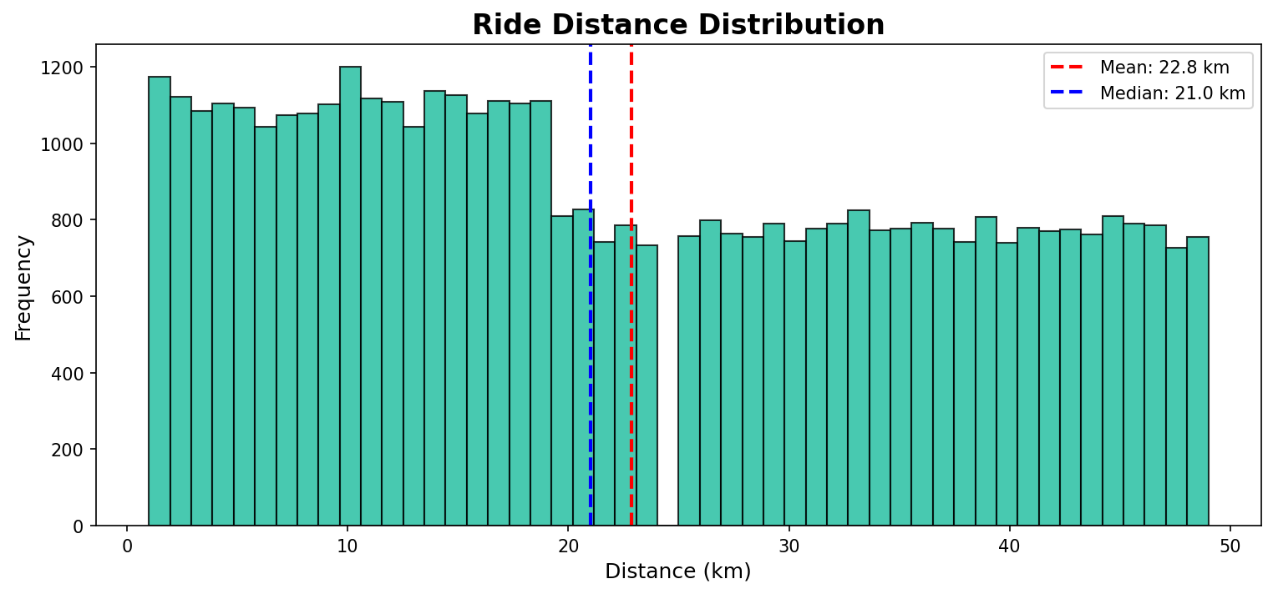
Figure 10.2: Ride Distance Distribution

11. Key Findings & Insights

11.1 Operational Insights
- Success Rate Gap: At 62.2%, nearly 38% of booking attempts fail, representing significant lost revenue potential.
- Driver Cancellations: 12,728 driver-initiated cancellations indicate potential issues with driver incentives, route preferences, or customer-related factors.
- Supply Issues: 6,988 "Driver Not Found" instances suggest supply-demand imbalance in certain areas or times.
- Fleet Balance: Relatively even distribution across vehicle types (ranging from 10,017 to 10,271) suggests healthy fleet diversity.

11.2 Financial Insights
- Revenue Concentration: Total revenue of ₹24,216,619 is generated from only 62.2% of booking attempts.
- Cash Dependency: 54.6% cash transactions create operational challenges and potential security concerns.
- Average Ticket Size: ₹547.01 per ride provides a baseline for pricing strategy optimization.
- Lost Revenue: Estimated ₹14,730,942 in potential revenue lost due to failed bookings.

11.3 Customer Behavior Insights
- Rating Satisfaction: Average rating of 4.00/5.0 indicates generally positive customer experiences.
- Payment Preference: Strong preference for cash suggests either limited digital payment access or trust issues with online payments.
- Time Sensitivity: Clear peak hours indicate predictable demand patterns that can be leveraged for supply optimization.
- Location Concentration: Top 10 locations account for significant booking volume, enabling focused resource allocation.

12. Strategic Recommendations

12.1 Immediate Actions (0-3 months)
- Driver Retention Program: Implement incentives to reduce driver cancellations, including bonus structures for high completion rates.
- Supply Optimization: Deploy predictive algorithms to position drivers in high-demand areas during peak hours.
- Cancellation Analysis: Conduct detailed driver surveys to understand primary cancellation motivations.
- Customer Communication: Implement proactive notifications about driver arrival to reduce customer cancellations.

12.2 Short-term Actions (3-6 months)
- Digital Payment Incentives: Offer discounts or cashback for UPI/card payments to reduce cash dependency.
- Dynamic Pricing: Implement surge pricing during peak hours (7-10 AM, 5-9 PM) to balance supply-demand.
- Quality Improvement: Target drivers with ratings below 3.5 for retraining or removal from platform.
- Fleet Expansion: Increase driver onboarding in areas with high "Driver Not Found" rates.

12.3 Long-term Strategy (6-12 months)
- Predictive Cancellation Model: Build ML models to predict and prevent cancellations before they occur.
- Customer Loyalty Program: Implement rewards for frequent riders to increase retention and lifetime value.
- Fleet Optimization: Analyze profitability by vehicle type and adjust fleet composition accordingly.
- Geographic Expansion: Identify underserved areas with high demand potential for targeted expansion.

13. Conclusion
This comprehensive analysis of 71,201 OLA booking records reveals both strengths and opportunities for the ride-hailing platform. With a success rate of 62.2% and total revenue of ₹24,216,619, the platform demonstrates solid market presence while having significant room for improvement.
The primary challenge lies in the 37.8% booking failure rate, particularly the 12,728 driver cancellations which directly impact customer experience and revenue. Addressing this through driver incentives, better matching algorithms, and supply optimization could potentially increase revenue by 20-30%.
The even distribution across vehicle types and strong ratings (4.00/5.0 average) indicate a well-managed fleet and generally satisfied customer base. However, the heavy reliance on cash transactions (54.6%) presents operational challenges that should be addressed through digital payment incentives.
By implementing the recommended actions across immediate, short-term, and long-term horizons, OLA can expect to see improvements in completion rates, revenue per booking, customer satisfaction, and overall operational efficiency.

──────────────────────────────────────────────────
Report Generated: November 30, 2025
Data Source: OLA Bookings Dataset (July 2024)
Analysis Tool: Python (Pandas, Matplotlib, Seaborn)
Total Records Analyzed: 71,201

