# Design a Page based on the Wireframe

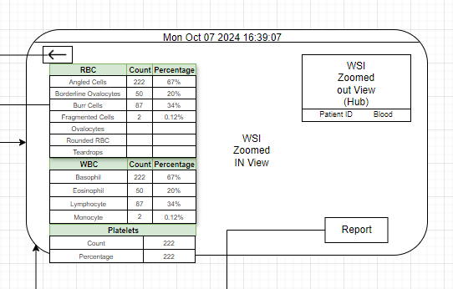

This wireframe depicts a Whole Slide Image Viewer. The left panel displays details about the finding, and the top right panel shows a zoomed-out view of the Whole Slide Image (like a Hub View). The center displays the Whole Slide Image, where the user can zoom in and out. The Hub also shows a pointer indicating the area of the WSI being viewed in the center.The Whole Slide Image to be used is available in the shared directory, plot the bounding boxes onto the Whole Slide Image using **[“detection_results”]** from output.json

The output in the zoom view should look like image given below:  
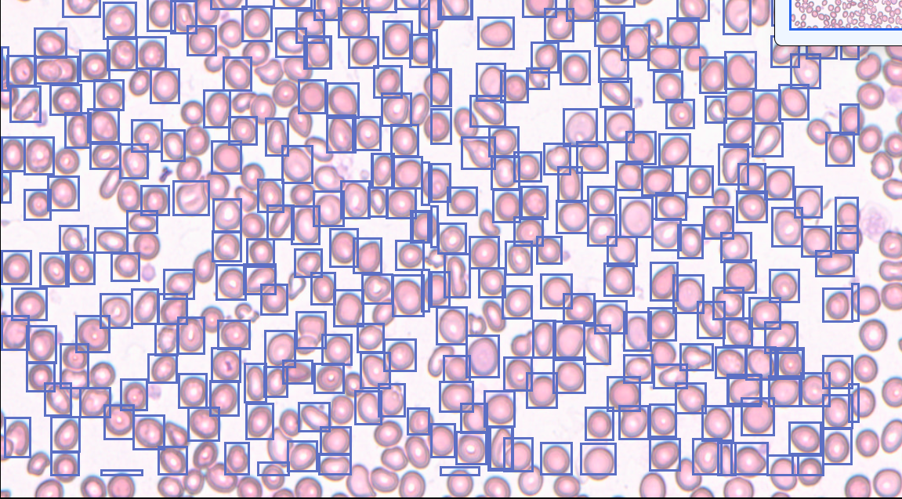

Here are few references that you can use to draw inspiration and ideas

1. <https://scopiolabs.com/scan_gallery/sickle-cell-anemia/> : It will access a survey before showing, just fill in any dummy details.
2. <https://youtu.be/scf-A92839k>

You need to develop and deploy the page on any platform like vercel or any other platform and then share the source code along with the deployed link.

You will be evaluated on the following criteria:

1. Coding Style, Structure, and Functionality (25% weightage): You are free to use any coding tools, ChatGPT, etc.
2. Design (25% weightage): This includes the aesthetic of the page.
3. Creativity: What you include from your end, beyond the wireframe and references, to enhance the functionality and ease of use of the page.

**Submission:**

It must include

1. Link to the Deployed Webapp
2. Github Repo containing the code