Samvardhana Motherson International Ltd.
DCF Investment Report
Valuation date: 10-Sep-2026

Executive Summary
The base-case DCF indicates approximately ₹62.41 per share versus a market price of ₹162.71. The market therefore trades at a 61.6% premium to the standalone base DCF. The gap represents the level of growth, margin expansion, reinvestment efficiency and risk discount that the market price implies relative to the base case.

Valuation Snapshot
Metric | Value
Market price | ₹162.71
Base DCF / share | ₹62.41
Enterprise value | ₹74,252 cr
Equity value | ₹65,873 cr
WACC | ~12.95%
Terminal growth | 4.0%

Operating Outlook
FY26 revenue is approximately ₹126,104 crore and reported EBITDA is approximately ₹12,033 crore. Base-case revenue growth moderates from 10.0% in FY27E to 7.0% in FY31E, while EBITDA margin rises from 10.2% to 11.0%.
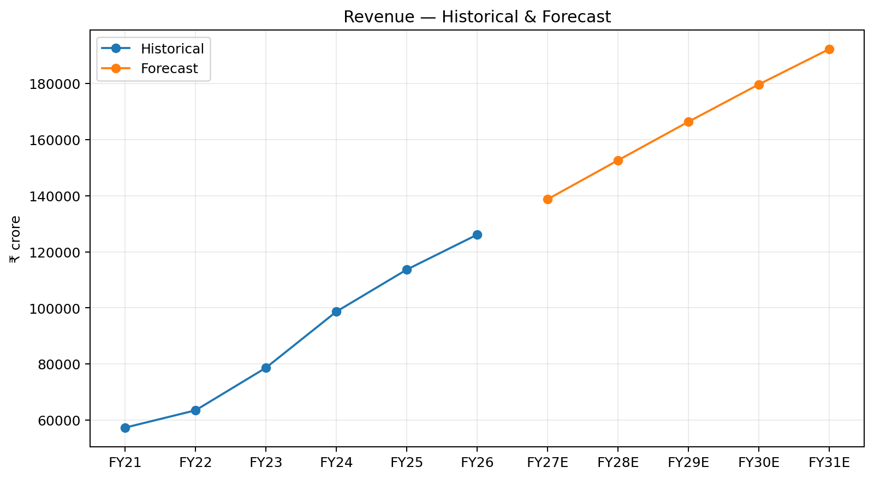
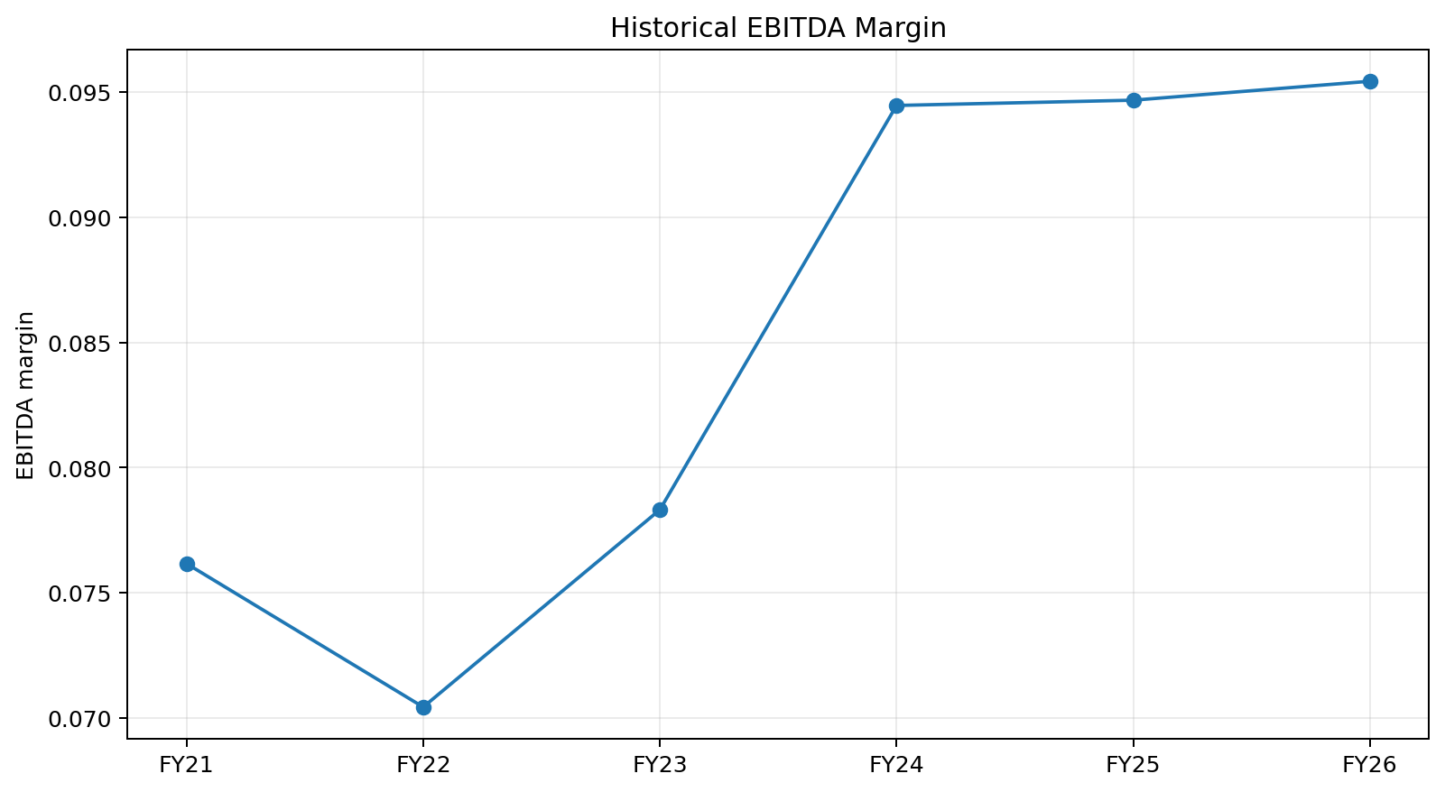

FCFF and DCF
FCFF is built from NOPAT, plus D&A, less CapEx and change in operating NWC. Financing costs are excluded from FCFF and reflected through WACC.
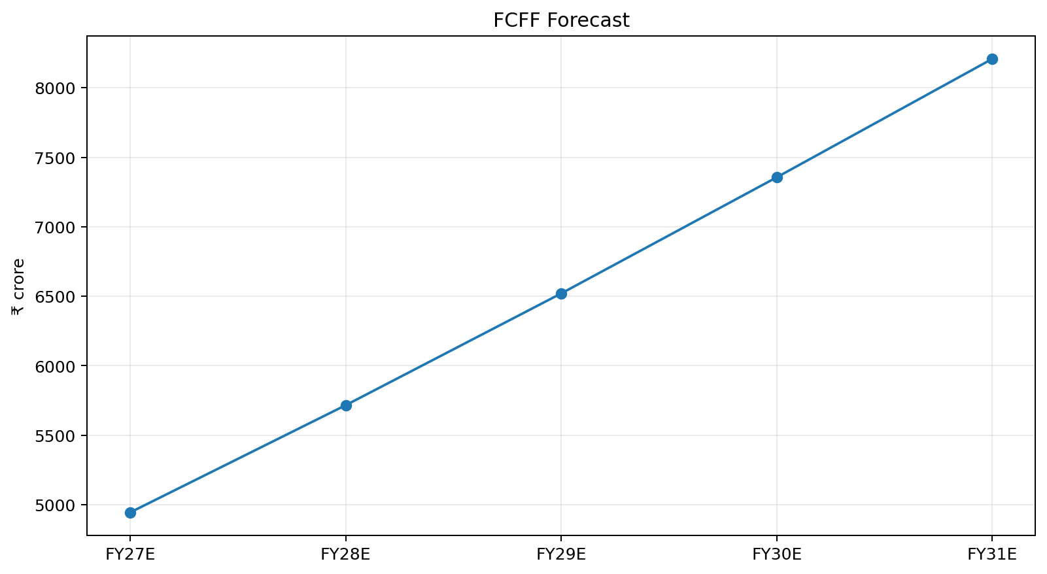
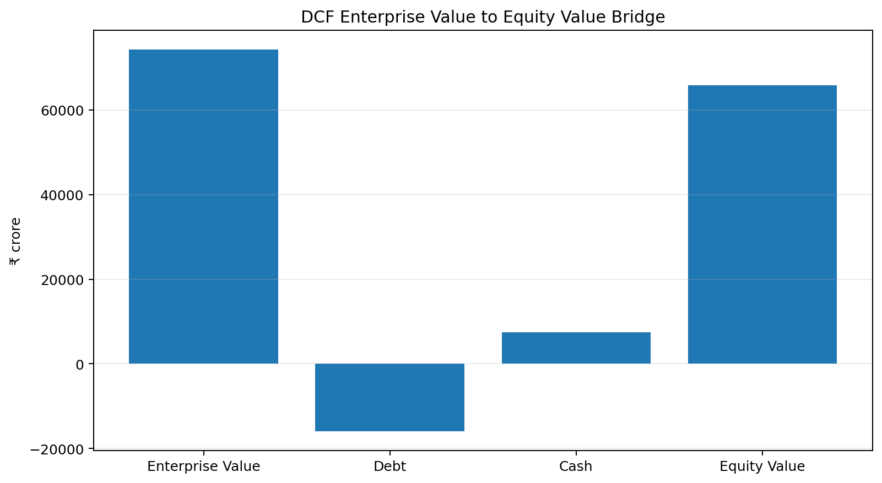

Scenario Analysis
Bear: ₹32.13/share; Base: ₹62.41/share; Bull: ₹96.31/share.
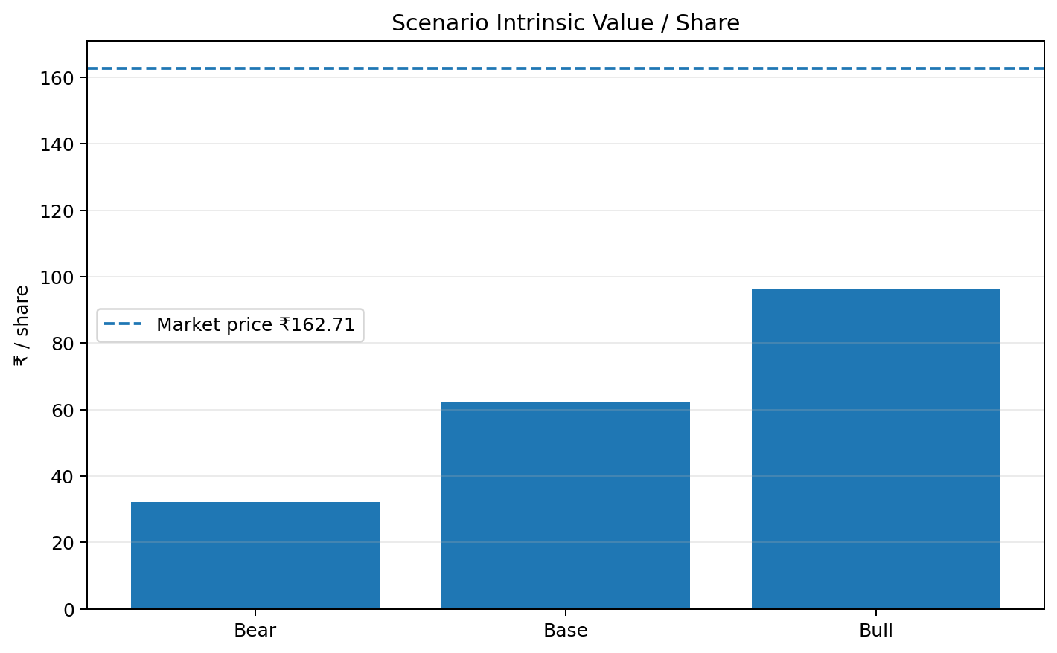

Sensitivity
The sensitivity matrix varies WACC from 10% to 14% and terminal growth from 2.0% to 4.0%.
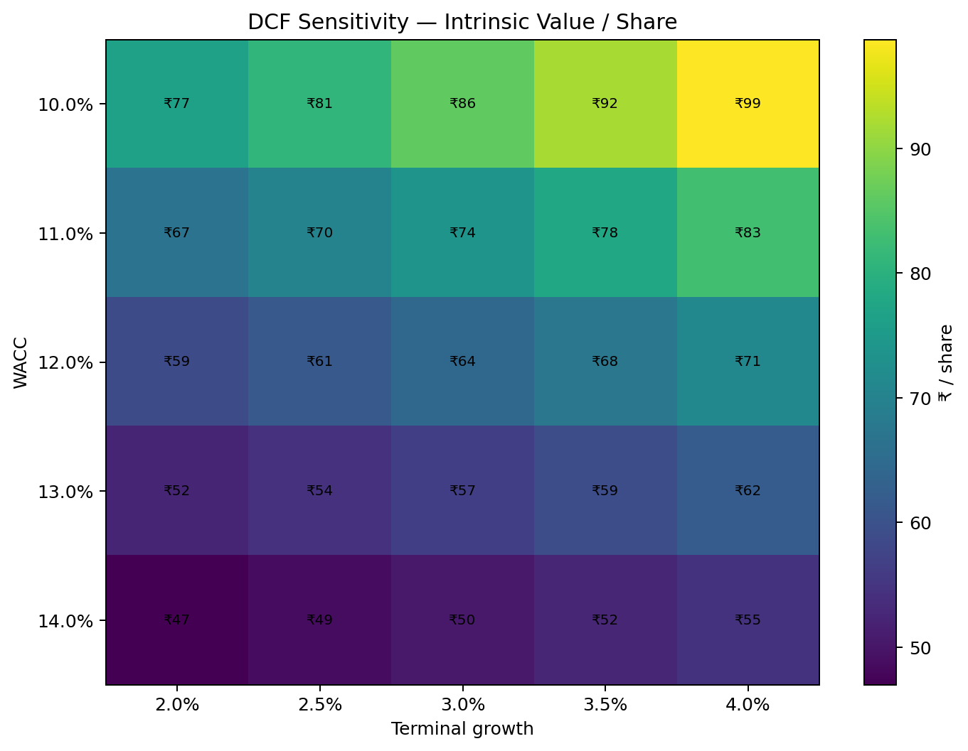

Key Risks and Catalysts
Risks include weaker OEM volumes, margin pressure, integration/execution issues, higher capital intensity and a higher required return. Catalysts include sustained margin improvement, stronger program wins, operating leverage and better cash conversion.

Methodology and Limitations
The workbook uses a five-year FCFF DCF with Gordon Growth terminal value, peer-derived bottom-up beta, comparable-company cross-checks and dynamic scenario analysis. The balance-sheet analysis is a selected operating working-capital view rather than a full three-statement balance-sheet forecast.

