SCHOOL
FINAL PROJECT REPORT
WHERE STUDENTS STUDY, WHERE STUDENTS LEARN, AND WHERE OUR TEACHERS TEACH US HOW THINGS REALLY WORK IN THE REAL WORLD.

SCHOOL

THE MODERN ONLINE SCHOOL
Where you choose your goal, choose your subject, and start learning every day through chapters, daily lessons, and homework.
Since I am an Artificial Intelligence and Data Science student, for now I am creating SCHOOL specifically for learning the Python programming language, with 100+ goals/learning paths.

Project Summary
SCHOOL is a goal-based Python learning platform. A student chooses the career they want, takes a short placement test, and is then given one hour of structured study a day, with homework, feedback and visible progress, in the same way a real school would run.
The catalogue now covers 100 learning paths across ten domains, from a student's first script to research-level artificial intelligence. Every path is a complete 180-day course with placement testing, daily lessons, automated practice checking and progress tracking. 97 of the 100 paths are fully live today.
This report walks through the complete system: what was built, how it works, how the content was produced and verified, and what remains open. Every figure quoted here is read directly from the running system rather than estimated.
Measure | Value
Learning paths | 100
Domains | 10
Lessons | 18,000
Milestones and assignments | 18,000 each
Placement questions | 1,300
Paths fully live | 97 of 100
Database tables | 15
Automated tests passing | 60

1. How SCHOOL works
The flow is deliberately short and mirrors what a student already understands about school.
First, when we open SCHOOL, we come to the home page. This is the starting point of the platform where the student can understand what SCHOOL is and start the journey by choosing a career path.
From the home page, the student opens Career Paths and chooses the goal they want to learn. The catalogue is grouped into ten domains ordered by depth, so a beginner and a research student can both find something at their level.
After choosing a path, the student enters their name and email. This creates the learner record and connects the assessment and all future progress to that student.
The student then takes a thirteen-question level test. This exists so that a student who already knows some Python is not forced to repeat material they have already demonstrated, and a student who is starting from zero is not dropped into content they cannot follow.
The result screen shows the score, the level assigned, the exact day the student will begin on, and the topics they should review. Learning then starts on that day and advances one day at a time.

2. The complete catalogue
The platform offers 100 learning paths grouped into ten domains, arranged from the surface of programming down to system-level and general-reasoning work. Each path is a full 180-day course with a placement test, daily lessons, practice assignments and tracked progress.
The diagram below shows the distribution of paths across domains, and how many paths in each domain are currently complete.
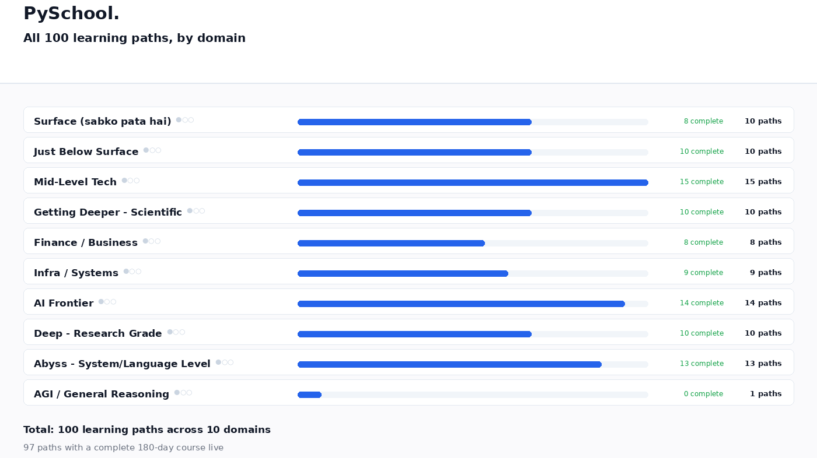
Figure 1 — All 100 learning paths grouped by domain, with completion status for each.
The ten domains and the paths they contain are listed below. Every path shown is live and reachable from the catalogue.

Surface (sabko pata hai) · 10 paths · 8 complete
Surface — everyday scripting and first contact with libraries
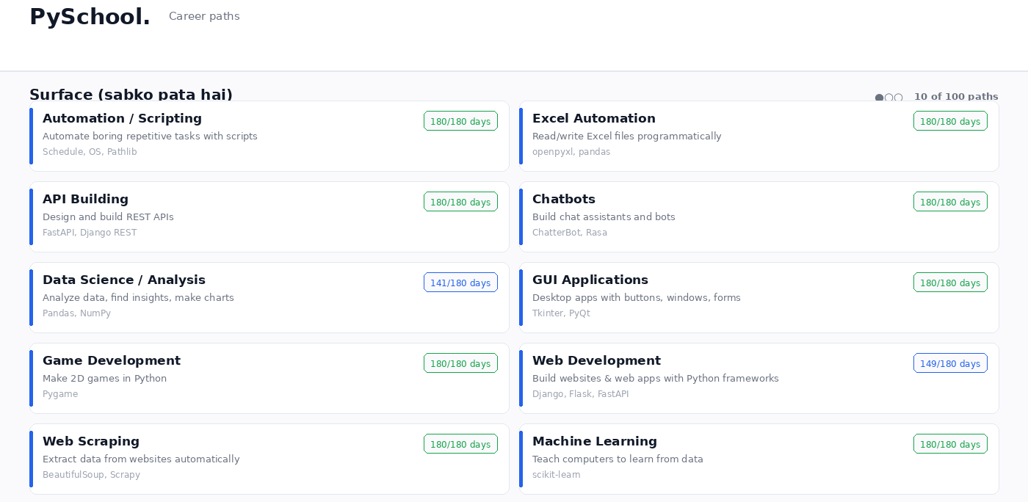
Figure 2 — Surface (sabko pata hai): all 10 learning paths, each with its libraries and live day count.
Just Below Surface · 10 paths · 10 complete
Just Below Surface — the tools professionals actually use daily
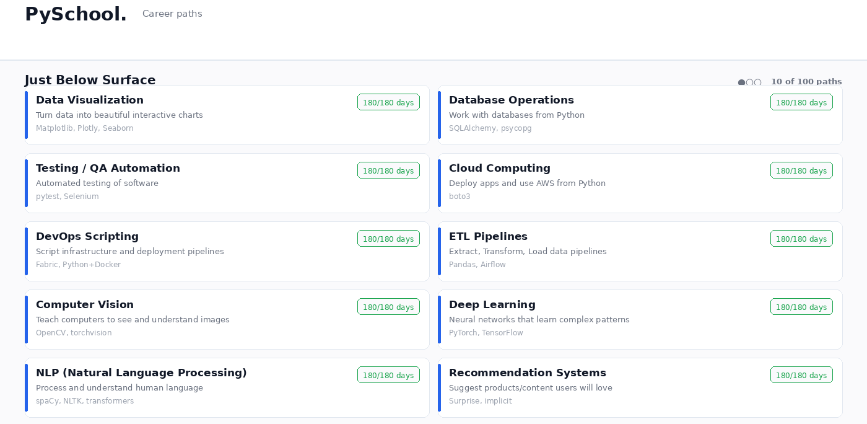
Figure 3 — Just Below Surface: all 10 learning paths, each with its libraries and live day count.
Mid-Level Tech · 15 paths · 15 complete
Mid-Level Tech — building real applications and services
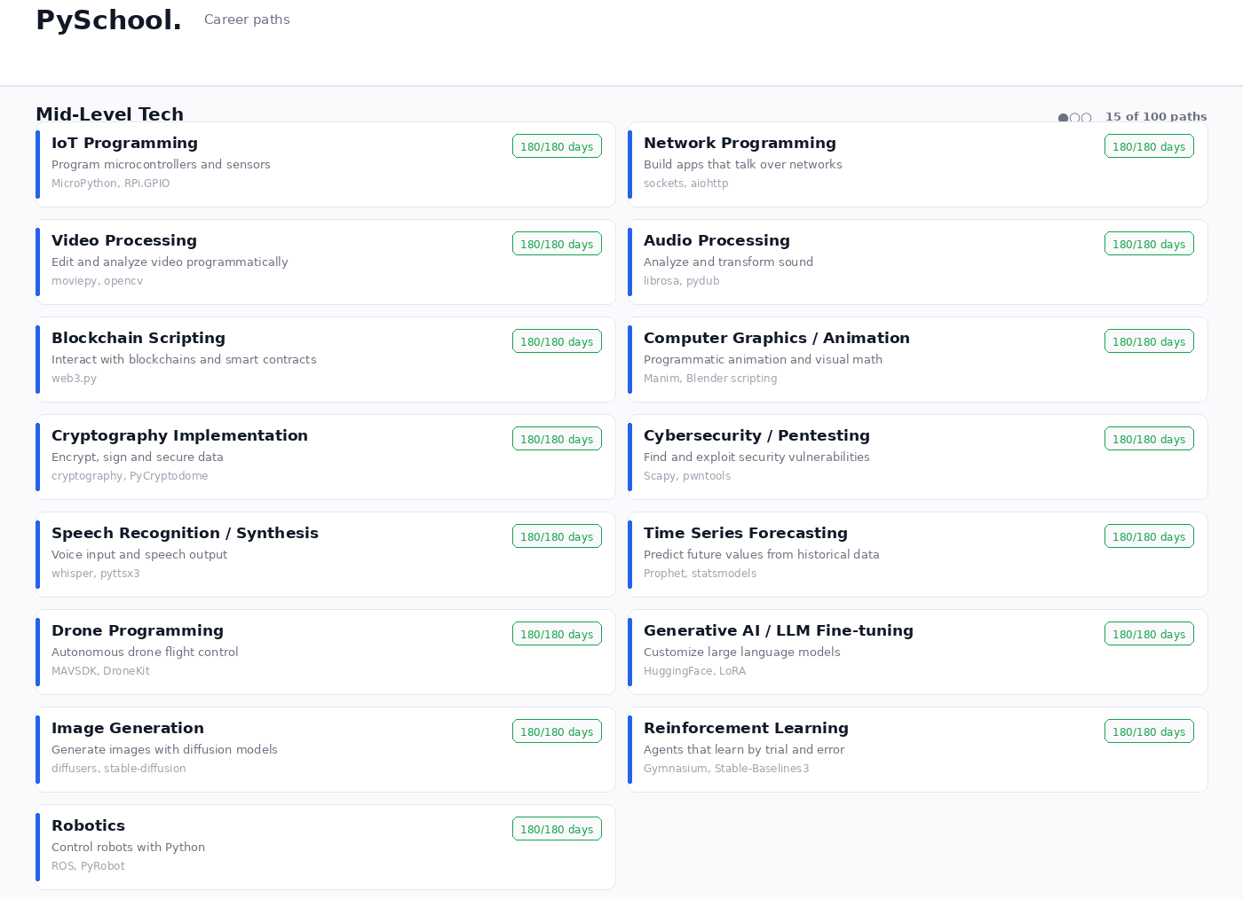
Figure 4 — Mid-Level Tech: all 15 learning paths, each with its libraries and live day count.
Getting Deeper - Scientific · 10 paths · 10 complete
Getting Deeper, Scientific — computation applied to science
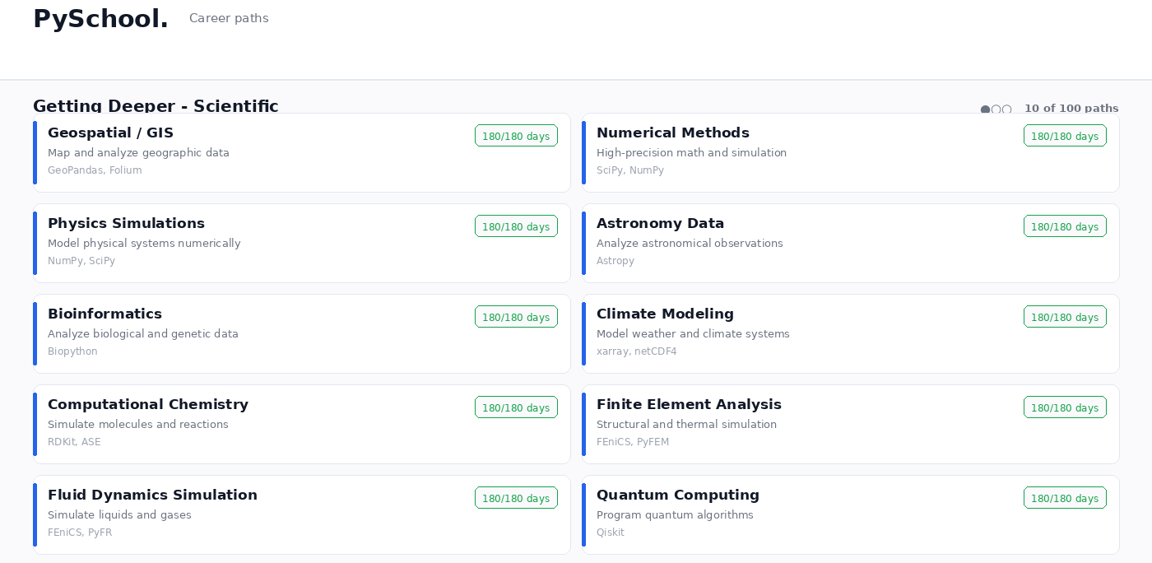
Figure 5 — Getting Deeper - Scientific: all 10 learning paths, each with its libraries and live day count.
Finance / Business · 8 paths · 8 complete
Finance and Business — data, markets and commercial decisions
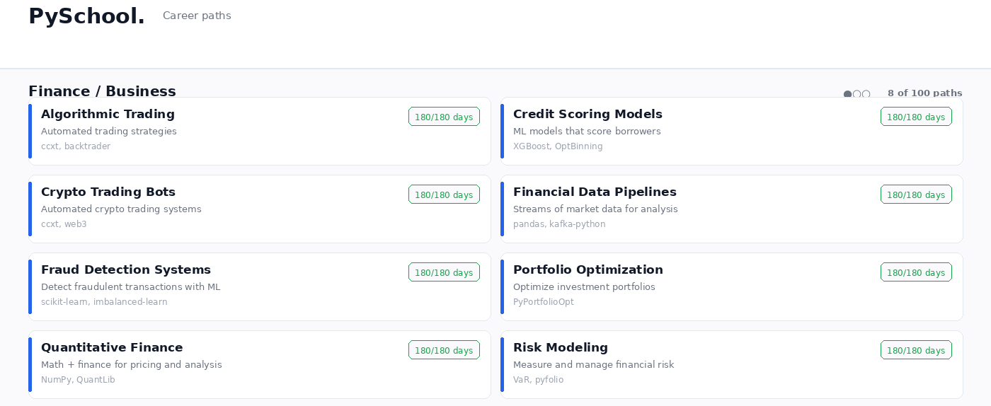
Figure 6 — Finance / Business: all 8 learning paths, each with its libraries and live day count.
Infra / Systems · 9 paths · 9 complete
Infrastructure and Systems — the machinery under the software
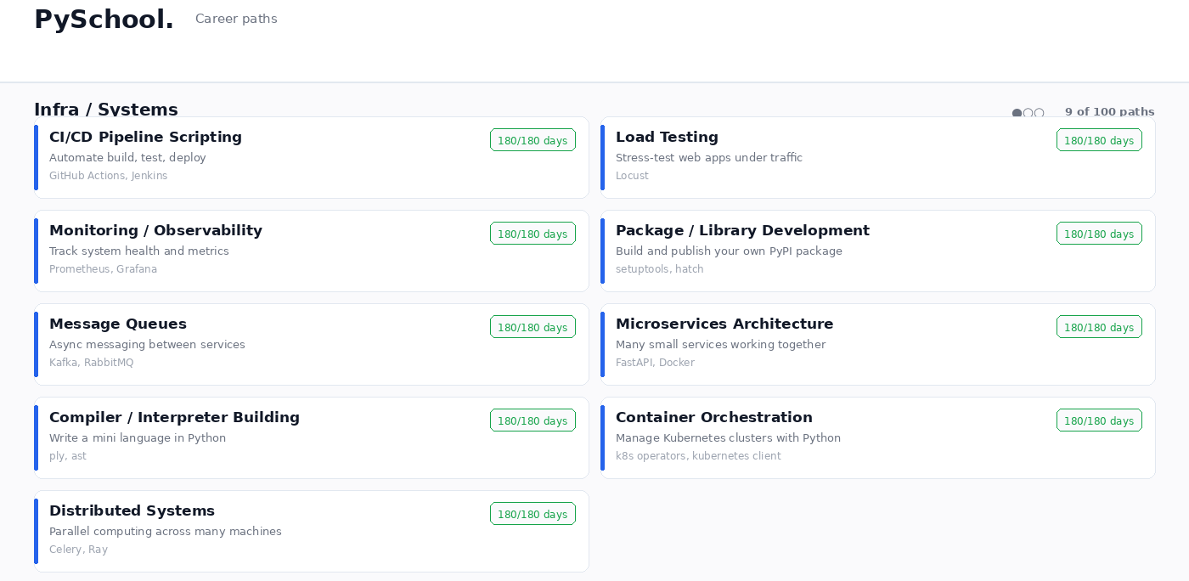
Figure 7 — Infra / Systems: all 9 learning paths, each with its libraries and live day count.
AI Frontier · 14 paths · 14 complete
AI Frontier — applied machine learning and neural networks
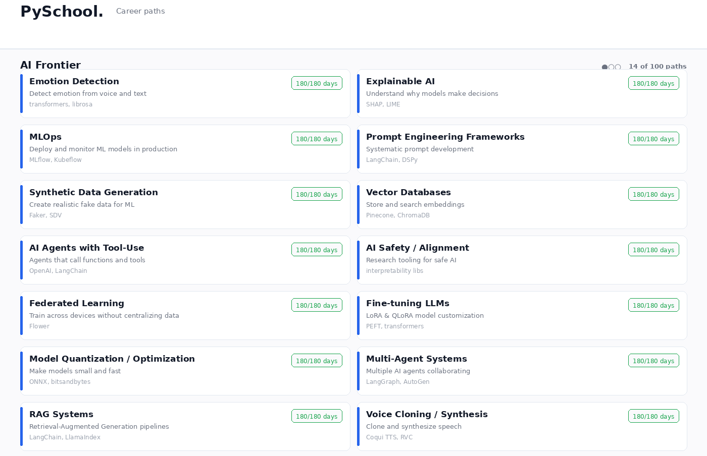
Figure 8 — AI Frontier: all 14 learning paths, each with its libraries and live day count.
Deep - Research Grade · 10 paths · 10 complete
Deep, Research Grade — advanced theory and research methods
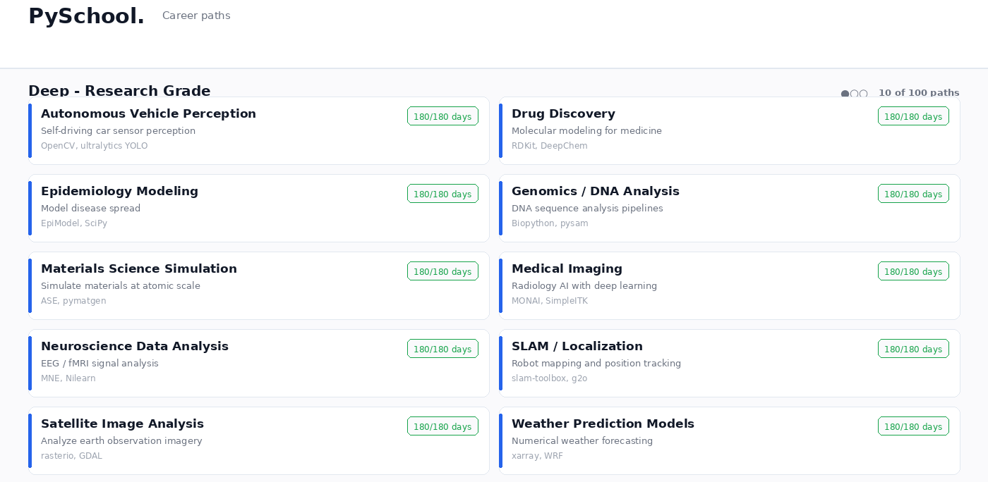
Figure 9 — Deep - Research Grade: all 10 learning paths, each with its libraries and live day count.
Abyss - System/Language Level · 13 paths · 13 complete
Abyss, System and Language Level — how the machine works
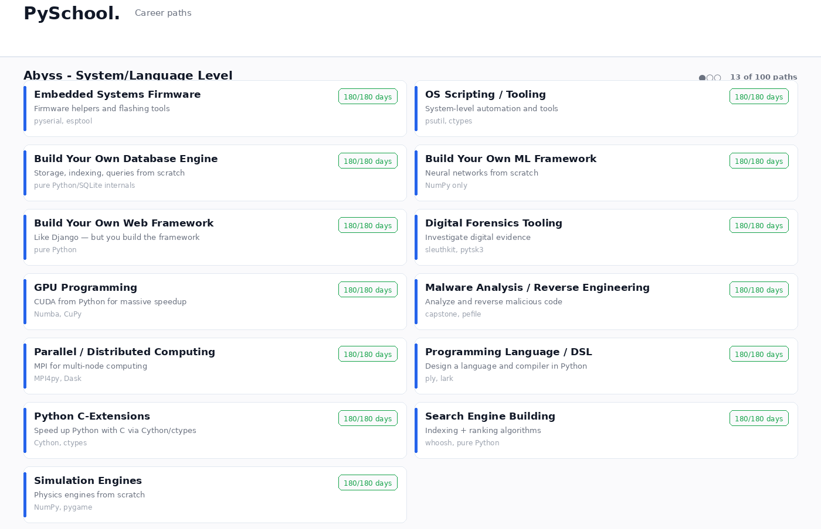
Figure 10 — Abyss - System/Language Level: all 13 learning paths, each with its libraries and live day count.
AGI / General Reasoning · 1 paths · 0 complete
AGI and General Reasoning — the frontier of the field
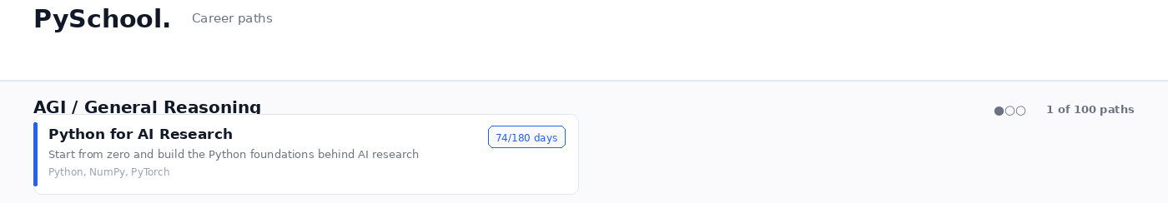
Figure 11 — AGI / General Reasoning: all 1 learning paths, each with its libraries and live day count.

3. A day at school
After the assessment, the student enters the first day of school. The day screen contains the lesson, explanation, Python code, questions and homework, so the student can start learning and doing practical work from day one.
Each day opens with a stated objective, so the student knows what the session is for before reading anything. The theory explains not only what to do but why it works, because material that only says what to do has to be memorised and material that explains why can be reasoned about.
The worked example runs alongside it. Every example in the system was actually executed when the content was written, and the output shown to the student is the output that was produced, not an illustration written by hand.
The Think Check panel asks the student a question about the day's material before the answer is shown. The student answers first, then reveals. Reading a lesson and understanding a lesson are different things, and this is how the platform tells the difference.
The practice panel then asks for code. The submission is checked against the day's rubric, which requires valid syntax, a minimum number of lines and the specific constructs that day was about.
One safety property is worth stating plainly. Student code is parsed, never executed on the server. This removes the risk of running arbitrary code from the application entirely, which is the correct default for a platform that accepts submissions from anyone.
When both the checklist and the practice check are complete, the day can be completed. The student earns experience, the streak advances, the next day unlocks, and a mastery record is written so the material can return later for revision.

4. How the content was produced and verified
Eighteen thousand lessons is a large amount of material, and the method used to produce it matters more than the count.
The curriculum began as three fully hand-written flagship tracks: Web Development, Data Science and Analysis, and Python for AI Research. These remain the quality benchmark for the project.
The remaining paths were originally filled from a generator, which produced structurally complete but repetitive material. An audit was run against the live database to measure this honestly: every lesson row was scanned, and ten thousand code examples were executed and their output compared against what the lesson claimed.
The audit found that structure was perfect while content was not. On most paths, a small number of lessons repeated across a hundred and five days, and the subject library appeared in the surrounding text but never in the code. A cryptography lesson would teach a conditional and print the word cryptography in the output.
Three responses followed. The Machine Learning track was rewritten day by day by hand. A reusable domain-authoring engine was built so that remaining domains could be given real subject knowledge rather than template text, with each domain carrying its own concepts, tools, workflows, common mistakes and project types. And a release-status system was introduced so the platform could never again display a path as finished when it was not.
Every authored day is held to the same standard. Theory falls within a defined length range. The example runs and its real output is captured. There are exactly three questions, of which the first is specific to that day rather than generic. Homework carries a rubric that checks something real. Lessons are compared against each other and near-duplicates are rejected, so repetition cannot reappear.
Writing to the live database is deliberately awkward. Content lives in source modules. A separate applier is the only thing that touches the database, it defaults to a dry run, it compares before writing, it refuses any path or day it was not explicitly given, and running it twice changes nothing the second time. Work is applied to a scratch copy and verified before the live database is touched at all.
Protected material is measured before any writing begins and checked afterwards, so damage to the finished tracks would be detected rather than discovered later.

5. Current state, stated honestly
97 of the 100 paths are structurally complete and live. Three paths are partially available and show exactly how many days are ready. The remaining path in the final domain is a single entry reserved for the most advanced material.
Five paths now have a genuinely distinct lesson on every one of their 180 days: Web Development, Data Science, Python for AI Research, Machine Learning and Cryptography. The remainder carry complete 180-day structures built on shared and generated material, which is honest and functional but is not the standard the flagship tracks meet.
This distinction is stated rather than hidden, and it is visible in the product itself. Every path card reports live day counts, and unfinished material is labelled as still in development. The gap between a complete structure and complete content is a content-authoring task, not a structural one, and it is the largest remaining body of work in the project.

6. Conclusion
SCHOOL began as an idea about why free programming material does not get finished: it is scattered, unmeasured, and nobody is watching. The platform answers that with placement, a daily hour, checked practice and visible progress.
The engineering behind it is deliberately conservative in the places that matter. Student code is never executed. Content is verified by running it. Writes to the live database are gated, scoped and reversible. The catalogue reports what is actually available rather than what would be convenient to claim.
The result is a working platform with 100 learning paths, 18,000 lessons, placement testing across ten domains, automated assessment, and a content pipeline that measures its own output. The work that remains is substantial and is stated plainly in this report, which is the same commitment the product itself now makes.

