SCHOOL
WHERE STUDENTS STUDY, WHERE STUDENTS LEARN, AND WHERE OUR TEACHERS TEACH US HOW THINGS REALLY WORK IN THE REAL WORLD.

SCHOOL

THE MODERN ONLINE SCHOOL
Where you choose your goal, choose your subject, and start learning every day through chapters, daily lessons, and homework.
Since I am an Artificial Intelligence and Data Science student, for now I am creating SCHOOL specifically for learning the Python programming language, with 100+ goals/learning paths.

Milestone 2: Teaching, not just building
Milestone 1 gave SCHOOL a working body. You could pick a path, take the test, open a lesson, submit homework and watch your score go up. What it did not have was a good teacher.
A student could sit through 180 days of material and finish without having understood much of it. The lessons covered the right topics in the right order, but a lot of them were generated from templates. They read like a syllabus, not like someone explaining the thing.
So Milestone 2 was not about adding more days. It was about making a single day better. Three things were done: the Data Science track was written out by hand, the first days of the course were rebuilt on a correct model of how Python actually works, and every lesson now asks the student a question before it shows them the answer.

1. The home page
First, when we open SCHOOL, we come to the home page. This is the starting point of the platform where the student can understand what SCHOOL is and start the journey by choosing a career path.
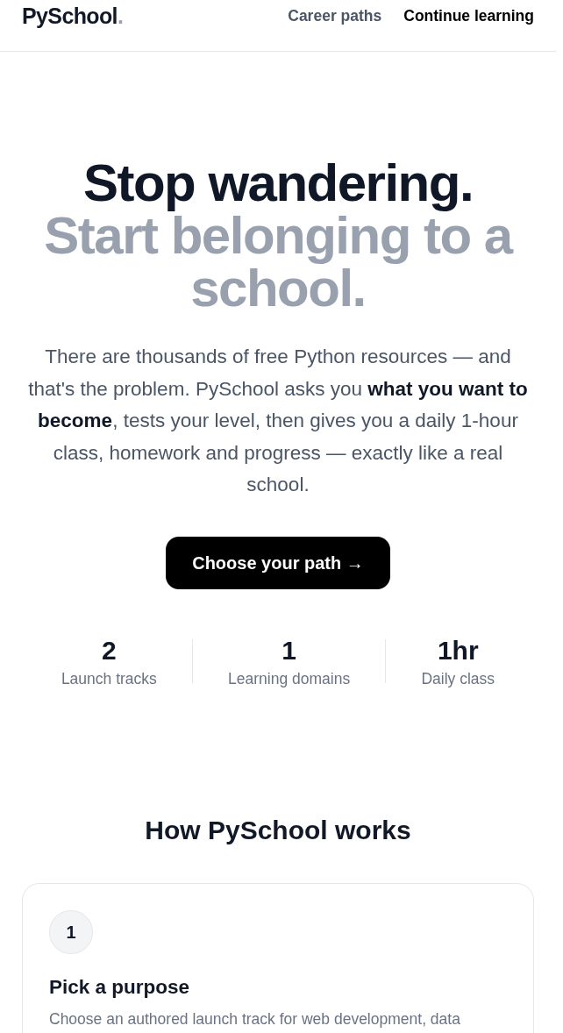
Figure 1 — Home page with platform overview and the four-step flow.

2. Choosing a career path
From the home page, I can open Career Paths and choose the goal I want to learn. Here the student can see different Python learning paths and select the one that matches their career goal.
Milestone 2 brought the Data Science track up to the same standard as the Web Development track, so it now shows 141 of 180 days available. Days that are written but not yet published are marked as coming soon instead of being hidden or faked.
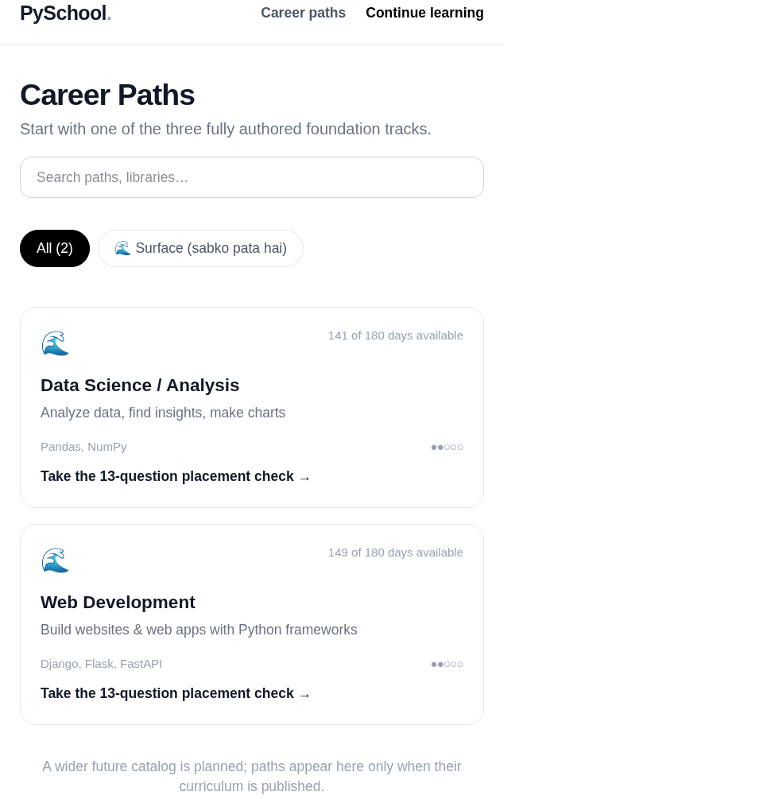
Figure 2 — Career paths, with days-available counts per track.

3. Creating the learner record
After choosing a career path, the student enters their name and email before starting. This information is used to create the learner record and connect the assessment and learning progress with that student.
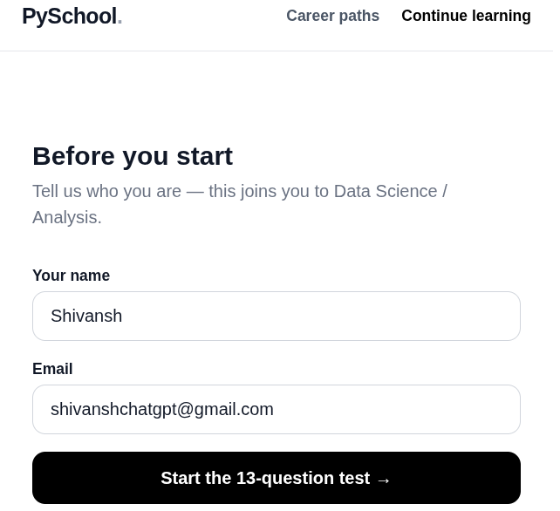
Figure 3 — Learner details, which create the enrolment record.

4. The level test
After entering the details, the student starts the Level Test. The test checks the student's existing Python knowledge so that the learning can start from a suitable level instead of giving the same content to everyone.
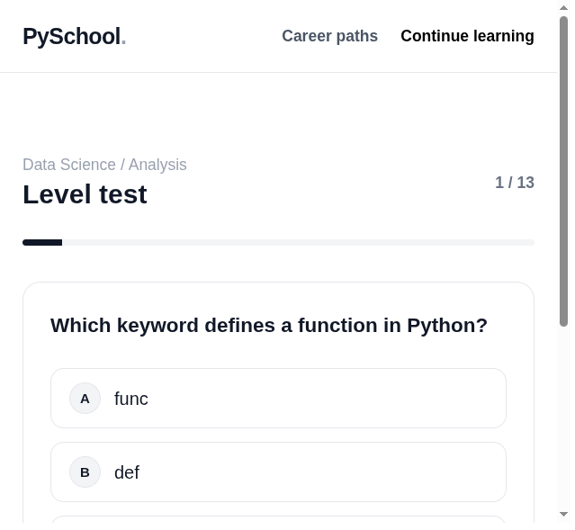
Figure 4 — The 13-question placement check, one question at a time.

5. The result and placement
When the test is completed, SCHOOL shows the assessment result and the level assigned to the student. This tells the learner where they currently stand before starting the daily learning process.
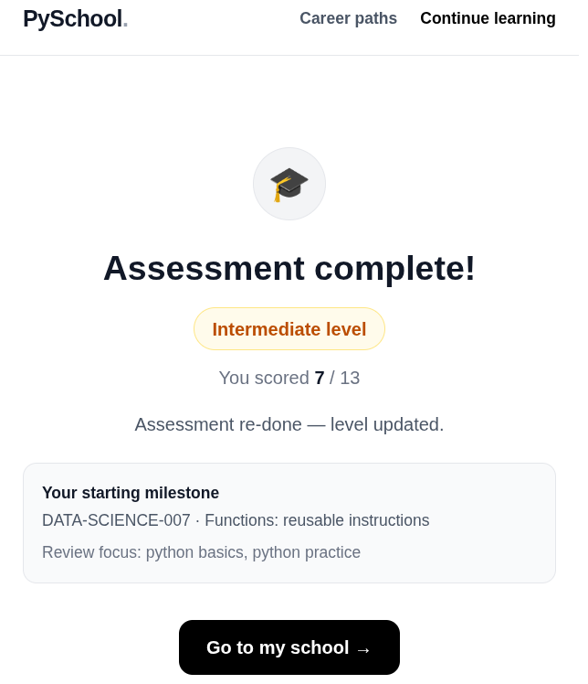
Figure 5 — Level, score, starting milestone and weak topics.

6. A day at school
After the assessment, the student enters the first day of school. The day screen contains the lesson, explanation, Python code, questions and homework, so the student can start learning and doing practical work from day one.
The screenshot below is Day 7 of the Data Science track. The lesson is not a summary of what functions are. It explains why a mutable default argument behaves the way it does, why a function without a return gives back None, and why keyword arguments are worth the extra characters. That is the difference between generated content and written content.
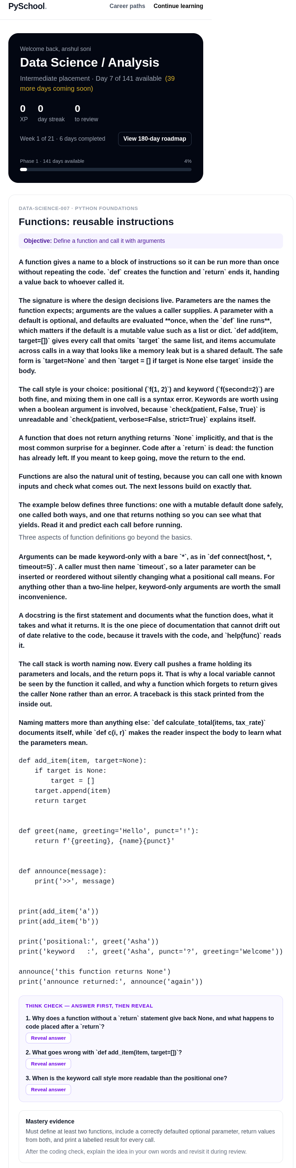
Figure 6 — The daily lesson: objective, theory, worked example.

7. Think Check: answer first, then reveal
This is the part of Milestone 2 I am most happy with. Every one of the 705 lessons in the system now carries a set of questions and a set of answers, and the dashboard shows them as a Think Check panel.
The student sees a question, answers it in their own head or on paper, and only then clicks to reveal the answer. There is no partial credit for guessing, and the answers are not sitting in the page waiting to be copied.
Reading a lesson and understanding a lesson are different things, and before this the platform had no way to tell the difference. A student who cannot answer these questions has not finished the day, even if they scrolled through all the text.
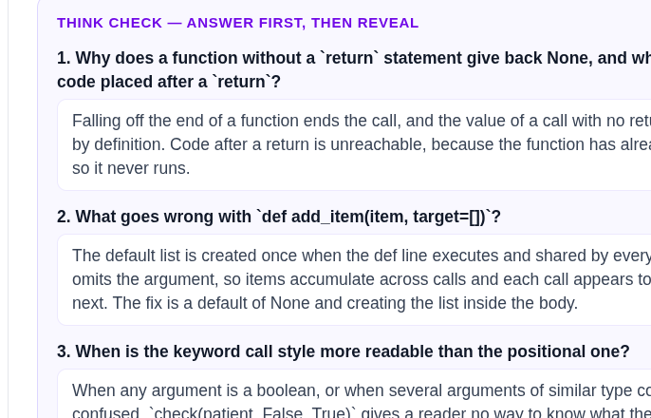
Figure 7 — Think Check with answers revealed after the student commits.

8. What was actually written
The numbers behind Milestone 2, measured from the running database rather than estimated:
Measure | Data Science | Web Development
Track days written | 180 | 180
Theory characters | 383,479 | 428,009
Code example characters | 117,149 | 125,557
Question characters | 43,517 | 44,748
Answer characters | 87,198 | 84,518
Homework characters | 49,011 | 55,005

All 105 track-phase days of the Data Science programme, covering Days 15 to 179, were written out by hand. That was about 1,000 lines of authored curriculum across six phase modules, and it is why the two tracks are now of comparable depth.
The first three days of the foundation block were also rewritten, after working through Mark Lutz's Learning Python, Chapter 6. The original lessons described variables as boxes holding values. The rewrite explains the reference model properly: variables are references to objects, the type belongs to the object rather than the name, and that is why reassignment behaves the way it does. Students who learn Python this way do not have to unlearn it later.
Across the whole milestone the change was 10 files and about 1,060 lines added. No new dependency, no new framework, no architectural change. The new lesson fields live in the existing lessons table and Think Check is a self-contained React component, which is the point: a separate service for questions, or a separate rendering path for authored versus generated content, would have made this milestone more interesting to build and the product worse to maintain.

9. What is still missing
The Python for AI Research track is written and functional across all 180 days, but it is lighter than the other two at roughly 253,000 characters of theory. It needs the same treatment next, one track at a time.
Then there is the work that has not started: real student accounts, a sandboxed execution service so assignments can be tested for behaviour and not just structure, spaced-repetition revision, peer review, project weeks, and deployment.
One thing worth being honest about. The homepage says three fully authored tracks, but only two are live right now. The Data Science and Web Development tracks are open to students, and the AI Research track is still being brought online. I would rather the page understate what is available than pretend.

10. In closing
Milestone 1 was about whether SCHOOL could work at all. Milestone 2 was about whether it could actually teach somebody. A thousand lines of curriculum written by hand, three foundation days rebuilt on a correct model of Python, and a question in every lesson that the student has to answer before they are allowed to move on.
The platform looks the same as it did a month ago. That is partly the point. Nobody notices a lesson that explains something properly, they just understand it.

