SCHOOL
WHERE STUDENTS STUDY, WHERE STUDENTS LEARN, AND WHERE OUR TEACHERS TEACH US HOW THINGS REALLY WORK IN THE REAL WORLD.

SCHOOL

THE MODERN ONLINE SCHOOL
Where you choose your goal, choose your subject, and start learning every day through chapters, daily lessons, and homework.
Since I am an Artificial Intelligence and Data Science student, for now I am creating SCHOOL specifically for learning the Python programming language, with 100+ goals/learning paths.

Milestone 3: Making 100 paths real
Milestone 1 built the school. Milestone 2 made it teach well, but only three tracks had properly written material. A student who chose one of the other ninety-seven paths found something much thinner, and the catalogue had been quietly implying otherwise.
So Milestone 3 went and checked. We audited all hundred paths by reading them and by running their code, and what we found was that the structure was perfect and the content was not. Eighteen thousand lessons existed. On most paths, a student would meet the same fifteen lessons repeated seven times, with the library name swapped in the text and nothing changed in the code.
This milestone is about closing that gap honestly. Two things happened. The Machine Learning track was written from scratch, day by day, and the platform was changed so it can no longer pretend a path is finished when it is not.

1. The audit
Before writing anything new, we measured what was already there. The audit was run against the live database and is reproducible: every lesson row was scanned, and ten thousand of the code examples were executed and their printed output compared against the output written in the lesson.
The structural results were clean. Every one of the hundred paths had 180 days, 180 milestones, 180 assignments and thirteen placement questions. Prerequisites were complete, day numbers ran without gaps, and there were no placeholder tokens left anywhere in the eighteen thousand lessons. Every example that ran produced exactly the output the lesson claimed it would.
The content results were not clean. Three findings mattered.
The first was repetition. On most paths only fifteen distinct lessons existed across a hundred and five days, each one appearing seven times with an identical body. The titles changed by phase, so a student reading "Orientation" on day seventy-five would meet the same orientation text again on day ninety, and again on day one hundred and five.
The second was that the code did not belong to the subject. A quantum-computing day taught list zipping. A bioinformatics day ran the same function on a different variable name. The library name appeared in the surrounding text, but no lesson ever imported it or used it. A student studying cryptography never touched a cipher, and a student studying robotics never touched a sensor.
The third was that the Think Check questions were generic. They asked what the lesson was about rather than whether the student understood it, so the same three questions appeared on lesson after lesson.
The audit also produced a piece of good news. Some lessons were genuinely excellent, grounded in named sources, with real domain work in the code. Those became the quality bar for the rest.
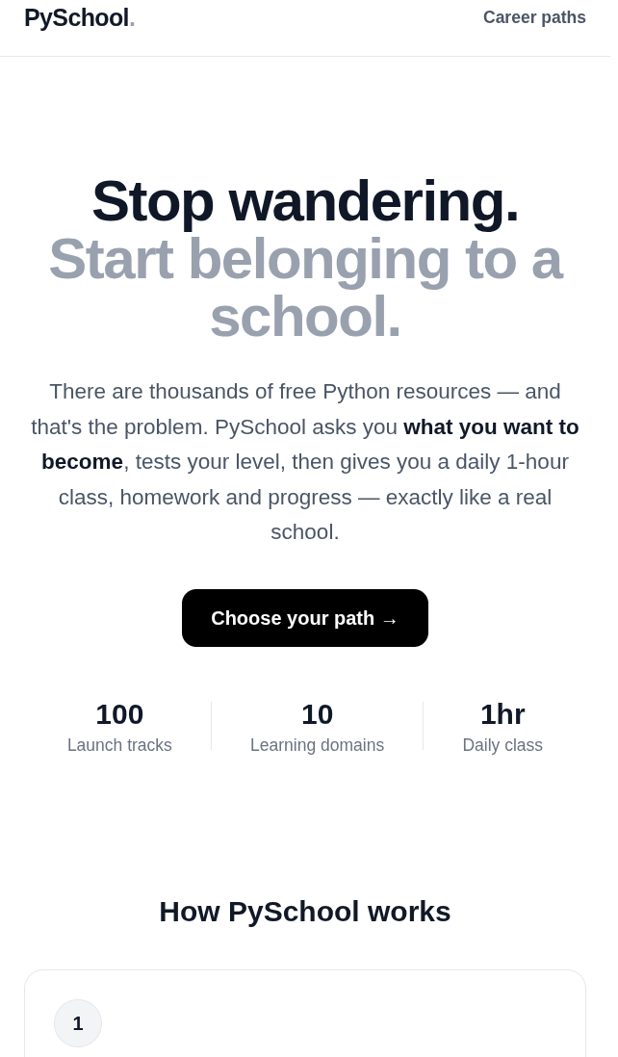
Figure 1 — The catalogue now reports one hundred live tracks.

2. Stopping the platform from overclaiming
The audit turned up something more serious than weak content. The interface had no way to say what was actually ready.
Every path card read the same way. The stored duration said one hundred and eighty days whether those days existed or not, and the lesson count came from a column that was written once and never updated. A path with four usable lessons and a path with a hundred and eighty looked identical from the outside. We had built the exact thing we said we were not building, which was a catalogue that presents unfinished work as ready.
Milestone 3 fixed this at three levels. Every lesson now carries a release status of active or in-progress, along with the reason for that status and a note. The API counts live days directly from the lessons rather than reading a stored number, so the figure cannot drift away from the content behind it. And the interface now shows "n of 180 days available" on every card, with anything unfinished marked as still in development.
This also caught a genuine bug in our own fix. The first version of the rule still consulted the old stored flag, so ninety-seven paths ended up displaying "180 of 180 days available" and "coming soon" on the same card. A path cannot be both finished and unfinished. The rule now derives the label from the live count alone.
There was a related fix on the failure side. Previously, if the backend could not be reached, the pages quietly displayed an empty catalogue and a count of zero. That reads as a working product with no content rather than a broken server, which is the most expensive kind of bug to debug. The pages now say plainly that the API is unreachable and what to check.
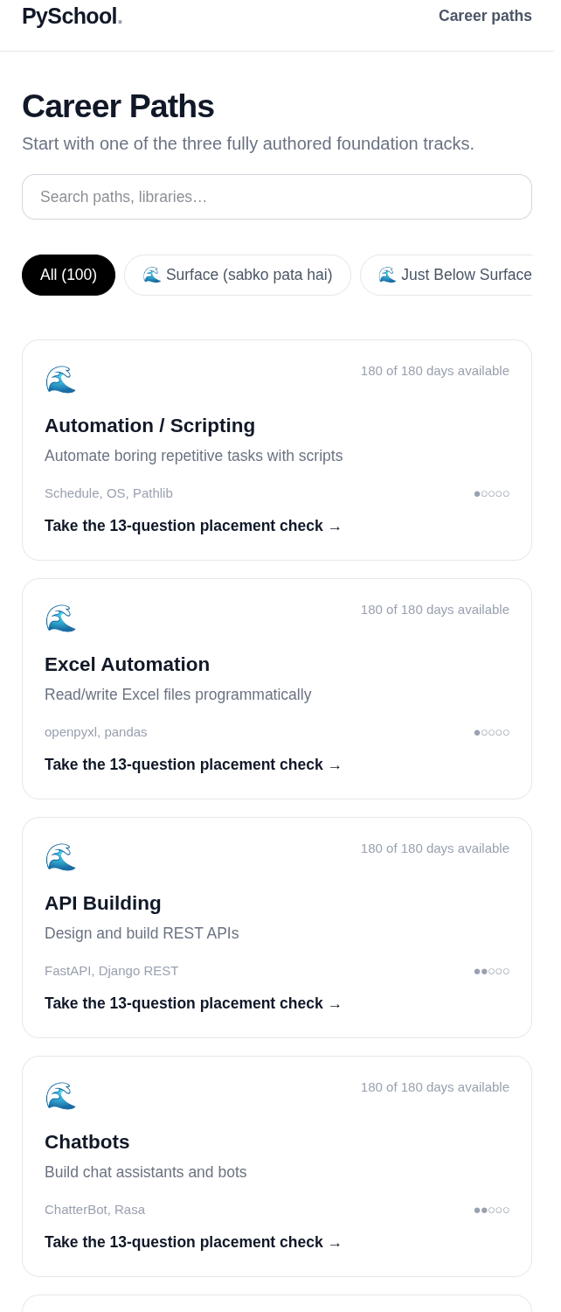
Figure 2 — Live day counts on every card; unfinished paths are labelled.

3. Writing the Machine Learning track
Machine Learning was chosen as the next track for four reasons. It sits in the beginner category where enrolment demand concentrates. It is the natural next step after Data Science, so it reuses what already works. It had the strongest existing foundation of any catalogue path, with eight book-grounded days already written. And scikit-learn is a single coherent library, which makes the worked examples consistent.
The work covered a hundred and eleven days: six foundation days to close the gap in the opening week, and a hundred and five days of track material organised into seven phases of fifteen days each, covering data setup, regression, classification, trees and forests, overfitting and validation, pipelines and tuning, and a capstone.
The rule applied throughout was that a lesson may not claim to teach something its code does not do. Where a full library call cannot run meaningfully on a small sample, the lesson builds the algorithm by hand in plain Python and then states exactly which scikit-learn call it corresponds to. Nothing in the track passes off standard-library code as machine learning.
Every day was validated before it was written to the database. The example is executed and its real output stored, so the output a student reads is output that was actually produced. Each lesson carries two variants, three named mistakes, three questions of which the first is always specific to that day's material, and homework with an honest rubric that checks for something real.
The applier that writes this content refuses to run over the launch tracks, the book-grounded days or the automation path, and it is gated behind an explicit flag. Running it twice writes nothing the second time. Content cannot be damaged by running the pipeline again by accident.
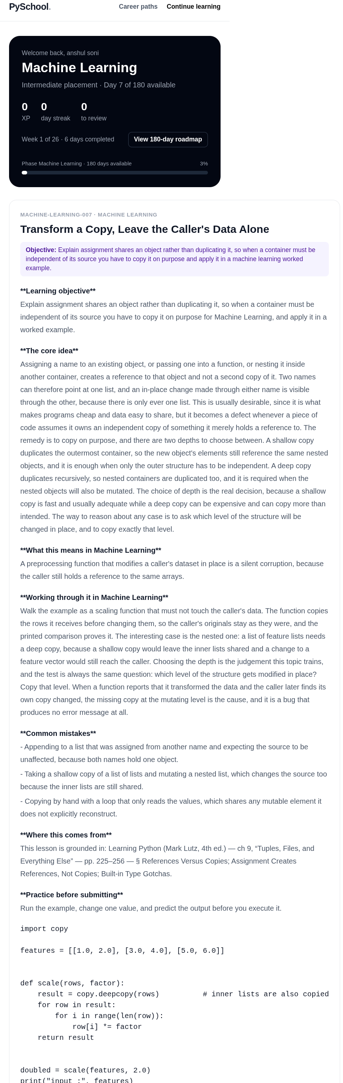
Figure 3 — Machine Learning Day 7. Domain framing, provenance, and a worked example that uses the domain.
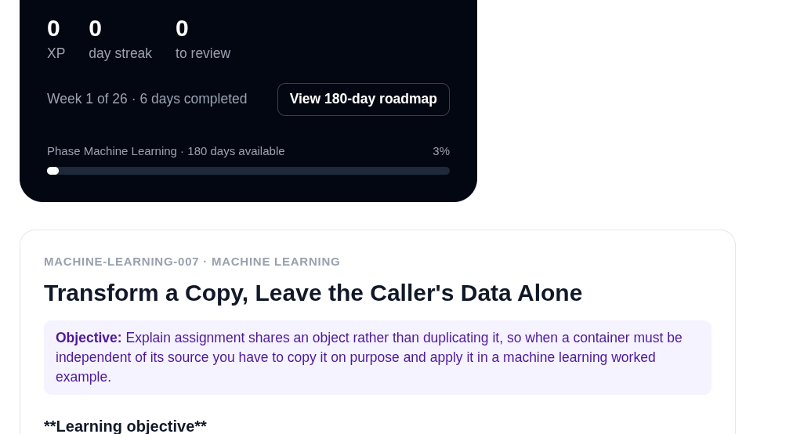
Figure 4 — Theory written for the track, not adapted from a template.
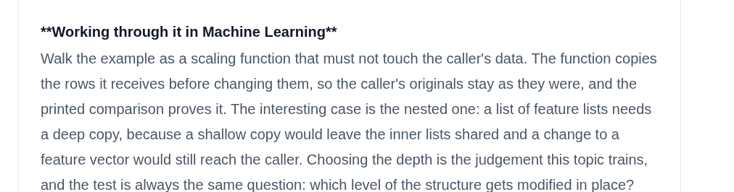
Figure 5 — A runnable example with its real captured output.

4. What the milestone produced
All figures below are read from the running database rather than estimated.
Measure | Result
Learning paths live in the catalogue | 100
Domains | 10
Lessons seeded | 18,000
Milestones and assignments | 18,000 each
Placement questions | 1,300
Paths with a complete 180-day course | 97
Paths partially available | 3
Machine Learning days written by hand | 111
Automated tests passing | 39
Distinct lesson bodies across the catalogue | 4,720

The last row is the honest one. Four thousand seven hundred and twenty distinct lesson bodies across eighteen thousand lessons means most of the catalogue is still template material. The Machine Learning track now has a hundred and eighty genuinely distinct days, and the three flagship tracks are complete, but ninety-seven paths are structurally finished and pedagogically thin. That work has not been done and this report does not claim it has.

5. Decisions worth recording
Audit before authoring. It would have been faster to keep generating content and let quality drift. Measuring first showed that the problem was not quantity but repetition, and that told us which track to write and in what order.
Count, do not store. Deriving available days from the lessons themselves means the number cannot lie. A stored column can disagree with reality forever; a count cannot.
Refuse by default. The content applier will not touch the flagship tracks or the canonical lessons. Making the destructive case the one that requires extra argument, rather than the default, is what allowed this to be run against a live database at all.
Say what is not finished. Showing days available and marking unfinished paths costs nothing and removes the temptation to pretend. The three partially available tracks are visible on purpose.

6. What is still open
Ninety-seven paths carry a full one hundred and eighty day structure on template content. Each needs the treatment the Machine Learning track received, and at roughly a hundred days per track that is the dominant remaining body of work in this project.
Also still open, and unchanged from earlier milestones: real student accounts, a sandboxed execution service so assignments can be tested for behaviour rather than only structure, spaced-repetition revision, peer review, project weeks, portfolio export, and deployment.

7. In closing
Milestone 3 did not add a feature students can see. It removed a habit the product had of implying it was finished when it was not, and then proved the alternative by writing one hundred and eleven days of machine learning material that does what it says on the label.
The number I would point at is not eighteen thousand lessons. It is four thousand seven hundred and twenty distinct ones. The gap between those two figures is the real state of the catalogue, and it is now visible in the product rather than hidden in a database column.

