SCHOOL
WHERE STUDENTS STUDY, WHERE STUDENTS LEARN, AND WHERE OUR TEACHERS TEACH US HOW THINGS REALLY WORK IN THE REAL WORLD.

SCHOOL

THE MODERN ONLINE SCHOOL
Where you choose your goal, choose your subject, and start learning every day through chapters, daily lessons, and homework.
Since I am an Artificial Intelligence and Data Science student, for now I am creating SCHOOL specifically for learning the Python programming language, with 100+ goals/learning paths.

Milestone 4: Deciding what to build next
Milestone 3 ended by naming an uncomfortable number. Of eighteen thousand lessons in the catalogue, only four thousand seven hundred and twenty were genuinely distinct. Ninety-seven paths carried a complete one hundred and eighty day structure on content that repeated itself and taught nothing about its own subject.
Fixing that means writing roughly nine thousand lessons by hand, which is months of work and cannot be parallelised without a way to choose the right order. Milestone 4 is the work of choosing. It covers the four security tracks, establishes exactly what will be written on which of them, locks down what must not be touched while the writing happens, and defines the checks that must pass before any of it reaches a student's screen.
This milestone is a specification rather than a release. Nothing new was written to the curriculum and no content was added to the database. What was produced is the plan, the safety rules and the verification gates that the next milestone will execute.

1. Scoping the security group
The catalogue holds five paths that read as security. One of them, Crypto Trading Bots, was excluded: it is financial rather than security work, and its controls are different enough to deserve a separate decision. That left four genuine targets.
All four were inspected against the database. Each carries a full one hundred and eighty days, a complete prerequisite chain with no missing links, thirteen placement questions, and all days marked as active. None of the four contains any book-grounded canonical lesson, which removes the main obstacle to rewriting them safely.
A further seven paths were considered and set aside rather than silently dropped: API development, network programming, testing, databases, DevOps, cloud and package development all touch security-adjacent ground but have different architectures and would need their own review before being brought into a security batch.
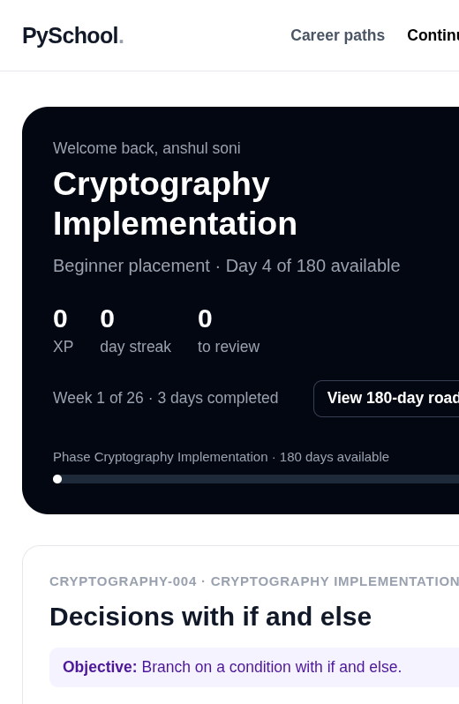
Figure 1 — Cryptography Implementation, Day 4. The lesson teaches if/else and prints 'cryptography check: passed'. The library appears in a string, not in the code.

2. What is being written, and what is refused
Security content carries a risk the other tracks do not. The same material that teaches a student to analyse malware also teaches techniques that could be misused. Authoring for these tracks therefore had to be bounded before a single lesson was written, not afterwards.
The batching order was chosen on risk, not on demand. Cryptography comes first because it is the safest to teach well: everything in it can be demonstrated with Python's standard library, and nothing in a hash or a cipher routine is offensive. Cybersecurity and pentesting come next and require explicit defensive framing and laboratory-only rules. Digital forensics follows using synthetic evidence only. Malware analysis is deliberately last, because static analysis of synthetic samples is the only form of it that will be written, and any material on evasion or persistence is out of scope entirely.
The dependency situation was checked before planning rather than discovered during writing. The environment has scikit-learn, pandas and pytest available, but no password-hashing library beyond the standard one, and no packet-crafting or symmetric-crypto packages. Rather than add dependencies, the plan commits to standard-library demonstrations and states the limitation plainly in the lesson: password storage is taught as PBKDF2 from the standard library and described as exactly that, not as a stronger algorithm it is not.

3. Protecting the work already done
The most dangerous outcome of this milestone would be a successful rewrite that quietly damaged four tracks of finished material. The plan therefore fixes the following as untouchable, with their sizes recorded as a baseline to check against afterwards.
Protected content | Theory size to preserve
Web Development track | 428,009 characters
Data Science track | 383,479 characters
Machine Learning track | 379,728 characters
Python for AI Research track | 253,413 characters
Automation, hand-written days 1 to 4 | 14,226 characters
Shared Python phases, days 15 to 74 | All 100 paths

Writing is restricted to an explicit list of path-and-day pairs. Any request touching a path outside that list, or a day outside it, is refused rather than skipped, so a mistake in configuration stops the run instead of quietly widening its scope.

4. How the writing will be done safely
The mechanism is deliberately dull, because the work is not.
Content lives in source modules, not in ad-hoc edits. A separate applier module is the only thing that touches the database, and it defaults to a dry run that reports what it would change without changing it. It reads the existing row and compares before writing, so unchanged content costs nothing and a second run is a no-op. It updates lesson text, assignment prompts and milestone wording, and never creates rows, never alters milestone identifiers or codes, and never touches prerequisite edges, so the chain a student follows through a course cannot be damaged by a content change.
Before any write, a file copy of the database is taken and its size verified. The run then happens against a scratch copy, not the live one. Only after every check passes is the live database touched, with a fresh backup first.
Content quality gates apply to every lesson, matching the standard set for the Machine Learning track: theory within a defined word range, code that executes successfully with its real output captured, exactly three questions of which the first is specific to that day's material, homework with a rubric that checks something real, and no placeholder text anywhere.

5. Checks that must pass before a student sees it
Six checks stand between finished writing and a live course.
Row counts confirm that exactly the intended lessons, assignments and milestones were written and nothing else was.
Content gates confirm the word ranges, that every example runs and its output matches what the lesson claims, that no lesson repeats another, and that no placeholder tokens survive.
Idempotency confirms that running the pipeline twice changes nothing the second time, which is the property that makes it safe to keep using.
Baseline hashes confirm the protected tracks are byte-identical to what they were before the run, which is the check that catches collateral damage.
Structure confirms every prerequisite chain is intact across all one hundred and eighty days, and that the automated test suite passes.
End-to-end confirms that a student can enrol on a rewritten path, open a lesson, answer the Think Check, submit practice and reach the dashboard, with the interface checked by hand for the rewritten material.

6. State of the four paths today
Stating this plainly, because it is the point of the milestone. No security content has been written yet. All four paths still carry the same template material the last audit identified: across a hundred and five track days, thirty distinct lessons rather than a hundred and five, with the library name present in the surrounding text and absent from the code.
The cryptography path in the screenshot above is representative. Day four is titled "Decisions with if and else". The lesson is a generic conditional exercise whose only connection to cryptography is a printed message reading "cryptography check: passed". A student choosing this path today receives a complete-looking one hundred and eighty day course that never uses a cipher.
That is precisely the failure mode Milestone 3 built the release-status system to make visible, and it is why the day count alone was never going to be enough evidence of quality.

7. Decisions worth recording
Refuse rather than skip. Out-of-scope writes are refused, not ignored. A silent skip hides a misconfiguration; a refusal stops the run.
Dry run by default. Writing to a live student-facing database requires an explicit flag. The dangerous action must be the one that needs typing.
Teach the standard library honestly. Where the environment cannot run a real library, the lesson says so and names the library call it is standing in for. This follows the rule set for the Machine Learning track: no lesson claims to teach something its code does not do.
Order by risk. Cryptography is easiest to write honestly, which makes it the right place to prove the pipeline before the paths that genuinely need care.
Record the baseline first. Protected content is measured before writing starts so that damage is detectable afterwards, rather than argued about.

8. What is still open
The next milestone executes batch one: the cryptography module, its applier, its tests and a hundred and nineteen authored lessons, verified against a scratch database before the live one is touched.
After that, three more batches of roughly a hundred and nineteen lessons each bring the security group to the standard the flagship tracks already meet. Ninety-three non-security paths remain on template content and are the largest remaining body of work in the project.
Carried over unchanged from earlier milestones: real student accounts, a sandboxed execution service so assignments can be tested for behaviour and not only structure, spaced-repetition revision, peer review, project weeks, portfolio export and deployment.

9. In closing
Milestone 4 produced no lessons, and it was the right milestone for that. The failure mode in this project is not writing bad content quickly; it is writing a great deal of content without knowing whether it is good. The audit in Milestone 3 proved that, and this milestone is the response.
What changed is that the next four hundred and seventy six lessons have a defined scope, a defined order chosen by risk, a defined set of content that must not be touched, and six checks that stand between the applier and a student's screen. When batch one runs, it will either produce verified cryptography lessons or it will stop and say so.

