PRACTICAL - 1
Understanding the Data Engineering Lifecycle

AIM
To study, dissect, and map the complete end-to-end data engineering lifecycle for an enterprise e-commerce platform by understanding data generation, ingestion, storage, transformation, and serving along with the cross-cutting concerns of security, observability, and data privacy.
PROBLEM DEFINITION
This practical focuses on analysing the complete enterprise data engineering lifecycle. The objective is to create an architectural data flow diagram, prepare a System Manifesto, define sample datasets, and document the entire workflow in a GitHub repository. The project demonstrates how enterprise data flows from multiple sources to business applications through a secure and scalable data pipeline.
Tools Used
- Draw.io
- Git
- GitHub
- Markdown
- Mock E-Commerce Dataset
WORK PERFORMED
- Studied the complete enterprise data engineering lifecycle.
- Identified the five lifecycle stages: Data Generation, Data Ingestion, Data Storage, Data Transformation and Data Serving.
- Designed the enterprise architecture using Draw.io.
- Prepared a System Manifesto describing Security, Observability and Data Privacy.
- Created a sample e-commerce database schema.
- Prepared sample clickstream JSON data.
- Organized all files in a GitHub repository with proper documentation.
ARCHITECHTURE DESIGN
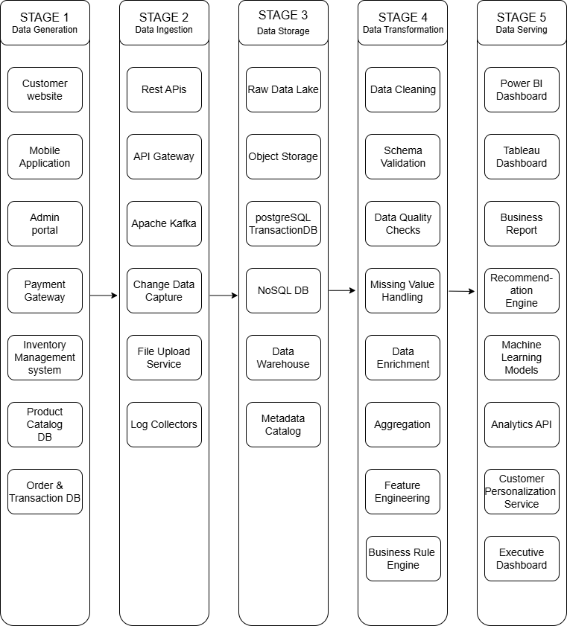
The architecture begins with data generation from multiple enterprise sources such as customer websites, mobile applications, admin portals, payment gateways, inventory management systems, product catalog databases, and order transaction databases. The generated data is collected through REST APIs, API Gateway, Apache Kafka, Change Data Capture (CDC), file upload services, and log collectors, enabling both real-time and batch data ingestion. The ingested data is then stored in a scalable storage layer consisting of a Raw Data Lake, Object Storage, PostgreSQL Transaction Database, NoSQL Database, Data Warehouse, and Metadata Catalog for efficient management and governance. Next, the data undergoes transformation, where it is cleaned, validated, checked for quality, processed for missing values, enriched with additional information, aggregated, feature engineered, and business rules are applied to ensure high-quality datasets. Finally, the processed data is delivered to the data serving layer, where it powers Power BI and Tableau dashboards, business reports, recommendation engines, machine learning models, analytics APIs, customer personalization services, and executive dashboards, enabling data-driven decision making while ensuring scalability, reliability, governance, and security throughout the entire data lifecycle.

GITHUB REPOSITORY
https://github.com/shivanshdalvadidhk-sud/24DIT014_Data-Engineering-Lab/tree/main/practical_1

CONCLUSION
This practical provided an understanding of the complete Data Engineering Lifecycle in an enterprise e-commerce platform. It demonstrated how data flows through the five stages—Data Generation, Data Ingestion, Data Storage, Data Transformation, and Data Serving. The architecture highlighted the importance of scalable data pipelines, reliable storage systems, and efficient data processing techniques for generating business insights. Additionally, cross-cutting aspects such as security, data privacy, and observability were considered throughout the lifecycle to ensure secure, reliable, and high-quality data management. Overall, this practical strengthened the understanding of designing end-to-end enterprise data engineering architectures.

