PRACTICAL - 2
Programmatic Data Generation, Profiling, and Data Quality Validation for Multiple Data Sources

AIM
To programmatically generate data from different sources such as CSV files, APIs, JSON files, and relational databases, perform schema discovery, profile the incoming data, detect data quality issues, and establish appropriate ingestion criteria before loading data into downstream systems.

PROBLEM DEFINITION
The objective of this practical is to programmatically generate and collect data from multiple sources, including CSV files, APIs, JSON files, and relational databases, and prepare it for ingestion into a data engineering pipeline. The system automatically discovers data schemas, profiles the incoming data, and performs data quality validation by identifying issues such as missing values, duplicate records, invalid data types, and schema inconsistencies. Based on these validations, appropriate ingestion criteria are established to ensure that only clean, accurate, and reliable data is processed by downstream systems. This practical helps in understanding how enterprise data engineering pipelines handle diverse data sources while maintaining high data quality and operational efficiency.
Objective
- To generate synthetic datasets from multiple data sources.
- To understand structured, semi-structured, and unstructured data.
- To automatically discover data schemas.
- To perform data profiling and quality validation.
- To detect missing values, duplicate records, and invalid data.
- To prepare clean and validated datasets for ingestion.

Workflow
- Generate synthetic customer data using the Faker library.
- Collect data from different sources.
- Automatically identify schema and data types.
- Profile the dataset.
- Detect missing values.
- Detect duplicate records.
- Validate data formats.
- Apply data quality rules.
- Store clean data for downstream processing.

Data Sources Used
Structured Data
- CSV Files
- SQLite/PostgreSQL Database
Semi-Structured Data
- JSON API Responses
Unstructured Data
- Configuration Text Files
- Log Files

Key Questions
1. How can schema drift be managed while handling third-party APIs?
Schema drift can be managed using dynamic schema detection, schema versioning, metadata catalogs, validation rules, and flexible storage formats such as JSON or Parquet. Data pipelines should automatically detect schema changes and handle new fields without breaking the ingestion process.

2. What are the advantages and trade-offs of using semi-structured JSON over normalized SQL tables?
JSON provides flexibility for storing nested and changing data structures without frequent schema modifications. It is suitable for APIs and event data. However, SQL databases provide better consistency, indexing, faster joins, and efficient querying for structured data.

3. How is data quality validated during ingestion without affecting performance?
Data quality can be maintained by performing lightweight validation during ingestion, validating only critical fields, using parallel processing, schema enforcement, rule-based validation, and logging invalid records instead of stopping the entire pipeline.

Code and Output

pip install faker
import pandas as pd
import json
import sqlite3
import random
import logging

from faker import Faker
fake = Faker()
customers = []

for i in range(1000):

customers.append({
"CustomerID": i + 1,
"Name": fake.name(),
"Email": fake.email(),
"Age": random.randint(18, 65),
"City": fake.city()
})

df = pd.DataFrame(customers)

df.head()
df.shape
df.to_csv("customers.csv", index=False)

print("Customer dataset saved successfully.")
df.loc[5, "Email"] = None

df.loc[20, "Age"] = "Unknown"

df.loc[35, "CustomerID"] = None

df.to_csv("customers.csv", index=False)

df.head(40)
df = pd.read_csv("customers.csv")

df.head(40)
df.info()
df.dtypes
df.describe(include="all")
df.isnull().sum()
schema = df.dtypes

print(schema)
expected_schema = {

"CustomerID": "float64",

"Name": "object",

"Email": "object",

"Age": "int64",

"City": "object"

}
for column in expected_schema:

print(column)

print("Expected :", expected_schema[column])

print("Actual :", df[column].dtype)

print()
missing_pk = df[df["CustomerID"].isnull()]

missing_pk
missing_email = df[df["Email"].isnull()]

missing_email
invalid_age = df[df["Age"] == "Unknown"]

invalid_age
bad_records = df[

df["CustomerID"].isnull()

|

df["Email"].isnull()

|

(df["Age"] == "Unknown")

]

bad_records
bad_records.to_csv("quarantine.csv", index=False)

print("Quarantine file created.")
good_records = df.drop(bad_records.index)

good_records.head(40)
good_records.shape
logging.basicConfig(

filename="ingestion.log",

level=logging.INFO,

format="%(asctime)s - %(levelname)s - %(message)s"

)
logging.info("Customer dataset loaded.")

logging.warning("Missing Email detected.")

logging.warning("Missing CustomerID detected.")

logging.warning("Invalid Age format detected.")

logging.info("Bad records moved to quarantine.")
transactions = []

for i in range(1500):

transactions.append({

"transaction_id": i + 1,

"customer": {

"id": random.randint(1, 200),

"name": fake.name()

},

"payment": {

"amount": random.randint(100, 5000),

"mode": random.choice(["UPI", "Card", "Cash"])

}

})
with open("api_logs.json", "w") as file:

json.dump(transactions, file, indent=4)

print("JSON file created.")
with open("api_logs.json") as file:

data = json.load(file)
api_df = pd.json_normalize(data)

api_df.head()
api_df.shape
api_df.info()
config = """

Server=localhost

Port=5432

Timeout=30

Cache=True

Random Text

Unknown Line

"""

with open("config.txt", "w") as file:

file.write(config)
with open("config.txt") as file:

lines = file.readlines()

for line in lines:

if "=" in line:

print("Valid :", line.strip())

else:

print("Invalid :", line.strip())
conn = sqlite3.connect("customer.db")

good_records.to_sql(

"Customers",

conn,

if_exists="replace",

index=False

)
pd.read_sql("SELECT * FROM Customers", conn)
summary = {

"Total Records": len(df),

"Valid Records": len(good_records),

"Invalid Records": len(bad_records),

"Missing Email": df["Email"].isnull().sum(),

"Missing CustomerID": df["CustomerID"].isnull().sum()

}

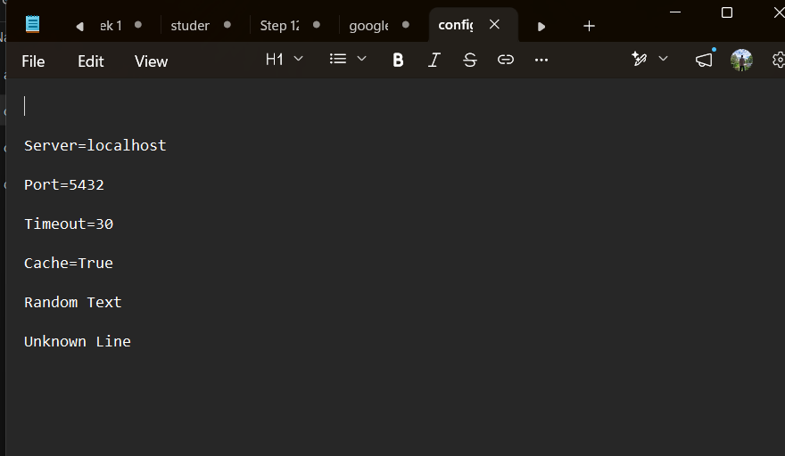
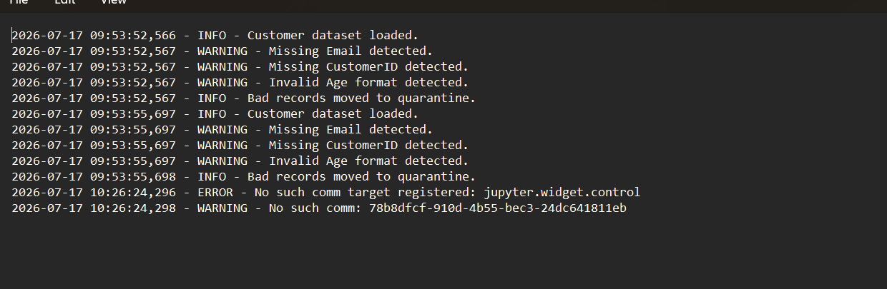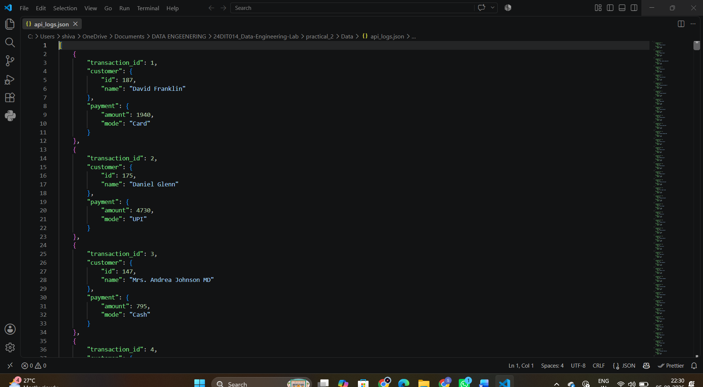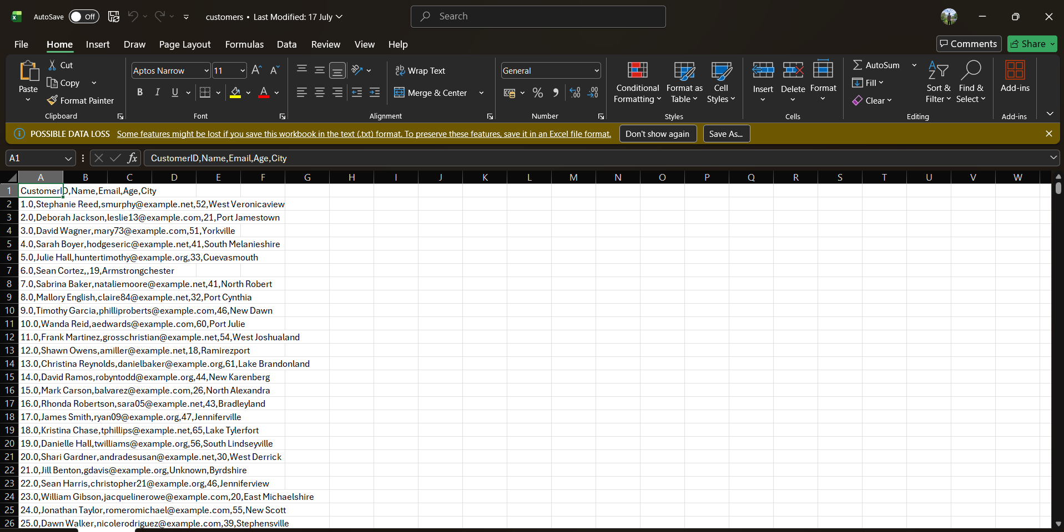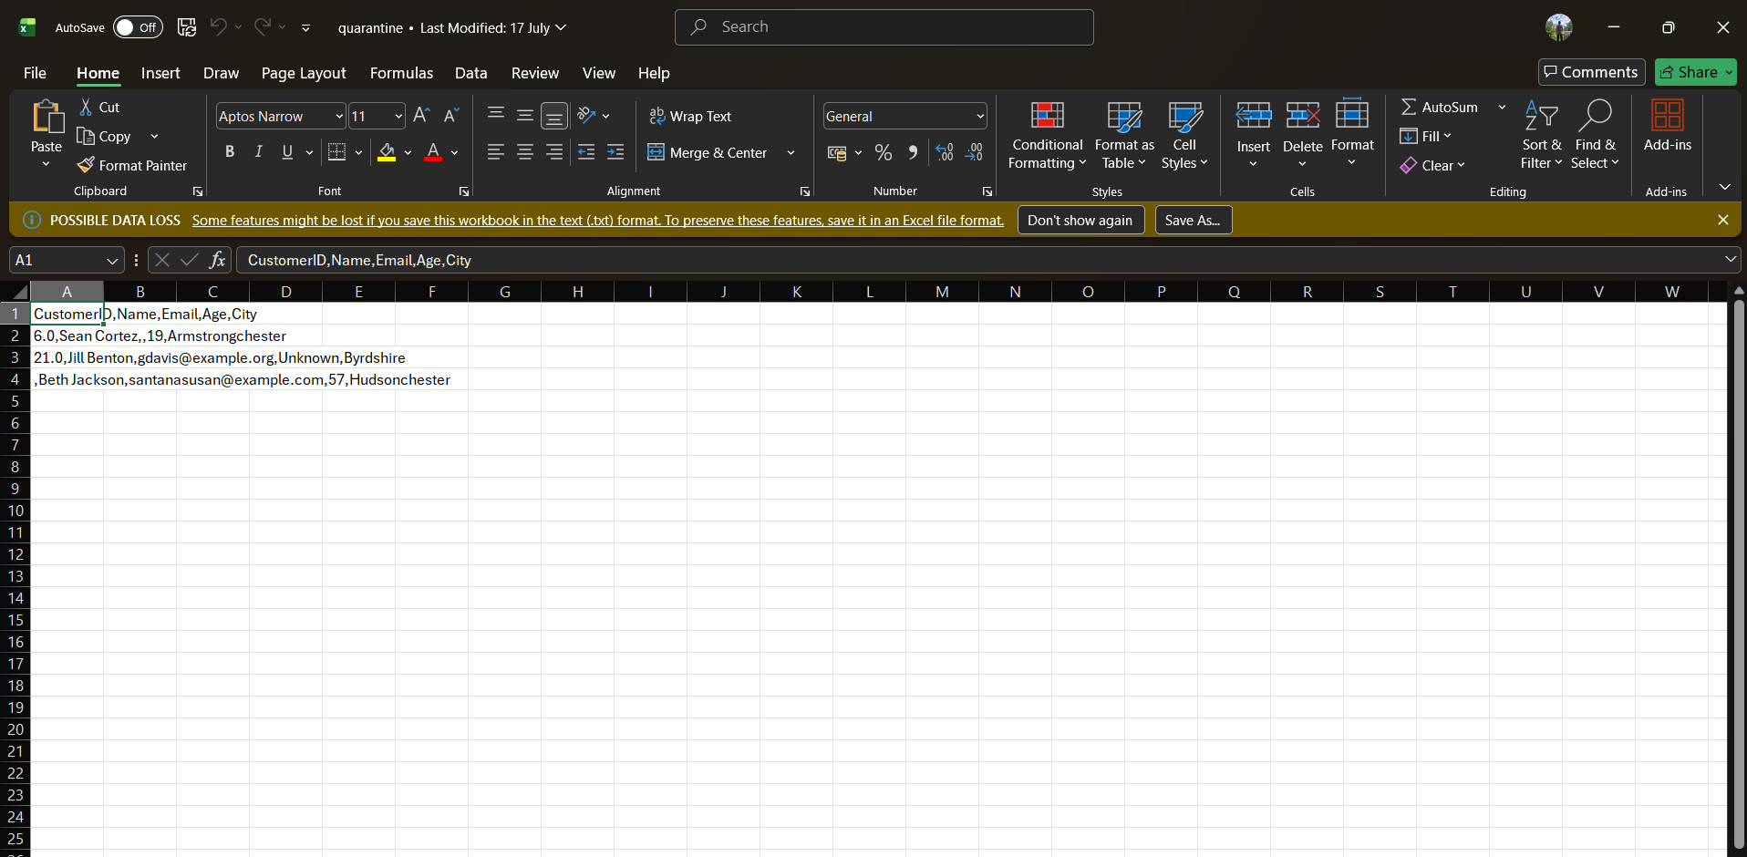

GITHUB REPOSITORY
https://github.com/shivanshdalvadidhk-sud/24DIT014_Data-Engineering-Lab/tree/main/practical_2

CONCLUSION
This practical demonstrated how data from multiple sources can be generated, profiled, and validated before ingestion into a data engineering pipeline. Automatic schema discovery and data quality checks helped identify missing values, duplicates, and structural inconsistencies, ensuring that only clean and reliable data moves to downstream systems. The practical provided hands-on experience with enterprise-level data validation techniques and highlighted the importance of data profiling in building robust and efficient data pipelines.

