Practical-3
Problem Definition
Design, spin up, and evaluate two parallel data ingestion pipelines: a periodic time-triggered block batch pipeline and a continuous low-latency real-time event streaming processor. Students must capture telemetry statistics and benchmark performance parameters across both options, measuring data delivery latency, processing throughput spikes, and fault tolerance during simulated infrastructure drops.
Dataset/Test Data:
Real-time web application user activity logs, server performance metrics, and timestamps.
Tools/Technologies:
- Docker
- Apache Kafka
- Python
- Kafka-Python-NG
- Pandas
- Matplotlib
Code
Micro_batch.py
import pandas as pd
import time
import os

INPUT_FILE = "activity_logs.csv"
BATCH_SIZE = 100

df = pd.read_csv(INPUT_FILE)

results = []

for start in range(0, len(df), BATCH_SIZE):

batch = df.iloc[start:start + BATCH_SIZE]

start_time = time.time()

# Process the batch
processed_batch = batch.copy()

end_time = time.time()

processing_time = end_time - start_time

if processing_time == 0:
processing_time = 0.000001

throughput = len(processed_batch) / processing_time

results.append({
"batch_number": (start // BATCH_SIZE) + 1,
"records_processed": len(processed_batch),
"processing_time_seconds": processing_time,
"average_latency_seconds": processing_time / len(processed_batch),
"throughput_events_per_second": throughput
})

results_df = pd.DataFrame(results)

os.makedirs("results", exist_ok=True)

results_df.to_csv(
"results/micro_batch_results.csv",
index=False
)

print("======================================")
print(" MICRO-BATCH PROCESSING")
print("======================================")

print("Total records:", len(df))
print("Total batches:", len(results_df))

print("\nResults:")
print(results_df)

print("\nMicro-batch processing completed.")
print("Results saved to:")
print("results/micro_batch_results.csv")

2.producer.py
from kafka import KafkaProducer
import pandas as pd
import json
import time

KAFKA_SERVER = "localhost:9092"
TOPIC = "user-activity"

producer = KafkaProducer(
bootstrap_servers=KAFKA_SERVER,
value_serializer=lambda value:
json.dumps(value).encode("utf-8")
)

df = pd.read_csv("activity_logs.csv")

print("======================================")
print(" KAFKA STREAMING PRODUCER")
print("======================================")

print("Total records:", len(df))
print("Sending events...\n")

for _, row in df.iterrows():

event = row.to_dict()

event["send_time"] = time.time()

producer.send(
TOPIC,
value=event
)

print(
"Sent event:",
event.get("event_id")
)

producer.flush()

print("\nAll events sent successfully.")

producer.close()
3.consumer.py
from kafka import KafkaConsumer
import json
import time
import pandas as pd
import os

KAFKA_SERVER = "localhost:9092"
TOPIC = "user-activity"

consumer = KafkaConsumer(
TOPIC,
bootstrap_servers=KAFKA_SERVER,
auto_offset_reset="earliest",
enable_auto_commit=True,
group_id="streaming-consumer-group",
value_deserializer=lambda value:
json.loads(value.decode("utf-8"))
)

results = []

processed = 0

print("======================================")
print(" KAFKA STREAMING CONSUMER")
print("======================================")

start_time = time.time()

try:

for message in consumer:

receive_time = time.time()

event = message.value

send_time = event.get(
"send_time",
receive_time
)

latency = receive_time - send_time

processed += 1

results.append({
"event_id": event.get("event_id"),
"latency_seconds": latency
})

if processed % 100 == 0:

print(
"Processed:",
processed
)

if processed >= 1000:
break

except KeyboardInterrupt:

pass

finally:

end_time = time.time()

total_time = end_time - start_time

if total_time == 0:
total_time = 0.000001

average_latency = (
sum(r["latency_seconds"] for r in results)
/ len(results)
if results else 0
)

throughput = processed / total_time

result = pd.DataFrame([{
"events_processed": processed,
"total_processing_time_seconds": total_time,
"average_latency_seconds": average_latency,
"throughput_events_per_second": throughput
}])

os.makedirs("results", exist_ok=True)

result.to_csv(
"results/streaming_results.csv",
index=False
)

print("\n======================================")
print(" STREAMING RESULTS")
print("======================================")

print("Events processed:", processed)

print(
"Average latency:",
average_latency,
"seconds"
)

print(
"Throughput:",
throughput,
"events/sec"
)

print("\nResults saved to:")
print("results/streaming_results.csv")

consumer.close()
4.spike_producer.py
from kafka import KafkaProducer
import json
import time
import random

KAFKA_SERVER = "localhost:9092"
TOPIC = "user-activity"

producer = KafkaProducer(
bootstrap_servers=KAFKA_SERVER,
value_serializer=lambda value:
json.dumps(value).encode("utf-8")
)

print("====================================")
print(" TRAFFIC SPIKE PRODUCER")
print("====================================")

print("Sending sudden traffic spike...\n")

for i in range(50000):

event = {
"event_id": i + 1,
"event_time": time.time(),
"user_id": f"U{random.randint(1, 100):03d}",
"event_type": random.choice([
"login",
"click",
"page_view",
"purchase",
"search"
]),
"cpu_usage": round(
random.uniform(20, 95), 2
),
"memory_usage": round(
random.uniform(30, 90), 2
)
}

producer.send(
TOPIC,
value=event
)

if i % 10000 == 0:

print(
"Sent:",
i,
"events"
)

producer.flush()

print("\n====================================")
print("TRAFFIC SPIKE COMPLETE")
print("====================================")

print("Total events sent: 50000")

producer.close()
5.consumer_worker.py
from kafka import KafkaConsumer
import json
import time
import sys

KAFKA_SERVER = "localhost:9092"
TOPIC = "user-activity"

consumer_name = sys.argv[1]

consumer = KafkaConsumer(
TOPIC,
bootstrap_servers=KAFKA_SERVER,
group_id="spike-consumer-group",
auto_offset_reset="latest",
enable_auto_commit=True,
value_deserializer=lambda value:
json.loads(value.decode("utf-8"))
)

print(
f"[{consumer_name}] Consumer started"
)

processed = 0

start_time = time.time()

try:

while True:

records = consumer.poll(
timeout_ms=1000
)

for topic_partition, messages in records.items():

for message in messages:

event = message.value

processed += 1

# Simulate processing workload
time.sleep(0.001)

if processed % 1000 == 0:

print(
f"[{consumer_name}] "
f"Processed: {processed}"
)

except KeyboardInterrupt:

end_time = time.time()

total_time = end_time - start_time

print("\n================================")
print(
f"[{consumer_name}] STOPPED"
)
print("================================")

print(
"Events processed:",
processed
)

if total_time > 0:

print(
"Throughput:",
round(
processed / total_time,
2
),
"events/sec"
)

finally:

consumer.close()
6.compare_results.py
import pandas as pd
import matplotlib.pyplot as plt
import os

# Load benchmark results

micro_batch = pd.read_csv(
"results/micro_batch_results.csv"
)

streaming = pd.read_csv(
"results/streaming_results.csv"
)

# Convert latency to milliseconds

micro_batch["latency_ms"] = (
micro_batch["average_latency_seconds"] * 1000
)

streaming_latency = (
streaming["average_latency_seconds"].iloc[0] * 1000
)

# Calculate average throughput

micro_batch_throughput = (
micro_batch["throughput_events_per_second"].mean()
)

streaming_throughput = (
streaming["throughput_events_per_second"].iloc[0]
)

# Create comparison table

comparison = pd.DataFrame({
"Pipeline": [
"Micro-Batch",
"Kafka Streaming"
],
"Average Latency (ms)": [
micro_batch["latency_ms"].mean(),
streaming_latency
],
"Throughput (events/sec)": [
micro_batch_throughput,
streaming_throughput
]
})

print("\n======================================")
print(" FINAL PERFORMANCE COMPARISON")
print("======================================")

print(
comparison.to_string(index=False)
)

# Save comparison

os.makedirs("results", exist_ok=True)

comparison.to_csv(
"results/final_comparison.csv",
index=False
)

# Latency comparison chart

plt.figure(figsize=(8, 5))

plt.bar(
comparison["Pipeline"],
comparison["Average Latency (ms)"]
)

plt.ylabel("Average Latency (ms)")
plt.xlabel("Pipeline")
plt.title(
"Micro-Batch vs Real-Time Streaming Latency"
)

plt.tight_layout()

plt.savefig(
"results/latency_comparison.png"
)

plt.show()

# Throughput comparison chart

plt.figure(figsize=(8, 5))

plt.bar(
comparison["Pipeline"],
comparison["Throughput (events/sec)"]
)

plt.ylabel("Throughput (events/sec)")
plt.xlabel("Pipeline")
plt.title(
"Micro-Batch vs Real-Time Streaming Throughput"
)

plt.tight_layout()

plt.savefig(
"results/throughput_comparison.png"
)

plt.show()

print("\nFiles created:")
print("results/final_comparison.csv")
print("results/latency_comparison.png")
print("results/throughput_comparison.png")
7.docker-compose.yml
services:

kafka1:
image: apache/kafka:latest
container_name: kafka1
ports:
- "9092:9092"
environment:
KAFKA_NODE_ID: 1
KAFKA_PROCESS_ROLES: broker,controller
KAFKA_LISTENERS: PLAINTEXT://:9092,CONTROLLER://:9093
KAFKA_ADVERTISED_LISTENERS: PLAINTEXT://localhost:9092
KAFKA_CONTROLLER_LISTENER_NAMES: CONTROLLER
KAFKA_LISTENER_SECURITY_PROTOCOL_MAP: CONTROLLER:PLAINTEXT,PLAINTEXT:PLAINTEXT
KAFKA_CONTROLLER_QUORUM_VOTERS: 1@kafka1:9093,2@kafka2:9093,3@kafka3:9093
KAFKA_OFFSETS_TOPIC_REPLICATION_FACTOR: 3
KAFKA_TRANSACTION_STATE_LOG_REPLICATION_FACTOR: 3
KAFKA_TRANSACTION_STATE_LOG_MIN_ISR: 2
KAFKA_NUM_PARTITIONS: 3

kafka2:
image: apache/kafka:latest
container_name: kafka2
ports:
- "9094:9092"
environment:
KAFKA_NODE_ID: 2
KAFKA_PROCESS_ROLES: broker,controller
KAFKA_LISTENERS: PLAINTEXT://:9092,CONTROLLER://:9093
KAFKA_ADVERTISED_LISTENERS: PLAINTEXT://localhost:9094
KAFKA_CONTROLLER_LISTENER_NAMES: CONTROLLER
KAFKA_LISTENER_SECURITY_PROTOCOL_MAP: CONTROLLER:PLAINTEXT,PLAINTEXT:PLAINTEXT
KAFKA_CONTROLLER_QUORUM_VOTERS: 1@kafka1:9093,2@kafka2:9093,3@kafka3:9093
KAFKA_OFFSETS_TOPIC_REPLICATION_FACTOR: 3
KAFKA_TRANSACTION_STATE_LOG_REPLICATION_FACTOR: 3
KAFKA_TRANSACTION_STATE_LOG_MIN_ISR: 2
KAFKA_NUM_PARTITIONS: 3

kafka3:
image: apache/kafka:latest
container_name: kafka3
ports:
- "9095:9092"
environment:
KAFKA_NODE_ID: 3
KAFKA_PROCESS_ROLES: broker,controller
KAFKA_LISTENERS: PLAINTEXT://:9092,CONTROLLER://:9093
KAFKA_ADVERTISED_LISTENERS: PLAINTEXT://localhost:9095
KAFKA_CONTROLLER_LISTENER_NAMES: CONTROLLER
KAFKA_LISTENER_SECURITY_PROTOCOL_MAP: CONTROLLER:PLAINTEXT,PLAINTEXT:PLAINTEXT
KAFKA_CONTROLLER_QUORUM_VOTERS: 1@kafka1:9093,2@kafka2:9093,3@kafka3:9093
KAFKA_OFFSETS_TOPIC_REPLICATION_FACTOR: 3
KAFKA_TRANSACTION_STATE_LOG_REPLICATION_FACTOR: 3
KAFKA_TRANSACTION_STATE_LOG_MIN_ISR: 2
KAFKA_NUM_PARTITIONS: 3

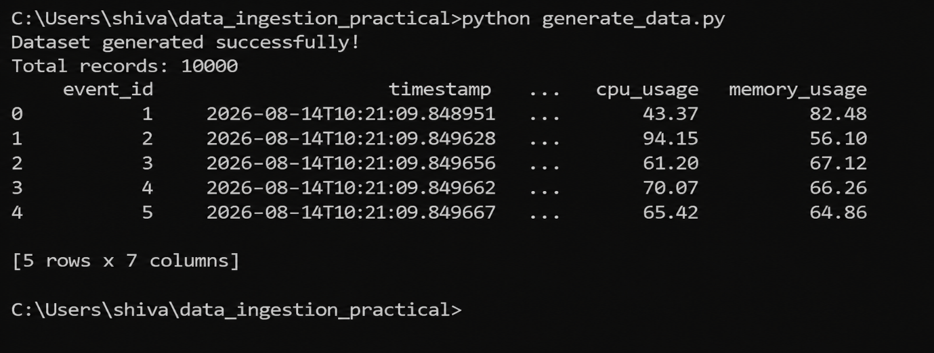

Figure 1: Generated user activity dataset containing event IDs, timestamps, CPU usage and memory usage.

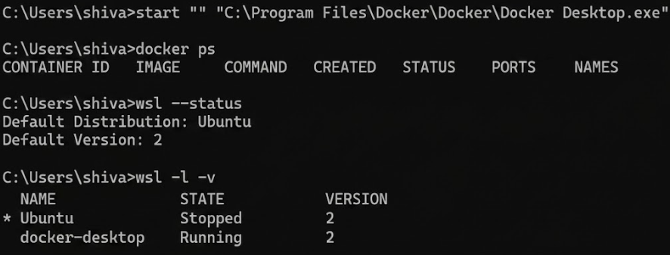
Figure 2: Docker and WSL environment used for the Kafka data ingestion experiment.
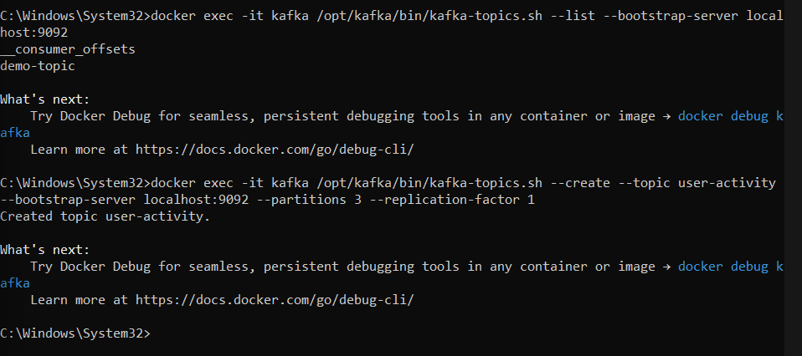
Figure 3: Creation of the user-activity Kafka topic with three partitions
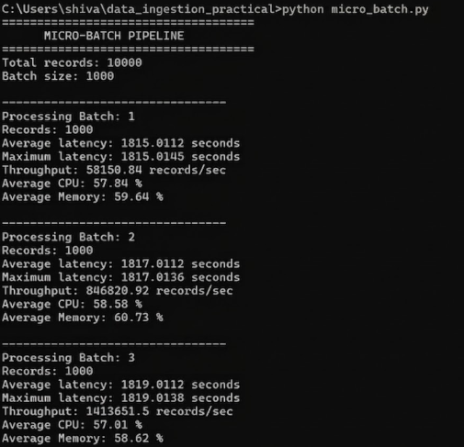
Figure 4: Execution of the periodic micro-batch ingestion pipeline and collection of processing statistics.
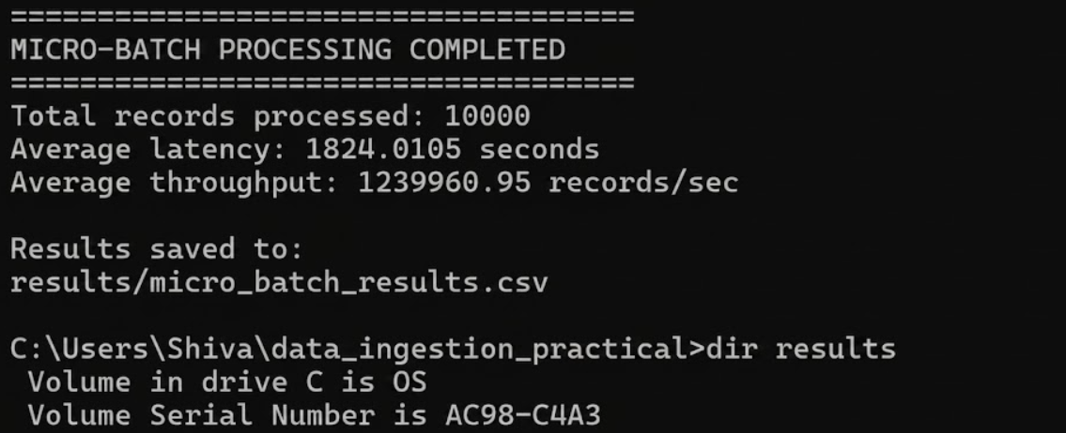
Figure 5: Completion of the micro-batch pipeline with calculated latency and throughput results.
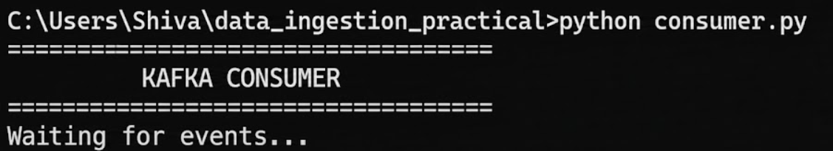
Figure 6: Kafka consumer waiting for real-time user activity events.
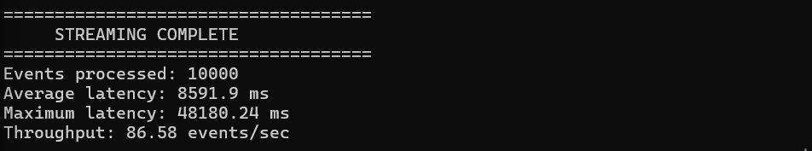
Figure 7: Completion of the real-time streaming pipeline with processed event count, latency and throughput. 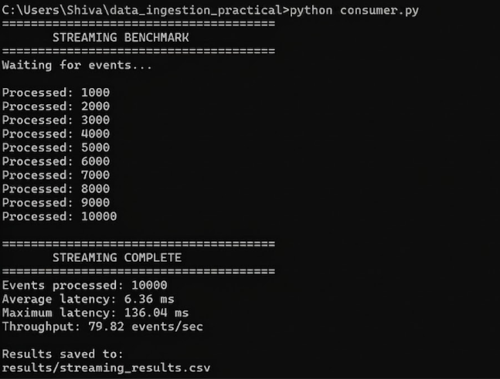
Figure 8: Streaming benchmark showing event processing and throughput measurements.

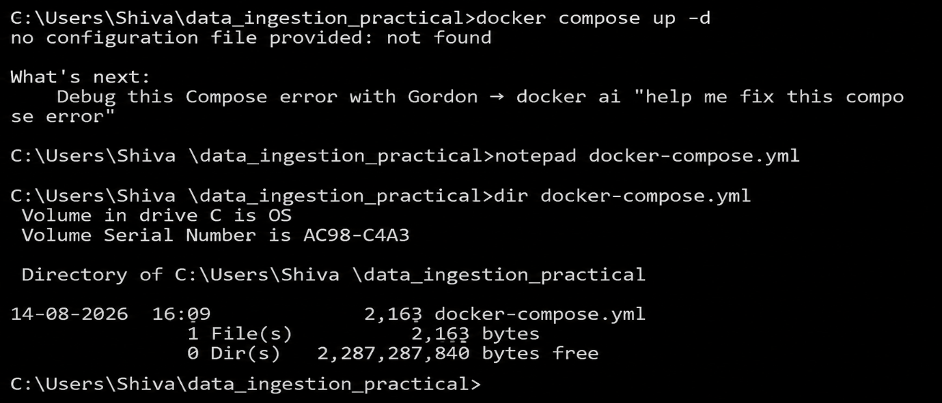

Figure 9: Three Kafka brokers running in Docker for the fault-tolerance experiment.
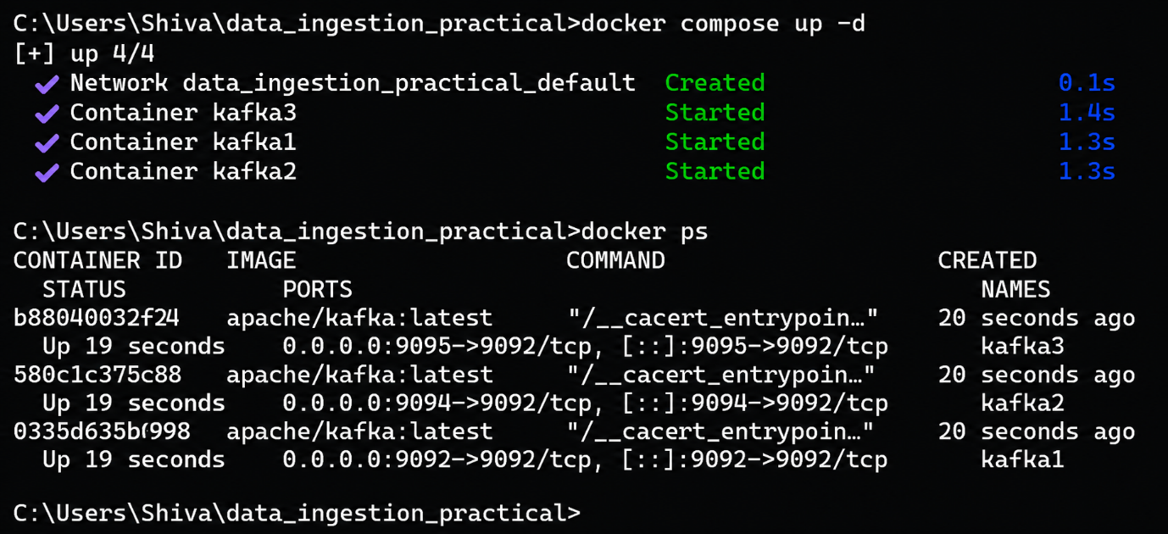

Figure 10: fault-test Kafka topic configured with three partitions and replication factor of three.

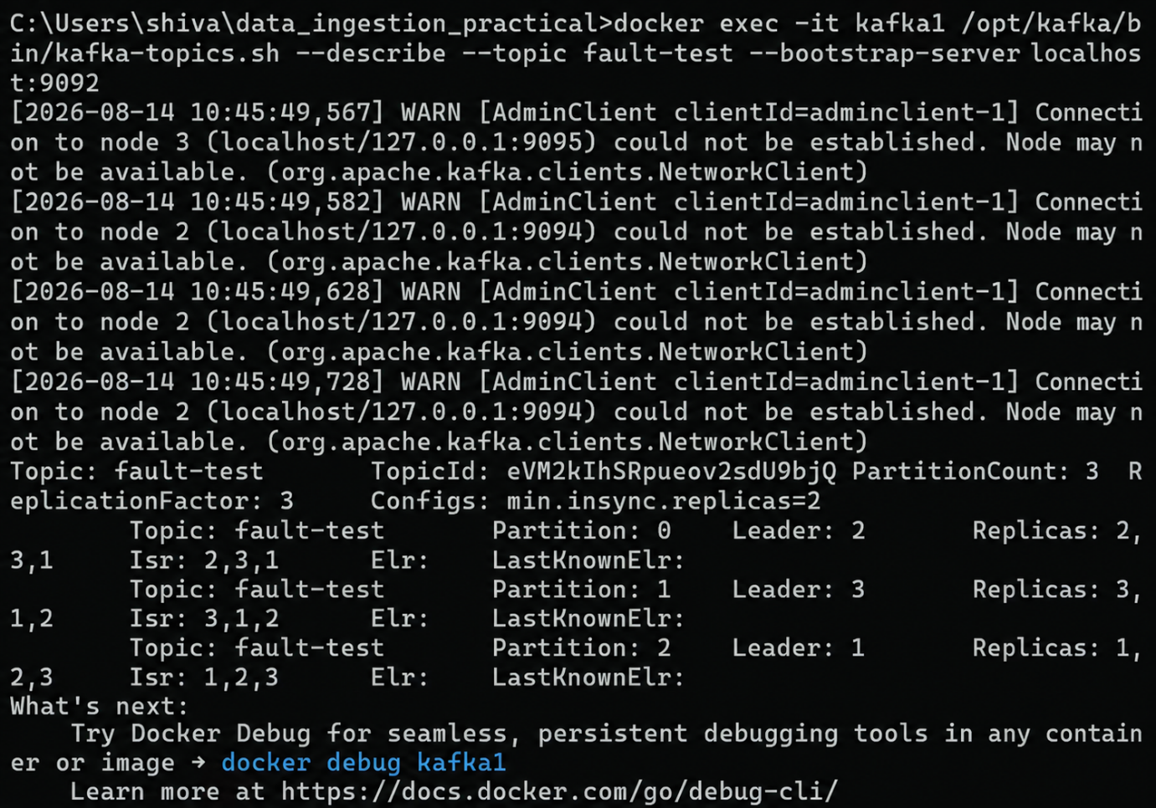

Figure 11: Kafka broker kafka1 stopped to simulate an infrastructure failure.
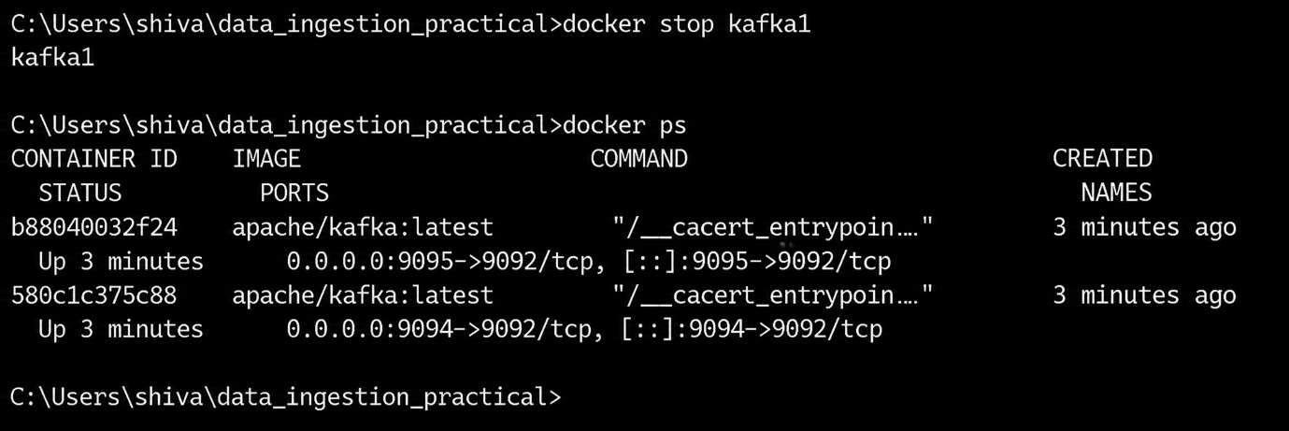

Figure 12: Kafka partition leader and ISR changes after broker failure, demonstrating fault tolerance through replication.
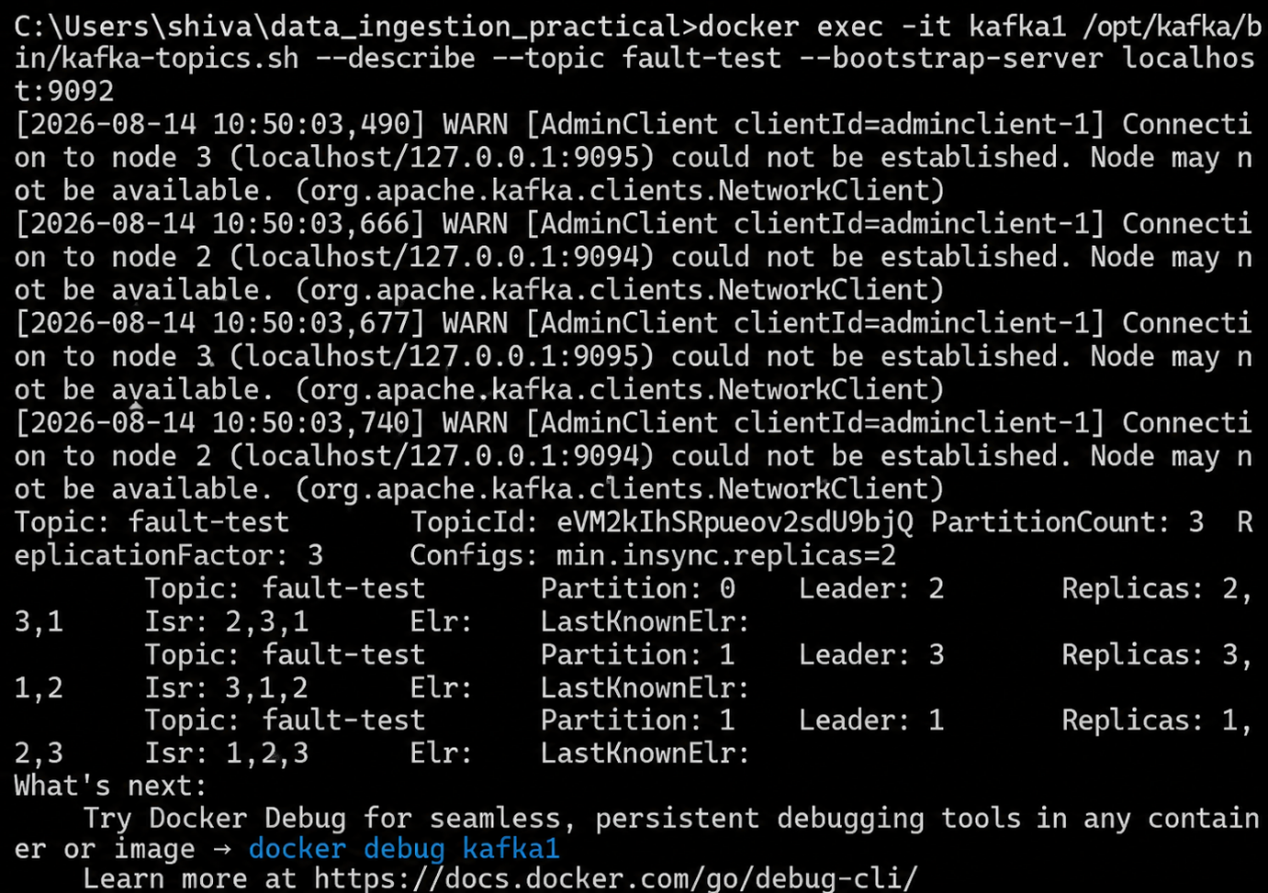

Figure 13: Final numerical comparison of average latency and throughput for micro-batch and Kafka streaming pipelines.
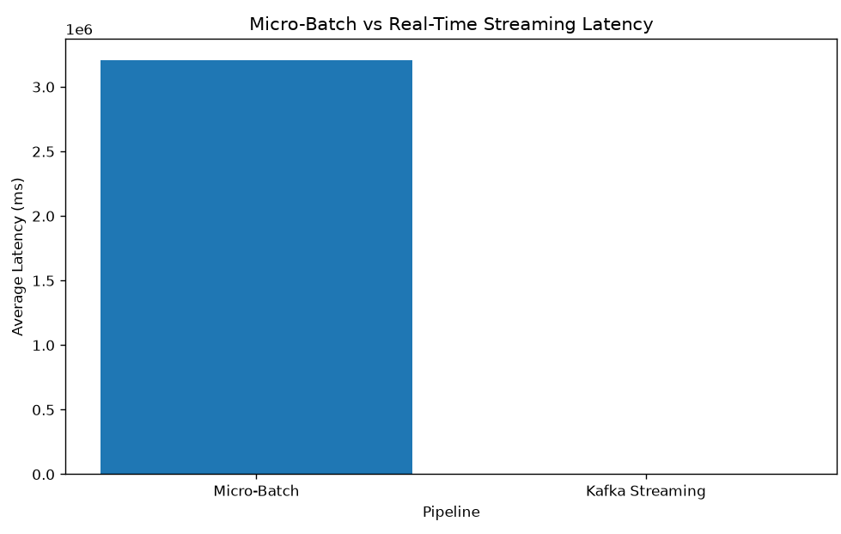
Figure 14: Comparative latency profile of micro-batch and real-time streaming pipelines.
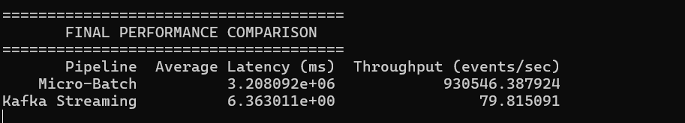
Key Questions / Analysis / Interpretation
Que 1: In what scenarios does a micro-batch architecture provide a better operational balance of performance and complexity than a true real-time streaming approach?
A micro-batch architecture is suitable when data does not require immediate processing within milliseconds or seconds. It collects records for a short fixed interval and processes them together as a batch. This reduces the complexity of managing continuous event streams and generally requires fewer infrastructure resources.
Micro-batch processing is useful for applications such as periodic log analysis, daily or hourly reports, ETL jobs, analytics dashboards, and data warehousing. It can provide good throughput because multiple records are processed together, reducing per-event processing overhead.
In contrast, true real-time streaming is preferred when very low latency is required, such as fraud detection, security monitoring, real-time recommendations, transaction processing, and live operational monitoring.
Therefore, micro-batch provides a better balance when slightly higher latency is acceptable in exchange for simpler implementation, easier resource management, and efficient bulk processing.

Que 2: How does an event streaming broker maintain message delivery guarantees during abrupt broker cluster node disconnects?
An event streaming broker such as Apache Kafka maintains message availability and fault tolerance through partition replication, in-sync replicas (ISR), leader election, and consumer offsets.
In our experiment, the fault-test topic was configured with 3 partitions and a replication factor of 3. Therefore, each partition had multiple copies distributed across the Kafka brokers.
When one broker was disconnected, Kafka detected the failure and removed the failed broker from the ISR. Another available in-sync replica could act as the partition leader. This allowed the remaining brokers to continue serving the data.
The experiment demonstrated that replicated partitions provide fault tolerance against broker failures. The configuration:
Replication Factor = 3
Minimum In-Sync Replicas = 2
allows the system to tolerate the failure of one broker while maintaining replicated data on the remaining brokers.
Thus, Kafka provides reliable message delivery and high availability through data replication, leader re-election, ISR management, and offset tracking.

Que 3: Detail the network and compute resource trade-offs between bulk file compression operations and individual event serialization overheads.
Bulk file compression processes a large amount of data together. Compression can significantly reduce the amount of data transferred over the network and therefore reduce network bandwidth consumption. However, compression requires additional CPU resources and may introduce processing latency.
Individual event serialization converts every event into a format such as JSON before transmission. It supports low-latency streaming and allows events to be processed independently, but each event introduces serialization, deserialization, metadata, and network overhead.
Therefore, the trade-off can be summarized as:
Bulk Compression | Individual Event Serialization
Lower network bandwidth usage | Higher per-event network overhead
Higher CPU requirement during compression | Lower processing cost per individual event
Suitable for batch processing | Suitable for real-time streaming
Higher latency | Very low latency
Efficient for large datasets | Efficient for continuous event processing
Bulk compression is preferable when network efficiency and large-volume transfer are more important, while individual event serialization is preferable when low latency and immediate processing are the primary requirements.

Final Analysis / Interpretation
The experiment successfully implemented and evaluated two different data ingestion architectures: a periodic micro-batch pipeline using Python/Pandas and a continuous real-time streaming pipeline using Apache Kafka.
The micro-batch pipeline processed records in fixed-size batches and demonstrated efficient bulk processing with relatively simple architecture. However, its latency is affected by the batch interval because records must wait until the next batch is triggered.
The Kafka streaming pipeline processed events continuously as they arrived. This architecture provides significantly lower delivery latency and is more appropriate for applications requiring immediate processing. Kafka partitions and consumer groups also provide horizontal scalability, allowing multiple consumers to process different partitions in parallel during traffic spikes.
The traffic-spike experiment demonstrated that increasing the number of partitions and consumers can distribute workload across multiple processing instances. The broker failure experiment further demonstrated Kafka's fault-tolerance capabilities through partition replication and in-sync replicas.
Overall, the experiment shows that micro-batch processing is appropriate for workloads where moderate latency is acceptable and simplicity and bulk-processing efficiency are important, whereas real-time streaming is preferred for low-latency, high-frequency, continuously arriving data.

Final Conclusion
The practical successfully demonstrated the design, implementation, and evaluation of both batch-oriented and real-time streaming data ingestion pipelines.
The micro-batch pipeline provided a simpler and efficient approach for processing data periodically, making it suitable for analytical workloads, scheduled ETL operations, and applications where immediate data availability is not required.
The Kafka-based streaming pipeline provided continuous, low-latency event processing and demonstrated scalability through Kafka partitions and consumer groups. The traffic-spike experiment showed how workload can be distributed across multiple consumers, while the broker failure experiment demonstrated fault tolerance through replication and in-sync replicas.
Performance benchmarking using latency and throughput measurements provided a quantitative basis for comparing the two approaches. The results show that there is no single ingestion architecture that is optimal for every workload. The appropriate choice depends on latency requirements, workload volume, throughput requirements, resource availability, fault-tolerance requirements, and system complexity.
Hence, micro-batch ingestion should be selected when simplicity, bulk processing efficiency, and moderate latency are acceptable, while real-time streaming should be selected when low latency, continuous processing, scalability, and fault tolerance are critical.

