Practical-4
Problem Definition
Implement and evaluate two different data integration pipelines using identical retail transaction data. The first pipeline follows the ETL (Extract, Transform, Load) architecture, where raw data is extracted from local storage, transformed in application memory using Pandas, and then loaded into a DuckDB analytical database.
The second pipeline follows the ELT (Extract, Load, Transform) architecture, where raw transaction data is first loaded directly into a DuckDB staging table and transformations are then performed using the DuckDB SQL engine.
The practical compares both architectures based on execution time, processing efficiency, data lineage, transformation recovery, resource utilization, and maintenance requirements.

Dataset
The dataset consists of high-volume, un-normalized retail sales transaction records.
The raw dataset contains 100,000 retail transaction records with fields such as:
- Transaction ID
- Store Code
- Product
- Category
- Quantity
- Price
- Sale Date
The dataset intentionally contains data-quality inconsistencies such as:
- Leading and trailing white spaces
- Inconsistent category capitalization
- Legacy store codes
- Raw numeric values
- Unstandardized product names

ETL Architecture
The ETL pipeline follows:
Raw CSV File
↓
Extract
↓
Pandas DataFrame
↓
Transform
↓
Cleaned Data
↓
DuckDB
↓
Final Table

ELT Architecture
The ELT pipeline follows:
Raw CSV File
↓
Extract
↓
DuckDB Staging Table
↓
Transform using SQL
↓
Final DuckDB Table

OUTPUT/SCREENSHOTS
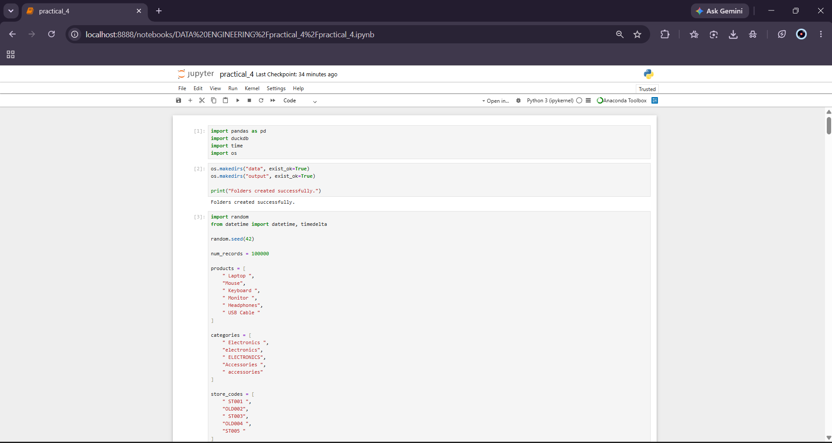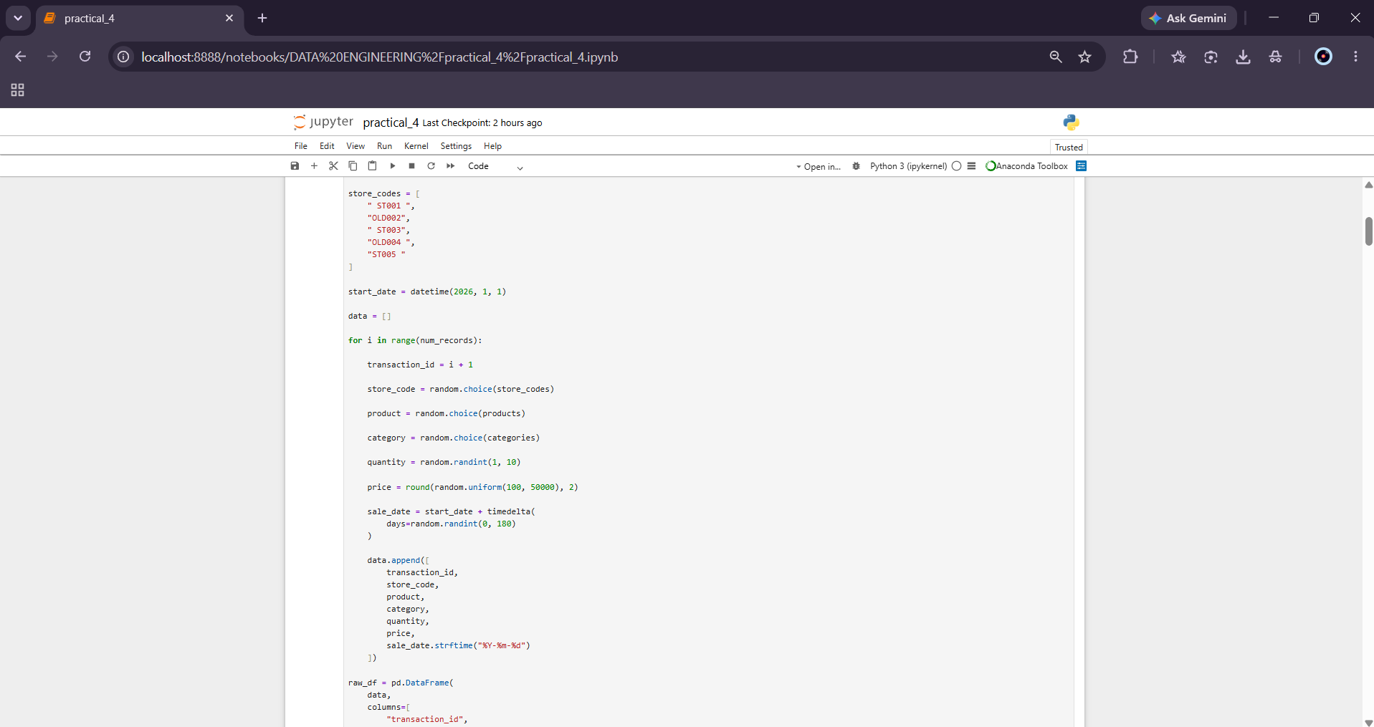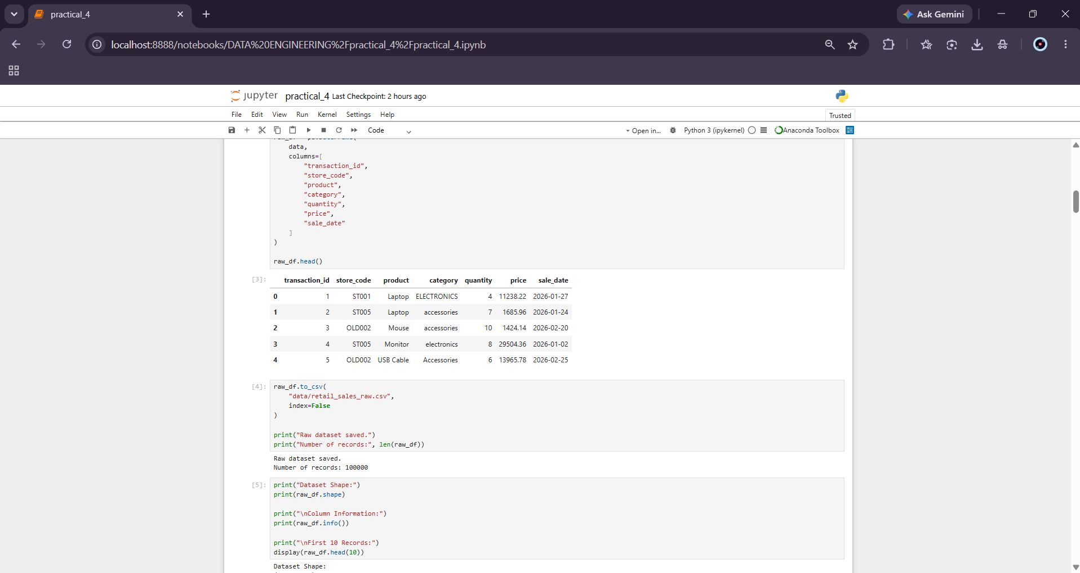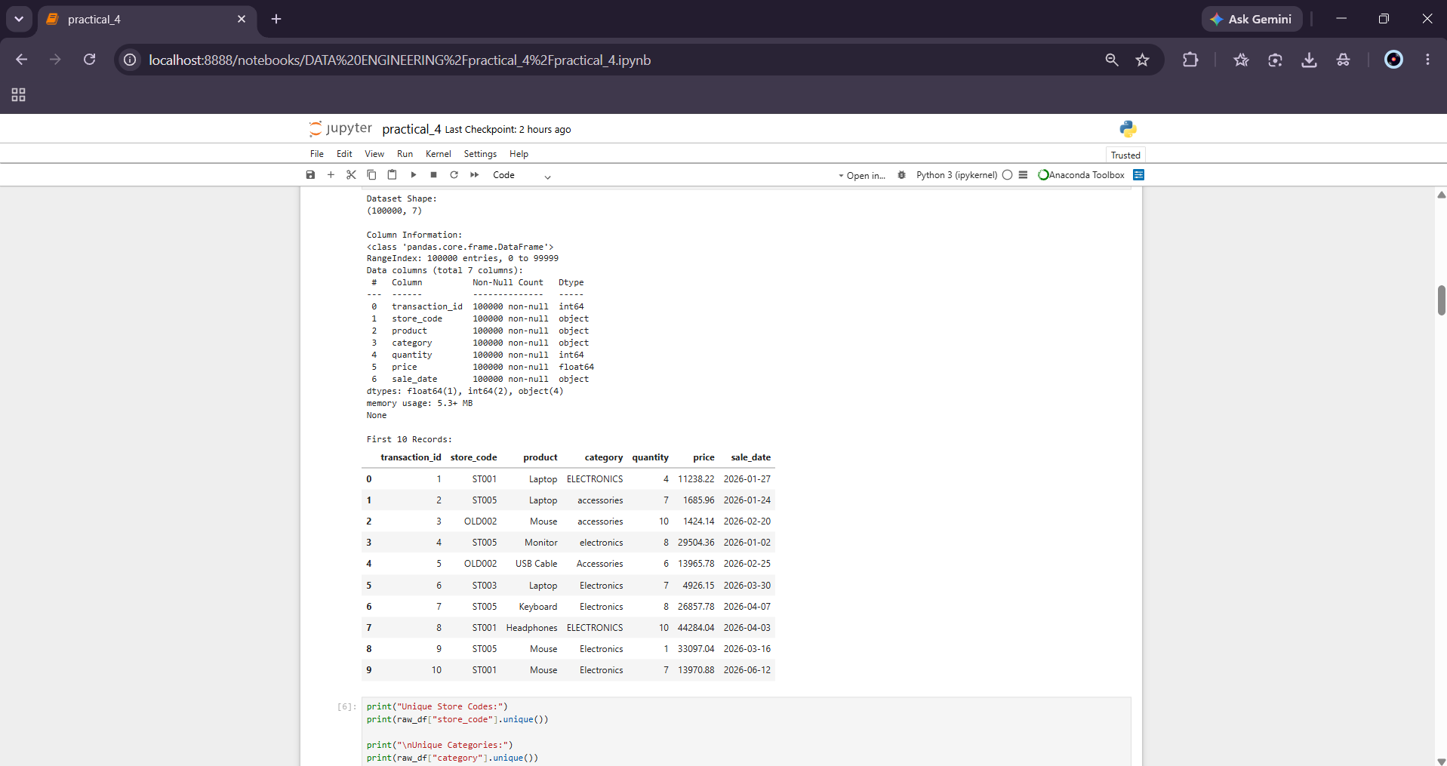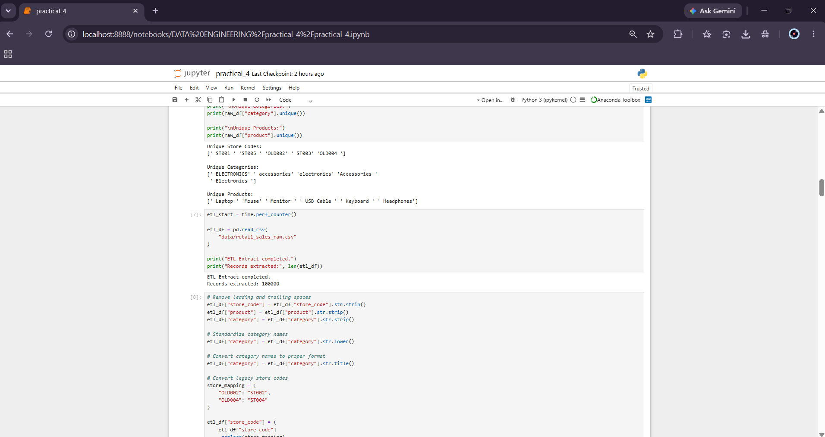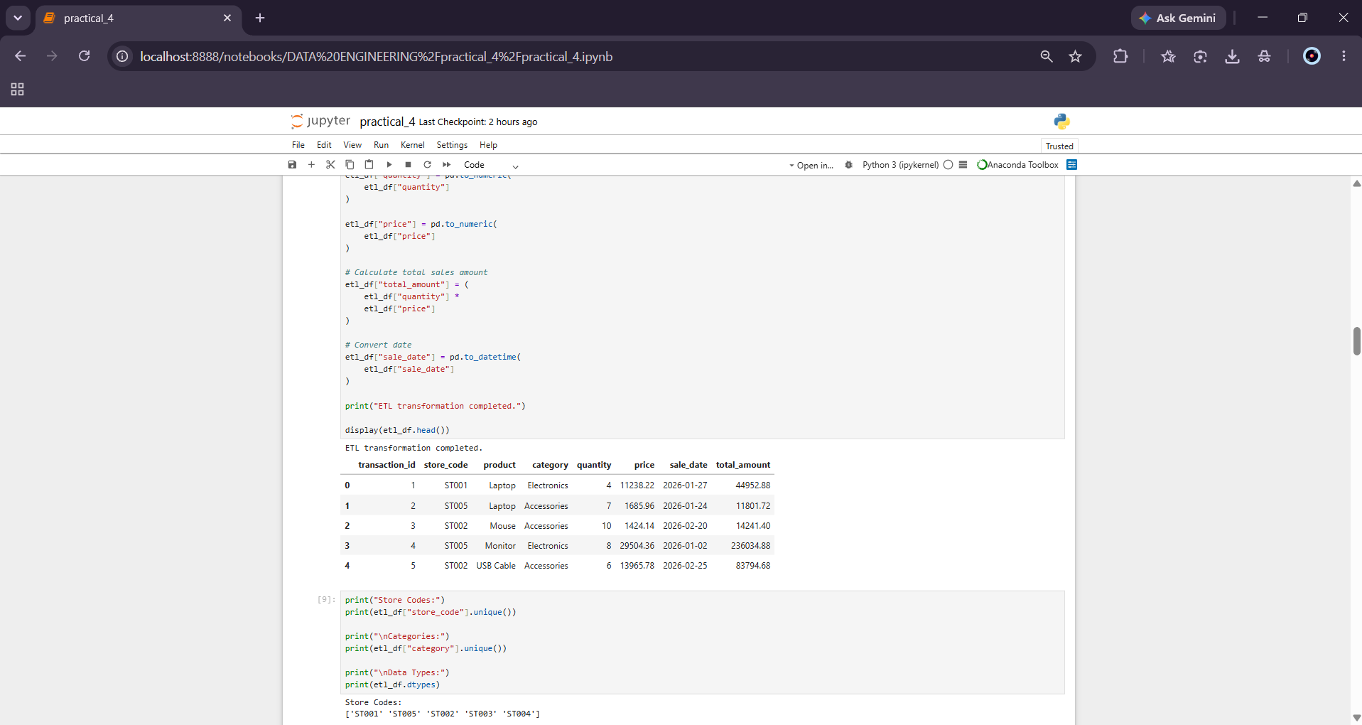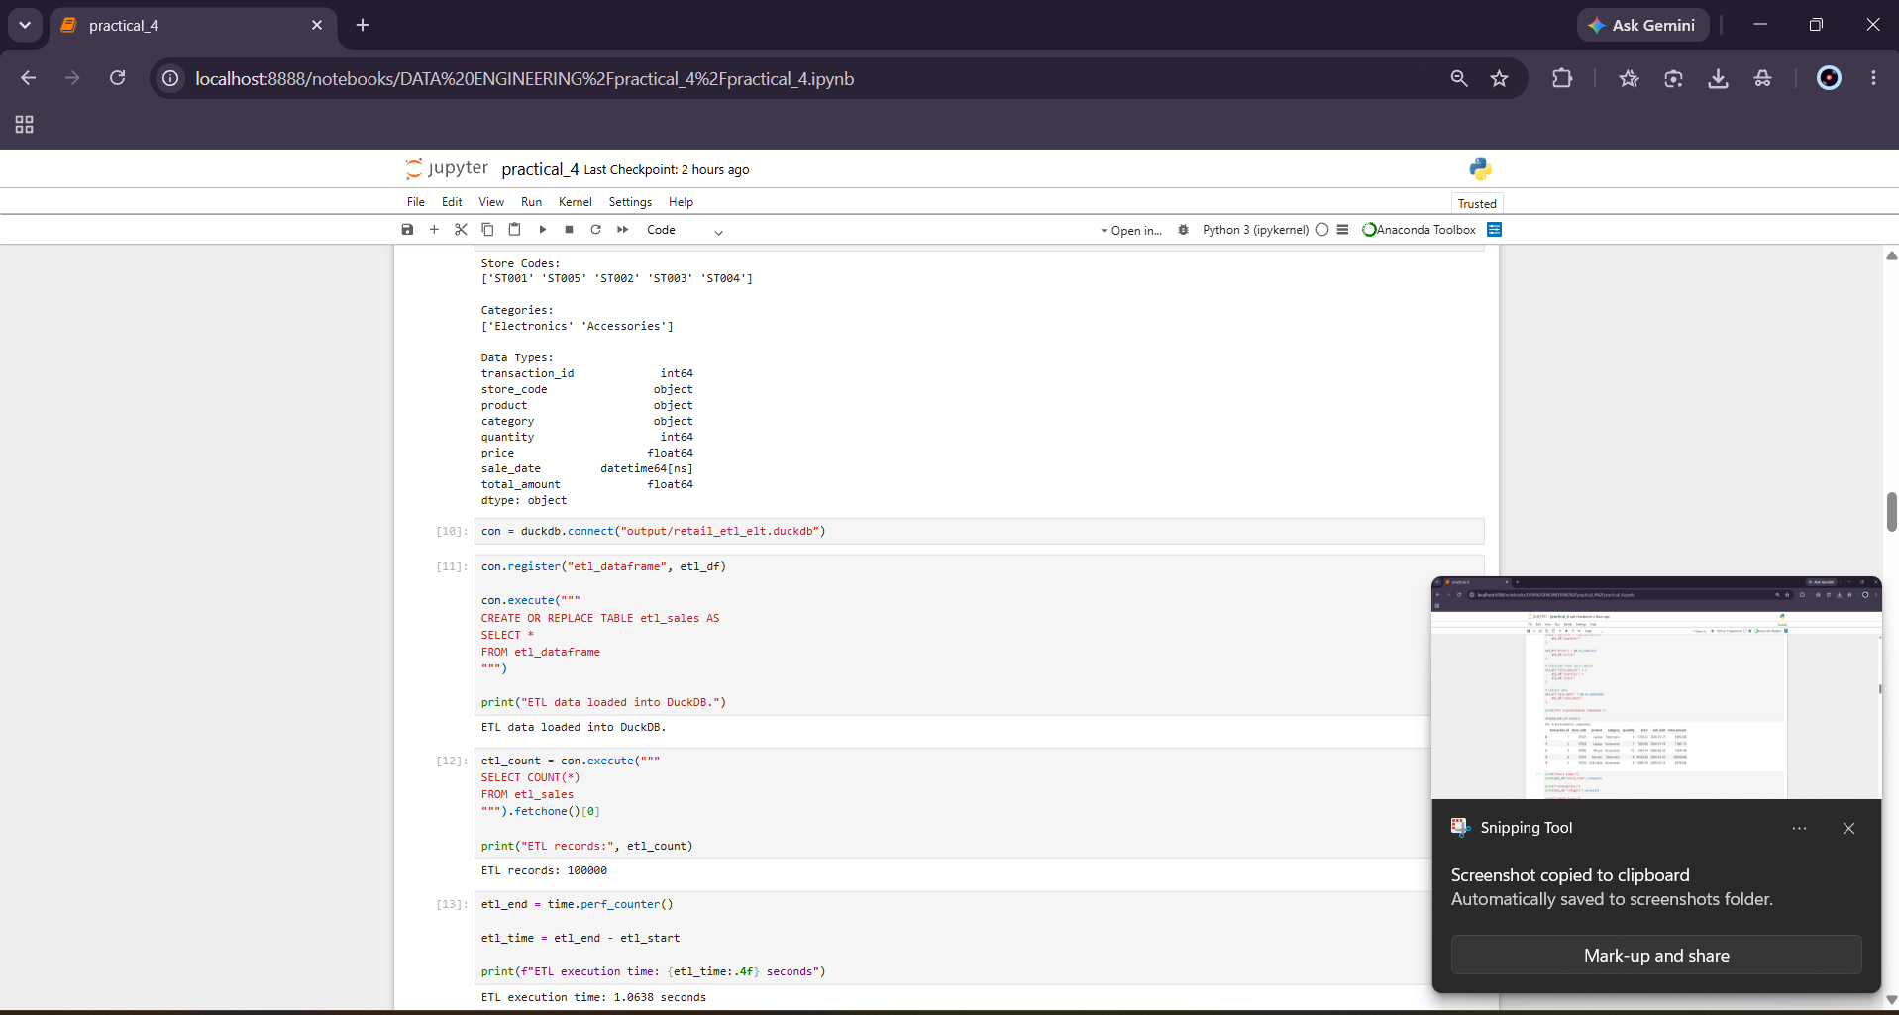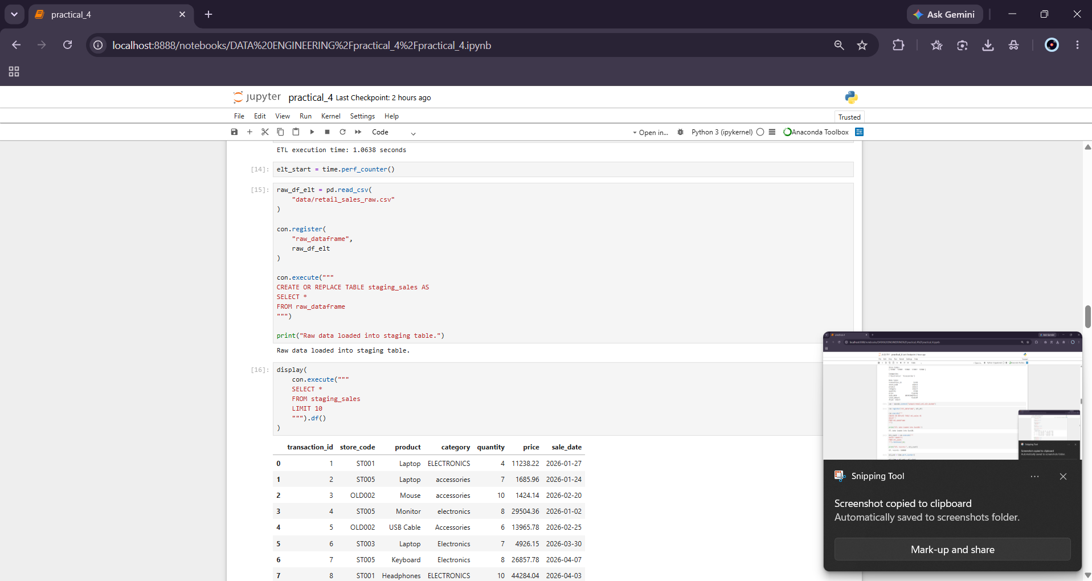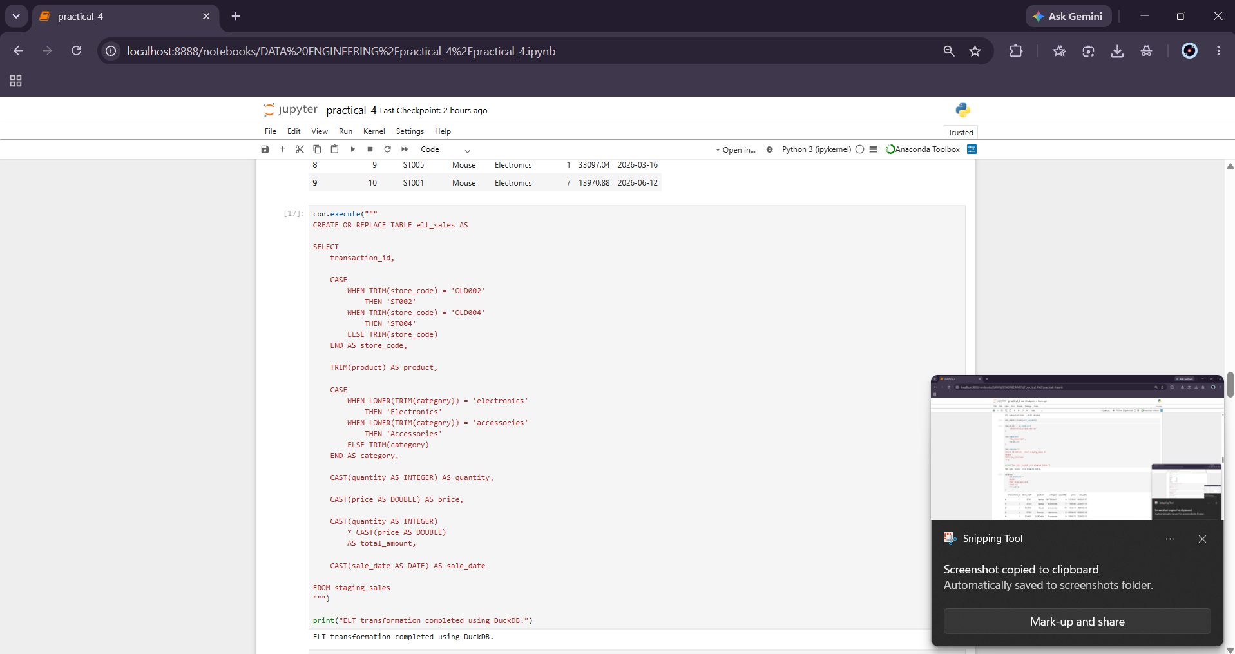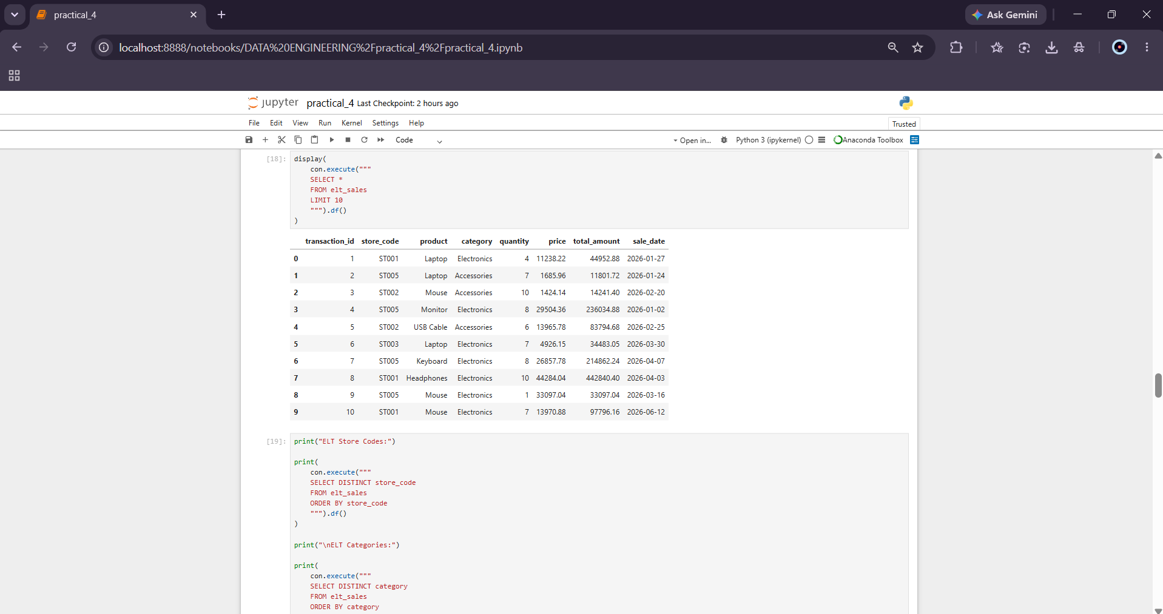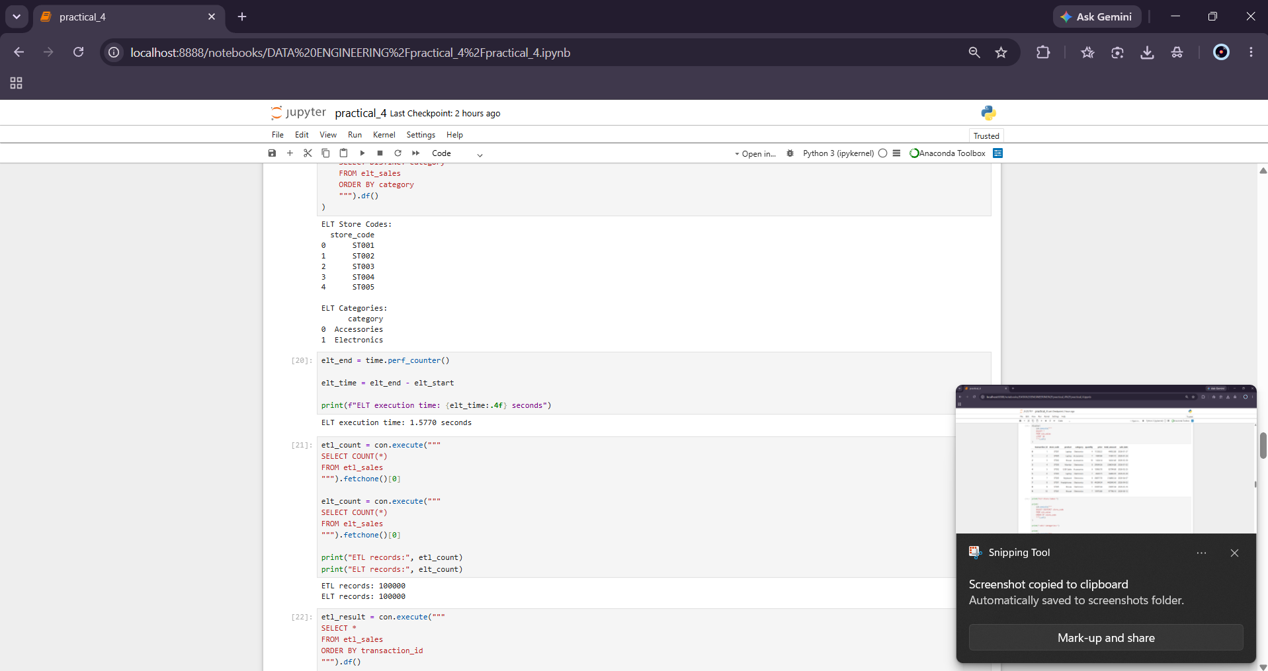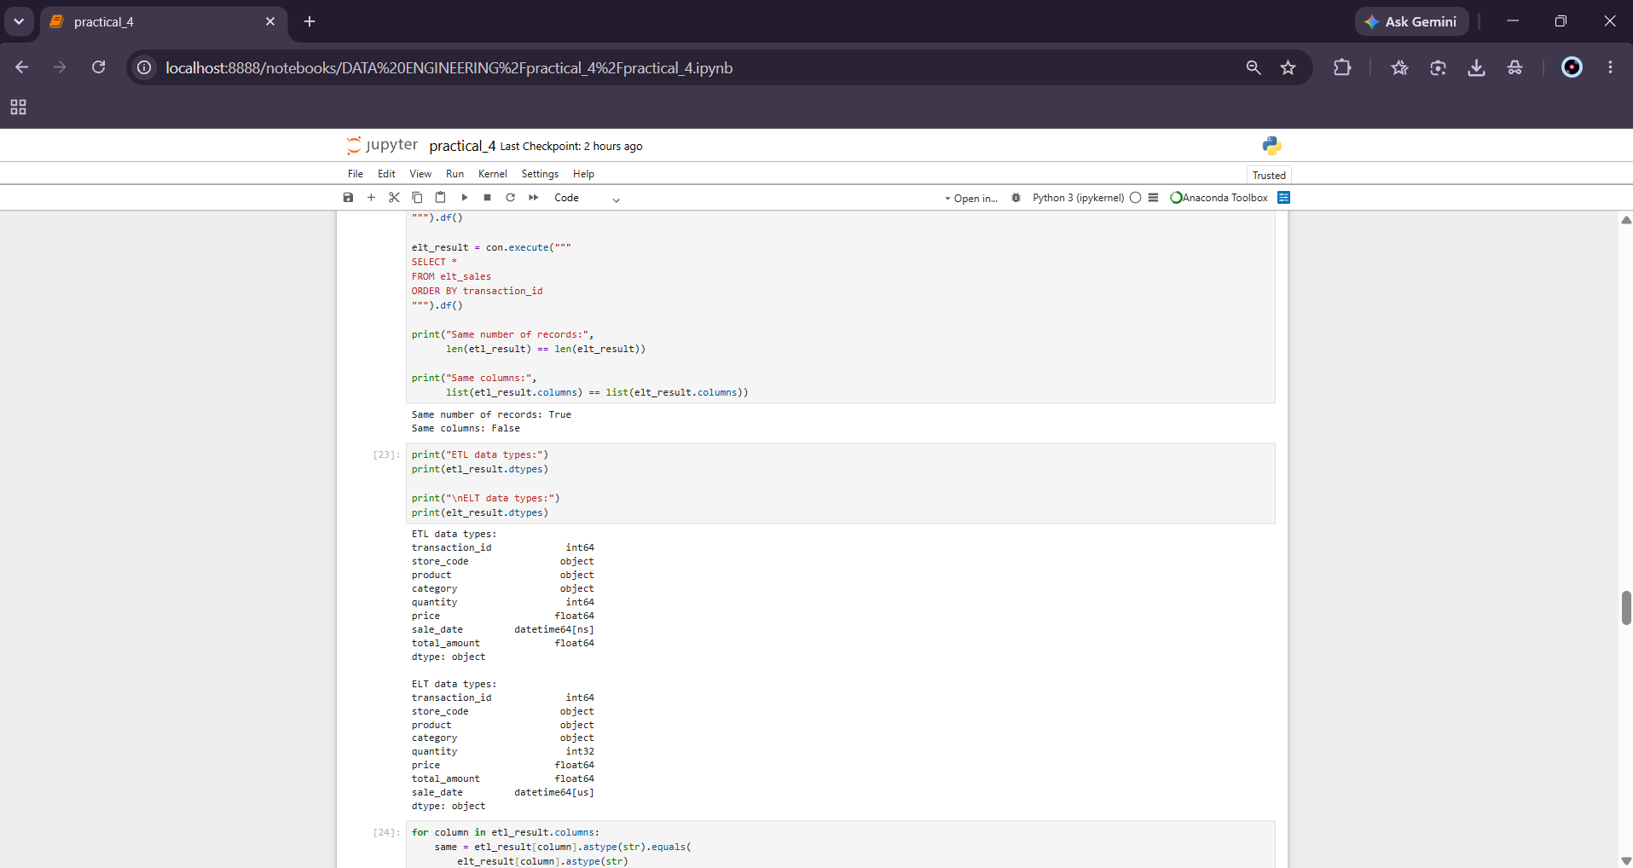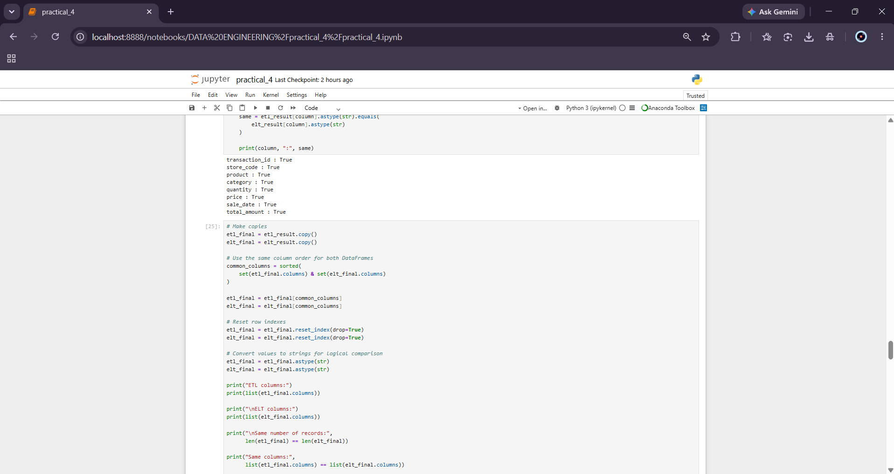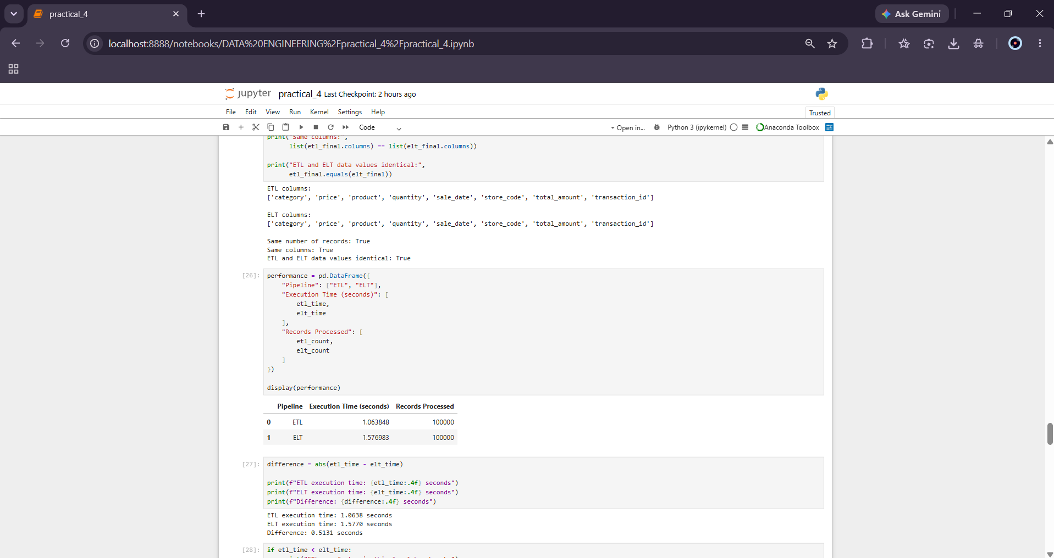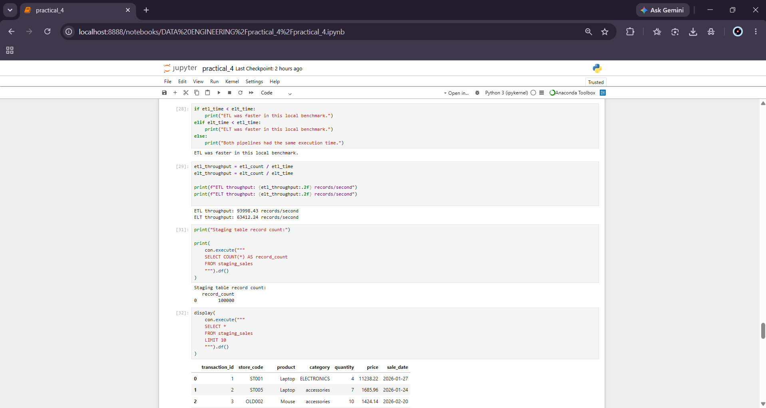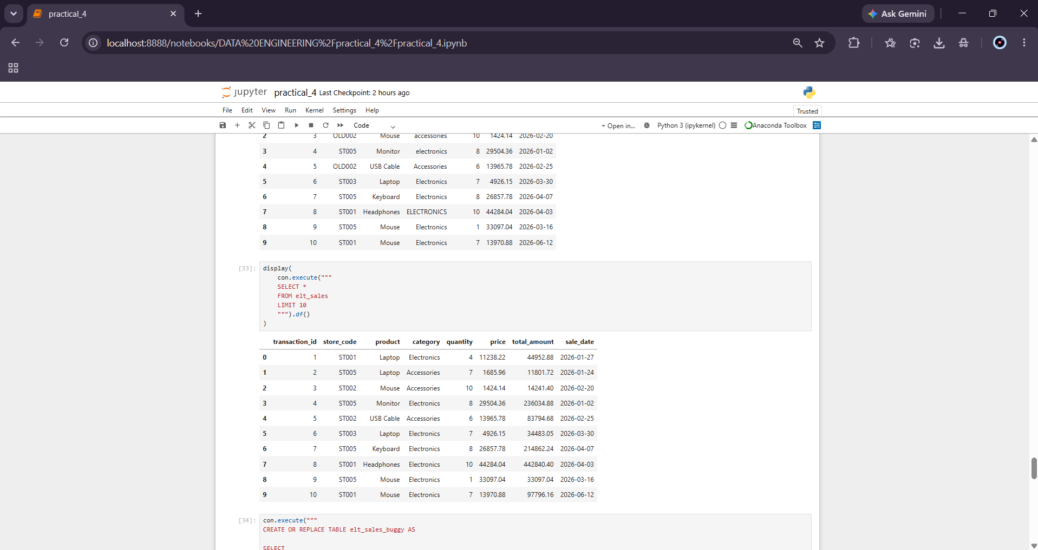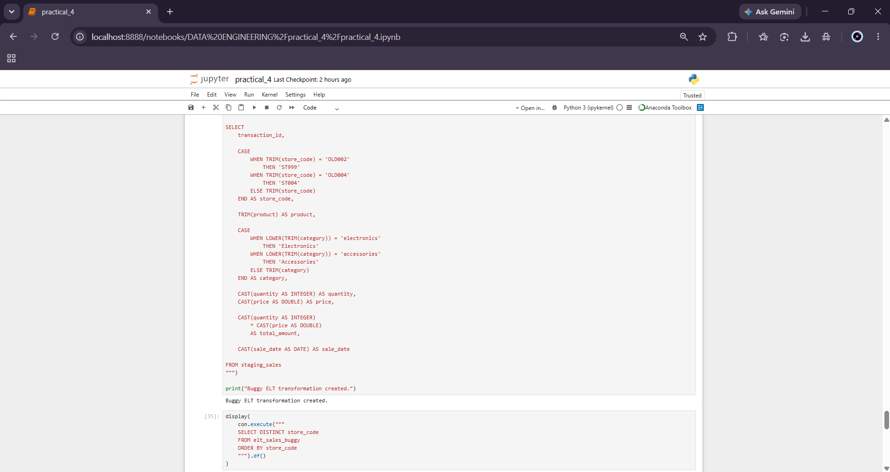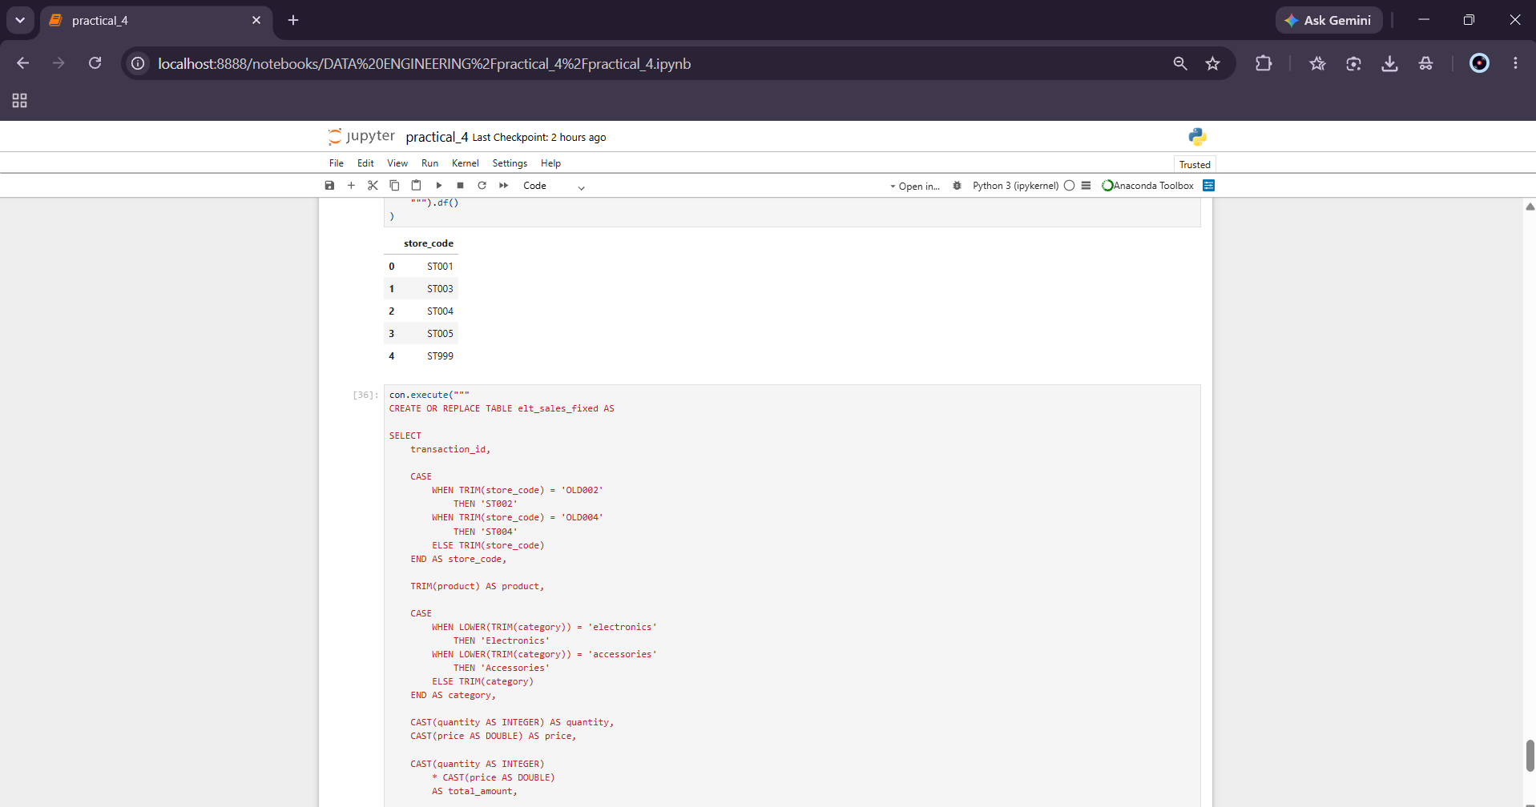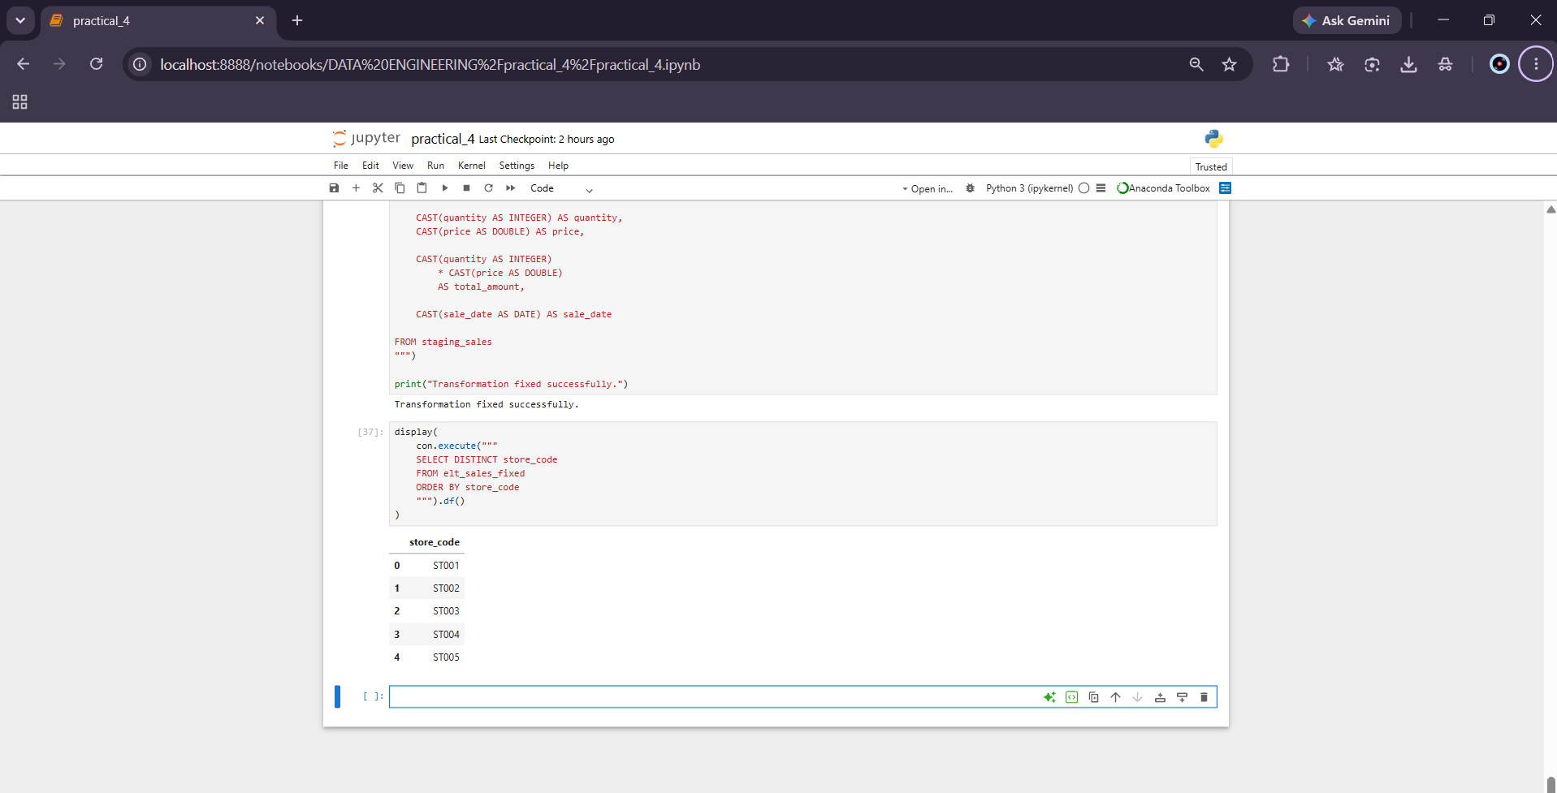
Key Questions / Analysis / Interpretation
Que 1: How does the separation of compute and storage in modern cloud data lakes shift the architectural preference from classic ETL models toward ELT?
Modern cloud data platforms commonly separate data storage from compute resources. Raw data can therefore be stored centrally and processed using scalable compute resources when required.
In ETL, transformations are performed before loading the data into the target system. This requires application-side processing and may require movement of raw data to application compute resources.
In ELT, raw data is loaded first and transformations are performed inside the target database or warehouse. This allows the database engine to use its own query-processing and compute capabilities.
Therefore, separation of storage and compute can make ELT suitable for large-scale analytical workloads because raw data can be retained and transformation processing can be performed using scalable database compute.

Que 2: Compare the pipelines in terms of maintaining robust data lineage tracking and recovering from intermediate transformation bugs.
ETL performs transformations in application memory before loading the final result. If intermediate datasets are not explicitly saved, debugging a transformation problem may require the pipeline to be executed again.
ELT provides a persistent staging layer between raw and transformed data:
Raw Data
↓
Staging
↓
Transformation
↓
Final Data
This makes it easier to inspect the original data and correct SQL transformation logic.
The experiment demonstrated this by intentionally introducing an incorrect store-code transformation and subsequently correcting it using the original staging_sales table.
Que 3: Evaluate how network resource costs shift when running transformation calculations inside application compute nodes versus inside database storage engines.
In an ETL architecture, raw data may need to move from storage to application compute nodes. After transformation, processed data may then be transferred to the target database.
In an ELT architecture, the raw data is first loaded into the database or warehouse and transformations are performed by the database engine.
Therefore, ELT can reduce unnecessary movement of large datasets between separate application and database environments when the database compute engine is located close to the stored data.
In this local experiment, network cost is minimal because all components operate on the same machine.

Final Analysis / Interpretation
The experiment successfully implemented and evaluated two data integration architectures: an ETL pipeline using Python and Pandas and an ELT pipeline using DuckDB SQL.
The ETL pipeline transformed the raw retail transaction data in application memory before loading the cleaned data into DuckDB. The ELT pipeline first loaded the raw records into a DuckDB staging table and then performed transformations using SQL.
Both pipelines processed the same dataset and produced logically equivalent cleaned results. Execution time was measured using the same local environment to provide a performance comparison.
The experiment also demonstrated differences in data lineage and transformation recovery. The ELT architecture retained the original data in the staging table, allowing transformation logic to be modified and executed again without recreating the raw input dataset.
The performance results obtained from the local benchmark should be interpreted according to the hardware, dataset size, implementation, and database configuration used during the experiment.

Final Conclusion
The practical successfully demonstrated the implementation and comparison of ETL and ELT data integration architectures using Python, Pandas, and DuckDB.
The ETL pipeline performed transformations in application memory before loading the processed data into DuckDB. The ELT pipeline loaded raw data into a staging table and performed transformations using the DuckDB analytical engine.
The experiment demonstrated that both architectures can produce equivalent cleaned datasets while differing in transformation location, data lineage, debugging, resource utilization, and maintenance requirements.
The ELT architecture provides a persistent staging layer that supports easier inspection and recovery from transformation errors. ETL provides a straightforward approach when transformation logic is naturally implemented in application code.
The appropriate architecture depends on factors such as dataset volume, infrastructure capabilities, compute location, network costs, transformation complexity, lineage requirements, and maintenance needs.

