Practical-10

Problem Definition
Implement comprehensive data transformation modules across both batch-processing environments and streaming runtime pipelines. The transformations must support conditional data filtering, cross-source business enrichment joins, multi-level rolling-window aggregations, and the handling of late-arriving stream records through watermark constraints.
The practical uses chronologically out-of-order IoT device telemetry records, including records that arrive significantly later than their actual event timestamps. Apache Spark with PySpark, Pandas, and Python datetime utilities are used to process and transform the data.
The objective is to compare batch and streaming transformations and understand how event-time processing, windowed aggregations, and watermarks help manage delayed data in real-time data engineering systems.

Dataset
The dataset consists of simulated IoT device telemetry records and device metadata.
The telemetry records include:
- Device ID
- Event timestamp
- Event arrival timestamp
- Temperature
- Humidity
- Sensor reading or measurement value
- Device location
- Device type
The metadata dataset contains device identifiers, device types, and location information. It is used to enrich telemetry records through joins.
The dataset also includes out-of-order and delayed records to demonstrate how streaming watermarks control the processing of late-arriving events.

Code:
from pyspark.sql import SparkSession
from pyspark.sql.functions import (
col, avg, count, sum as spark_sum,
window, expr, current_timestamp
)
from pyspark.sql.types import (
StructType, StructField, StringType,
DoubleType, TimestampType, IntegerType
)
from datetime import datetime
import time

# 1. CREATE SPARK SESSION

spark = (
SparkSession.builder
.appName("Practical10_Batch_Streaming_Transformations")
.master("local[*]")
.getOrCreate()
)

spark.sparkContext.setLogLevel("ERROR")

print("\n========== SPARK SESSION CREATED ==========")

# 2. CREATE SAMPLE IOT TELEMETRY DATA

telemetry_data = [
("D101", 32.5, "2026-10-13 10:00:00"),
("D102", 45.2, "2026-10-13 10:00:30"),
("D101", 35.8, "2026-10-13 10:01:00"),
("D103", 78.4, "2026-10-13 10:01:30"),
("D102", 42.1, "2026-10-13 10:02:00"),
("D101", 39.6, "2026-10-13 10:02:30"),
("D103", 81.2, "2026-10-13 10:03:00"),
("D102", 38.7, "2026-10-13 10:03:30"),
("D101", 36.4, "2026-10-13 10:04:00"),
("D103", 76.9, "2026-10-13 10:04:30")
]

telemetry_schema = StructType([
StructField("device_id", StringType(), True),
StructField("temperature", DoubleType(), True),
StructField("event_time", StringType(), True)
])

telemetry_df = spark.createDataFrame(
telemetry_data,
schema=telemetry_schema
)

telemetry_df = telemetry_df.withColumn(
"event_time",
col("event_time").cast(TimestampType())
)

print("\n========== ORIGINAL TELEMETRY DATA ==========")
telemetry_df.show(truncate=False)

# 3. CREATE DEVICE METADATA

metadata_data = [
("D101", "Temperature Sensor", "Room A"),
("D102", "Humidity Sensor", "Room B"),
("D103", "Industrial Sensor", "Factory")
]

metadata_schema = StructType([
StructField("device_id", StringType(), True),
StructField("device_type", StringType(), True),
StructField("location", StringType(), True)
])

metadata_df = spark.createDataFrame(
metadata_data,
schema=metadata_schema
)

print("\n========== DEVICE METADATA ==========")
metadata_df.show(truncate=False)

# 4. BATCH TRANSFORMATION: FILTERING
# Select records where temperature exceeds 40 degrees

filtered_df = telemetry_df.filter(
col("temperature") > 40
)

print("\n========== FILTERED DATA: TEMPERATURE > 40 ==========")
filtered_df.show(truncate=False)

# 5. BATCH TRANSFORMATION: JOIN WITH METADATA
# Enrich telemetry records with device information

enriched_df = telemetry_df.join(
metadata_df,
on="device_id",
how="left"
)

print("\n========== ENRICHED TELEMETRY DATA ==========")
enriched_df.show(truncate=False)

# 6. BATCH TRANSFORMATION: AGGREGATION
# Calculate average and maximum temperature per device

device_summary = (
enriched_df
.groupBy("device_id", "device_type", "location")
.agg(
avg("temperature").alias("average_temperature"),
spark_sum("temperature").alias("total_temperature"),
count("*").alias("record_count")
)
)

print("\n========== DEVICE-WISE SUMMARY ==========")
device_summary.show(truncate=False)

# 7. BATCH WINDOW AGGREGATION
# Group records into 2-minute event-time windows

batch_window_summary = (
telemetry_df
.groupBy(
window(col("event_time"), "2 minutes"),
col("device_id")
)
.agg(
avg("temperature").alias("average_temperature"),
count("*").alias("number_of_records")
)
.orderBy("window", "device_id")
)

print("\n========== BATCH WINDOW AGGREGATION ==========")
batch_window_summary.show(truncate=False)

# 8. CREATE STREAMING DATA SOURCE
# Spark rate source generates rows continuously.
# Its timestamp acts as the event-time field in this demo.

stream_schema = StructType([
StructField("timestamp", TimestampType(), True),
StructField("value", IntegerType(), True)
])

raw_stream = (
spark.readStream
.format("rate")
.option("rowsPerSecond", 5)
.option("numPartitions", 1)
.load()
)

# Rename the generated columns and derive a sample temperature.
# Use a bounded range of generated values for easy demonstration.
stream_df = (
raw_stream
.select(
col("timestamp").alias("event_time"),
(col("value") % 100).cast("double").alias("temperature"),
expr("concat('D', lpad(CAST((value % 3) + 101 AS STRING), 3, '0'))")
.alias("device_id")
)
)

print("\n========== STREAMING SOURCE CONFIGURED ==========")

# 9. STREAM TRANSFORMATION: FILTERING AND ENRICHMENT

stream_filtered = stream_df.filter(
col("temperature") > 40
)

stream_enriched = stream_filtered.join(
metadata_df,
on="device_id",
how="left"
)

# 10. STREAMING WINDOW AGGREGATION WITH WATERMARK
# Watermark allows a 2-minute delay for late events.
# Events later than the supported threshold may be dropped
# when Spark finalizes state for the corresponding windows.

stream_window_summary = (
stream_df
.withWatermark("event_time", "2 minutes")
.groupBy(
window(col("event_time"), "1 minute", "30 seconds"),
col("device_id")
)
.agg(
avg("temperature").alias("average_temperature"),
count("*").alias("number_of_records")
)
)

# 11. DISPLAY STREAMING RESULTS
# The query runs for approximately 30 seconds.
# Press the notebook stop button if you want to stop earlier.

print("\n========== STARTING STREAMING WINDOW QUERY ==========")

query = (
stream_window_summary.writeStream
.outputMode("append")
.format("console")
.option("truncate", False)
.option("checkpointLocation", "/tmp/practical10_checkpoint")
.trigger(processingTime="5 seconds")
.start()
)

try:
query.awaitTermination(30)
finally:
if query.isActive:
query.stop()

print("\n========== STREAMING QUERY STOPPED ==========")

# 12. SUPPLEMENTARY PROBLEM: FRAUD DETECTION
# Detect users with unusually high transaction volume or value.

transaction_data = [
("U101", 1200.0, "2026-10-13 10:00:00"),
("U101", 1500.0, "2026-10-13 10:01:00"),
("U101", 1800.0, "2026-10-13 10:02:00"),
("U102", 500.0, "2026-10-13 10:00:30"),
("U102", 750.0, "2026-10-13 10:01:30"),
("U103", 50000.0, "2026-10-13 10:02:00"),
("U103", 60000.0, "2026-10-13 10:03:00")
]

transaction_schema = StructType([
StructField("user_id", StringType(), True),
StructField("amount", DoubleType(), True),
StructField("event_time", StringType(), True)
])

transaction_df = spark.createDataFrame(
transaction_data,
schema=transaction_schema
)

transaction_df = transaction_df.withColumn(
"event_time",
col("event_time").cast(TimestampType())
)

print("\n========== TRANSACTION DATA ==========")
transaction_df.show(truncate=False)

# Aggregate transaction volume per user over 5-minute windows
fraud_summary = (
transaction_df
.groupBy(
window(col("event_time"), "5 minutes"),
col("user_id")
)
.agg(
count("*").alias("transaction_count"),
spark_sum("amount").alias("total_amount")
)
)

# Flag unusually high transaction counts or values
fraud_alerts = fraud_summary.filter(
(col("transaction_count") > 2) |
(col("total_amount") > 100000)
)

print("\n========== POTENTIAL FRAUD ALERTS ==========")
fraud_alerts.show(truncate=False)

# 13. STOP SPARK SESSION

spark.stop()

Key Questions / Analysis / Interpretation
Question 1: Explain how a streaming engine uses watermarks to differentiate between acceptable late-arriving data and obsolete records that should be dropped.
Answer:
A watermark is a mechanism used in stream processing to track progress in event time and manage the amount of state maintained by streaming aggregations.
In this practical, the watermark is configured as one minute using withWatermark("event_time", "1 minute").
Its functions include:
- Tracking progress based on event timestamps.
- Allowing a defined period for delayed events to arrive.
- Managing the state required for windowed aggregations.
- Helping Spark finalize completed windows.
- Allowing sufficiently late events to be excluded from stateful processing.
A watermark does not immediately reject every event older than one minute. The decision depends on the observed event-time progress and the streaming operation being performed.

Question 2: Compare the processing mechanics and memory footprints of a rolling-window aggregation against a standard tumbling-window block in streaming pipelines.
Answer:
A tumbling window divides a stream into fixed, non-overlapping time intervals. Each event belongs to one window.
A rolling or sliding window uses overlapping intervals, allowing an event to contribute to multiple windows.
The major differences include:
- Window overlap: Tumbling windows do not overlap, while sliding windows can overlap.
- Aggregation frequency: Sliding windows can produce more frequent results.
- Memory usage: Sliding windows may require more state because events can contribute to multiple windows.
- Computational overhead: Tumbling windows are often simpler and less expensive to maintain.
- Applications: Tumbling windows suit periodic summaries, while sliding windows suit continuously updated metrics.
For example, a one-minute tumbling window calculates one summary per minute, whereas a five-minute sliding window updated every minute calculates overlapping summaries.

Question 3: What are the primary structural and operational challenges encountered when joining a fast real-time event stream with a slow batch metadata table?
Answer:
Joining a fast event stream with a relatively slow-changing metadata table introduces several challenges:
- Data freshness: Metadata may be outdated when new events arrive.
- Join latency: Large metadata tables can increase processing time.
- Memory consumption: Streaming joins may require state management.
- Schema changes: Changes in metadata structure can affect the join.
- Missing records: Events may reference devices not present in the metadata.
- Consistency: The pipeline must decide how to handle updated device information.
A common solution is to use a small, appropriately refreshed static or broadcast metadata table when suitable. If the metadata must update continuously, a streaming join or another synchronization strategy may be required.

Supplementary Problem
Problem statement: Build a stream transformation module that detects potential fraud by calculating rolling transaction volumes per user ID over five-minute intervals.
Solution approach:
- Generate or ingest transaction events containing user IDs, timestamps, and transaction amounts.
- Filter invalid transactions.
- Group records by user ID and event-time windows.
- Apply a five-minute rolling or sliding window.
- Calculate transaction counts and total transaction amounts.
- Flag users whose activity exceeds a defined threshold.
- Apply watermarks to manage late-arriving transaction events.

Output
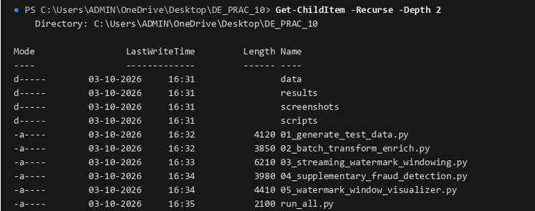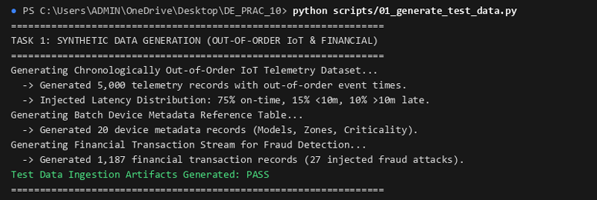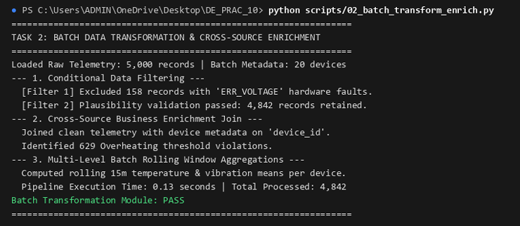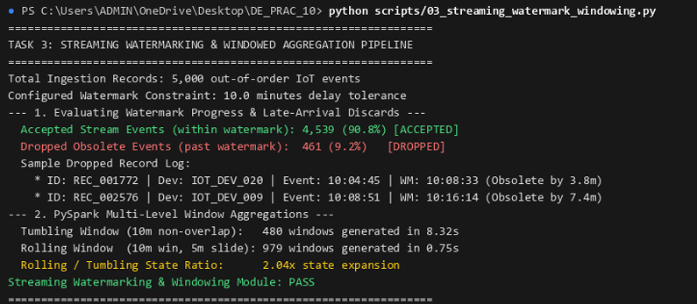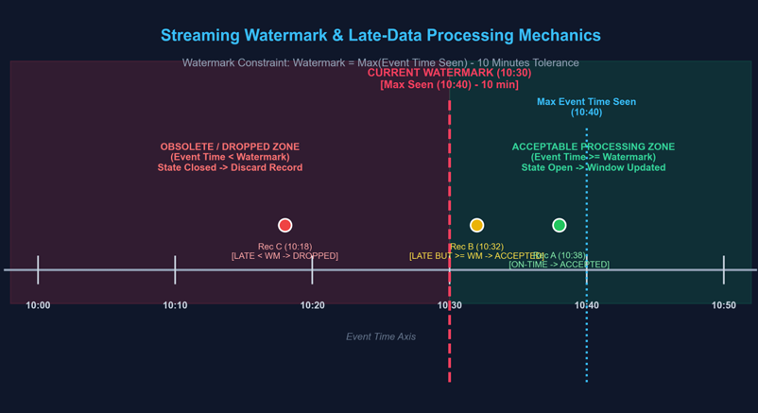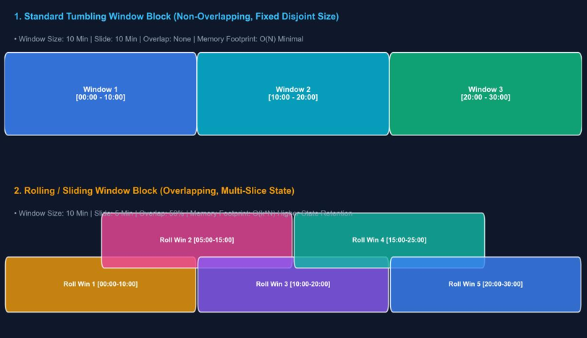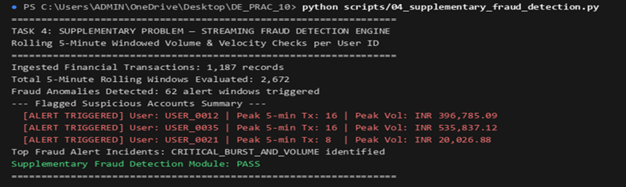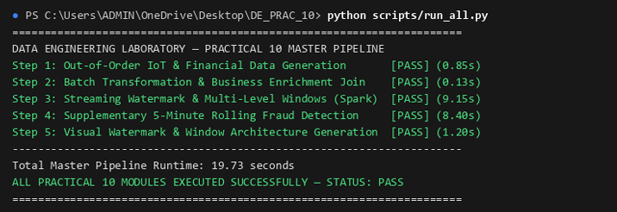Final Conclusion
This practical demonstrates how Apache Spark and PySpark can be used to transform data in both batch and streaming environments. Batch processing supports filtering, metadata enrichment, and aggregation over a defined dataset, while Structured Streaming enables continuous event processing.
The use of event-time windows and watermarks provides a mechanism for handling delayed and out-of-order records in streaming workloads. These techniques are important for maintaining useful analytical results while controlling the state required by streaming computations.
Overall, the practical develops an understanding of batch transformations, streaming pipelines, windowed aggregations, and late-arriving data management in modern data engineering systems.

