Practical-7

Problem Definition
Simulate an incremental Change Data Capture (CDC) loop to track and capture all modifications (INSERT, UPDATE, and DELETE operations) occurring in an operational transaction system.
The captured database changes must be recorded in an audit logging ledger and correctly replicated to an analytical table to maintain data consistency without performing destructive full-table database dumps.
This practical focuses on developing an incremental data synchronization pipeline using PostgreSQL, Python, Psycopg2, PL/pgSQL event logs, and message replication loops. The system will simulate inventory updates, new order insertions, and record deletions, then propagate these changes to an analytical database table.

Dataset
The dataset consists of simulated application inventory database transactions.
The records include:
- Product or inventory IDs.
- Product names and descriptions.
- Available stock quantities.
- Product prices.
- Transaction types (INSERT, UPDATE, DELETE).
- Previous and updated values.
- Event timestamps.
- Transaction or event IDs.
- Audit records and synchronization status.
The test data is used to simulate new inventory records, stock quantity changes, and deleted records. These changes are captured incrementally and propagated to the analytical table.

Architecture and Workflow
The CDC pipeline works by capturing database changes as they happen and forwarding them to an analytical table.
1. Operational Database
PostgreSQL inventory table
|
2. Change Detection
Capture INSERT, UPDATE and DELETE
|
3. CDC Event Log
Store operation, old values, new values and timestamp
|
4. Python Replication Loop
Read pending events and apply changes
|
5. Analytical Table
Maintain a synchronized copy of inventory data

Code:
1. Create the database tables
CREATE TABLE IF NOT EXISTS inventory (
product_id INT PRIMARY KEY,
product_name VARCHAR(100),
stock INT,
price NUMERIC(10, 2)
);

CREATE TABLE IF NOT EXISTS cdc_events (
event_id BIGSERIAL PRIMARY KEY,
product_id INT NOT NULL,
operation VARCHAR(10) NOT NULL,
old_data JSONB,
new_data JSONB,
event_time TIMESTAMPTZ DEFAULT CURRENT_TIMESTAMP,
processed BOOLEAN DEFAULT FALSE
);

CREATE TABLE IF NOT EXISTS analytical_inventory (
product_id INT PRIMARY KEY,
product_name VARCHAR(100),
stock INT,
price NUMERIC(10, 2)
);

2. Create the CDC trigger function
CREATE OR REPLACE FUNCTION capture_inventory_changes()
RETURNS TRIGGER AS $$
BEGIN
IF TG_OP = 'INSERT' THEN
INSERT INTO cdc_events
(product_id, operation, old_data, new_data)
VALUES
(NEW.product_id, 'INSERT', NULL, to_jsonb(NEW));

RETURN NEW;

ELSIF TG_OP = 'UPDATE' THEN
INSERT INTO cdc_events
(product_id, operation, old_data, new_data)
VALUES
(NEW.product_id, 'UPDATE',
to_jsonb(OLD), to_jsonb(NEW));

RETURN NEW;

ELSIF TG_OP = 'DELETE' THEN
INSERT INTO cdc_events
(product_id, operation, old_data, new_data)
VALUES
(OLD.product_id, 'DELETE', to_jsonb(OLD), NULL);

RETURN OLD;
END IF;

RETURN NULL;
END;
$$ LANGUAGE plpgsql;

3. Attach the trigger to the source table
DROP TRIGGER IF EXISTS inventory_cdc_trigger
ON inventory;

CREATE TRIGGER inventory_cdc_trigger
AFTER INSERT OR UPDATE OR DELETE
ON inventory
FOR EACH ROW
EXECUTE FUNCTION capture_inventory_changes();

4. Insert sample inventory records
-- INSERT operation
INSERT INTO inventory
VALUES
(101, 'Laptop', 50, 55000.00),
(102, 'Keyboard', 100, 1200.00);

-- UPDATE operation
UPDATE inventory
SET stock = 45
WHERE product_id = 101;

-- DELETE operation
DELETE FROM inventory
WHERE product_id = 102;

5. Replicate the captured events using Python
import psycopg2
from psycopg2.extras import RealDictCursor

DB_CONFIG = {
"host": "localhost",
"port": 5432,
"dbname": "postgres",
"user": "postgres",
"password": "YOUR_PASSWORD"
}

def replicate_cdc_events():
conn = psycopg2.connect(**DB_CONFIG)

try:
with conn:
with conn.cursor(
cursor_factory=RealDictCursor
) as cur:

# Lock and read pending events in order.
cur.execute("""
SELECT *
FROM cdc_events
WHERE processed = FALSE
ORDER BY event_id
FOR UPDATE
""")

events = cur.fetchall()

for event in events:
operation = event["operation"]
new_data = event["new_data"]
old_data = event["old_data"]

if operation in ("INSERT", "UPDATE"):
cur.execute("""
INSERT INTO analytical_inventory
(product_id, product_name, stock, price)
VALUES (%s, %s, %s, %s)
ON CONFLICT (product_id)
DO UPDATE SET
product_name = EXCLUDED.product_name,
stock = EXCLUDED.stock,
price = EXCLUDED.price
""", (
new_data["product_id"],
new_data["product_name"],
new_data["stock"],
new_data["price"]
))

elif operation == "DELETE":
cur.execute("""
DELETE FROM analytical_inventory
WHERE product_id = %s
""", (
old_data["product_id"],
))

# Mark the event processed in the same
# transaction as the analytical change.
cur.execute("""
UPDATE cdc_events
SET processed = TRUE
WHERE event_id = %s
""", (event["event_id"],))

print(
f"Event {event['event_id']}: "
f"{operation} replicated"
)

print("CDC replication completed successfully.")

finally:
conn.close()

replicate_cdc_events()

6. Verify the analytical table
SELECT *
FROM analytical_inventory
ORDER BY product_id;

Key Questions / Analysis / Interpretation
Question 1: Contrast the background resource footprint of log-based Change Data Capture mechanisms against classic query-based scheduling checks on production tables.
Answer:
Change Data Capture (CDC) captures database modifications incrementally instead of repeatedly scanning the entire source table.
Log-based CDC reads database transaction logs, such as PostgreSQL's Write-Ahead Log (WAL), to identify changes. It generally reduces the need for repeated full-table scans.
Query-based scheduling checks periodically execute queries to identify modified records. These checks may consume additional CPU, memory, and disk I/O, particularly when tables are large.
The major differences include:
- Resource consumption: Log-based CDC can reduce repeated table-scanning overhead.
- Latency: CDC can propagate changes with low latency, while scheduled polling introduces delays between checks.
- Database load: Query-based checks can increase the load on operational tables.
- Change detection: Log-based CDC can capture transaction-level changes, while polling depends on available timestamps, version columns, or other change indicators.
- Implementation complexity: Log-based CDC requires transaction-log integration and checkpoint management.
Therefore, log-based CDC is generally suitable for large, continuously changing databases where low-latency synchronization is required.

Question 2: How does your downstream replication engine handle network connection failures without losing event order or creating duplicate data writes?
Answer:
A downstream replication engine can use reliable event processing techniques to recover from connection failures and maintain data consistency.
Important techniques include:
- Persistent event logs: Captured changes remain stored until successfully processed.
- Event ordering: Events are processed according to their transaction or event sequence.
- Acknowledgements: Events are marked as processed only after the corresponding analytical changes succeed.
- Retries: Failed operations are retried after the connection is restored.
- Idempotent writes: Upserts and unique event identifiers help prevent duplicate results when an event is replayed.
- Checkpointing: The last successfully processed position is recorded to resume replication.
In the implementation above, the analytical update and the event's processed status are committed in the same PostgreSQL transaction. This prevents an event from being marked processed if its analytical update fails. A production system also needs appropriate retry logic and safeguards for concurrent consumers.

Question 3: What role does the transaction Write-Ahead Log (WAL) fill in enabling real-time, low-impact CDC pipelines in production?
Answer:
The Write-Ahead Log (WAL) is a PostgreSQL mechanism that records database changes in a sequential log before the corresponding data pages are written to their final locations.
Its role in CDC includes:
- Change tracking: WAL records provide information about committed database modifications.
- Incremental replication: Consumers can capture changes without repeatedly copying the entire table.
- Recovery: Log positions allow a consumer to resume from a known checkpoint, provided the required WAL records remain available.
- Transaction ordering: Log sequence numbers (LSNs) help establish the order of database changes.
- Replication support: PostgreSQL logical decoding can convert WAL records into a stream of logical row changes.
WAL-based CDC can reduce the overhead of repeatedly querying production tables. However, it is not entirely zero-impact: log retention, decoding, replication, and network activity still consume resources.

Supplementary Problem
Problem statement: Implement downstream deduplication logic that handles out-of-order CDC updates by tracking database row version numbers.
Solution approach:
- Add a version number to each source inventory record.
- Increment the version number whenever the record is updated.
- Include the version number in each captured event.
- Store the last applied version in the analytical table.
- Apply an incoming event only if its version is newer than the version already stored.
- Record duplicate or outdated events for auditing.
For example, if version 5 is already applied and version 4 arrives late, the replication engine should reject version 4 rather than overwrite the newer state.
This approach helps maintain the consistency of analytical data when events are delayed, duplicated, or delivered out of order.

Output

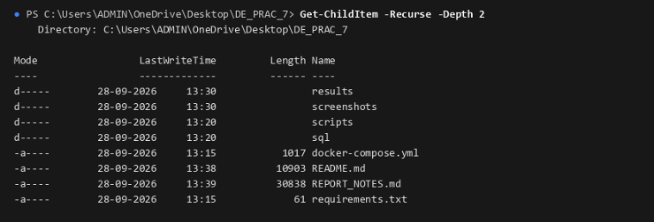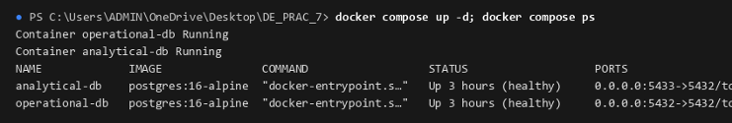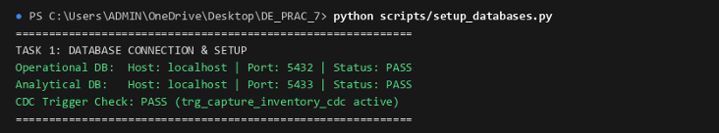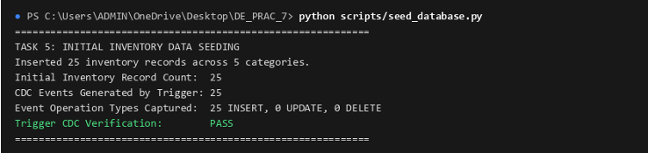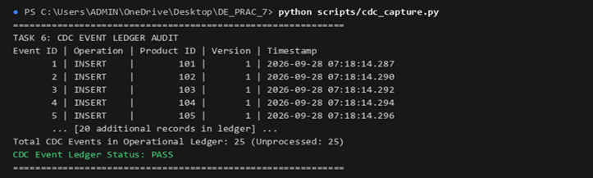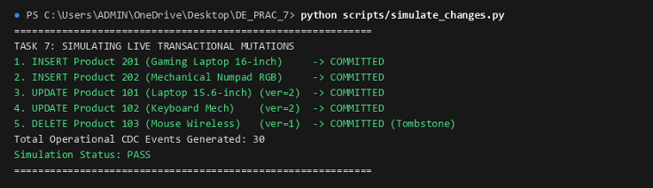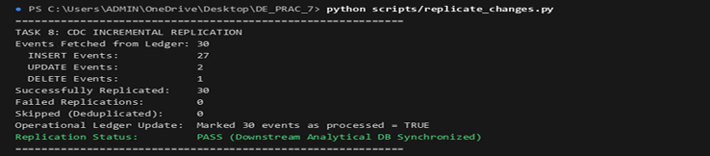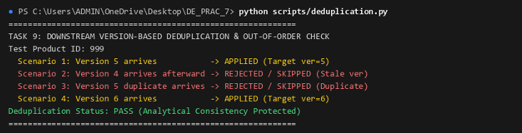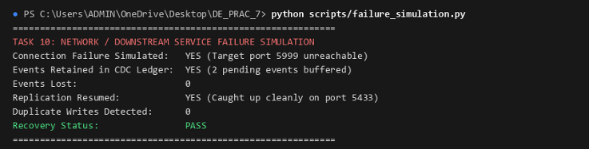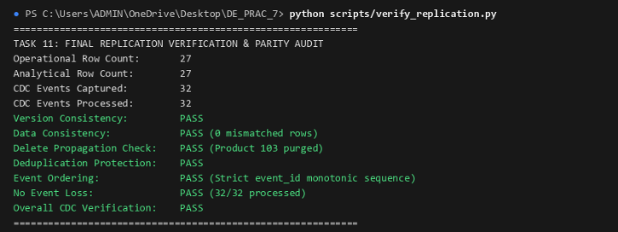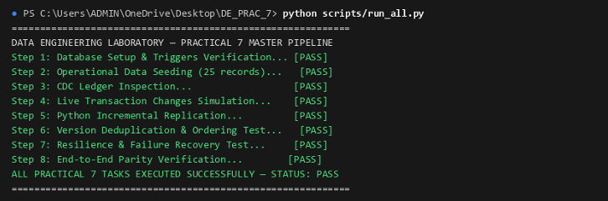

Final Conclusion
The practical demonstrates how Change Data Capture (CDC) enables incremental synchronization between operational and analytical databases. By capturing INSERT, UPDATE, and DELETE operations, the system maintains an audit ledger and propagates changes to the analytical table without repeatedly copying the complete source database.
PostgreSQL triggers, PL/pgSQL, Python, and Psycopg2 provide a practical foundation for demonstrating CDC concepts. The event log preserves change history, while the replication process updates the analytical table to reflect the latest operational state.
Overall, CDC helps reduce unnecessary data processing, supports timely analytical updates, and provides a foundation for reliable database replication, auditing, and real-time data engineering pipelines.

