UNIVERSITY INSTITUTE OF COMPUTING

Mini Project

Program name: BCA

Subject name: Social media analytics

Online reputation report for a brand(NYKAA)

Submitted by:

Name: Shivanshi
ID: 23BCA10432
Section: 23BCA- 8(B)

Submitted to:

Name: Mrs . Ankita
Assistant Professor

Online Reputation Management Report: Nykaa
- Introduction
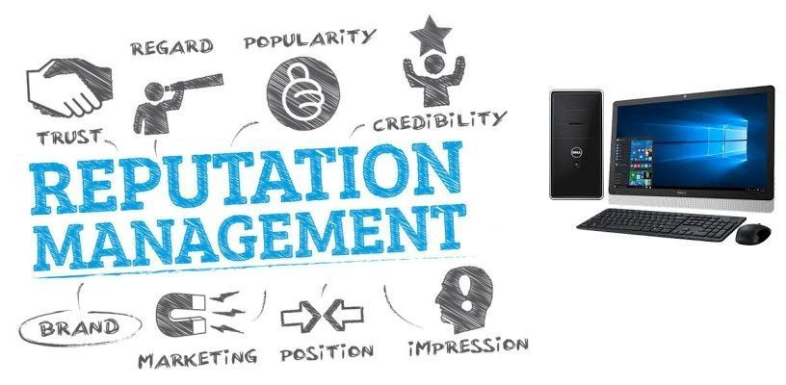
Definition of Online Reputation Management (ORM)
Online Reputation Management (ORM) represents the strategic orchestration of a brand's digital presence across the vast, interconnected landscape of the internet. It is far more than conventional marketing; it is a comprehensive campaign involving continuous monitoring, strategic influence, and narrative control over how a brand is perceived in the digital realm. ORM deploys a full arsenal of tactics—both proactive and reactive—to shape public opinion, encompassing meticulous management of online reviews, strategic manipulation of search engine results, domination of social media conversations, and execution of precision public relations interventions. In essence, ORM is the practice of forging an image of authority, trustworthiness, and desirability in a digital world where perception directly translates to reality.
The Importance of ORM in Digital Marketing
In the digital arena, a brand's reputation is its lifeblood—the critical shield that stands between market supremacy and digital extinction. A positive online perception functions as a powerful weapon that directly influences consumer trust, purchasing decisions, and unwavering customer loyalty. The statistics paint a stark picture: 93% of consumers admit their choices are influenced by online reviews, and a single star's difference in ratings can trigger a catastrophic 5-9% shift in revenue. In an age where negative sentiment can go viral instantly, a masterful ORM strategy is not merely important—it is essential for corporate survival in the beauty and e-commerce industry.
Brand Selection: Nykaa

For this analysis, Nykaa presents an exceptionally compelling case study—an e-commerce titan whose meteoric rise has revolutionized India's beauty landscape. Founded in 2012 by Falguni Nayar, a former investment banker, and headquartered in Mumbai, Nykaa has ascended to become India's most valuable beauty retailer and a cultural phenomenon. With a market capitalization exceeding $7 billion at its 2021 IPO and operations spanning 130+ physical stores alongside its dominant digital platform, Nykaa is not merely an e-commerce website—it is a beauty revolution that has democratized access to premium cosmetics.
Yet this empire faces intense competition from global giants, supply chain challenges, customer service controversies, and the delicate balance between premium positioning and mass-market accessibility. From its authentic product guarantee to counterfeit controversies, from influencer marketing mastery to delivery delays—Nykaa's reputation is a study in contrasts, making it the ultimate subject for unflinching reputational examination.

2. Brand Profile
Company Overview
Nykaa is India's beauty and wellness empire that has revolutionized how millions engage with cosmetics and personal care. Established in April 2012 by Falguni Nayar, who left investment banking at age 50, Nykaa operates under FSN E-Commerce Ventures Limited, which went public in November 2021 valued at approximately ₹53,000 crores.
Today, Nykaa dominates India's online beauty market with approximately 20 million monthly active users and over 4,000 brands across beauty, personal care, and fashion categories. With 130+ physical stores across 80+ cities—including flagship "Nykaa Luxe" stores for premium brands—the company has seamlessly blended digital convenience with experiential retail.
Nykaa has created an ecosystem that educates consumers through "Nykaa Network," offers personalized beauty consultations, provides authentic product guarantees, and launched successful private labels including Nykaa Cosmetics, Nykaa Naturals, and Twenty Dresses.
Brand Presence
Website: nykaa.com serves as the primary shopping destination featuring over 4,000 brands, 400,000+ products, detailed reviews, beauty guides, and personalized recommendations. The mobile app accounts for over 60% of total transactions.
Social Media:
- Instagram: 4.2 million followers—visual storytelling through beauty tutorials, influencer collaborations, product launches, and user-generated content
- Facebook: 3.1 million followers—detailed product information, customer testimonials, live shopping events, and community building
- YouTube: 1.8 million subscribers—makeup tutorials, product reviews, celebrity beauty secrets, and educational content
- Twitter/X: 89,000 followers—customer service, trend commentary, and real-time engagement
- LinkedIn: 180,000 followers—corporate culture, careers, and thought leadership
E-commerce and Distribution: Omnichannel presence spanning mobile apps, 130+ physical stores, quick-commerce partnerships, and pan-India logistics network with direct relationships with 4,000+ brands.

- Tools Used for Analysis

- Google Alerts: Monitoring "Nykaa," "Nykaa delivery," "Nykaa customer service," and related topics
- Social Media Monitoring & Sentiment Analysis: Processing conversations across Instagram, Facebook, Twitter, YouTube
- Review Platform Analysis: Trustpilot, Google Reviews, Mouthshut, Complaintsboard
- Platform-Specific Metrics: Financial reports, RedSeer, Bain & Company, Economic Times analysis
- Social Media Platform Analytics: Engagement rates, follower growth, content performance
- News Media Monitoring: Business publications, technology news, beauty industry coverage
- E-commerce Marketplace Analysis: Comparison with Amazon Beauty, Flipkart, Tira, Sephora India

4. Data Collection & Analysis
a) Customer Reviews & Ratings
The Beauty Authority: Product Excellence
Product Authenticity Leadership: Nykaa's "100% Authentic Products" guarantee establishes the platform as the gold standard in a market plagued by counterfeits. Direct brand partnerships and rigorous quality checks build foundational trust.
Unparalleled Product Range: 4,000 brands and 400,000+ products spanning mass to luxury—from Maybelline to MAC, Lakmé to La Mer. One-stop shopping for all beauty needs receives consistent praise.
Content Excellence: "Nykaa Network" generates millions of pageviews monthly with tutorials, buying guides, and ingredient education, positioning Nykaa as more than a retailer.
Private Label Success: Nykaa Cosmetics products achieve remarkable credibility, with items like Matte To Last Liquid Lipstick receiving praise for quality-to-price ratios.
The Operational Antagonist: Service Failures
Delivery Delays: Orders taking 7-15 days when 2-3 days were promised, particularly during Pink Sale events. Products arriving after special occasions, inadequate tracking information.
Customer Service Deficiencies: Difficulty reaching human representatives, generic scripted responses, long wait times for refunds (10-15 days), lack of accountability for damaged/wrong products.
Counterfeit Concerns: Sporadic reports of suspected counterfeits, expired items, broken seals, or tampered products despite authenticity guarantee.
Return Policy Frustrations: Inflexible policies prohibiting returns on cosmetics create frustration when products arrive damaged, wrong items shipped, or promotional offers not honored.
Price Perception Issues: Products sometimes cheaper on brand websites or competitor platforms, especially during sales, damaging value perception.
b) Social Media Sentiment
Positive Sentiment: Beauty Democratization
Influencer Marketing Mastery: Partnerships with mega-influencers like Malvika Sitlani and hundreds of micro-influencers generate millions of impressions. #NykaaBeautyBook and #GetTheLook campaigns create authentic advocacy.
User-Generated Content: #NykaaLove and #MyGlamm hashtags encourage customers to become brand ambassadors through makeup looks, unboxing videos, and reviews.
Sale Event Excitement: "Nykaa Pink Sale" generates massive buzz with customers sharing wishlists, haul videos, and discount discoveries, creating communal shopping experiences.
Educational Content: Beauty tutorials for Indian skin types, skincare routines, makeup tips receive consistent positive engagement.
Negative Sentiment: Growth Pains
Delivery Delay Outrage: Twitter becomes a battleground during sales with #NykaaDeliveryFail trending and complaints about orders stuck in processing.
Customer Service Call-Outs: Frustrated customers post screenshots of unhelpful chat conversations, threatening to switch to competitors.
Authenticity Doubts: Viral posts questioning product authenticity create reputational fires requiring immediate containment.
Competitive Pressure: Comparisons with Tira, Sephora, Amazon highlighting better pricing, faster delivery, or superior service elsewhere.
c) Major Case Studies
Case Study I: The Pink Sale Paradox

Nykaa's signature sales generate extraordinary traffic but consistently expose infrastructure limitations:
- Website/app crashes during peak hours
- Lightning-fast sellouts within seconds
- Payment gateway failures
- Inventory mismanagement leading to order cancellations
- Delivery delays extending 10-15 days
- Overwhelmed customer service
Social media explodes with frustration, creating patterns where ambition exceeds execution capabilities.
Case Study II: The Counterfeit Controversy
Periodic allegations threaten Nykaa's core authenticity promise:
- MAC lipsticks with suspicious packaging
- Tampered seals or partially used products
- Expired items or illegible batch codes
- Wrong shade substitutions
Each incident, regardless of validity, strikes at Nykaa's fundamental value proposition.
Case Study III: Refund Policy Backlash
Industry-standard return restrictions become persistent friction points:
- No returns on most cosmetics for hygiene reasons
- Customers unable to return wrong shades or unsatisfactory products
- Lengthy refund processes for damaged items
- Credit notes instead of original payment method refunds
Policy becomes particularly damaging when combined with other service failures.
d) Brand Engagement
Current Approach:
- Content-driven commerce through "Nykaa Network"
- Influencer ecosystem via "Nykaa Beauty Book" creator program
- Personalization through recommendation engine
- Multi-channel support (phone, email, chat, social media, WhatsApp)
- "Nykaa Rewards" loyalty program
- Virtual beauty masterclasses and in-store events
Weaknesses:
- Inconsistent response quality
- Limited regional language support
- Reactive rather than proactive communication
- Promotional saturation creating fatigue

5. Affiliate Marketing and Trust Building
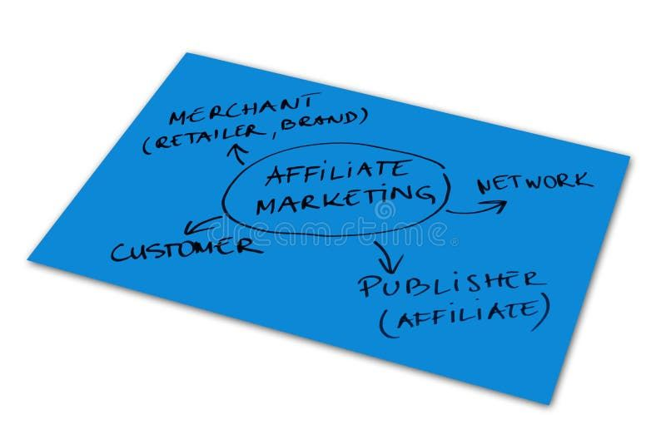
Influencer and Affiliate Ecosystem
Multi-Tier Partnership Strategy:
- Mega-Influencers: Celebrity makeup artists and beauty YouTubers creating aspirational content
- Micro-Influencers: 10,000-100,000 followers creating authentic, relatable content
- Nano-Influencers: 1,000-10,000 followers sharing everyday experiences
- Affiliate Revenue Sharing: Commission-based partnerships aligning incentives
Trust-Building Mechanisms
Authenticity Guarantee: "100% Authentic Products" promise backed by direct brand partnerships creates fundamental differentiation in counterfeit-plagued market.
Content as Education: Tutorials, skincare routines for Indian skin, ingredient education position Nykaa as trusted advisor generating millions of pageviews monthly.
Customer Reviews: Displayed ratings and uploaded images create social proof influencing purchase decisions.
Expert Curation: Beauty experts curate collections and offer personalized recommendations through "Beauty Concierge."
Omnichannel Experience: Physical stores enabling product testing and personalized consultations build tactile trust.
Private Label Quality: Successful own-brand products validate overall curation and quality standards.
Brand Partnerships: Positioning as preferred Indian launch partner for international brands creates exclusive access building trust with customers.

6. Findings Summary (SWOT Analysis)
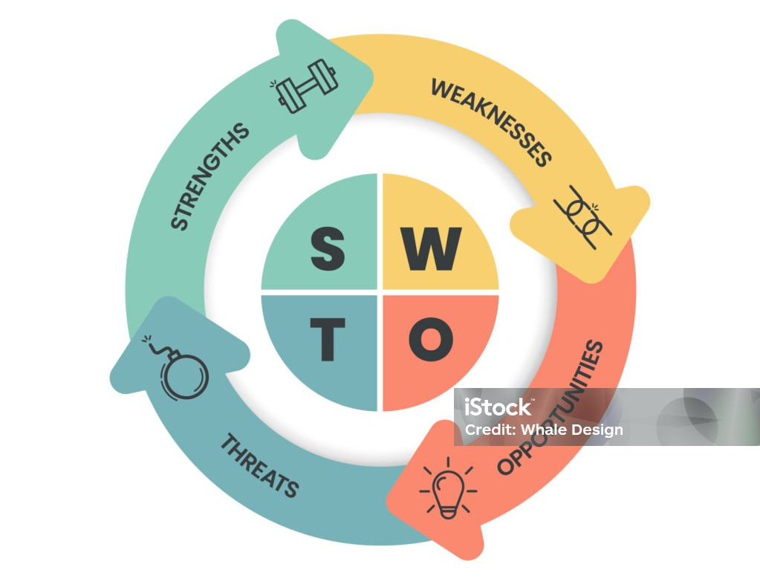
Strengths | Weaknesses
Market Leadership: Dominates India's online beauty market with 20 million monthly active users, recognized as most trusted beauty retailer | Operational Inconsistency: Persistent delivery delays during sales damage trust and create recurring reputational crises
Authenticity Guarantee: "100% Authentic Products" creates fundamental differentiation in counterfeit-plagued market | Customer Service Quality: Inconsistent support, lengthy refunds, generic responses frustrate customers
Comprehensive Range: 4,000+ brands, 400,000+ products—unmatched breadth serving as one-stop beauty destination | Return Policy Inflexibility: Restrictive policies create friction especially when combined with service failures
Content Excellence: "Nykaa Network" educates consumers, building authority beyond mere transactions | Technical Infrastructure: App crashes, payment failures during high-traffic events expose capacity limitations
Omnichannel Presence: 130+ physical stores blend digital convenience with experiential retail | Price Competitiveness: Products sometimes cheaper elsewhere, damaging value perception
Influencer Ecosystem: Sophisticated multi-tier partnerships generate authentic advocacy and massive reach | Communication Gaps: Reactive rather than proactive updates about delays, issues, policy changes

Opportunities | Threats
Tier 2/3 City Expansion: Untapped markets with growing disposable income and beauty awareness | Intense Competition: Tira (Reliance), Sephora, Amazon Beauty, Flipkart fragment market share
Men's Grooming: Rapidly growing segment currently underserved by Nykaa's offerings | Economic Pressures: Downturns increase churn as consumers cut discretionary beauty spending
Private Label Expansion: Success of Nykaa Cosmetics demonstrates potential for category expansion | Counterfeit Products: Ongoing threat undermines core authenticity promise if quality controls fail
Regional Language Content: Creating vernacular content unlocks massive non-English speaking audience | Quick-Commerce Disruption: 10-minute delivery platforms challenge Nykaa's logistics model
Wellness Integration: Expanding beyond beauty into holistic wellness creates adjacent growth | Brand Direct-to-Consumer: Brands building own D2C channels bypass Nykaa's platform
Technology Enhancement: AI-powered virtual try-on, personalized skincare analysis differentiate experience | Regulatory Changes: E-commerce regulations, data privacy laws could constrain operations

7. Recommendations
1. Infrastructure Investment for Operational Excellence
The Challenge: Recurring delivery delays and technical failures during high-traffic events damage trust and create customer exodus opportunities for competitors.
The Solution:
- Warehouse capacity expansion in strategic locations for faster fulfillment
- Predictive analytics for demand forecasting during sales events
- Stress testing infrastructure before major sales
- Real-time inventory synchronization preventing overselling
- Transparent delivery tracking with proactive delay notifications
- Backup payment gateway systems for seamless transactions
2. Customer Service Transformation
The Challenge: Mediocre support creates stark contrast with premium positioning, driving negative reviews and social media complaints.
The Solution:
- Empower agents with authority to resolve issues without escalation
- Reduce refund processing time to 3-5 days maximum
- Implement callback systems instead of lengthy hold times
- Create premium support tier for high-value customers
- Publish response time commitments and track publicly
- Regional language support for tier 2/3 city customers

3. Flexible Return Policy Innovation
The Challenge: Inflexible return policies create friction, particularly for first-time online beauty shoppers unfamiliar with products.
The Solution:
- Virtual try-on technology reducing wrong shade purchases
- Sample programs for expensive products before full-size commitment
- Extended return windows for premium tier loyalty members
- Simplified damage claim process with instant approvals for photo verification
- Clear communication of policy during checkout
- Strategic exceptions for wrong items shipped by Nykaa error
4. Authenticity Assurance Program
The Challenge: Periodic counterfeit allegations threaten core value proposition requiring absolute vigilance.
The Solution:
- Blockchain-based product authentication system
- QR code verification on all products
- Temperature-controlled storage facility investments
- Third-party quality audits published transparently
- Rapid response team for authenticity complaints
- Insurance coverage for customers receiving counterfeit products
5. Proactive Communication Strategy
The Challenge: Reactive communication leaves customers in the dark about delays, issues, and changes, amplifying frustration.
The Solution:
- Automated delay notifications before customers inquire
- Pre-sale capacity disclosure (expected delivery times during high-traffic)
- Policy change announcements with customer benefit framing
- Transparent content departure explanations
- Regular "state of the platform" updates during sales
- Personalized apology offers for service failures
6. Regional Market Customization
The Challenge: One-size-fits-all approach fails to leverage India's linguistic and cultural diversity.
The Solution:
- Regional language content across platforms
- Local influencer partnerships in vernacular languages
- Culturally relevant product curation (festival collections)
- Regional payment preferences (UPI, regional wallets)
- Tier 2/3 city specific logistics partnerships
- Localized customer service with cultural competency
7. Technology-Driven Personalization
The Challenge: Generic experiences fail to match sophisticated competitors' AI-powered customization.
The Solution:
- Virtual try-on using AR for makeup and hair color
- AI skin analysis recommending personalized skincare routines
- Predictive replenishment reminders for consumable products
- Dynamic pricing for loyalty members
- Personalized app interfaces based on beauty preferences
- Voice shopping integration for vernacular accessibility

8. Conclusion
Nykaa's online reputation represents a compelling paradox—India's most beloved beauty destination simultaneously grappling with operational growing pains that threaten its premium positioning. This exhaustive analysis reveals several undeniable truths about Nykaa's reputational position in late 2025:
Nykaa's Core Value Remains Unmatched: The authenticity guarantee, comprehensive product range, content excellence, and omnichannel presence continue to set industry standards. With 20 million monthly active users and market leadership in India's beauty e-commerce, Nykaa's fundamental value proposition is extraordinarily strong.
Operational Execution Creates Self-Imposed Wounds: Delivery delays, customer service inconsistencies, return policy inflexibility, and technical infrastructure limitations have created significant friction. These issues represent a concerning pattern where rapid growth has outpaced operational maturity.
The Competitive Landscape Demands Excellence: With Tira, Sephora, Amazon Beauty, and quick-commerce platforms fragmenting the market, Nykaa cannot rely on first-mover advantage alone. The company must demonstrate superior execution across all touchpoints.
Social Media Amplifies Both Triumph and Failure: Nykaa's influencer ecosystem and content mastery create unparalleled positive engagement, but this same visibility amplifies operational failures when delivery delays or service issues occur.
The Path Forward Requires Balanced Investment: The recommendations outlined—infrastructure enhancement, customer service transformation, flexible policies, authenticity assurance, proactive communication, regional customization, and technology personalization—represent essential strategic imperatives, not optional enhancements.
Nykaa stands at a crossroads. One path leads to continued dominance built on operational excellence matching content excellence, where customer service equals product quality. The other leads to gradual erosion as competitors capitalize on execution gaps, offering superior reliability even if lacking Nykaa's brand heritage.
The company has the resources, brand equity, and market position to choose the first path. The question is whether it possesses the institutional will to prioritize operational investment with the same intensity it has applied to content marketing and brand building.
Nykaa's reputation in 2026 and beyond will be determined not by its past achievements but by the choices it makes today in response to the warning signs illuminated by this analysis. The beauty revolution continues—Nykaa must decide whether it will lead that revolution as a beloved, operationally excellent institution or watch competitors claim that mantle while Nykaa becomes merely the largest, not the best.

