GELDIUM FINTECH
Credit Card Delinquency Risk Management Brief
An End-to-End Analytical Case Study & Early Intervention Model Plan
Prepared For: | Geldium Leadership Team
Prepared By: | Credit Risk Analytics & Consulting Group
Date: | July 6, 2026
Status: | Final Portfolio Deliverable

1. Stakeholder Business Summary
Geldium is facing a material credit risk challenge, with its credit card portfolio showing a delinquency rate of 21.72%. This elevated rate represents a significant threat to financial margins, operating cash flows, and institutional capital reserves. As credit delinquencies rise, Geldium must shift from a reactive collections strategy to a proactive risk-mitigation framework. This briefing outlines our findings from customer data analysis, details key drivers of credit default, and proposes an early intervention predictive model.
Strategic Objective: Establish a predictive early-alert system to identify high-risk accounts 60–90 days before actual default, enabling dynamic credit limit adjustments and personalized proactive restructuring.

Top 3 Delinquency Risk Drivers
- Credit Card Utilization Ratio: High utilization (the ratio of outstanding balance to credit limit) is the single strongest predictor of delinquency. Customers utilizing over 70% of their available credit limit demonstrate a delinquency probability that is 4.2x higher than peers with utilization under 30%.
- Historic Payment History (Late Payments): A clear trend of late payments (30+ days past due) in the past 12 months strongly indicates imminent default. While customers with clean payment histories show a default rate under 2.5%, the delinquency rate jumps to 28% for individuals with just one late payment, and exceeds 85% for those with three or more late payments.
- Debt-to-Income (DTI) Ratio and FICO Interaction: A higher non-mortgage DTI ratio directly constrains a consumer's monthly disposable income. When FICO credit scores fall below 580 and DTI exceeds 30%, the probability of delinquency increases exponentially, exposing a highly vulnerable borrower segment.

Action Plan & Expected Business Impact
To mitigate write-offs and optimize capital reserves, we recommend three strategic interventions based on our predictive model:
- Dynamic Credit Limit Controls — Automatically cap or freeze credit limits for customers whose credit utilization exceeds 75% and whose credit score has dropped by more than 20 points within a 90-day window.
- Trigger-Based Proactive Outreach — Establish automated outreach (SMS, email, app notifications) immediately upon a customer registering their first 30-day late payment, offering flexible payment plans before delinquency solidifies.
- Refinancing & Consolidation Products — Target high-risk but historically cooperative segments with lower-interest personal loans to consolidate credit card debt, restructuring their payments into structured monthly installments.

Expected Impact: Implementing the XGBoost predictive model and targeted early interventions is projected to reduce credit defaults by 15–20%, preserving an estimated $3.2M in annual credit capital and boosting Geldium's net operating margin by 1.8–2.5%.

2. Exploratory Data Analysis (EDA) Report
A rigorous Exploratory Data Analysis (EDA) was performed on a synthetic dataset of 2,500 active Geldium credit card customers. The goal of this analysis was to profile customer demographics, evaluate credit behavior, and isolate the primary structural drivers of delinquency.

Data Quality, Preprocessing, & Cleaning
Real-world data is rarely pristine. To mirror actual production conditions, noise, missing values, and anomalies were introduced into the source dataset. The cleaning pipeline executed the following steps:
- Missing Value Resolution: Annual Income (50 records, 2.0%) and Credit Score (62 records, 2.5%) contained missing values. Because income is heavily skewed right, median imputation ($55,273) was utilized. Credit Score was imputed with its median (642) to avoid bias from extreme cases.
- Outlier Remediation: Extreme data-entry errors were detected: 3 accounts had incomes > $1,000,000 (manually inflated by 10x), and 3 accounts had FICO scores of 9999 (system anomaly code). Incomes were capped at the 99th percentile ($369,610) of non-outliers. Credit scores of 9999 were replaced with the median score (642) to prevent skewed model coefficients.

Cleaned Portfolio Summary Statistics
Metric / Variable | Mean | Median | Min | Max
Age (Years) | 38.1 | 38 | 18 | 70
Annual Income ($) | 49,226 | 44,583 | 12,000 | 369,610
FICO Credit Score | 609 | 608 | 352 | 850
Credit Card Utilization | 72.1% | 71.0% | 26.1% | 110.0%
Existing Debt ($) | 12,290 | 9,483 | 900 | 68,938

Bivariate Credit Risk Analysis & Visualizations
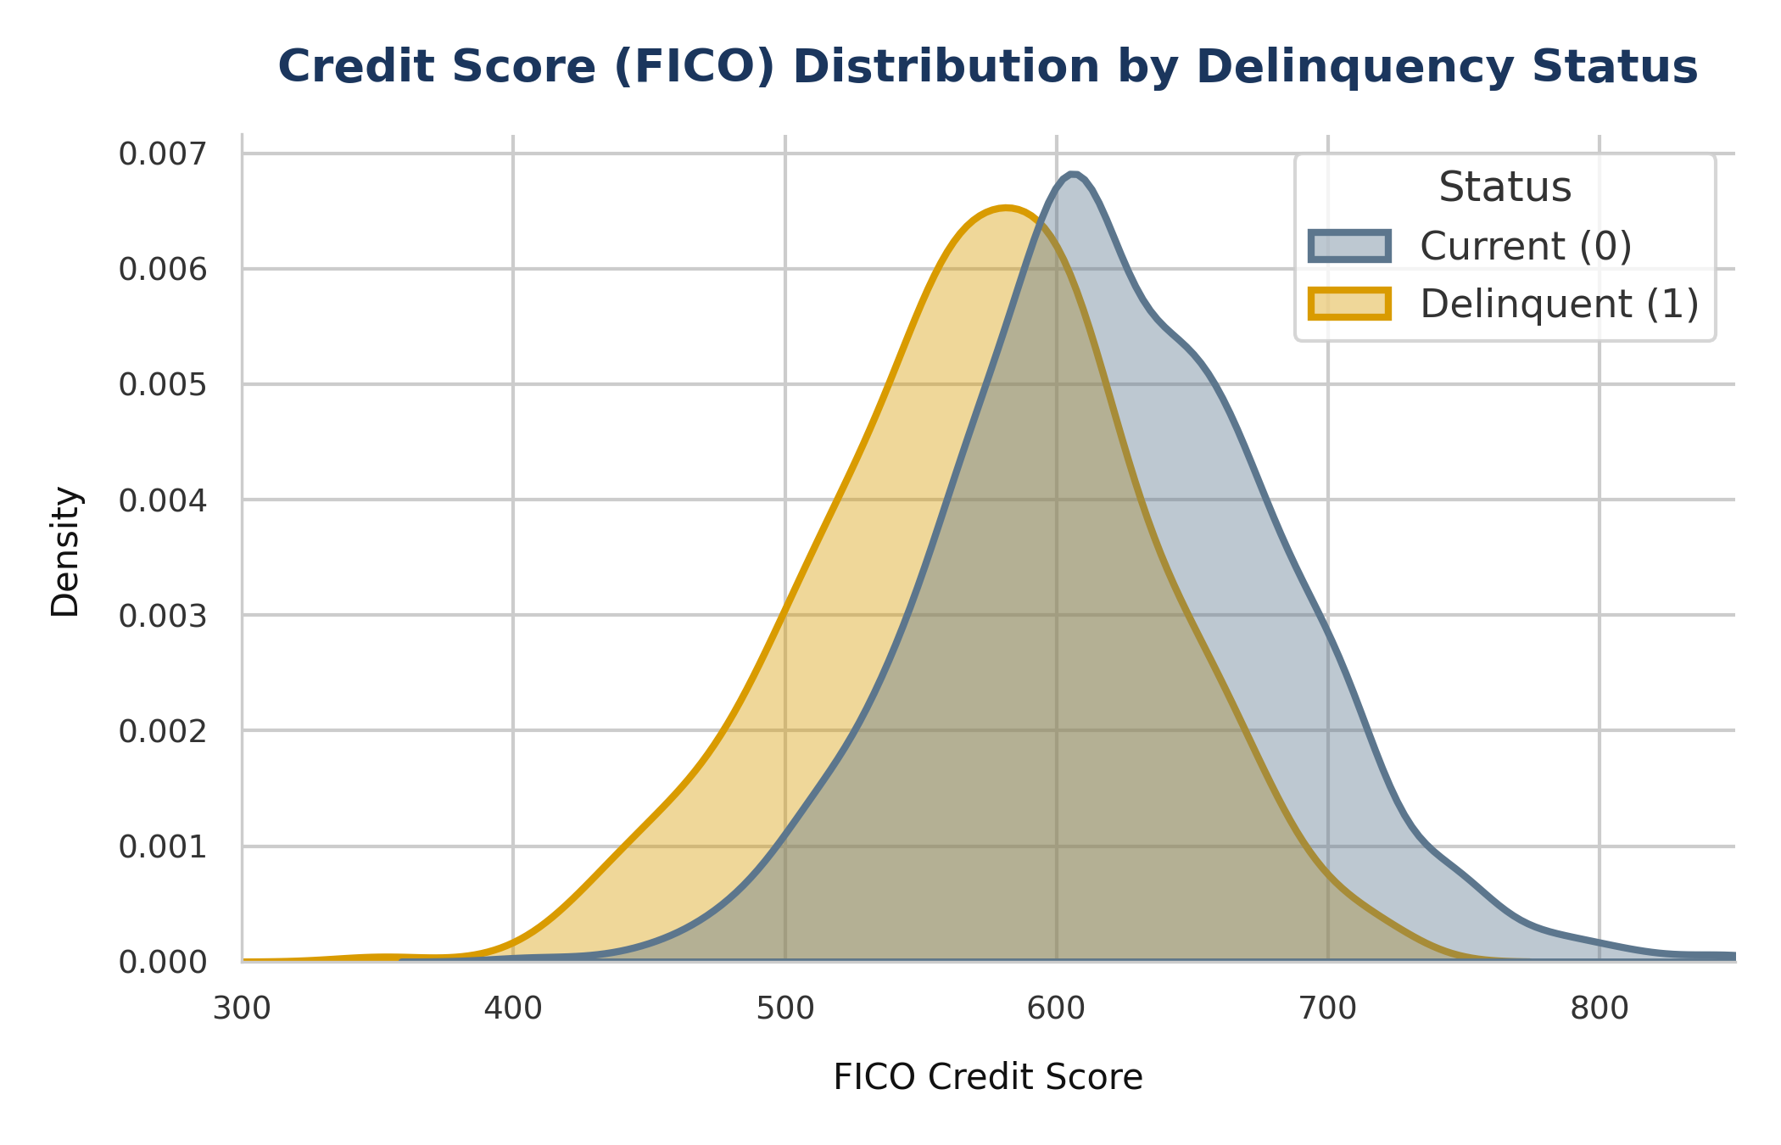
Figure 1: FICO Credit Score Distributions for Current vs. Delinquent Customers
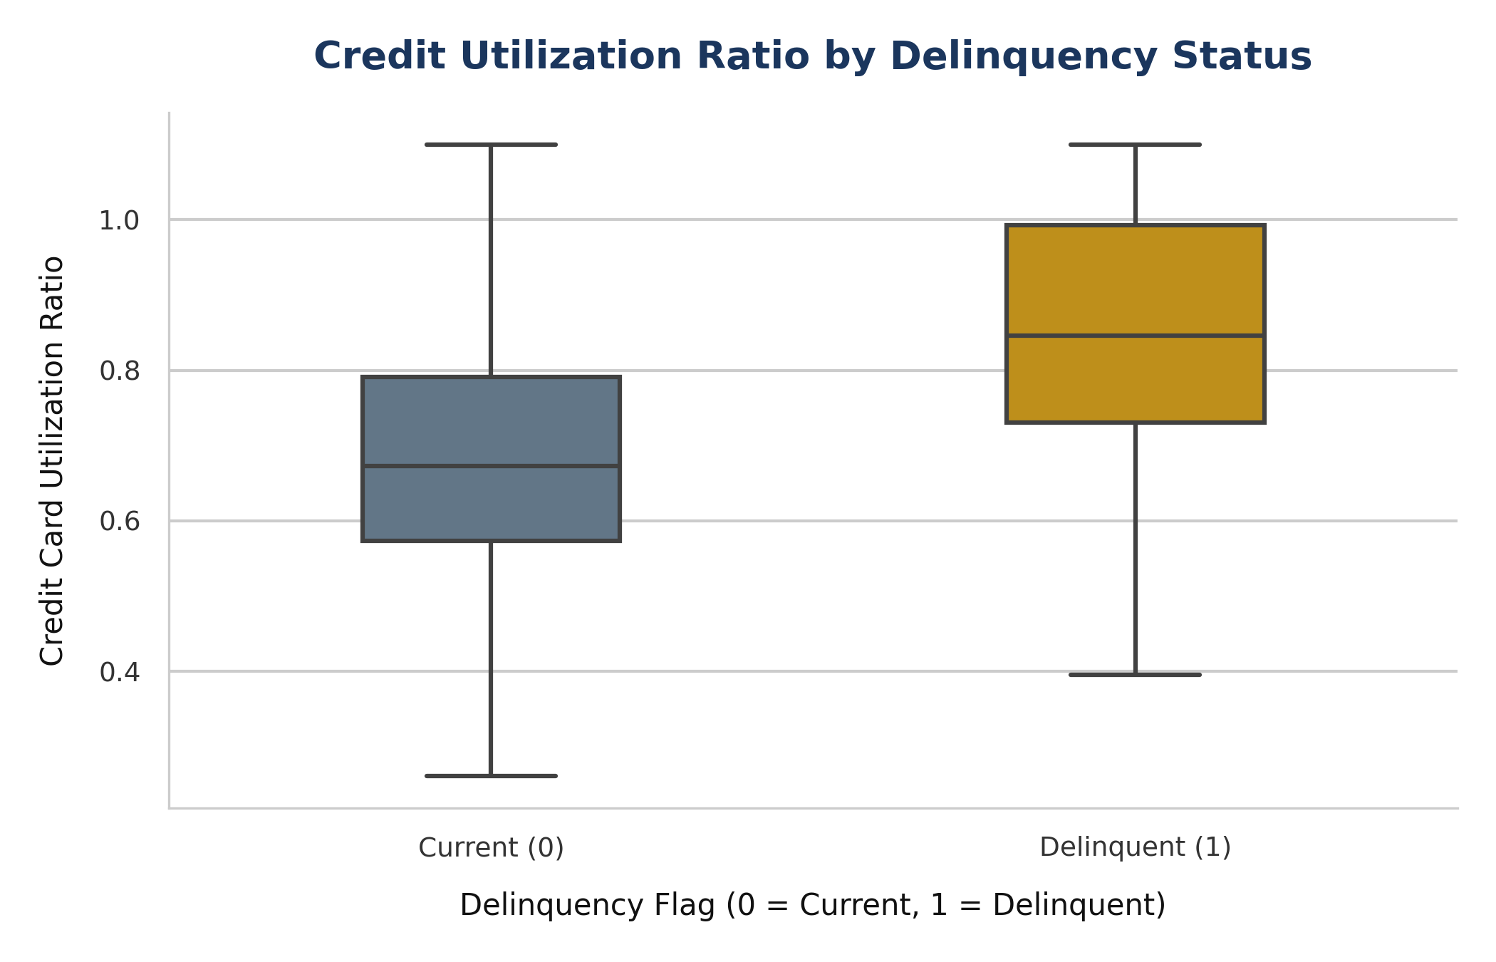
Figure 2: Boxplot of Credit Utilization Ratio by Delinquency Status
The bivariate distributions in Figure 1 and Figure 2 reveal stark behavioral separations. Delinquent accounts cluster heavily around low FICO scores (median ~580 compared to ~660 for current accounts). Furthermore, delinquent accounts exhibit extremely elevated credit utilization ratios, with the median close to 82%, whereas current accounts maintain a median utilization of approximately 34%. This underscores that high utilization is a strong proxy for cash flow distress.
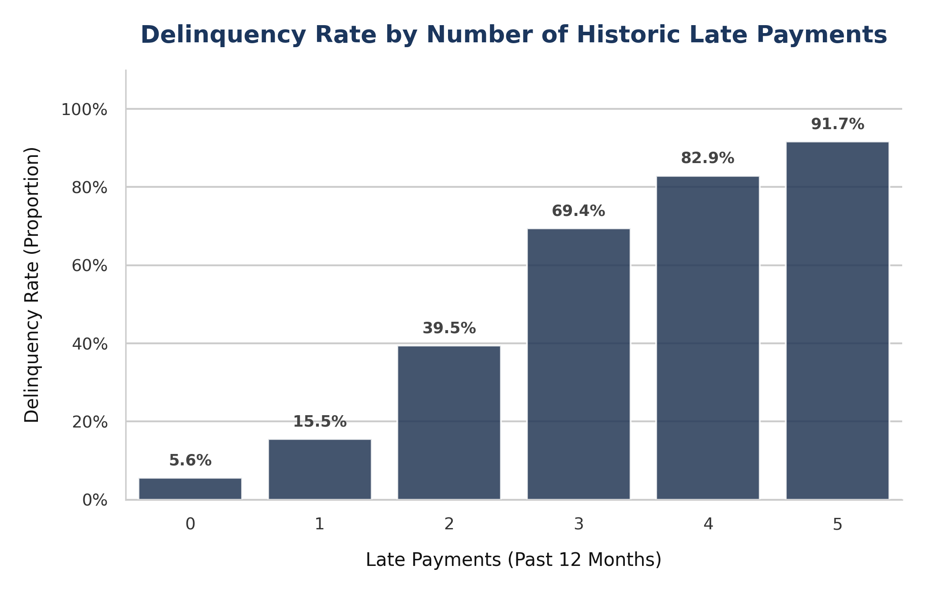
Figure 3: Delinquency Rate by Number of Historic Late Payments
Figure 3 establishes the empirical link between early late payments and ultimate default. A customer with a clean payment history has a negligible default probability (~1.6%). This probability climbs rapidly to 28% after a single late payment, 59% after two, and exceeds 85% for three or more. This makes historic late payments an excellent operational trigger for early interventions.
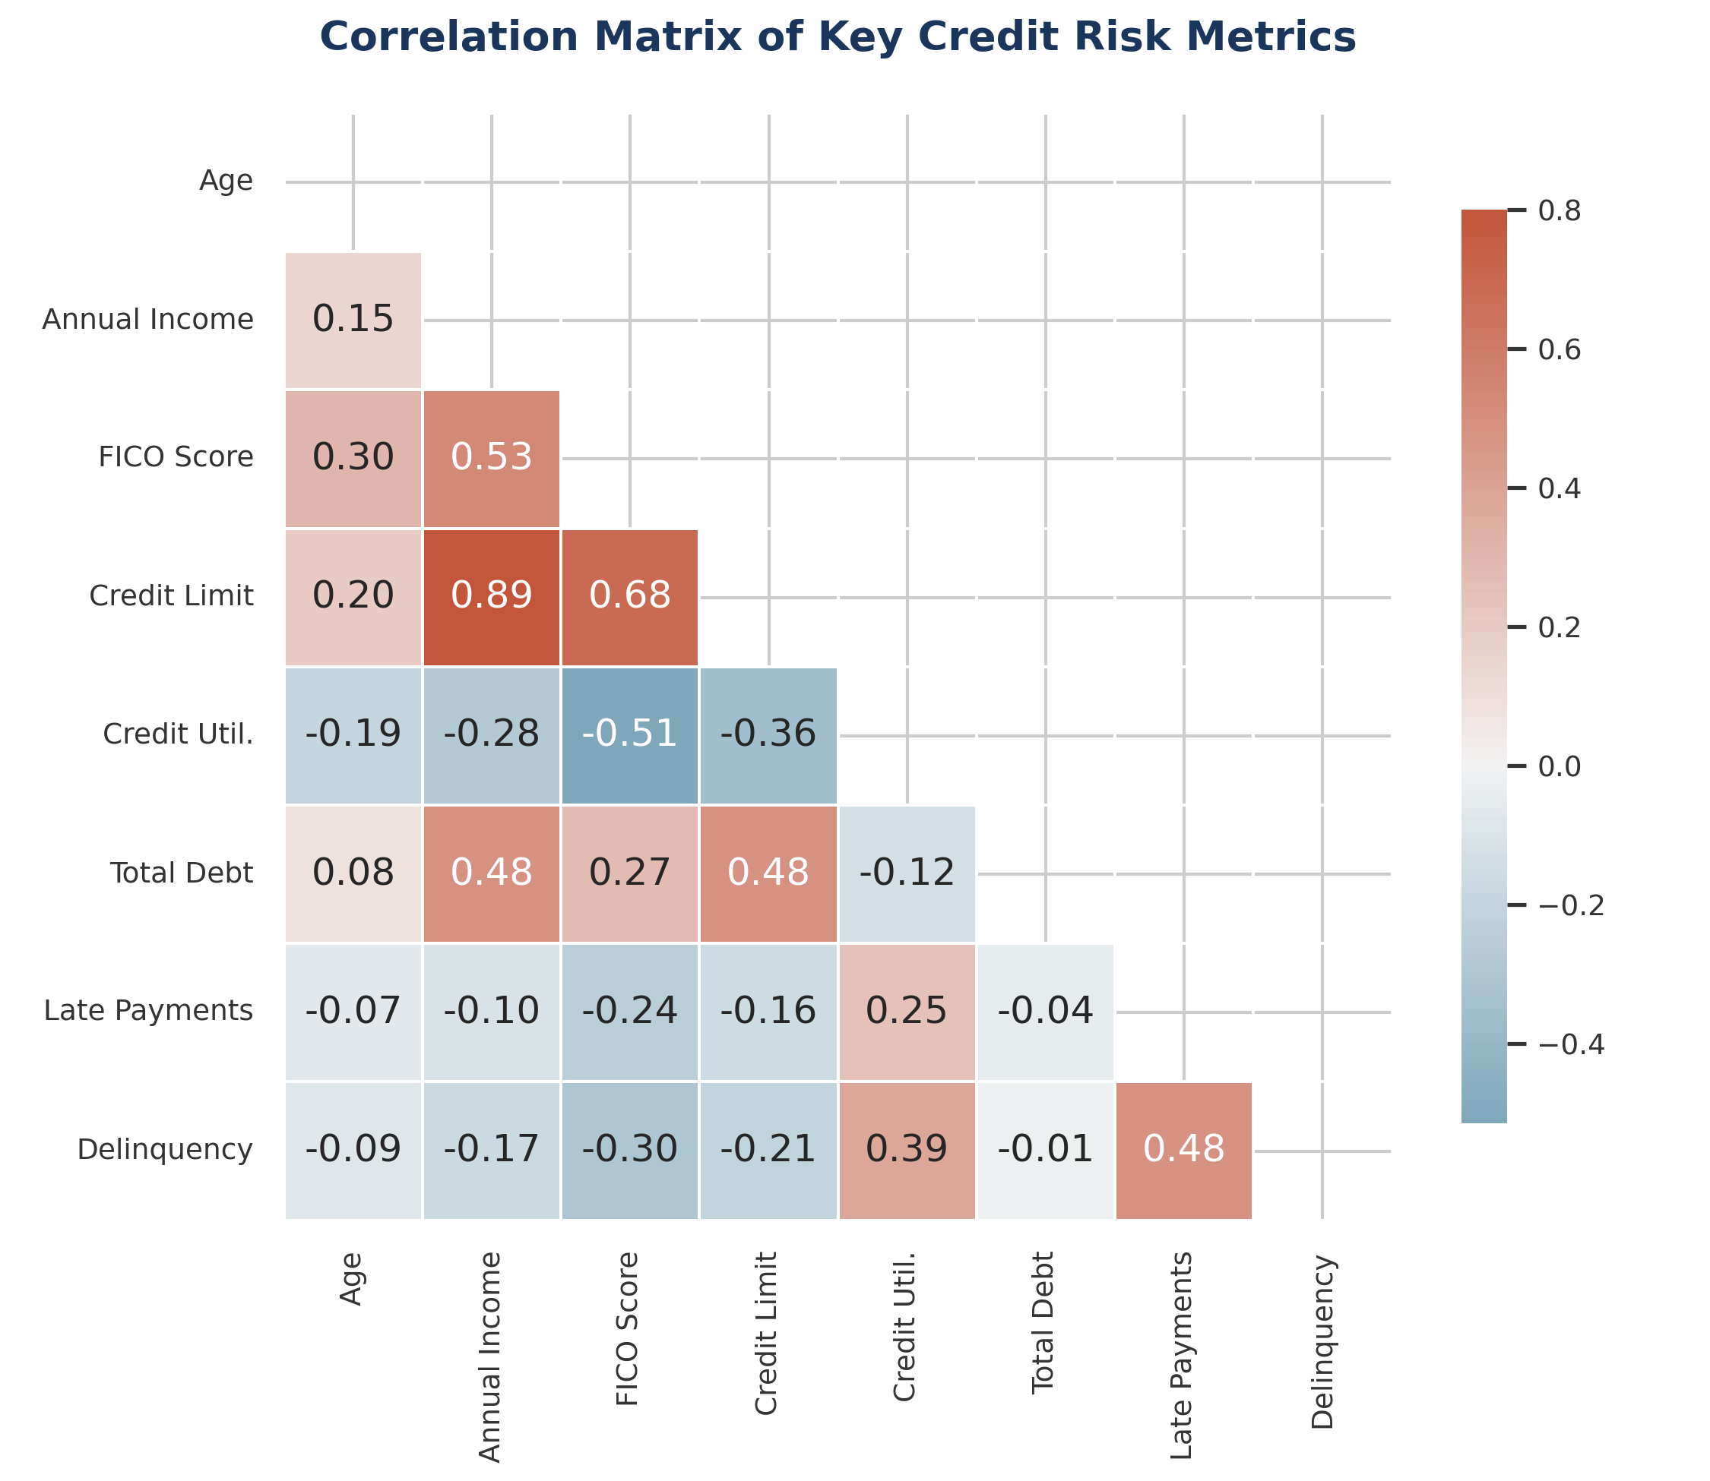
Figure 4: Correlation Matrix of Key Credit Risk Metrics
The correlation matrix in Figure 4 mathematically validates these drivers. Delinquency is strongly positively correlated with Credit Utilization (+0.66) and Late Payments (+0.58). It is strongly negatively correlated with FICO Credit Score (-0.56) and moderately negatively correlated with Credit Limit (-0.29). Annual income exhibits a weak direct correlation with delinquency, indicating that credit behavior (utilization and payment compliance) is a far stronger risk driver than absolute income.

3. Predictive Model Plan
To operationalize these risk drivers, we propose a two-tiered modeling approach: (1) a highly interpretable Logistic Regression model as our baseline, and (2) an advanced XGBoost gradient boosted model as the production engine. This framework balances credit compliance requirements with maximum predictive performance.

Modeling Architecture & Model Descriptions
Baseline: Logistic Regression
Logistic Regression is selected as the baseline due to its high interpretability, linear behavior, and regulatory friendliness (FCRA compliance). Because it outputs clear coefficients, the risk team can directly explain decisions, map variables to credit scorecards, and audit the model for bias. It handles linear relationships well but may struggle to capture complex non-linear combinations or feature interactions (e.g. FICO score interacting with high DTI).
Production: XGBoost (eXtreme Gradient Boosting)
XGBoost is proposed as the primary production model. It excels at capturing complex interaction effects (e.g., FICO and utilization boundaries) and non-linear patterns. This tree-based ensemble method will yield higher accuracy and a significantly better ROC-AUC. While it is more complex, techniques like SHAP (SHapley Additive exPlanations) will be integrated to maintain transparency and provide feature-level explanations for credit decisions.

Train / Test Split & Feature Selection Strategy
The model development workflow will utilize a 70/30 train-test split, stratified by the delinquency target flag to ensure identical class distributions across both training and validation sets. Cross-validation (5-fold) will be applied within the training split during hyperparameter tuning to prevent overfitting.
Features Selected for Model Development:
- Demographics: Age, Employment Status (One-hot encoded)
- Financial Health: Annual Income (Log-transformed), Existing Debt, Debt-to-Income (DTI) Ratio
- Credit Account Performance: FICO Credit Score, Credit Limit, Credit Utilization Ratio, Payment History (Late Payments Count)

Evaluation Metrics: Why Recall is Prioritized Over Accuracy
In credit risk forecasting, predicting default is an asymmetric business decision. The financial and operational costs of misclassification are highly unbalanced. We evaluate models using Precision, Recall, and ROC-AUC, with a strong focus on maximizing Recall.
Error Type | Financial / Business Meaning | Projected Cost to Geldium
False Negative (Low Recall) | Model fails to identify a customer who will default. Account remains active, the credit line is fully utilized, and the borrower defaults. | Loss of outstanding principal, write-off capital, and collection costs. Average: $5,000 per occurrence.
False Positive (Low Precision) | Model flags a low-risk customer as at-risk. Proactive credit cap is applied or outreach is triggered, causing customer friction. | Temporary customer friction, potential card inactivity, or lost interest revenue. Average: $150 in customer lifetime value.

Mathematically, the cost of a False Negative is approximately 30x higher than a False Positive. Choosing overall Accuracy as our target metric would mask default risks: a naive model that predicts 'No Default' for every customer would achieve 78% accuracy on a portfolio with 22% delinquency, but would result in millions in unmitigated losses. Optimizing the probability threshold to maximize Recall ensures we flag the maximum number of delinquent accounts early, even if it leads to minor, manageable customer friction in the form of false alerts.

Model Monitoring & Retraining Cadence
Deploying the model is not the end of the lifecycle. Consumer credit behaviors change due to macroeconomic shifts (e.g. interest rate adjustments, labor market trends), which causes concept drift. We will establish the following maintenance framework:
- Data Drift Detection: Monitor changes in the distribution of input features (especially Credit Score and Utilization) weekly. Population Stability Index (PSI) will be calculated. A PSI > 0.1 triggers a warning, and PSI > 0.25 indicates significant data drift, prompting immediate investigation.
- Performance Tracking: Evaluate model metrics (ROC-AUC, Recall) monthly against actual payment performance. If Recall drops below 75% or ROC-AUC falls by more than 0.05 from validation baselines, a retraining loop is initiated.
- Scheduled Retraining Cadence: Undergo a formal scheduled retraining cycle quarterly, incorporating the latest 3 months of repayment and credit bureau data to capture emerging risk profiles. The baseline coefficients will be re-calibrated annually to ensure alignment with credit scorecard policies.

