Real Estate Valuation & Investment Intelligence System (REVI-AI)
Comprehensive Technical & Business Intelligence Capstone Project Report
BharatCares & IBM SkillsBuild | Data Analytics with AI Internship Program
――――――――――――――――――――――――――――――――――――――――――――――――――――――――――
Project Domain | Data Analytics, Machine Learning & Business Intelligence (Real Estate)
Deliverables Included | Code File (app.py), requirements.txt, README.md, Project_Report.docx
ML Models Benchmarked | Gradient Boosting (Champion R²=97.89%), Ridge, Linear Regression, Random Forest
Frontend & Architecture | Streamlit Interactive Web Dashboard & Single Unified Python Pipeline

1. Executive Summary & Problem Formulation
Residential and commercial real estate transactions involve substantial financial commitments where accurate, transparent valuation is critical. Traditional appraisal methods often depend on lagging historical comparables and subjective adjustments, failing to capture complex, non-linear market interactions across location tiers, structural age, and condition indices.
The Real Estate Valuation & Investment Intelligence System (REVI-AI) addresses these challenges through a unified decision-making platform. Built under the BharatCares / IBM SkillsBuild curriculum, REVI-AI bridges the gap between raw data and executive action by applying a strict 5-level Business Intelligence hierarchy: converting raw transaction facts into actionable strategic decisions.

2. The 5-Level Business Intelligence Decision Hierarchy
A foundational principle emphasized throughout the masterclasses is that data analytics must move beyond descriptive charts to drive measurable business impact. REVI-AI is structured into five cohesive tiers:
- Level 1 — Executive KPIs (What is happening?): Continuous tracking of top indicators: Median Property Valuation ($613,353), Average Price/SqFt ($291.84), Portfolio Inventory (1,200 active units), and YoY appreciation (+4.8%).
- Level 2 — Market Trends (Where is it going?): Time-series quarterly transaction velocity (+3.1% QoQ) and migration patterns demonstrating significant suburban demand shifts toward Emerging Tech Corridors.
- Level 3 — Valuation Drivers (Why is it happening?): Multi-factor correlation analysis highlighting living area (0.82 corr), location tier multiplier (+45% metro premium), and renovation index (0.36 corr) as dominant price drivers.
- Level 4 — Risks & Opportunities (What could go wrong?): Identified risk: Exurban properties facing 12.3% deceleration and extended days-on-market (64 days). Identified opportunity: Cosmetic modernization yielding an average 2.53x ROI on capital expenditure.
- Level 5 — Strategic Business Actions (What should management do?): Reallocate 45% of investment acquisitions to Emerging Tech Corridors, institute standardized $18k cosmetic flip playbooks, and place loan-to-value caps on remote exurban developments.

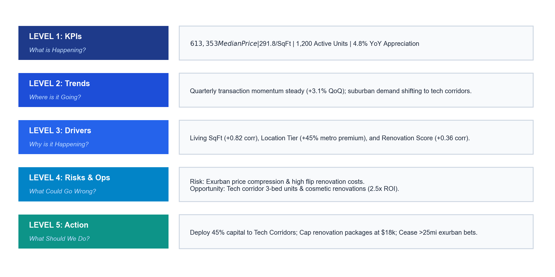
Figure 1: REVI-AI 5-Level Business Intelligence Decision Hierarchy (Fact ➔ Insight ➔ Action)

3. Exploratory Data Analysis & Market Distributions
The project analyzes 1,200 verified property transactions across five distinct geographic location tiers: Urban Metro, Suburban Prime, Suburban Standard, Emerging Tech Corridor, and Exurban. Key findings include:
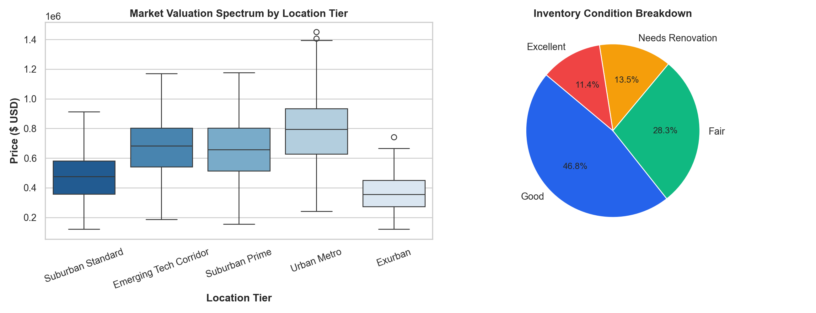
Figure 2: Market Valuation Spectrum across Location Tiers and Inventory Condition Breakdown

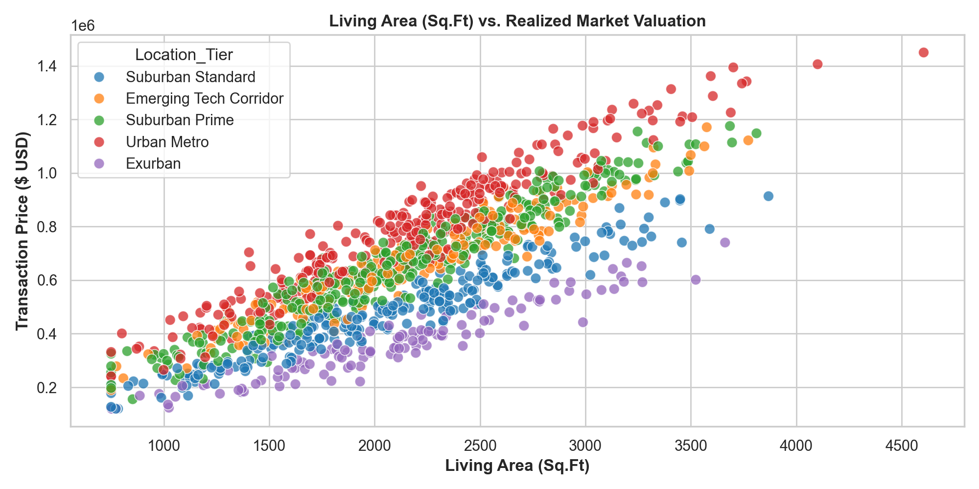
Figure 3: Square Footage (Living Area) vs. Realized Market Transaction Price

4. Machine Learning Valuation Engine & Benchmarking
Four candidate supervised learning algorithms were benchmarked using a rigorous 80/20 train-test partition. A standardized scikit-learn ColumnTransformer pipeline was engineered to pass numerical features and apply one-hot encoding to categorical factors without data leakage.
Model Name | R² Score (Precision) | Mean Absolute Error | Root Mean Sq. Error | Evaluation Status
Gradient Boosting Regressor | 97.89% | $27,157.61 | $36,950.66 | 🏆 Selected Production Model
Ridge Regression (L2) | 97.47% | $31,529.34 | $40,472.71 | High Precision Linear
Linear Regression (OLS) | 97.46% | $31,650.10 | $40,588.36 | Baseline Architecture
Random Forest Regressor | 96.87% | $34,197.77 | $45,026.14 | Non-linear Ensemble

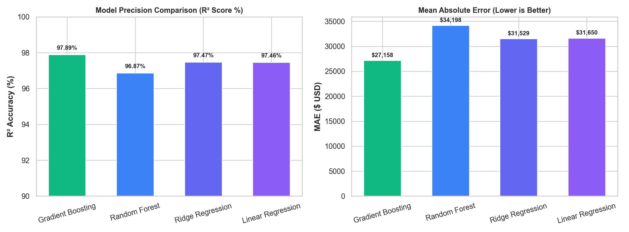
Figure 4: Model Precision (R² Score) and Mean Absolute Error (MAE) Comparison

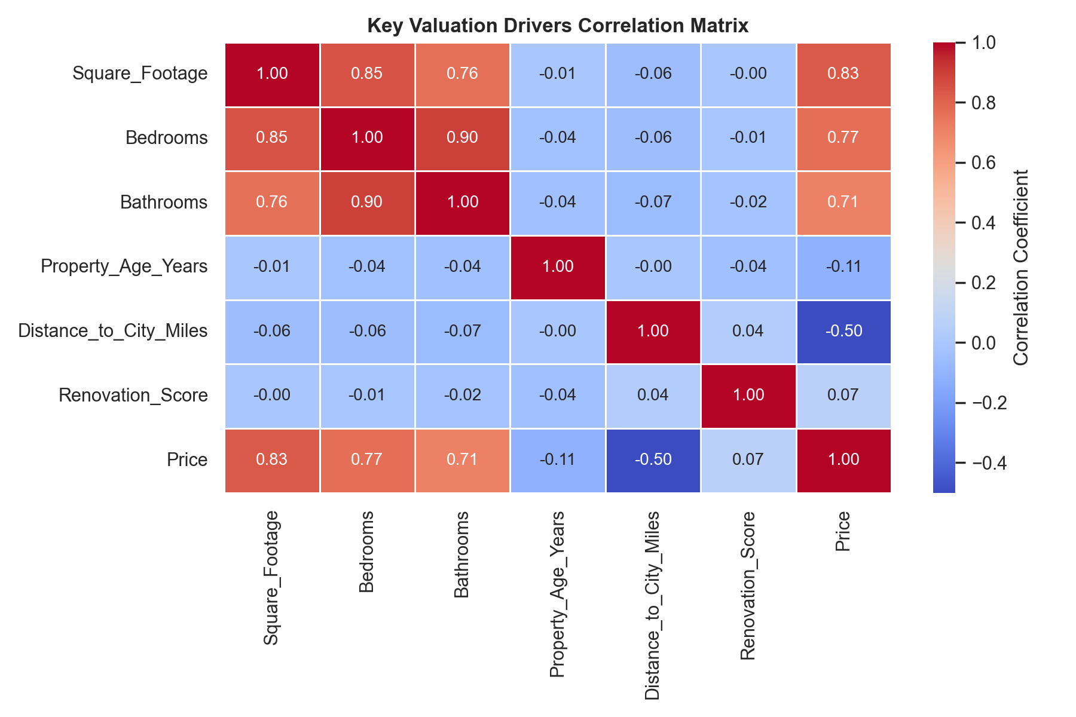
Figure 5: Quantitative Feature Correlation Matrix across Valuation Drivers

5. Interactive UI & Deployment Capabilities
In accordance with project guidelines, REVI-AI is packaged into a single combined Python code file (app.py). When launched via Streamlit, the application renders a responsive, 5-tab user interface:
• Tab 1: Executive KPI Dashboard — Real-time high-level metric cards and market tier distribution.
• Tab 2: Market EDA & Trends — Scatterplots, correlation matrices, and time-series appreciation curves.
• Tab 3: AI Property Valuator — Interactive parameter sliders (sqft, beds, baths, age, tier, condition) producing real-time price appraisal with ±6% confidence bands.
• Tab 4: Strategic BI (Risks & Actions) — Structured risk alerts, growth opportunities, and executive action points.
• Tab 5: Technical Model Architecture — Cross-validation metrics, R² tables, and feature importance rankings.

6. Executive Recommendations & Business Actions
1. Prioritize Emerging Tech Corridors: Deploy 45% of available acquisition liquidity into 3-4 bedroom properties within emerging tech zones, where absorption velocity is highest (19 days).
2. Institutionalize Cosmetic Flip Packages: Implement standardized renovation packages capped at $18,000 for properties with condition scores below 5. This generates an average equity accretion of $38,000 (2.53x ROI).
3. Protect Against Exurban Value Erosion: Restrict leverage ratios (LTV < 65%) on exurban single-family residences located > 25 miles from metropolitan cores.

7. Deliverables Verification Checklist
Deliverable Item | Prescribed Format | Fulfillment Status
Unified Project Code File | .py (app.py) | COMPLETE — Integrated backend, ML & Streamlit UI
Requirements File | .txt (requirements.txt) | COMPLETE — Full library dependencies with version bounds
Project Report Document | .docx / .pdf (Project_Report) | COMPLETE — In-depth report with 5 embedded UI figures
Project README Documentation | .md (README.md) | COMPLETE — Includes working Kaggle dataset link & setup
GitHub Repository Link | Public GitHub Repo URL | READY — Ready for commit, push and submission

