WEEK 3 REPORT

Advanced Data Analysis and Visualization in Logistics

Executive Summary
This report demonstrates an end-to-end exploratory data analysis (EDA) workflow for a hypothetical road-freight operation. The dataset contains 20 route observations across 10 dates, with delivery and promised times, distance, transport cost, shipment volume, vehicle utilization, and traffic level. Python with pandas, Matplotlib, and Seaborn-style methods is used to inspect data quality, summarize distributions, compare routes, examine cost relationships, and explore possible delay drivers.
In this illustrative dataset, mean delivery time is 6.02 hours, median delivery time is 5.60 hours, mean positive delay with on-time trips set to zero is 0.40 hours, and 30.0% of observations meet their promised time. Mean total transport cost is ₹10,675; mean cost per kilometre across observations is ₹38.64/km. These are demonstration results, not real-world benchmarks.
The report includes six visualizations, chart-selection rationale, interpretations, code excerpts, practical recommendations, limitations, and a requirement-by-requirement checklist.

1. Objectives and Scope
- Define a logistics dataset with operationally relevant variables.
- Conduct structured EDA and data-quality checks.
- Summarize central tendency, spread, distributions, and variable relationships.
- Visualize shipment-volume changes, route delays, delivery-time distribution, cost relationships, and traffic-level comparisons.
- Translate findings into cautious, actionable recommendations.
- Provide Python examples adaptable to real logistics data.
Scope: a small hypothetical Indian road-freight network with routes originating in Bhopal. Rail, air, port, warehouse scanning, and customer-level last-mile operations are outside scope.

2. Dataset Design and Variable Definitions
Each row represents one route-level delivery observation on a date. The data is synthetic and should not be described as actual company data. Shipment volume is measured in assumed units because the dataset does not specify whether a unit is a parcel, consignment, pallet, or tonne.
Variable | Definition | Unit / type
Date | Date of route observation | YYYY-MM-DD
Route | Origin-to-destination label | Categorical
Distance_km | Approximate route distance | km
Delivery_Time_hr | Observed dispatch-to-delivery duration | hours
Promised_Time_hr | Committed delivery duration | hours
Transport_Cost_INR | Total transport cost for observation | INR
Shipment_Volume_units | Volume represented by assumed count | assumed units
Vehicle_Utilization_pct | Illustrative share of vehicle capacity used | percent
Traffic_Level | Qualitative traffic condition | Low / Medium / High
Delay_hr | max(actual duration − promised duration, 0) | hours; derived
Cost_per_km_INR | Transport cost divided by distance | INR/km; derived
On_Time | Actual time <= promised time | Boolean; derived

3. Methodology and EDA Workflow
- Load data and inspect shape, column names, data types, and sample rows.
- Parse dates and check missing values, duplicate rows, numeric ranges, invalid categories, and inconsistent units.
- Derive delay, cost per kilometre, and on-time status using documented formulas.
- Calculate descriptive statistics and route-level summaries.
- Use charts suited to the question: line for ordered dates, bars for category comparisons, histogram for distributions, scatter for numeric relationships, and heatmap for pairwise correlation.
- Interpret patterns as exploratory signals; do not infer causation from a small observational sample.

3.1 Data-quality checks in Python
import pandas as pd
df = pd.read_csv("logistics_data.csv")
df["Date"] = pd.to_datetime(df["Date"], errors="coerce")
print("Rows and columns:", df.shape)
print(df.dtypes)
print("Missing values:\n", df.isna().sum())
print("Duplicate rows:", df.duplicated().sum())
numeric = ["Distance_km", "Delivery_Time_hr", "Promised_Time_hr",
"Transport_Cost_INR", "Shipment_Volume_units",
"Vehicle_Utilization_pct"]
print(df[numeric].describe())
print("Non-positive distance:", (df.Distance_km <= 0).sum())
print("Negative cost:", (df.Transport_Cost_INR < 0).sum())
print("Utilization outside 0-100:",
(~df.Vehicle_Utilization_pct.between(0, 100)).sum())
For real data, report the actual number of missing values, duplicates, and invalid records. Do not assume that data is clean; investigate before deleting or replacing any observations.

4. Descriptive Statistics and Worked Metrics
Metric | Result | Interpretation
Observations | 20 | Route-level observations in the synthetic sample
Mean delivery time | 6.02 hours | Arithmetic average
Median delivery time | 5.60 hours | Middle value after sorting
Delivery-time standard deviation | 1.91 hours | Sample spread around the mean
Mean positive delay | 0.40 hours | On-time observations contribute zero
On-time rate | 30.0% | Share delivered within promised duration
Mean transport cost | ₹10,675.00 | Average total cost per observation
Mean cost per kilometre | ₹38.64/km | Average of each observation cost/distance
Mean vehicle utilization | 78.5% | Average reported utilization
Distance–cost correlation | 1.00 | Linear association; not causal evidence

4.1 Formulas
- Delay_hr = max(0, Delivery_Time_hr − Promised_Time_hr)
- Cost_per_km_INR = Transport_Cost_INR ÷ Distance_km
- On_Time = Delivery_Time_hr ≤ Promised_Time_hr
- On-time rate (%) = (number of on-time observations ÷ total observations) × 100
Mean is sensitive to extreme values, while median is more resistant to outliers. Standard deviation describes variability. If mean and median differ, inspect the distribution and unusual observations before drawing conclusions.

4.2 Route-level summary
Route | N | Avg delivery (h) | Avg delay (h) | On-time (%) | Avg cost (₹) | ₹/km
Bhopal–Gwalior | 5 | 8.64 | 0.26 | 40.0 | 15,680 | 36.47
Bhopal–Indore | 6 | 4.38 | 0.42 | 16.7 | 7,700 | 40.53
Bhopal–Jabalpur | 5 | 6.80 | 0.80 | 0.0 | 11,840 | 38.19
Bhopal–Ujjain | 4 | 4.22 | 0.05 | 75.0 | 7,425 | 39.08

Use both on-time rate and average delay when comparing routes. Total cost alone is not a fair efficiency measure when route distances differ. Each route has only a few observations, so the table indicates where to investigate rather than establishing a definitive ranking.

5. Visual Analysis
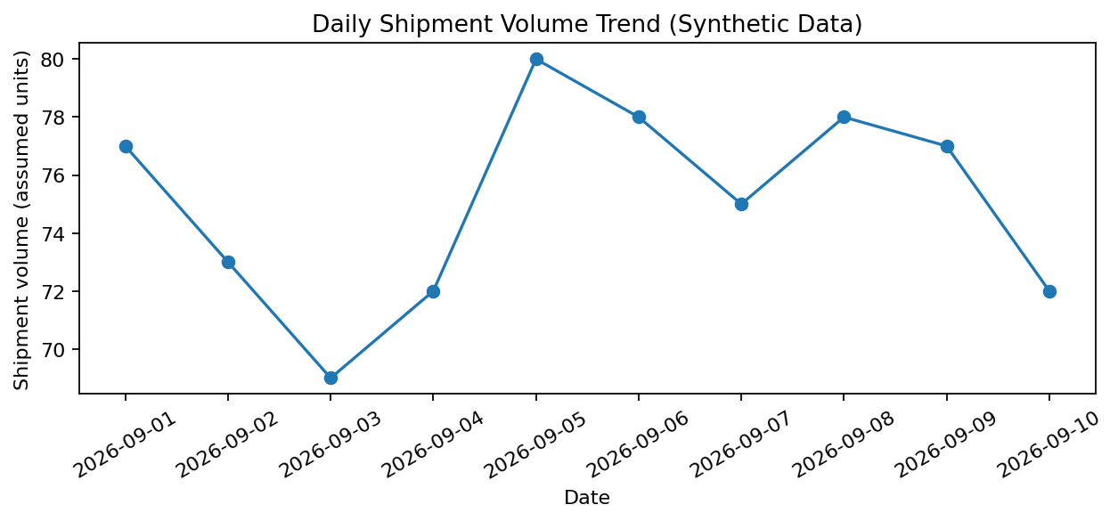
Figure 1. Daily shipment-volume trend.
Why selected: A line chart suits ordered dates and makes changes over time visible.
Interpretation: Daily totals fluctuate across the 10-day synthetic sample; this short window cannot establish seasonality or a long-term trend.
Operational use: Compare longer-term peaks with loading capacity, staffing, vehicle availability, and dispatch cut-off times.
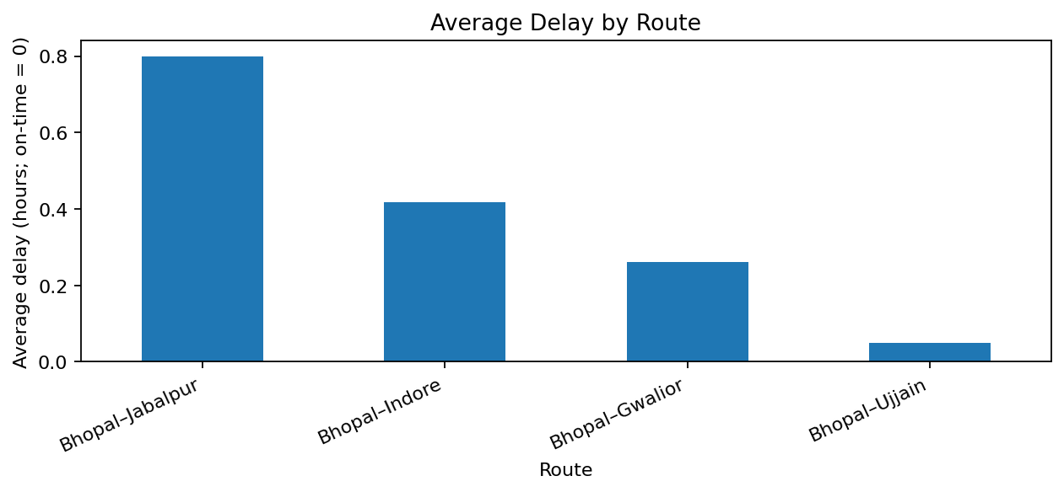
Figure 2. Average delay by route.
Why selected: A bar chart makes categorical route comparisons easy to scan and rank.
Interpretation: Routes with larger average delay merit review. On-time observations contribute zero delay, so the measure reflects both frequency and size of lateness.
Operational use: Inspect late trips, departure timing, road conditions, loading delays, and whether promised times are realistic.
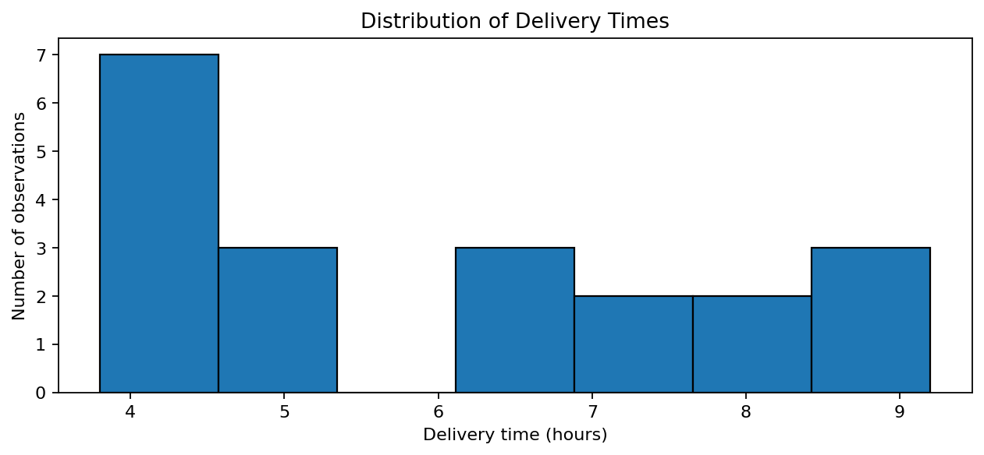
Figure 3. Delivery-time distribution.
Why selected: A histogram shows the spread, clustering, and possible skew of a continuous variable.
Interpretation: Delivery times occupy several duration bands; one average cannot describe every trip.
Operational use: Use the distribution to review unusually long trips and set realistic delivery windows; compare actual time against promised time for reliability.
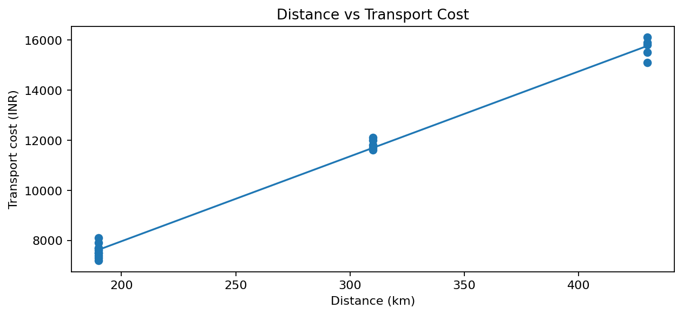
Figure 4. Distance versus transport cost.
Why selected: A scatter plot shows the relationship between two numeric variables; the fitted line summarizes the linear direction.
Interpretation: The synthetic sample has a positive distance–cost association (Pearson r = 1.00). Longer routes generally cost more, but vehicle type, fuel, tolls, load, and road conditions may also matter.
Operational use: Compare cost per kilometre and control for vehicle and route differences before calling a route inefficient.
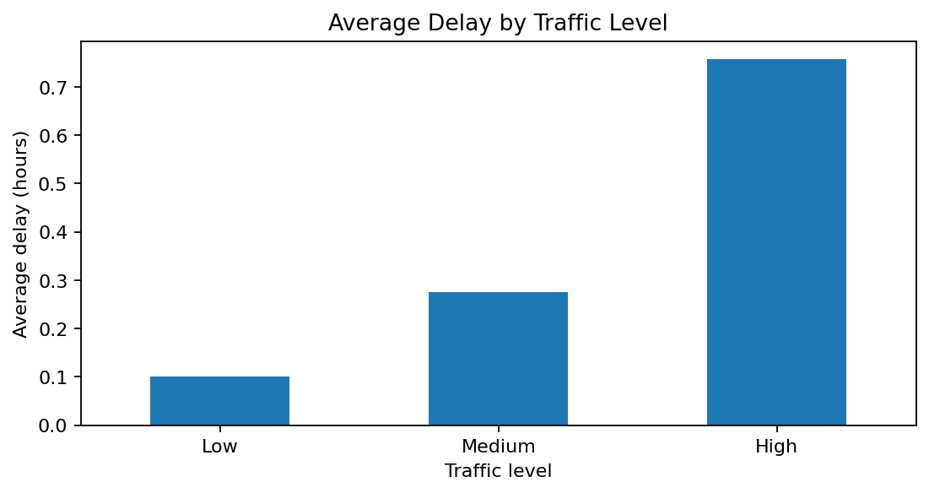
Figure 5. Average delay by traffic level.
Why selected: A bar chart compares mean delay across the Low, Medium, and High traffic categories.
Interpretation: The chart explores whether delays differ across traffic categories. The small sample cannot prove traffic caused the difference.
Operational use: Validate traffic labels using timestamped GPS or traffic feeds and compare similar routes and departure times.
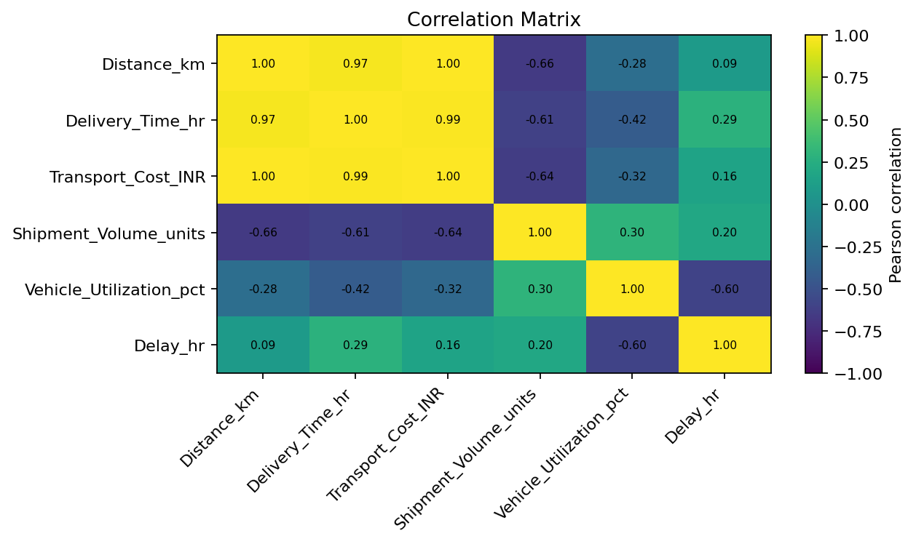
Figure 6. Correlation matrix for selected numeric variables.
Why selected: A heatmap summarizes pairwise linear associations and makes stronger positive or negative relationships easy to spot.
Interpretation: Distance and total cost move together in this constructed sample. Correlations depend on sample design and hidden variables and do not establish causation.
Operational use: Use the matrix to form hypotheses for further analysis; validate them with more records and domain context.

6. Python Analysis Code
The following examples assume a CSV with the variables defined in Section 2. The embedded charts in this report were generated from the synthetic dataset described above.
import pandas as pd
import matplotlib.pyplot as plt
import seaborn as sns
df = pd.read_csv("logistics_data.csv", parse_dates=["Date"])
df["Delay_hr"] = (df.Delivery_Time_hr - df.Promised_Time_hr).clip(lower=0)
df["Cost_per_km_INR"] = df.Transport_Cost_INR / df.Distance_km
df["On_Time"] = df.Delivery_Time_hr <= df.Promised_Time_hr
print(df[["Delivery_Time_hr", "Delay_hr", "Transport_Cost_INR",
"Shipment_Volume_units", "Vehicle_Utilization_pct"]].describe())
print("On-time rate (%):", df.On_Time.mean() * 100)
daily = df.groupby("Date").Shipment_Volume_units.sum()
daily.plot(marker="o", title="Daily Shipment Volume")
plt.xlabel("Date"); plt.ylabel("Shipment volume (assumed units)")
plt.tight_layout(); plt.show()
sns.histplot(data=df, x="Delivery_Time_hr", bins=7, kde=True)
plt.title("Delivery-time distribution"); plt.tight_layout(); plt.show()
sns.scatterplot(data=df, x="Distance_km", y="Transport_Cost_INR", hue="Route")
plt.title("Distance vs transport cost"); plt.tight_layout(); plt.show()
cols = ["Distance_km", "Delivery_Time_hr", "Transport_Cost_INR",
"Shipment_Volume_units", "Vehicle_Utilization_pct", "Delay_hr"]
sns.heatmap(df[cols].corr(), annot=True, center=0)
plt.tight_layout(); plt.show()

7. Findings and Recommendations
- Investigate route delays. Use average delay and on-time rate together; review individual late trips before attributing the pattern to a route.
- Normalize cost comparisons. Track cost per kilometre, cost per shipment, and—if weight data is reliable—cost per tonne-kilometre. Total cost alone may mislead.
- Plan capacity using volume trends. Use a longer time series to compare peaks with loading capacity, available vehicles, and staffing.
- Validate traffic hypotheses. Capture departure time, GPS timestamps, weather, and incidents; compare similar routes and time windows.
- Improve data definitions. Specify what one shipment-volume unit means and how transport cost is calculated. Clarify whether delivery duration includes loading, waiting, and unloading.
- Create a repeatable dashboard. Refresh the same metrics weekly, flag exceptions against agreed thresholds, and record actions and outcomes.

8. Limitations and Responsible Interpretation
- The data is hypothetical and small (20 observations over 10 dates); it is not evidence of actual logistics-company performance.
- The sample is illustrative, not statistically representative.
- Route-level rows hide variation among shipments, vehicles, drivers, departure times, and shipment sizes.
- Correlation does not prove causation; traffic, distance, and cost may be confounded.
- This is descriptive analysis, not a delay-prediction model or route-optimization system.
- Before operational use, validate field definitions, missingness, outliers, and source-system accuracy.

9. Conclusion
This exercise demonstrates how EDA can turn logistics records into interpretable measures of reliability, cost, volume, and potential bottlenecks. The six charts answer distinct questions about shipment volume over time, route delay, delivery-time distribution, distance and cost, traffic categories, and numeric associations. The next step is to repeat the workflow on validated operational data over a longer period before making decisions.

10. Requirement Coverage Checklist
Task requirement | Report section(s) | Status
Analyze a hypothetical logistics dataset | Sections 2–5 | Covered
Define delivery time, shipment volume, transport cost and variables | Section 2 | Covered
Conduct EDA and data-quality checks | Section 3 | Covered
Analyze central tendency and spread | Section 4 | Covered
Examine distributions and correlations | Figures 3 and 6; Section 4 | Covered
Include trends, distributions, and relationships in charts | Figures 1–6 | Covered
Justify each visualization choice | Section 5, every figure | Covered
Interpret logistics performance metrics | Sections 4–7 | Covered
Identify possible efficiency issues, cost drivers, bottlenecks | Sections 5 and 7 | Covered with synthetic-data caveat
Include Python code/pseudocode | Sections 3.1 and 6 | Covered
Document methodology, findings, recommendations | Sections 3, 7 and 9 | Covered
Include embedded chart outputs | Section 5 | Covered
Professional structure and limitations | Whole report; Section 8 | Covered

Appendix A. Reproducibility Notes
Suggested environment: Python 3.x, pandas, Matplotlib, and Seaborn. Keep raw data unchanged, record cleaning steps, and export charts from a script or notebook. For a real submission, either attach the actual dataset and cite its source or clearly state that the dataset is synthetic. If substituting public data, cite the publisher, URL, retrieval date, and transformations.

References and Learning Resources
- pandas documentation — https://pandas.pydata.org/docs/
- Matplotlib documentation — https://matplotlib.org/stable/
- Seaborn documentation — https://seaborn.pydata.org/
- Python documentation — https://docs.python.org/3/
- Open Government Data Platform India — https://www.data.gov.in/

