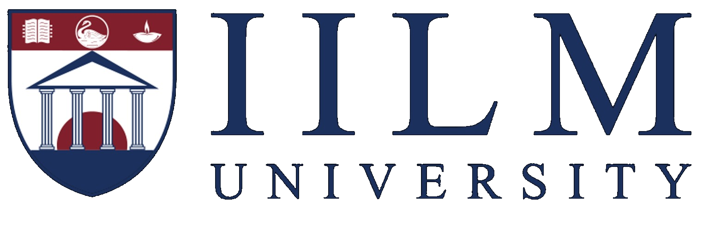
INTERNSHIP REPORT
on
SOCIAL MEDIA MANAGEMENT
Fokuszy.in
Internship Period: 15 June 2026 – 15 July 2026
Student Name | ____________________________________________
Roll Number | ____________________________________________
Programme / Branch | ____________________________________________
Semester / Year | ____________________________________________
Academic Session | ____________________________________________

Submitted to
IILM University, Greater Noida
Plot No. 16–18, Knowledge Park II, Greater Noida, Uttar Pradesh – 201306

INTERNSHIP CERTIFICATE
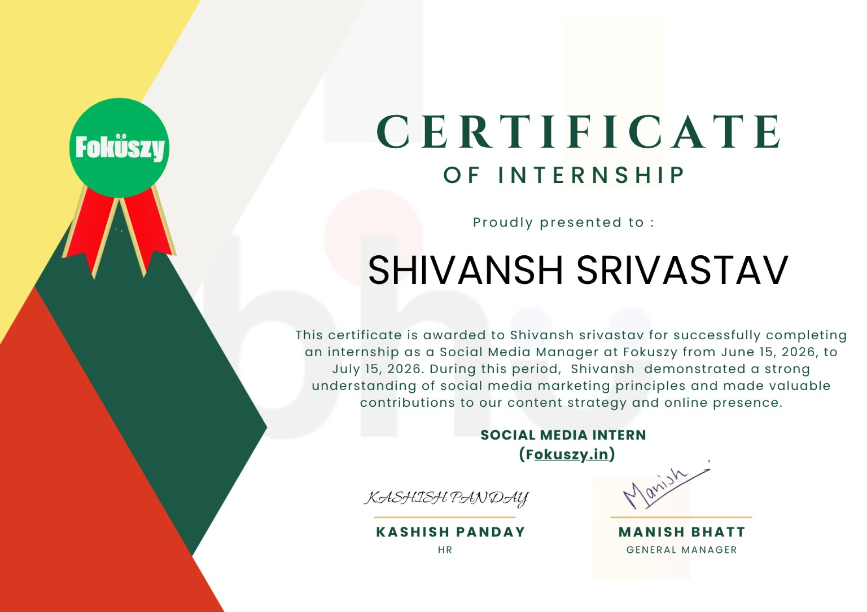
Certificate provided by Fokuszy.in

DECLARATION
I hereby declare that this internship report titled “Social Media Management Internship at Fokuszy.in” is prepared as a record of my internship experience carried out from 15 June 2026 to 15 July 2026. The report presents my understanding of the work exposure, responsibilities, learning outcomes, and professional skills developed during the internship.
The information included in this report is intended for academic documentation. Specific organisational details are discussed only to the extent supported by the internship certificate and the nature of the internship role.

ACKNOWLEDGEMENT
I would like to express my sincere gratitude to Fokuszy.in for providing me with the opportunity to undertake an internship in the field of social media management. The internship provided practical exposure to digital communication, content planning, online audience engagement, and the importance of maintaining a consistent brand presence.
I am thankful to the HR team and management of Fokuszy.in for their support and guidance. I also acknowledge the support of my university, faculty members, and everyone who contributed to my learning experience.

EXECUTIVE SUMMARY
This report documents a one-month internship experience as a Social Media Intern / Social Media Manager at Fokuszy.in. The internship focused on understanding social media marketing principles and contributing to content strategy and online presence. The experience provided an opportunity to learn how content is planned, prepared, communicated, reviewed, and improved for digital audiences.

1. INTRODUCTION
Social media has become an important communication channel for organisations, brands, creators, and businesses. A strong social media presence is not limited to posting content; it involves understanding the target audience, maintaining a consistent brand identity, selecting suitable formats, encouraging engagement, and reviewing performance.
The internship at Fokuszy.in provided practical exposure to these principles. As stated on the internship certificate, the role involved social media responsibilities and contributions to content strategy and online presence. This made the internship relevant to digital marketing, communication, branding, and content management.

2. ORGANISATION OVERVIEW – FOKUSZY.IN
Fokuszy.in is the organisation associated with the internship certificate. The certificate identifies the position as Social Media Manager / Social Media Intern and records the internship period as 15 June 2026 to 15 July 2026.
For this academic report, the organisation is discussed primarily from the perspective of the internship role rather than making unverified claims about its complete business operations.

3. INTERNSHIP OBJECTIVES
- Understand the fundamentals of social media marketing and digital communication.
- Learn how content contributes to an organisation’s online identity and visibility.
- Develop practical understanding of content planning and social media workflow.
- Improve communication, creativity, consistency, and professional coordination skills.
- Understand the importance of audience engagement and performance-oriented content.
- Gain workplace discipline through deadlines, feedback, revision, and task completion.

4. ROLE AND RESPONSIBILITIES
The internship certificate describes the position as Social Media Manager / Social Media Intern. Based on this role and the stated contribution to content strategy and online presence, the internship involved practical exposure to the following areas:
- Content Planning: Understanding what type of content is suitable for a social media audience and arranging content around clear themes or objectives.
- Content Development: Supporting the preparation of captions, post ideas, creative concepts, and other communication material.
- Social Media Communication: Learning how wording, tone, visuals, and timing influence how a message is received.
- Brand Consistency: Maintaining a recognisable tone and presentation across social media content.
- Audience Engagement: Understanding the importance of responses, interactions, comments, and community-oriented communication.
- Content Review: Checking content for clarity, relevance, formatting, spelling, and consistency before publication.
- Performance Awareness: Developing an introductory understanding of reach, impressions, engagement, likes, shares, comments, and follower growth.

5. SOCIAL MEDIA CONTENT WORKFLOW
A structured social media workflow can be represented as: objective setting → audience understanding → idea generation → content creation → review → publishing → engagement → performance observation → improvement.
This workflow helped me understand that successful social media management requires both creativity and discipline. Creative ideas need clear objectives, consistent execution, timely delivery, and continuous learning from audience response.

6. TOOLS AND DIGITAL SKILLS
The internship developed familiarity with the broader digital tools and skills required for social media work. The exact software used may vary according to organisational requirements; therefore, this report focuses on transferable workflow and skills rather than claiming specific software that is not stated on the certificate.
- Content writing and caption drafting
- Basic visual-content planning
- Social media publishing and scheduling concepts
- Audience and engagement observation
- Basic performance-metric interpretation
- Digital communication and professional collaboration
- Content proofreading and quality checking

7. METHODOLOGY
The internship methodology followed a practical learning approach. Tasks were understood from their objective, content was prepared or reviewed, feedback was incorporated, and the final output was aligned with the intended communication purpose.
Stage | Purpose
1. Objective | Define what the content should communicate.
2. Research / Ideas | Identify suitable topics, themes and audience needs.
3. Creation | Develop captions, concepts or social media content.
4. Review | Check clarity, accuracy, tone and consistency.
5. Publish / Engage | Share content and observe audience interaction.
6. Learn / Improve | Use feedback and performance observations for improvement.

8. LEARNING OUTCOMES
The internship contributed to both technical and professional development. The most important learning outcomes are summarised below.
- Better understanding of social media as a professional communication channel.
- Improved ability to think from the perspective of a target audience.
- Greater awareness of content quality, consistency, and brand tone.
- Improved written communication and caption-writing skills.
- Understanding of why social media performance should be observed through measurable indicators.
- Improved time management and ability to work with deadlines.
- Greater confidence in receiving feedback and revising work.
- Understanding that digital marketing combines creativity, communication, analysis, and consistency.

9. CHALLENGES AND HOW THEY WERE ADDRESSED
- Generating relevant content ideas: Use themes, audience needs, communication goals, and content categories to structure ideas.
- Maintaining consistent communication: Follow a defined tone, visual direction, and quality-check process.
- Meeting deadlines: Break larger work into smaller tasks and prioritise time-sensitive content.
- Understanding audience response: Observe engagement patterns and use them as learning inputs rather than relying only on assumptions.

10. RESULTS AND OUTCOMES
The internship resulted in practical exposure to the workflow of social media management and digital content strategy. The experience strengthened my understanding of how online presence is built through regular, relevant, and audience-oriented communication.
A major outcome was the development of a more structured approach to content work. Instead of viewing a social media post as an isolated creative activity, I learned to consider its objective, audience, message, presentation, consistency, and possible performance.

11. PROFESSIONAL SKILLS DEVELOPED
- Communication and professional writing
- Creative thinking and idea generation
- Time management and task prioritisation
- Team coordination and feedback handling
- Attention to detail
- Basic digital marketing awareness
- Audience-oriented thinking
- Adaptability and willingness to learn

12. CONCLUSION
The internship at Fokuszy.in was a valuable practical learning experience in social media management. The period from 15 June 2026 to 15 July 2026 provided exposure to the principles of content strategy and online presence, as reflected in the internship certificate.
The experience helped bridge the gap between academic learning and professional practice. It demonstrated that effective social media management requires creativity, consistency, communication, planning, and continuous improvement.

13. FUTURE SCOPE
Future development can include advanced social media analytics, paid campaign concepts, campaign optimisation, content calendars, A/B testing, influencer collaborations, search-oriented content strategy, and data-driven audience segmentation.

14. REFERENCES
1. IILM University, Greater Noida – Official University Website and Greater Noida campus information.
2. IILM University – Official institutional and programme information.
3. Fokuszy.in – Internship certificate issued to Shivansh Srivastav for the internship period 15 June 2026 to 15 July 2026.

15. APPENDIX
Appendix A – Internship Certificate
End of Internship Report

