**DHT11**

**ABOUT SENSOR:**

-It stands for Digital Humidity and Temperature which used to measure humidity and temperature.

- They consist of a humidity sensing component, a NTC temperature sensor (or thermistor) and an IC on the back side of the sensor.

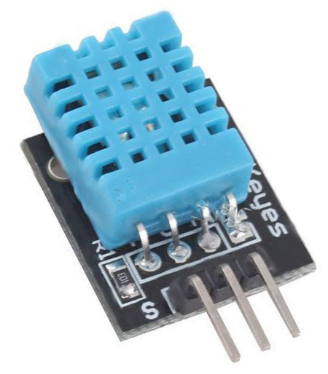

**WORKING:**

For measuring humidity they use the humidity sensing component which has two electrodes with moisture holding substrate between them. So as the humidity changes, the conductivity of the substrate changes or the resistance between these electrodes changes. This change in resistance is measured and processed by the IC which makes it ready to be read by a microcontroller.

On the other hand, for measuring temperature these sensors use a NTC temperature sensor or a thermistor.

A thermistor is actually a variable resistor that changes its resistance with change of the temperature.

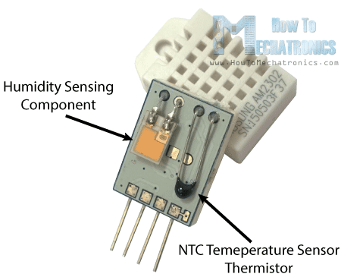

**INTERFACING OF THE SENSOR WITH ARDUINO UNO**

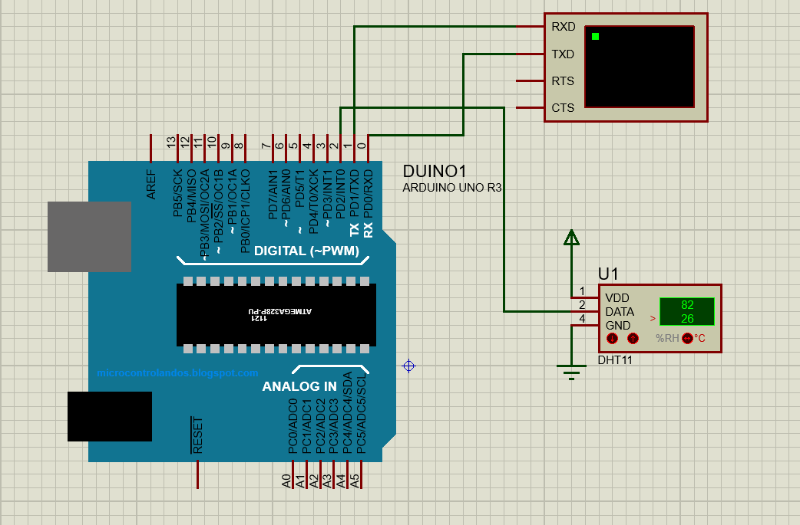

**PINOUTS:**

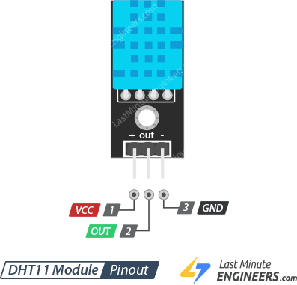

|  |  |  |
| --- | --- | --- |
| **PIN NUMBER** | **PIN NAME** | **PIN DESCRIPTION** |
| 1 | Vcc | The supply voltage of 5v is given to power the sensor from the Arduino. |
| 2 | Data | The output of the digital signal is taken from this pin. |
| 3 | Gnd | This pin is connected to the ground. |

**APPLICATIONS:**

It is basically used to get the reading temperature and and humidity of a particular place.

**CODE:**

**#include<DHT.h>**

**DHT dht(2,DHT11);**

**void setup() {**

**// put your setup code here, to run once:**

**Serial.begin(9600);**

**dht.begin();**

**}**

**void loop() {**

**// put your main code here, to run repeatedly:**

**float t=dht.readTemperature();**

**float h=dht.readHumidity();**

**Serial.println("Temperature-");**

**Serial.println(t);**

**Serial.println("Humidity-");**

**Serial.println(h);**

**delay(5000);**

**}**