**PIEZO** **BUZZER**

**ABOUT SENSOR:**

A *buzzer* or beeper is an audio signalling device, which may be mechanical, electromechanical, or piezoelectric [piezo] for short.  A buzzer in a circuit is a kind of speaker. It can beep and make tones based on the frequency and voltage and these are usually pitches that are higher in frequency, not buzzing or low tones.

**WORKING:**

-The buzzer consists of an outside case with two pins to attach it to power and ground.

-Inside is a piezo element, which consists of a central ceramic disc surrounded by a metal (often bronze)vibration disc.

-When current is applied to the buzzer it causes the ceramic disk to contract or expand. This then causes the surrounding disc to vibrate.  That’s the sound that you hear.  By changing the frequency of the buzzer, the speed of the vibrations changes, which changes the pitch of the resulting sound.

**INTERFACING OF THE SENSOR WITH ARDUINO UNO**

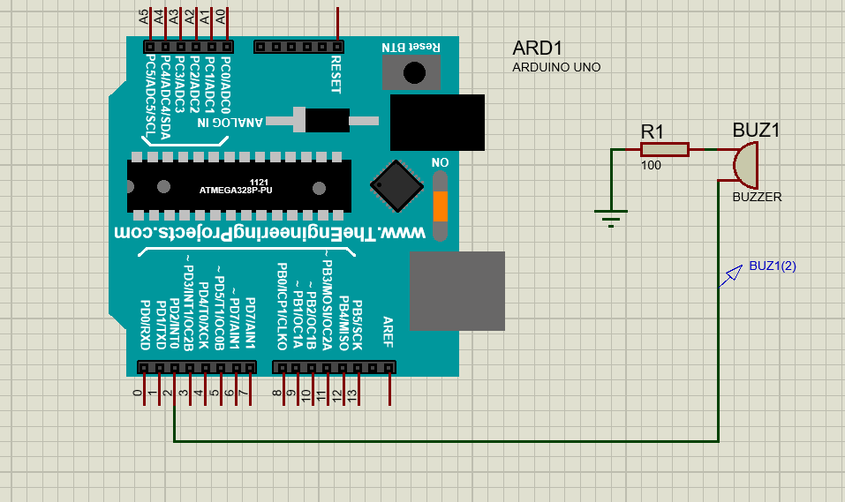

**PINOUTS:**

-The red wire is connected to the digital pin of Arduino.

-The black wire is connected to the Gnd of Arduino.

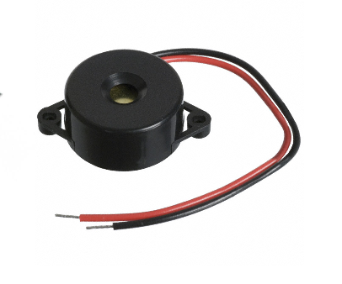

**CODE:**

void setup() {

// put your setup code here, to run once:

pinMode(2,OUTPUT);

}

void loop() {

// put your main code here, to run repeatedly:

tone(2,1000); //frequency in Hz:

delay(500);

noTone(2);

delay(500);

}