**LCD**

**ABOUT SENSOR:**

An LCD (Liquid Crystal Display) screen is an electronic display module and has a wide range of applications. A 16x2 LCD display is very basic module and is very commonly used in various devices and circuits. A 16x2 LCD means it can display 16 characters per line and there are 2 such lines. In this LCD each character is displayed in 5x7 pixel matrix. The 16 x 2 intelligent alphanumeric dot matrix display is capable of displaying 224 different characters and symbols. This LCD has two registers, namely, Command and Data.

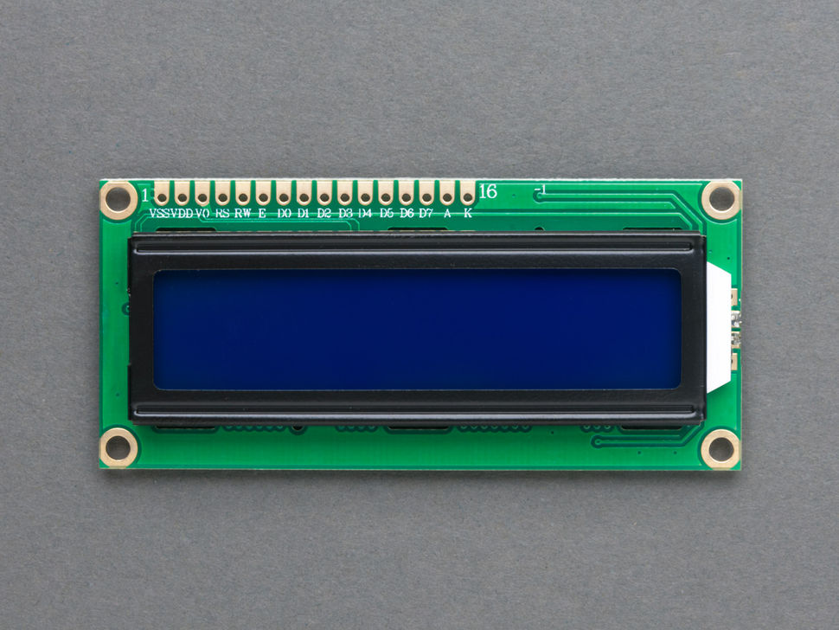

**WORKING:**

As mentioned above about the register pins ,Command register stores various commands given to the display. Data register stores data to be displayed. The process of controlling the display involves putting the data that form the image of what you want to display into the data registers, then putting instructions in the instruction register. In the arduino project Liquid Crystal Library simplifies this for you . Contrast of the display can be adjusted by adjusting the potentiometer to be connected across VEE pin.

**INTERFACING OF THE SENSOR WITH ARDUINO UNO**

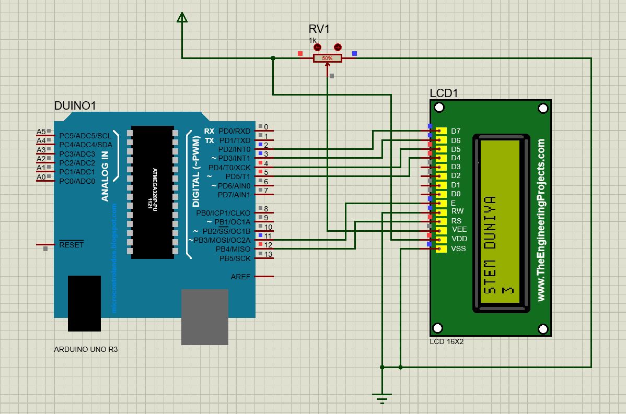

**PINOUTS:**

|  |  |  |
| --- | --- | --- |
| PIN NUMBER | PIN NAME | PIN DESCRIPTION |
| **1** | **GND** | This pin is connected to the ground. |
| **2** | **VCC** | The supply voltage of 5v is given to power the sensor from the Arduino. |
| **3** | **VO** | Display contrast pin. |
| **4** | **RS** | controls where in the LCD's memory you're writing data to. |
| **5** | **R/W** | Read and write pin. |
| **6** | **EN** | enables writing to the registers. |
| **7-14** | **DATA PIN** | The states of these pins (high or low) are the bits that you're writing to a register when you write, or the values you're reading when you read. |

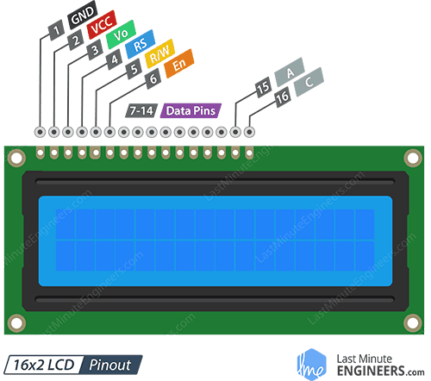

**CODE:**

#include<LiquidCrystal.h>

LiquidCrystal lcd(12,11,5,4,3,2);

void setup() {

// put your setup code here, to run once:

lcd.begin(16,2);

lcd.print("STEM DUNIYA");

}

void loop() {

// put your main code here, to run repeatedly:

//Turn on the display:

lcd.display();

lcd.setCursor(0,1);

lcd.print(millis() /1000);

delay(500);

}