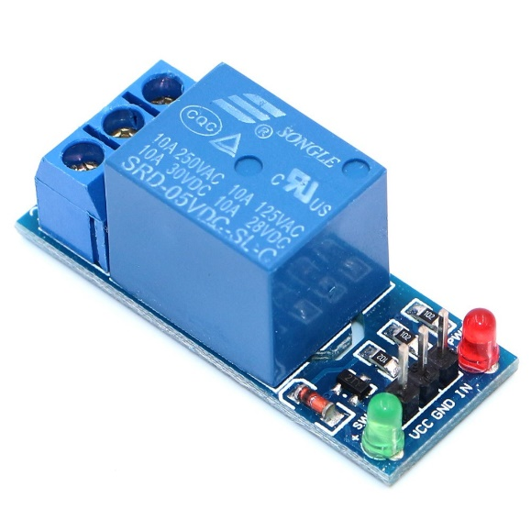**RELAY**

**What is Relay?**

Sometimes we have to control high current devices or AC devices using a small signal. So, this is where Relay comes into play. It is used to control high current requirement devices through a small signal from Microcontrollers.

**How does Relay works?**

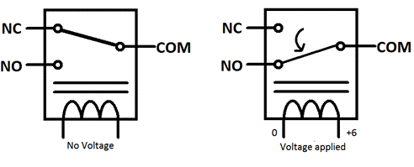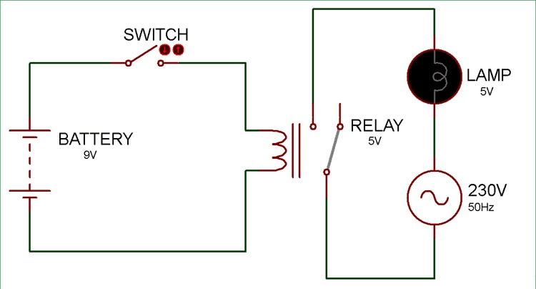The relay has an electronical switch (in the figure represented using an SPST switch) which can be controlled using a small signal. The switch is usually made using a Bi-Polar Junction transistor or using and Optocoupler. So, when the switch is ON, the electromagnet starts charging and produces a temporary magnetic field which attracts or repels the electromagnetic switch depending on its initial state. In the Single Pull Double Throw (SPDT) switch, there is one common terminal which is used in either configuration, another is NO, which means normally open which means the circuit would be open when the electromagnet is not charged and last one is NC which means normally closed when the electromagnet is not charged. In the first figure, the relay is in NO configuration, i.e. when electromagnet is not charged, it is an open circuit and when we charge the electromagnet, the switch gets attracted towards the normally closed side and current in the other circuit flows.

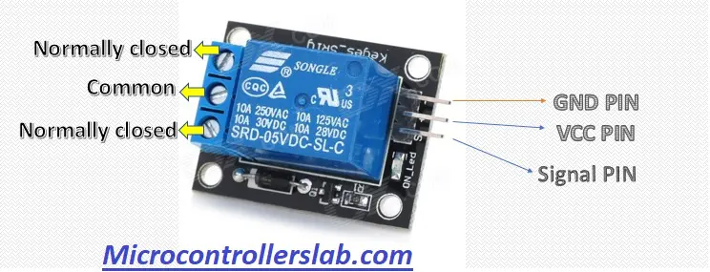**PINOUTs**

|  |  |
| --- | --- |
| **Pin Name** | **Description** |
| GND (-) | Connected to ground |
| VCC (+) | Power supply for the relay, usually 5V |
| Signal(S) | The signal to control the relay is given |
| Common (COM) | Common is connected to one End of the Load that is to be controlled |
| Normally Close (NC) | The other end of the load is either connected to NO or NC. If connected to NC the load remains connected before trigger |
| Normally Open (NO) | The other end of the load is either connected to NO or NC. If connected to NO the load remains disconnected before trigger |

**Some More Specifications**

|  |  |
| --- | --- |
| Trigger Voltage (Voltage across coil) | 5V DC |
| Trigger Current (Nominal current) | 70mA |
| Maximum AC load current | 10A @ 250/125V AC |
| Maximum DC load current | 10A @ 30/28V DC |
| Release time | 5msec |
| Operating time | 10msec |
| Maximum switching | 300 operating/minute (mechanically) |